 



Project name

Personal Assistant

**Project Supervisor** **Department:**

**Dr/ Basel Hafez** **Computer sc**ience

Team Members

1. Ahmed Ibrahim Abdel Sattar
2. Ahmed Moustafa Abdel Halim
3. Abdel Rahman Mohamed Hesham
4. Esraa Mahmoud Khataab
5. Farah Mahmoud
6. Khalid Mahmoud
7. Mennah Mohsen
8. Seham Anwer mohamed

Table of Contents

Background------------------------------------------------------------1

Why mobile application ? ------------------------------------------------1.1

Introduction------------------------------------------------------------------2.1

Motivation -------------------------------------------------------------------3.1

Beneficiary ------------------------------------------------------------------4.1

Users:---------------------------------------------------------------------------------4.1

Developers:---------------------------------------------------------------------------4.1

Tools& technology---------------------------------------------------------5.1

For ios--------------------------------------------------------------5.1

For android--------------------------------------------------------5.1

Problems----------------------------------------------------------6.1

Problem definition -----------------------------------------6.1

Problems statements---------------------------------------6.1

Applications that exist in the online market currently--------------7.1

Project aim and Objectives----------------------------------------------8.1

Advantage of our application--------------------------------------------9.1



*Why we make a android and ios app*

Smart phones are extremely versatile gadgets, offering unlimited chances to utilize our time efficiently. On average, a smart phone has 41 applications, and every day more new phones are being activated .

Perhaps the most startling statistic is that currently, 1.3 million Android devices are

activated every day which means that every 24 hours, more than four times as many new smart phones and tablets are set up than babies are born. And once the devices are activated, they are checked on average 150 times a day once every 6.5 minutes. The apps in both Apple’s and Google’s app store combined is over 2 millions .

Admittedly, the apps are the purpose behind the smart phone. Furthermore, on average

every smart phone contains 41 apps which are used for regular needs. The Statistics in

 **Figure 1.1: Increase in smart phone market over years**



Introduction:

The best personal assistant apps keep your day flowing smoothly. Ideally, you should be able to review it at the top of the week for an overview and every morning to get a grasp on your day, relying on notifications for the rest of the time. The right calendar app helps you stay on top of appointments, holidays, and celebrations, not to mention deadlines.

The personal assistant app that's right for you depends on your needs and lifestyle. Do you rely on notifications and reminders or do you find them a nuisance? Do you need to manage a calendar collectively with a household or other coworkers? Do you prefer a streamlined and subtle interface or an app that's jammed full of features, such as in-app notes and to-dos, design be damned?

We considered and tested several dozen calendar apps to find the 10 best that meet a variety of needs.

Motivation:

We know that many people, especially businessmen and employees need to organize their agenda and remind them of the most important events, and this requires a special secretary for each person and this is very expensive, so we have done this application in order to save money and time and provide the best service to the user and access to a high degree of User Satisfaction,so

**What Makes a Great personal assistant App?**

* **Easy to use**
* **Designed with intention**
* **Packed with features and customizable**
* **Simple to share**
* **Available for multiple devices**

**Beneficiary**

|  |  |
| --- | --- |
| **Users** | **Developers** |
| * Available (everyone uses ios ,android) * Saves time. * Easy to search * easy to modification * ability to sharing * ability to send gmail | * We gain knowledge about user's requirement * We gain knowledge about The practical life of each user * As developers we have a future look at the potential demands of the user next time |

Tools & technology

To build a personal assistant we make a ios & android app

For ios

* MVware workstation 15 PRO : You can replicate server, desktop, and tablet environments in a virtual machine and allocate multiple processor cores, gigabytes of main memory and graphics memory to each virtual machine, whether the virtual machine resides on a personal PC or on a private enterprise cloud.
* Mac_os java 10.14: Every time you launch a Java applet, a Java Web Start application or the Java Control Panel, the system first launches your program and then, in the background (so that performance of your Java application is not impacted)
* X_code (ios editor)
* Swift (language)
* Frameworks
* FireBase

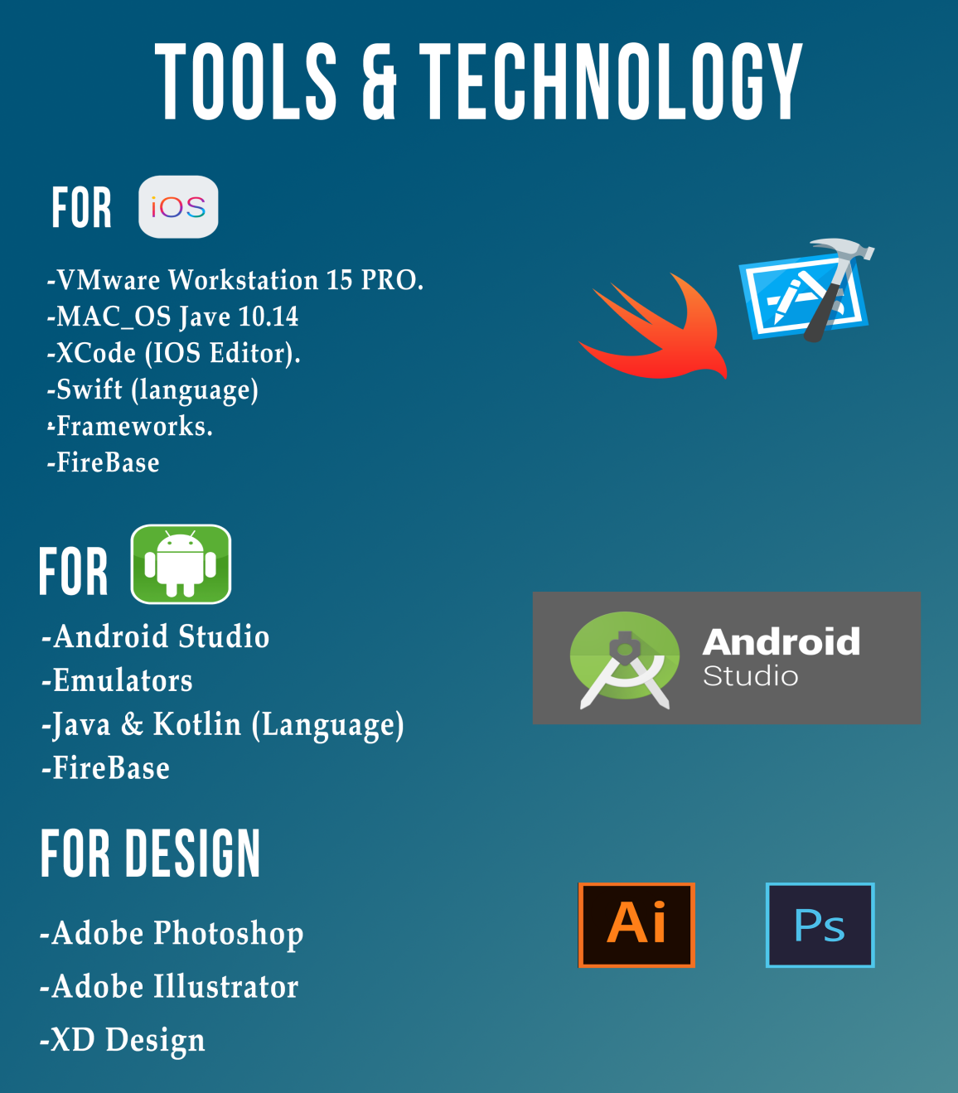

For android

* Android studio: Android Developers have to use several tools to design, program and test their projects, in order to create an optimized app with no bugs or issues that cause trouble to users.
* Emulator: An Android emulator lets you run Android on a Windows, Mac or Linux. This allows you to gain access to Android features and apps without needing to buy an Android device, Like any other software
* Java & kotlin (language)
* FireBase



Problem Definition:

Most of the problems that we faced as developers, many people were suffering from the organization of their time in the presence of a lot of meetings, conferences, trips and other important events in their lives, and many people had their opinion to get a special secretary in the organization of these events so that it reaches the maximum efficiency possible in Organize and arrange time, but get a special secretary is very expensive, especially if dealing with all segments of society.

A problem statement is a short, succinct explanation of a problem a business is facing and a proposed solution to the problem .

Problem statements can be effective ways to define an issue and communicate a solution within a short span of time.

Before you write your problem statement, think about the problem and your proposed solution, and be prepared to back it up with facts!

Problem statements :

**The most important**

1. Many people were suffering from daily organization of their time in presence of a lot of meetings , conference , trips and important events in life
2. many people need to a special secretary in organization to organize and arrange time but get a special secretary is very expensive , specially if dealing with all segments of society
3. acclimate weather with important meeting places
4. solve the problem that conflict dates with each others
5. determine place location
6. need to alarm for events and meetings
7. problem of schedule medication for patients
8. Know the most important meetings and appointments

Applications that exist in the online market currently:

Most of the applications now exist in the eCommerce Marketplace serving some parts of the problems presented, not all of them , Here are some of these applications:-

Applications for calendar

1. **Studious ->** This application helps you keep track of your daily schedule, schedules or lectures with assignments, and exams in the future. Features of this application also puts the phone on the shock automatically at the start of the lecture or lecture.
2. **Any.Do ->** Every person who is tired of the chaos of his life and needs to organize his schedule, it helps to remember all the tasks that must be done during the day, and the time it must be played in order to remind you to wake up on time.
3. [**Wave**](http://www.wavecalendarapp.com/) **->** Synchronization with other applications, event notifications, and the most important feature you may not find in many calendar applications is that you can also use the application as a task list, in one place you will know the meeting times, and the daily tasks that you must work on.
4. [Today Calendar](https://play.google.com/store/apps/details?id=com.underwood.calendar&hl=en) -> It is very simple, and there is an addition to show the important appointments on the main screen of the phone, so remember from time to time if you are busy, it is a good choice for any independent wants to apply a distinctive and practical

**Weather applications**

1. **NOAA Radar Pro**
2. **Yahoo! Weather**
3. **Weather Timeline**
4. **1Weather**
5. **YoWindow Free**

## Map application

## Google map

## Apple map

## Waze

## Map facror

These applications are good in organizing appointments and daily life, but unfortunately all problems are not solved, Each application of these applications is displayed, specializing in solving only a specific problem, not solving all problems

This is done through complaints submitted and the existence of an application that includes solutions to these problems

Our application will solve all these problems by putting all these features and possibilities into one easy and simple application

Project aim and Objectives:

The goal of this application is to access what is distinctive and to deliver the best service to the user, in terms of time management and ability to communicate and share events , Create a calendar planning app that can be processed at a glance. The user will be able to create events in different time zones without schedule conflicts and be able to account for travel in a few easy steps. **Constraint:** Solution has to be mobile-friendly for both iOS and Android. Also it has to use current viable technologies.

Here we will illustrate the project objectives:

**Flexible Structure:**

The purpose of building a flexible hierarchical structure is the ability and ease of user to use this application in a smooth and fast way, where each class can understand, use and their ability to communicate, share events, schedule appointments and other activities in this application with ease and no user resort to any instructions. In order to use the application

So it is very important to build a flexible structure because this is what distinguishes application from another

**Various Features**

The application contains all the features that needed to communicate in application efficiently in a formal way (send messages- create events - create meetings – share location )

**Effective Communication**

This application provides effective communication among its users through the possibility of sharing between events, meetings, places and timetables important to be asked by others, and setting the special status of the public and private to block certain events from some people and others should be informed, and the ability of users to send text messages and voice

**Time Management**

The application manages all your important dates and remind you by sending a notification for upcoming meetings or events using a Schedule and notify you with your task deadline and the voting you are assign to make a quick decision

**Role Management**

**Advantage of our application:**

Personal assistant app are important parts of our daily lives. In fact, I don’t think I have ever met a single person who doesn’t use a calendar.

In the last few years, one of the more popular kinds of calendars that have come into use is the online calendar. The most likely reasons this type of calendar has become a top choice of many people is because of these advantages of using an online calendar.

## Use Easily Access from Multiple Devices

## As so many of us hustle between work, home, family, and many other activities and obligations we must have a way to keep track of everything. Of course, we have phones, Fitbits and other methods of keeping track of time. But calendars need to be mobile too.

## Schedule Meetings and Appointments

Another advantage of online calendars is the ability to [schedule meeting and appointments](https://www.calendar.com/blog/how-to-make-sure-only-the-right-people-access-your-calendar/) from anywhere. If you are in a meeting, for instance, you can set up the next one using the online calendar right on your phone.

## Set up Reminders

You can also [set up reminders](https://www.calendar.com/blog/can-calendar-reminders-increase-efficiency/) on your phone to prevent you from missing important appointments and meetings. This is just one more advantage of an online calendar.

## Block Time in Your Day

Online calendars can be used as a way to [increase your productivity](https://www.calendar.com/calendar-productivity/). One example of this is through time blocks.

## Create Recurring Events in Your Online Calendar

## Do you have meetings or appointments that occur regularly? If so, you can schedule them as a recurring event right on your calendar. This is just another example of the advantages of an online calendar.

Project Plan

we start our project by select a vital problem in our society to solve it and found that in our time all organizations

heading to use online communications so we decide to make an easy work space for online communication

after selecting the idea, we started in the analysis phase we divided the work on the team members

1. gathering the requirements for our goal in project (using brain storming)

2- selecting the factual requirements that are required and possible to be implemented

3-making case study on multiple teams to know them requirements to

solve them problems by our app

4- add the case study requirements to our requirements

5- dividing the requirements into modules using the relations between features

6- making a detailed description for each module and what does it do and its features.

7- making detailed description for each feature on each module

8- imagine an initial or primal view for each module

9- making database description for each module

10- making an estimation to determine the available time for designing and implementing each module

11- give a priority percentage for each feature to determine the important

features and them related features to start with them

then we started in the design phase(frontend) :

we have to platforms in our app (IOS & Android) so we was divided on two teams

each team started on designing our app UI using "Android Studio" for Android UI and "Sketch" for IOS UI

the implementation phase (backend):

1- designing the database using MYSQL.

2- each team implement the app features on android using "Android Studio" , on IOS using "VMWARE

**Project Specification**

* **Functional Requirements**
* **Non_functional requirements**

|  |  |
| --- | --- |
| **Functional** | **Description** |
| Sign up Module | * create a user account that enable the user to access the application. * The user must enter valid data in account form to create the account. * Which consists of: * E-mail address. * User name. * Password. * Mobile number |
| Login Module | * Enable the user to access his own account. * Login is dependent on signup module; the user must have an account to login. * User can log in with: * Email address. * Password. |
| Profile | * a portfolio that contain all the user account data that define him. * Profile Module enableyou to:  1. **View:**  * user can see his own profile as public view or private view. * Public view: profile view that other users can see it. enable you to control on your profile where you can show or hide any of your information * Private view: profile view that only can be seen by me. |
| Notifications | * Where user receive new updates like: * Request to join a new community. * Invitations to attend meetings or events. * New changes happen to the community |
| ***Ability to search*** | Give the user the possibility to search for any content he needs |
| ***Give calendar*** | The application provides a calendar in order to get an important appointment status, and this gives a more organized schedule so as not to collide with each other |
| ***Create*** | * **Create** * Add a new date to the date List * A Form Contains The information of the date.  1. Meeting Title (What’s the meeting about ?). 2. Meeting Description that ‘ll appear as a hint or subtitle in meetings list 3. Community the user assigned to – Team in that Community. |
| ***Give to do list*** | It is a statement to the user about: -   * Events that have ended * Events that must be completed immediately * Events to be completed in the future |
| ***Find location*** | One of the advantages of this application not only gives you the organization and arrangement of events, it also gives you a map in order to get the shortest route to the site and this gives saving in time and effort |
| ***Ability to send message***  ***(gmail)*** | By using your email, you can communicate with anyone and share your things with you |
| ***Alarm_notification*** | One of the advantages of this application is that it gives an alert and notice to the user before the events occur, in a time period is reduced, so that the user prepares to clarify the requirements |

|  |  |
| --- | --- |
| ***Note*** | One of the most important things a user needs is to take notes in each event |
| ***Knowing of weather*** | Knowing the weather is one of the most important points to be considered, with the location determined because the user will be informed so that he has full knowledge of what he will face. |
| ***Sharing the location*** | In order to get everyone to know his location |
| ***Save and delete*** | User can save any information and delete any others |

* **Non_functional reruirement:-**

|  |  |
| --- | --- |
| ***Performance*** | Speed ​​the application in the answer and reply in a few seconds |
| ***Availability*** | This app is available on all mobile servers if it is Android or ios |
| ***Usability*** | * It will be usable because most people have mobile * -The language is in Egyptian Arabic and English * -Buttons and selection tools will be provided   as well to make it easier to make a choice   * Google assistant it make more easier to find your destination on app |
| ***Efficiency*** | * -We’ll use trusted websites to build our database * -The results will be as accurate as possible.   . |
| ***Portability*** | * All you need to use this application is to work account and login * The possibility of user navigating from one page to another * The possibility of the user accessing his email on Google |
| ***Appearance*** | * The external appearance of the most important things that attract the user, and give the ease and speed in the application |
| ***Usefulness*** | * It meets people’s needs with helping them instantly anywhere |
| ***Testability*** | * Our software will follow SOLID principles Testing will be applied to all functions. |
| ***Reliability*** | * Application is Reliability in anywhere |
| ***Security*** | * This application has a high security system through your own account work, data preservation and avoiding volatilization and leakage |
| ***Privacy*** | * The application will only access the public information of the user. * The system will ask the user only about the information that’s needed to enhance replying and he may not reply if he don’t |
| ***maintainability*** | * The founders of the application will be constantly updating and producing new versions with better improvements. the possibility of a failure occurs is closer to impossibility**.** |
| ***Serviceability*** | The application provides too many services to the users to make it easy to use |

Project Summary

A good personal assistant is a handy addition to your smartphone, helping you stay on top of upcoming appointments and events, whether they're personal or for work. Several calendar apps also offer variety of extra features, from event management and social features to highly customizable and easy-to-read view modes. If you're having a hard time keeping track of all the places you have to be today, these 25 calendar apps for Android and iOS can boost your productivity now that a new year has begun

1. ***Give calendar***
2. **Put the date and events**
3. ***Give to do list***
4. ***Sharing the* dates and meetings with friends**
5. ***Knowing of weather***
6. ***Find location***
7. ***Sharing the location* and event**
8. ***Note***
9. ***Alarm_notification***
10. ***Ability to send message (gmail)***