

Version: 3.0

Buildings Permits System

Business Requirements Specification

Dubai Municipality

Information Technology Department

# Statement of Confidentiality

This document and all associated attachments mentioned therein are the intellectual property of DM. This document shall be used only by persons authorized by DM, for the purpose of carrying out their obligations under a specific contract with DM. Unauthorized copying, printing, disclosure to third party and transmission of this document to any other destination by any media will constitute an unlawful act, attracting appropriate

All information presented in this document or shared with the addressee, as part of the proposing process is considered strictly confidential. As such, the addressee should not disclose this document or any attachments in whole, or in part to any third party without the prior written consent of Dubai Municipality (DM).

The addressee also acknowledges that information shared here within is the intellectual property of Dubai Municipality and is subject to a disclosure agreement as recognized by the copyright and intellectual property protection regulations.

# Copyright Information

Copyright © DM, 2020

This document and all associated attachments mentioned therein are the intellectual property of DM. This document shall be used only by persons authorized by DM, for the purpose of carrying out their obligations under a specific contract with DM. Unauthorized copying, printing, disclosure to third party and transmission of this document to any other destination by any media will constitute an unlawful act, attracting appropriate legal actions.

# Control Document Notification

This is a controlled document. Unauthorized access, copying, replication and usage for a purpose other than for which this is intended are prohibited.

This document is being maintained on electronic media. Any hard copies of it are uncontrolled and may not be the latest version. Ascertain the latest version from the Document Master List available with ISOFT Emirates Project Manager.

Document Control Sheet

|  |  |  |  |  |  |
| --- | --- | --- | --- | --- | --- |
| Document Information | | | | | |
| **Document Title:** | | Business Requirements Specification | | | |
| **Owner:** | | DM | | | |
| **Document Reference:** | | BRS | | | |
| Document Change History | | | | | |
| **Version** | **Date** | **Description of Change** | | | **Author** |
| 1.0 | 09 Mar 2020 | Document Initiation | | | Isoft |
| 1.1 | 30 May 2020 | Service Details | | | Hani Imran |
| 1.1 | 30 May 2020 | Service Details | | | Assmaa Hussien |
| 1.1 | 30 May 2020 | Service Details | | | Mohamed Elshourbagy |
| 1.1 | 30 May 2020 | Service Details | | | Ahmed Hashem |
| 1.1 | 30 May 2020 | Service Details | | | Omnia Mostafa |
| 1.1 | 30 May 2020 | Service Details | | | Mai Rashed |
| 1.1 | 22 Jun 2020 | Review | | | Hani Imran |
| 1.1 | 24 Jun 2020 | Review | | | Assmaa Hussien |
| 1.2 | 26 Jun 2020 | Update Service Details | | | Mohamed Elshourbagy |
| 1.2 | 26 Jun 2020 | Update Service Details | | | Ahmed Hashem |
| 1.2 | 26 Jun 2020 | Update Service Details | | | Omnia Mostafa |
| 1.2 | 26 Jun 2020 | Update Service Details | | | Mai Rashed |
| 1.3 | 29 Jun 2020 | Review | | | Maha Gabr |
| 1.4 | 30 Jun 2020 | QA Review | | | Eman Alayyat |
| 1.5 | 31 Aug 2020 | Divide BRS into two files one for each department  Update business owners feedback based on Meeting A | | | Omnia Mostafa |
| 1.6 | 01 Sep 2020 | Review Updates | | | Assmaa Hussein |
| 1.7 | 09 Sep 2020 | Update business owners feedback based on Meeting B | | | Omnia Mostafa |
| 1.8 | 10 Sep 2020 | Review Updates | | | Assmaa Hussein |
| 1.9 | 17 Sep 2020 | Update business owners feedback based on Meeting C | | | Omnia Mostafa |
| 2.0 | 20 Sep 2020 | Review Updates | | | Assmaa Hussein |
| 2.1 | 28 Sep 2020 | Update as per business feedback | | | Omnia Mostafa |
| 2.2 | 01 Oct 2020 | Update BRS with Survey results | | | Omnia Mostafa |
| 2.3 | 05 Oct 2020 | Review updates | | | Assmaa Hussein |
| 2.4 | 06 Oct 2020 | Review highlighted sections | | | Maha Osama |
| Document Sign Off | | | | | |
| **Version** | **Date** | **Person** | **Role** | **Comments** | |
| 1.0 | 24 Jun 2020 | Assmaa Hussein | Product Manager |  | |
| 2.0 | 17 Sep 2020 | Assmaa Hussein | Product Manager |  | |
| 3.0 | 07 Oct 2020 | Assmaa Hussein | Product Manager |  | |
| 4.0 | 14 Oct 2020 | Assmaa Hussein | Product Manager |  | |

**Table of Contents**

1 Introduction 6

1.1 Document Purpose 6

1.2 Intended Audience 6

1.3 Scope 6

2 Business Process Overview 8

2.1 Proposed Business Process 8

GEO Consolidated Information Hub 8

Business Domain Model 10

Smart Modules 13

2.2 Smart Modules 14

User Management 14

Customer Management 14

Staff Management 14

Dynamic Dashboard 15

KPIs Evaluation & Monitoring 15

Web Analytics 17

Business Intelligence 17

E-Checking 17

BIM 18

Notification & Communication 19

Appointments Module 19

Chatbot 20

Scheduler Management 20

Employees Allocation and Utilization 20

Staff Availability Monitoring 21

Task Management 21

Dues Management 21

Digital Process Automation 22

Dynamic Business Rule Engine 22

Audit Trail 23

Services’ SLA 23

Reporting Utility 23

2.3 Permit Services 24

2.3.1 Core Components 26

Land Card 26

Project Profile 27

Fast Track Inquiry 31

2.3.2 Core Services 32

Building Permit 32

Concept Design Approval 37

2.3.3 Supporting Services 40

Building Exception 40

Land Procedures 46

3 Dependencies 50

4 Risks 51

5 Assumption 52

6 Appendices 53

6.1 References 53

6.2 Survey Result 0

# Introduction

## Document Purpose

The purpose of this document is to describe the business specifications of an Application completely, accurately, and unambiguously in a Technology-independent manner. All attempts have been made to use business terminology and business language mostly while describing the solution in this document. Very minimal and commonly used Technical terminology has been used. Use case / Designer approach is used in modeling the business specifications in this document.

## Intended Audience

The main intended audience for this document is the business owners of the Building Permit and Control system. This document should be readable by business owners of the proposed system. They shall be able to verify that their business specifications have been documented here completely, accurately, and explicitly.

Data Architects, Application Architects, and Technical Architects shall also find the information in this document useful when there is a need to verify the solution to address these business specifications.

Since the specifications are documented here in Technology-independent manner, the end-users of the system should be able to comprehend the features fairly and easily from this document.

## Scope

This year, Dubai Municipality has achieved remarkable success in obtaining the first position in the Arab region, and the third worldwide in the ease of obtaining Building Permits until its completion, according to the International Bank's assessment and annual study conducted under the title « **Business Practice in the World**».

This success was the result of an unusual effort by the **Dubai Building Licensing Committee's** teamwork, comprising government departments, and licensing agencies, which canceled and merged many of the previously required steps, as the application process was consolidated through the unified form instead. This has resulted in significant progress over the past few years based on International Bank evaluation criteria, which includes the number of licensing steps, fees, duration, and quality.

Therefore, we built a comprehensive strategy to enhance Building Permit and Control procedures, raised the level of customer satisfaction, and provided distinguished services to create a competitive investment environment in the Emirate of Dubai. This is where we started to develop a new vision for the Building Permits and Control based on Building Information Modeling and Geographic Information systems, which is the latest global mechanism in design buildings and their oversight. Accordingly, this contributes to shortening time and effort, raising the level of quality of the building permit and control, as well as helps to provide comprehensive and detailed 3D maps of Dubai to support the provision of smart city services.

# Business Process Overview

## Proposed Business Process

##### GEO Consolidated Information Hub

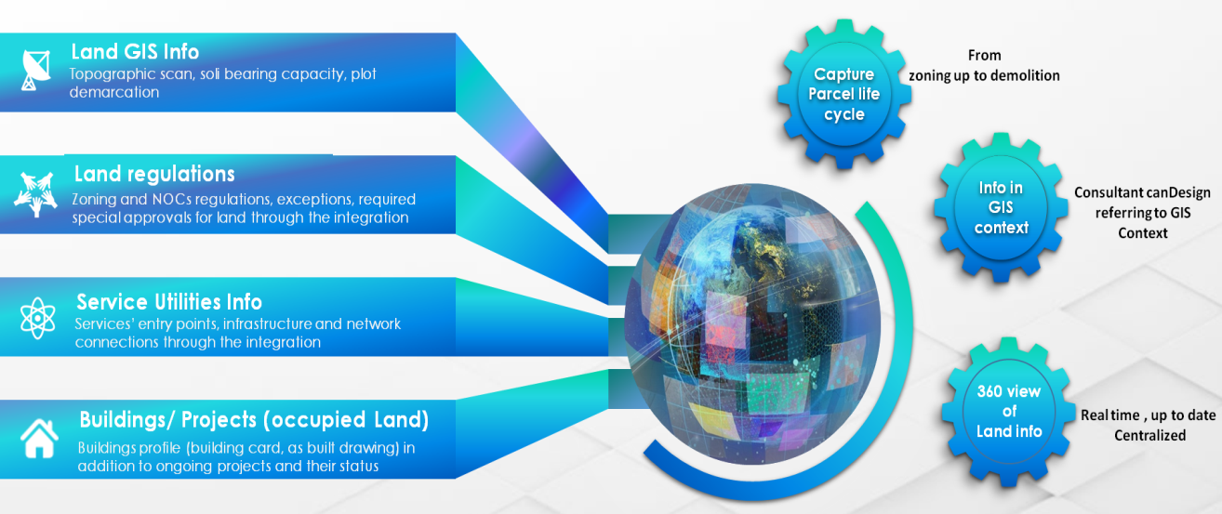

**GEO Consolidated Hub**

Regarding the new business process proposed, we introduce the *#GEO Consolidated Hub* which will be constructed through the integration between GIS and internal and external authorities.

The *#GEO Consolidated Hub* demonstrates:

* Parcel life cycle from zoning up to demolition.
* Increase Drawings’ accuracy using GIS context.
* 360 view on real time, up-to-date and centralized information.
* Integration with 24 internal /external departments and authorities.

1. **External**

* Land Department ***New***
* Real Estate Regulatory Authority ***New***
* Department of Economic Development ***Modified***
* Dubai Electricity and Water Authority ***Modified***
* Dubai Civil Defense ***Modified***
* Dubai Civil Aviation Authority ***Modified***
* Roads and Transport Authority ***Modified***
* Department of Tourism and Commerce Marketing ***Modified***
* Emirates Integrated Telecommunications Company [Etisalat /DU] ***Modified***
* Dubai Naturalization and Residence Department ***Modified***
* UAE Pass ***New***

1. **Internal**

* Planning Department ***New***
* Demarcation Survey Department ***New***
* Drainage Project Department ***New***
* Environment Department ***Modified***
* Architectural Heritage and Antiquities Department ***New***
* Consultants and Contractors Prequalification section ***Modified***
* Finance Department ***Modified***
* IT Department (Archive system, Active Directory, GRP, SMS/Email Gateway) ***New***

##### Business Domain Model

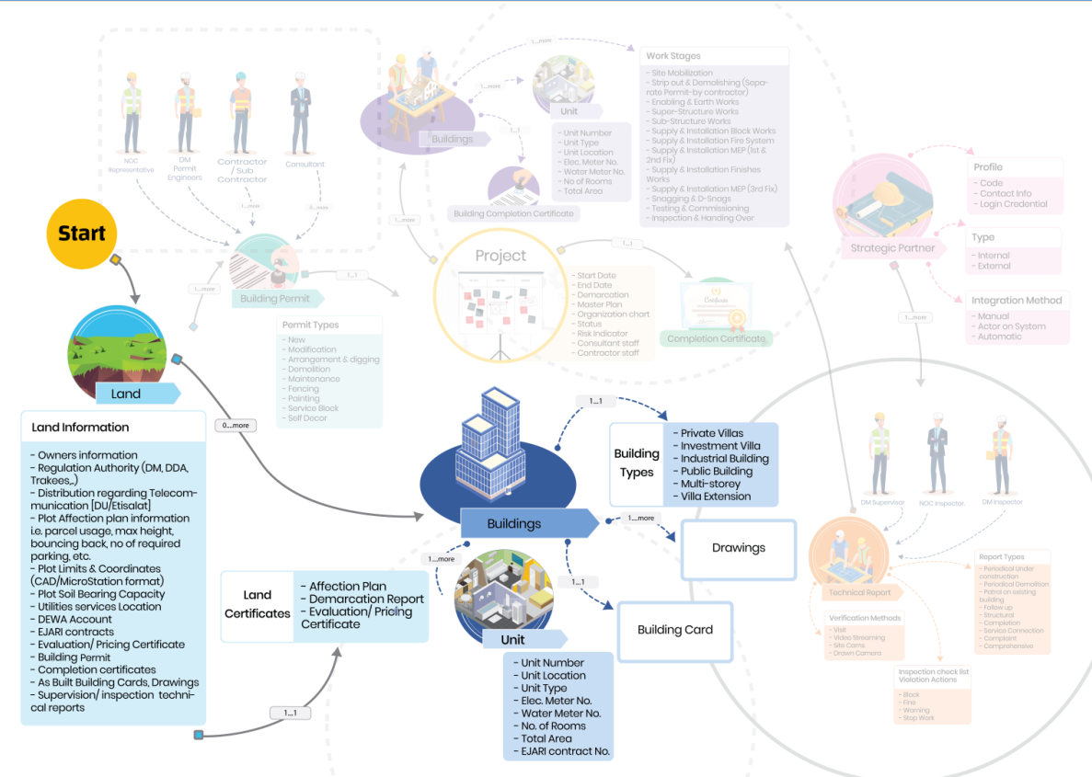

**Domain Model – Self-assignment to Land**

Through applicant’s dashboard, the land can be searched for and selected for assignment without additional step from Landowner(s) using *#GEO Consolidated Hub* presented in the map.

* Based on Self-assignment, no appointment documents or actions required from Landowner(s).
* Self-assignment will not be accomplished unless the applicant accepts legal Terms and Conditions.
* The applicant will be authorized only to apply for Lands/Permit types that match his/her qualification and specialty based on *#integration* with pre-qualification section. Landowner(s) will be notified according to self-assignment actions, in case there is any objection, Landowner(s) can easily block the applicant from accessing the land through their dashboard, and the Applicant KPIs will be impacted by this objection.

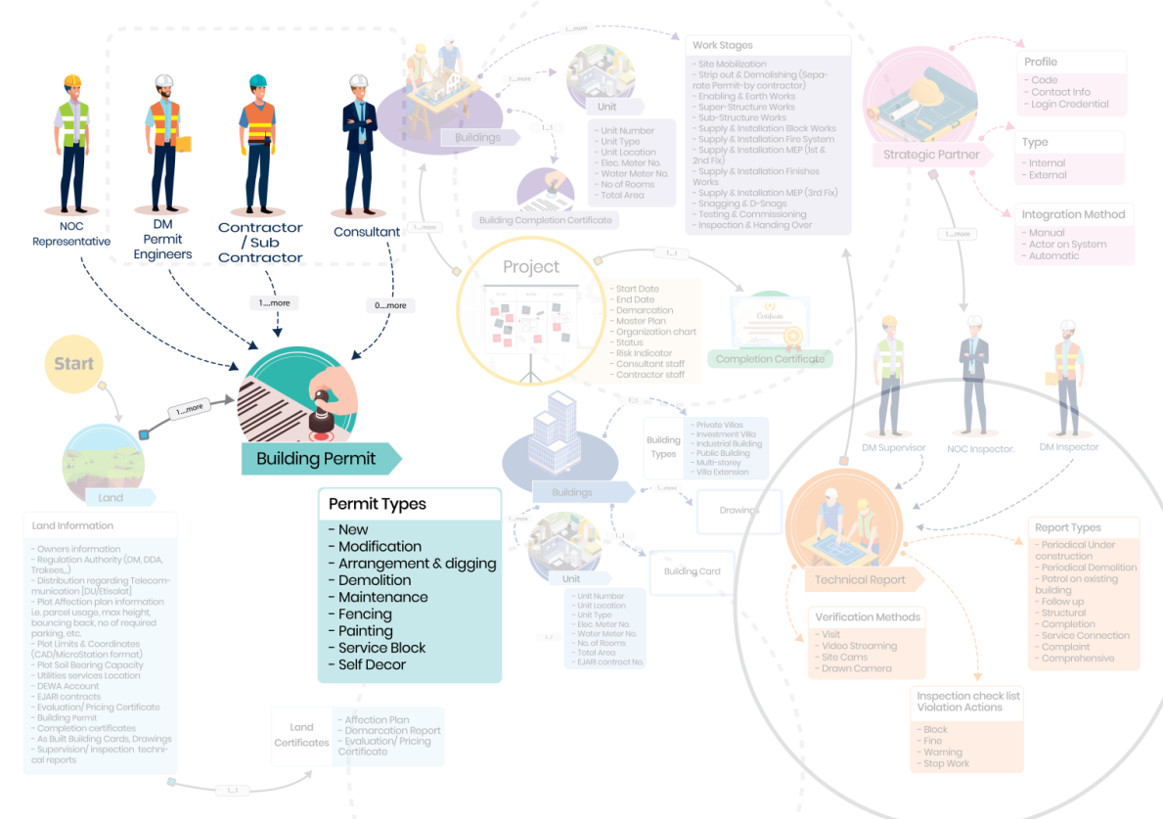

**Domain Model – Building Permit**

On Land, assigned applicants will be able to apply for building permit through unified service with no entries or documents. Moreover, applicants will benefit from various indicatives components in permitting stage such as:

* Fast Track Inquiry: provide the ability to inquire as applicant from DM and also from other authorities during preparation stage *(optional)*
* Concept Design Approval: Approval for initial design *(optional)*
* Drawing Unification and versioning: for both CAD and BIM models
* Auto generated Building Card extracted from uploaded Drawings
* E-checking on uploaded drawings (CAD or BIM) against DM regulation based on building type, usage and permit type as a first level of verification on submission level
* Human expertise verification as a second level of verification by DM engineers and NOC’s representatives after permit submission, according to configuration.

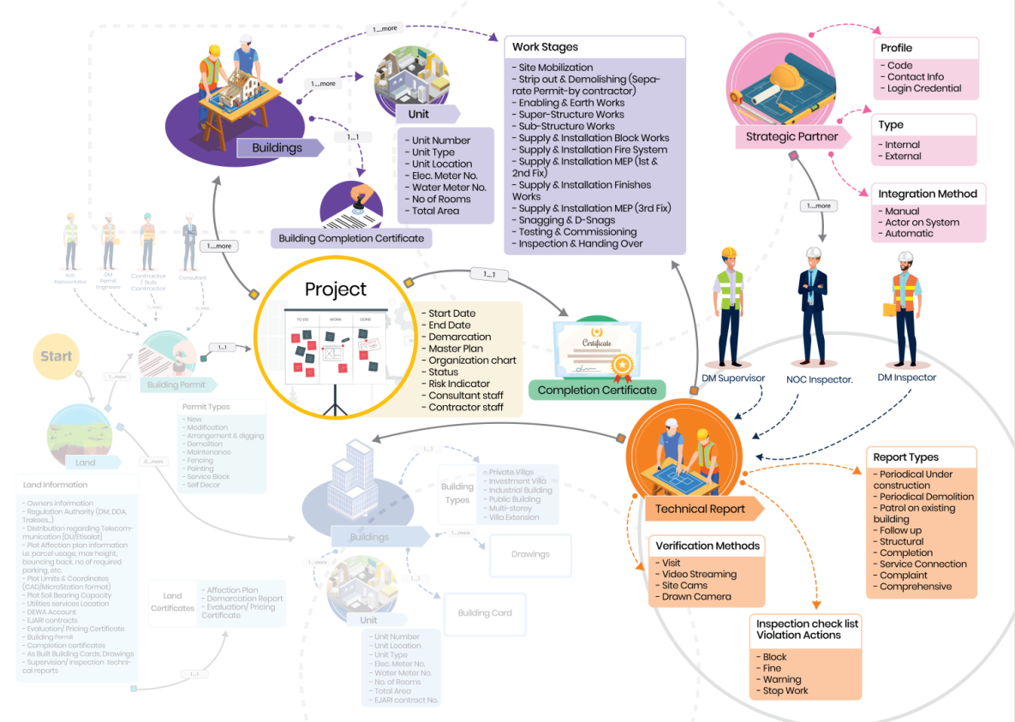

**Domain Model – Project Inspection & completion**

Once the permit is issued, the Project will be initiated accordingly exploring the information of plan, staff, activities, scope, risks, and accountability.

Applicants will also have the facility of incremental completion for each building separately, or full completion for the whole project with cooperation of our strategic partners (internal/external authorities). This cooperation is performed through configurable inspection checklist based on building type, usage and work stages using the technology trends in the field of building inspection.

##### Smart Modules

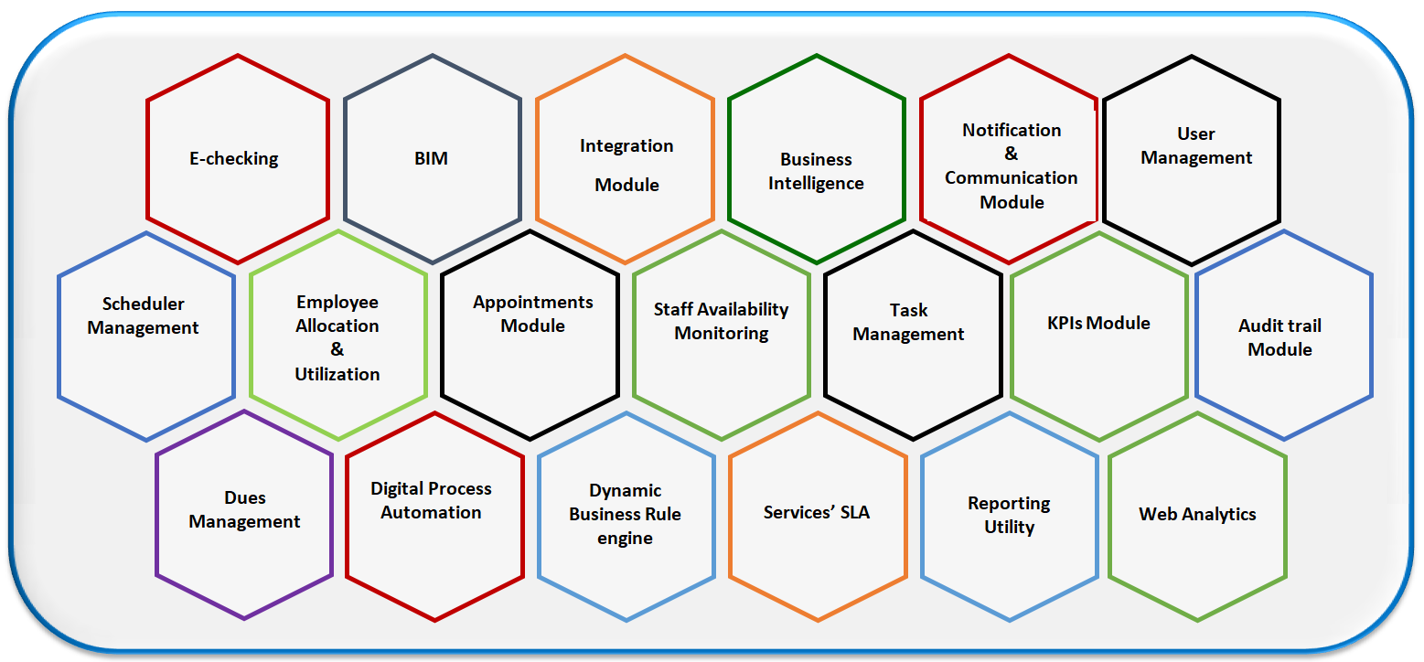

**Smart modules domain model**

Besides, an additional 19 smart modules supporting the proposed process automation as listed below:

1. E-checking Engine
2. BIM Engine
3. Integration Module
4. Business Intelligence
5. Notification & Communication
6. User Management
7. Scheduler Management
8. Employees allocation and utilization
9. Appointments Module
10. Staff Availability Monitoring
11. Task Management
12. KPIs Evaluation & Monitoring
13. Audit trail
14. Dues Management
15. Digital process Automation
16. Dynamic Business rule engine
17. Services’ SLA
18. Reporting Utility
19. Web Analytics

## Smart Modules

##### User Management

###### Customer Management

* Seamless on boarding using UAE Pass based on Customer type (Owner, Consultant, Contractor, Secondary contractor, Individual) all customers will login to the system in no time without the need for Separate Username and Password
* By Integrating with DEQ, the consultants, contractors and secondary contractors will be able to view their technical staff profiles.
* Every Consultant office or Construction company will be responsible for making quick on boarding to their Staff without any involvement from the DM engineers.
* This will allow electronic assignments to the Technical engineers on the running projects and will allow quick and easy steps for Consultant, Contractor and Secondary contractor to set the responsibility for each Staff Member.

###### Staff Management

* Seamless onboarding using integration with active directory and GRP to handle staff login DM staff, government authorities and NOC’s Staff, and keep up to date for any transformation to the staff members from Department/Unit to another, as these information will be updated in the Active Directory and GRP system, and will be automatically reflected to the system with no need to make any updates.
* Each Staff will have privileges on the system according to his/her role, department and unit in the mapped-on organization structure.
* According to these privileges and roles of staff member, the system will be able to set up his/her Calendar according to the task estimated time, working hours, capacity, utilization, and availability.
* Admin will be able to set up the DM Staff Calendar including holidays.

###### Dynamic Dashboard

* This Feature will be available for both Customers (including individuals, Consultant’s admin, Consultant’s staff, Contractor’s admin, Contractor’s staff), and DM Staff members and NOCs representative.
* The Dashboard will be displayed as per the persona type, interests, and role.
* This includes Real-time statistics and charts that related to the persona active projects and needed information according to the current state.
* It will include life Geographic MAP for lands using GEO CONSOLIDATED HUB integration with Internal and External Authorities to display all needed information related to any parcel on the map. This will help the persona to search any parcel easily and display all related information.
* Urgent and Recommended actions based on the business intelligence and data analysis done by the system’s smart agent that analyzes the current persona type, status and the next action required from him/her in all his/her running projects, and automatically display it to allow persona take the actions on the spot. In case the next required actions from the customer doesn’t need any extra information from the customer, the system will submit it automatically on behalf of the customer, for example:
  + After finishing supervision on the last work stage on the current project, the system will automatically recommend or apply for Completion certificate.
  + Disconnect services request after demolition permit will be issued.

##### KPIs Evaluation & Monitoring

* Dynamic configuration of KPI as definition, weight, equation, and calculation method based on persona type.
* KPIs will handle strategic, operational, business stakeholders (consultant, contractor) and DM Staff evaluation as well,
  + Strategic KPIs of the Building Control Department
    - Compliance of under construction buildings
    - Compliance of existing buildings
  + Operation KPIs of the Building Control Department
    - Indicators of average number of construction safety accidents in Dubai (building under construction).
    - Indicators of average number of construction safety accidents in Dubai (Existing building)
    - Indicators of the percentage of delivering services to customer on time
    - Indicators of the frequency of entering the transaction because the customer did not comply with the application requirements.
    - Indicators of the percentage of sites that are inspected from the total buildings for both under construction & existing buildings
  + Business stakeholder's evaluation KPIs may capture and measure the below:
* Compliance with Renewal regulations
* Compliance according to Field audit
* Issued violations
* Compliance with rules and regulations
* Application version submission average and notes response
* Engineering Submission Quality
* Compliance with safety and security requirements on construction sites
* Compliance with building laws, regulations and legislation during the periodic inspection process
* The record is free of technical complaints related to construction work
* Compliance with the requirements to submit a structural audit and completion transaction
* Compliance and commitment with building laws, regulations and legislation during the periodical inspection process
* Compliance with the completion application requirement
  + Staff evaluation KPI’s may capture and measure the below:
* Compliance with section/unit goals
* Verification accuracy based on building laws and regulations taking into consideration the reason of repeated applications
* Actual capacity compared with configured ones on daily basis
* Customer evaluation for Staff after each appointment as per Customer Feedback
* On spot reports and statistics customizable according to Management, need using Reporting tool.
* The evaluation of the current business stakeholders and DM staff, and how they are aligned with the KPI’s related to their type role and responsibility will be handled according to scheduled / manual triggers.
* Scheduled and dynamic evaluation reports and statistics for Management monitoring.
* Achieve Transparency by publishing evaluation results with personas through their dashboard.
* At any time, persona can View his/her progress and evaluation according to the configured KPIs to improve themselves.
* Any Manager can see the alignment of his/her staff on the configured KPIs to be able to fix any problem facing them, and take the corrective actions needed if any.
* Motivational actions will be configured for high performance personas, for example recommend working in mega projects, or issue certificate of accreditation.

##### Web Analytics

* User Flow: Visual representation of the most popular paths your users followed through your website or app. Moreover, getting more insights by analyzing those paths and where along the path they exited your site.
* Content Tracking: Measure impressions, clicks, and CTR for image banners, text banners, and any elements on your pages.
* Site Search Analytics: Track searches done on your internal search engine.
* Site speed and page speed reports: Track how fast your website delivers content to your visitors.

##### Business Intelligence

* Analyze existing and historical data, and trigger recommended actions to relevant persona type and role, i.e. the system can notify the DM engineer with the most common mistakes occurring by a specific consultant/engineer during:
  + The permit submission of a specific permit type and building type.
  + The periodical inspection over under construction buildings
* Moreover, based on the configured business rules, the system can direct the consultant to assign the contractor after the permit is issued.

##### E-Checking

* According to Land, status whether it is an empty or an occupied land, approved /as built drawings will be verified.
* Case of occupied Land, drawings version will be verified to apply unification.
* Based on the type of latest approved or as built drawings (CAD or BIM), uploaded drawings will be verified to validate the drawings version and standards.
* The system will extract the building information automatically from the uploaded drawings and map the extracted information with the saved Building Card details schema.
* Parking and Garbage area will be calculated automatically from system based on configured equations and these calculations will be used by E-checking engine in order to validate drawings automatically according to configured checklists.
* Automatic generation for Building Card from drawings based on DM approved standards for building classified object and design guidelines (Layers) for both CAD and BIM Models.
* Automatic verification on Drawings using configured checklists based on building types, usage and permit type will be run on the generated Building Cards.
* The output of E-Checking module will be:
  + The automatic Generated Building Card
  + The E- checking verification result with clear and detailed error messages. In case of errors, identify what is the error and in which drawing file.

Note that both extracted information and verified checklist will be configured for each service type, building type, and building usage.

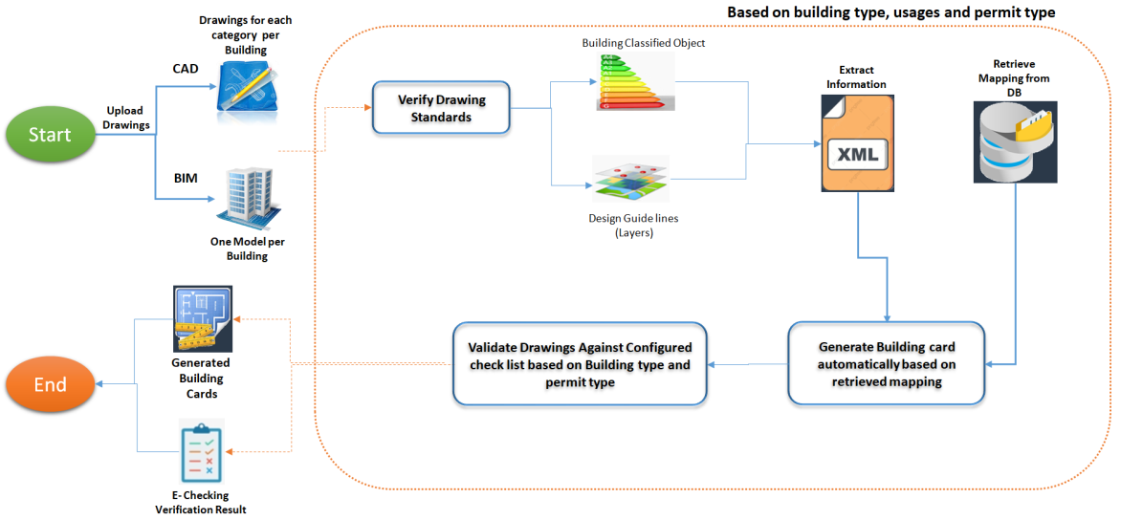

**E-checking Process Flow**

##### BIM

* Integration with BIM Drawings Type to Extract Information by E- checking
* Integration with BIM Drawings to view Drawings and Add Comments on verification to be saved on the Drawings directly.
* Track all comments added on drawings and verify any changes done on Drawings
* BIM integration with GIS information (such as the municipality’s city plans, topographical maps and digital elevation models).
* Analytical and Visual Rule Checking using information that can be extracted from BIM models.

##### Notification & Communication

* This module facilitates communication among different users to maintain workflow and maximize productivity.
* It allows broadcasting messages to users automatically and effectively.
* Highly configurable engine that can handle sending/receiving different types of messages on various events and situations globally or to specific groups/Individuals through available channels such as emails or SMSs to consider costs as well.
* Handle both Arabic and English languages for notification text.
* The Notification will include three types:
  + Services Notification
    - Handle configuration of all services actions that need notifications
    - Handle configuration of users to be notified according to defined responsibility Matrix of each service
    - Ability to seclude periodical notification to be sent in configured periods
  + Circular Notification
    - Ability to handle Circular notifications for DM staff, Customers, or both of them
  + Surveys
    - Design the surveys to be sent to both DM staff and Customers.

##### Appointments Module

* Responsible for defining the appointments between DM engineer and Applicant (Owner, Consultant, Contractor, Secondary Contractor) to discuss/clarify remarks, permit application details, drawings, violations and any remarks raised while project stages and activities of Buildings control (Inspection, Supervision).
* Module start with define the Appointment configuration to be used by applicant while Request appointment with DM engineer.
* Applicant will be able to request, reschedule, and cancel appointments.
* The system will display the applicants’ appointments with the ability to filter and sort them according to their interest.
* The system will display the DM staff appointments with the ability to filter and sort them according to their interest.
* The system will send notification to Applicant and DM engineers with configured actions of Appointments.
* The system will integrate with appointment tool that will record the meeting along with exchanged files during the meeting.

##### Chatbot

* Chatbots are responsible for answering basic customer questions via business messenger. Chatbots use the existing information and resources, like FAQs or knowledge base articles, to help answer and resolve customers’ questions.
* Chatbots will present instance response on the customers’ enquiries without involving the customer support engineer for the FAQ questions and saved topics.
* Chatbots will be able to redirect the customer question to the customer support in case the customer asks new questions, or the question needs extra details.
* Chatbots can be trained to add questions and answers to handle most of customer’s enquiries.

##### Scheduler Management

* Configure the slots according to the defined staff working hours.
* Automatic plan DM staff Schedule according to the staff department, unit, role, and responsibilities.
* Generate the available time slots for DM engineers to enable them to execute the appointments and tasks.
* Manage task reschedule and task transfer.
* Manage scheduled notifications.

##### Employees Allocation and Utilization

* Keep track of all tasks assigned to the DM engineers and monitor their utilization.
* Monitor Actual Time allocated to projects versus the plan percent.
* Measure how much employees are utilized and whether they are under or over allocated to projects.
* Maximize the use of resources time.

##### Staff Availability Monitoring

* Track the DM engineer leaves, permission, and vacations.
* Track the availability of NOCs’ representatives to form the completion committee for example.
* Help the task management to handle tasks and appointment according to the staff availability

##### Task Management

* Task Planning.
* Task Rotation.
* Task Assignment/Transfer by the DM engineer or his/her direct supervisor.
* Task Acceptance or Notification.
* Task Scheduling/Rescheduling by the DM engineer or his/her direct supervisor.
* Appointment Scheduling/Rescheduling.
* Configuration of the Recurring Tasks.
* Handle tasks Priority.
* Task Tracking: Trace exactly which activities are started, in progress and completed.
* Calendar Syncing: Easily integrated with a simplified calendar that is easy to manage and access through a calendar.
* Configured to organizing and scheduling tasks as well as using it to work for project timelines and meetings.
* Time Tracking: Keep track of the time for each activity

##### Dues Management

* Build fees and fines structure.
* Configure and calculate services’ fees.
* Handle insurance deposits and refunds.
* Integrate with DM payment gateways, real-time evaluation along with motivated actions.
* Calculate the Permit application charges according to the Configured rules on application Submission.
* Calculate the Permit Charges and Deposit amount after Application approval.
* Generate all payment details related to charges and permit deposit amount.

##### Digital Process Automation

* Easy Modeling of Processes and Forms.
* Enterprise Architecture Modeling.
* Data Capture, Management, and Analysis.
* Social Collaboration Features.
* Enterprises are discovering the utility of social collaboration. From document sharing to discussions to approval cycles, BPM system will allow social collaboration in context of your business activities, with a friendly interface that is familiar to users.
* Real-Time Monitoring and KPI Measurement.
* BPMN 2.0 Support.
* Adaptive Case Management (custom workflows).
* Responsible for handling services workflow and automatically forking to send the tasks’ steps to the assigned Staff / NOC’s representatives automatically according to the configurations.

##### Dynamic Business Rule Engine

* Enables the DM policies and other operational decisions to be defined, tested, executed and maintained separately from application code.
* Typically support rules, facts, priority (score), mutual exclusion, preconditions, and other functions.
* Accessible, semantically rich, and declarative rule syntax.
* A repository to store, version, manage, and audit rules.
* Tools for testing, validating, verifying, and simulating rules and rule changes.
* Deployment capabilities to package up rules and put them into a decision service.

##### Audit Trail

* Tracks changes and actions in the system.
* Assists in maintaining transparency, accountability and integrity in between DM and Customers.
* Provides documentary evidence of the activities sequence that might have affected a specific operation, procedure, or event log at any time.

##### Services’ SLA

* Configure and monitor the SLA’s Structure, Setup and runtime.
* Will be used to track the Staff evaluation and define the KPI’s related to services.
* Will be monitored to be able to improve the customer satisfaction on all the presented services by DM.
* Track services performance against Configured SLA.

##### Reporting Utility

* Interactive reports.
* Ad hoc reports.
* Rich presentation and report layout library.
* Data mash-up across multi-source data objects.
* Aggregating, grouping, and filtering.
* Viewing Real-time or queued reports.
* Export to Excel, PowerPoint, PDF, RTF-Word, CSV, PostScript, Text, and SVG.
* In-report sorting, filtering, hide/unhide.
* Enable data visualization, customization, and formulas.
* Generate scheduled reports and auto-share.
* Built-in analytics and dashboards.
* Display Reports per search criteria, Custom Reporting Software.