

Version: 3.0

Buildings Permits System

Business Requirements Specification

Dubai Municipality

Information Technology Department

# Statement of Confidentiality

This document and all associated attachments mentioned therein are the intellectual property of DM. This document shall be used only by persons authorized by DM, for the purpose of carrying out their obligations under a specific contract with DM. Unauthorized copying, printing, disclosure to third party and transmission of this document to any other destination by any media will constitute an unlawful act, attracting appropriate

All information presented in this document or shared with the addressee, as part of the proposing process is considered strictly confidential. As such, the addressee should not disclose this document or any attachments in whole, or in part to any third party without the prior written consent of Dubai Municipality (DM).

The addressee also acknowledges that information shared here within is the intellectual property of Dubai Municipality and is subject to a disclosure agreement as recognized by the copyright and intellectual property protection regulations.

# Copyright Information

Copyright © DM, 2020

This document and all associated attachments mentioned therein are the intellectual property of DM. This document shall be used only by persons authorized by DM, for the purpose of carrying out their obligations under a specific contract with DM. Unauthorized copying, printing, disclosure to third party and transmission of this document to any other destination by any media will constitute an unlawful act, attracting appropriate legal actions.

# Control Document Notification

This is a controlled document. Unauthorized access, copying, replication and usage for a purpose other than for which this is intended are prohibited.

This document is being maintained on electronic media. Any hard copies of it are uncontrolled and may not be the latest version. Ascertain the latest version from the Document Master List available with ISOFT Emirates Project Manager.

Document Control Sheet

|  |  |  |  |  |  |
| --- | --- | --- | --- | --- | --- |
| Document Information | | | | | |
| **Document Title:** | | Business Requirements Specification | | | |
| **Owner:** | | DM | | | |
| **Document Reference:** | | BRS | | | |
| Document Change History | | | | | |
| **Version** | **Date** | **Description of Change** | | | **Author** |
| 1.0 | 09 Mar 2020 | Document Initiation | | | Isoft |
| 1.1 | 30 May 2020 | Service Details | | | Hani Imran |
| 1.1 | 30 May 2020 | Service Details | | | Assmaa Hussien |
| 1.1 | 30 May 2020 | Service Details | | | Mohamed Elshourbagy |
| 1.1 | 30 May 2020 | Service Details | | | Ahmed Hashem |
| 1.1 | 30 May 2020 | Service Details | | | Omnia Mostafa |
| 1.1 | 30 May 2020 | Service Details | | | Mai Rashed |
| 1.1 | 22 Jun 2020 | Review | | | Hani Imran |
| 1.1 | 24 Jun 2020 | Review | | | Assmaa Hussien |
| 1.2 | 26 Jun 2020 | Update Service Details | | | Mohamed Elshourbagy |
| 1.2 | 26 Jun 2020 | Update Service Details | | | Ahmed Hashem |
| 1.2 | 26 Jun 2020 | Update Service Details | | | Omnia Mostafa |
| 1.2 | 26 Jun 2020 | Update Service Details | | | Mai Rashed |
| 1.3 | 29 Jun 2020 | Review | | | Maha Gabr |
| 1.4 | 30 Jun 2020 | QA Review | | | Eman Alayyat |
| 1.5 | 31 Aug 2020 | Divide BRS into two files one for each department  Update business owners feedback based on Meeting A | | | Omnia Mostafa |
| 1.6 | 01 Sep 2020 | Review Updates | | | Assmaa Hussein |
| 1.7 | 09 Sep 2020 | Update business owners feedback based on Meeting B | | | Omnia Mostafa |
| 1.8 | 10 Sep 2020 | Review Updates | | | Assmaa Hussein |
| 1.9 | 17 Sep 2020 | Update business owners feedback based on Meeting C | | | Omnia Mostafa |
| 2.0 | 20 Sep 2020 | Review Updates | | | Assmaa Hussein |
| 2.1 | 28 Sep 2020 | Update as per business feedback | | | Omnia Mostafa |
| 2.2 | 01 Oct 2020 | Update BRS with Survey results | | | Omnia Mostafa |
| 2.3 | 05 Oct 2020 | Review updates | | | Assmaa Hussein |
| 2.4 | 06 Oct 2020 | Review highlighted sections | | | Maha Osama |
| Document Sign Off | | | | | |
| **Version** | **Date** | **Person** | **Role** | **Comments** | |
| 1.0 | 24 Jun 2020 | Assmaa Hussein | Product Manager |  | |
| 2.0 | 17 Sep 2020 | Assmaa Hussein | Product Manager |  | |
| 3.0 | 07 Oct 2020 | Assmaa Hussein | Product Manager |  | |
| 4.0 | 14 Oct 2020 | Assmaa Hussein | Product Manager |  | |

**Table of Contents**

1 Introduction 6

1.1 Document Purpose 6

1.2 Intended Audience 6

1.3 Scope 6

2 Business Process Overview 8

2.1 Proposed Business Process 8

GEO Consolidated Information Hub 8

Business Domain Model 10

Smart Modules 13

2.2 Smart Modules 14

User Management 14

Customer Management 14

Staff Management 14

Dynamic Dashboard 15

KPIs Evaluation & Monitoring 15

Web Analytics 17

Business Intelligence 17

E-Checking 17

BIM 18

Notification & Communication 19

Appointments Module 19

Chatbot 20

Scheduler Management 20

Employees Allocation and Utilization 20

Staff Availability Monitoring 21

Task Management 21

Dues Management 21

Digital Process Automation 22

Dynamic Business Rule Engine 22

Audit Trail 23

Services’ SLA 23

Reporting Utility 23

2.3 Permit Services 24

2.3.1 Core Components 26

Land Card 26

Project Profile 27

Fast Track Inquiry 31

2.3.2 Core Services 32

Building Permit 32

Concept Design Approval 37

2.3.3 Supporting Services 40

Building Exception 40

Land Procedures 46

3 Dependencies 50

4 Risks 51

5 Assumption 52

6 Appendices 53

6.1 References 53

6.2 Survey Result 0

### Core Services

##### Building Permit

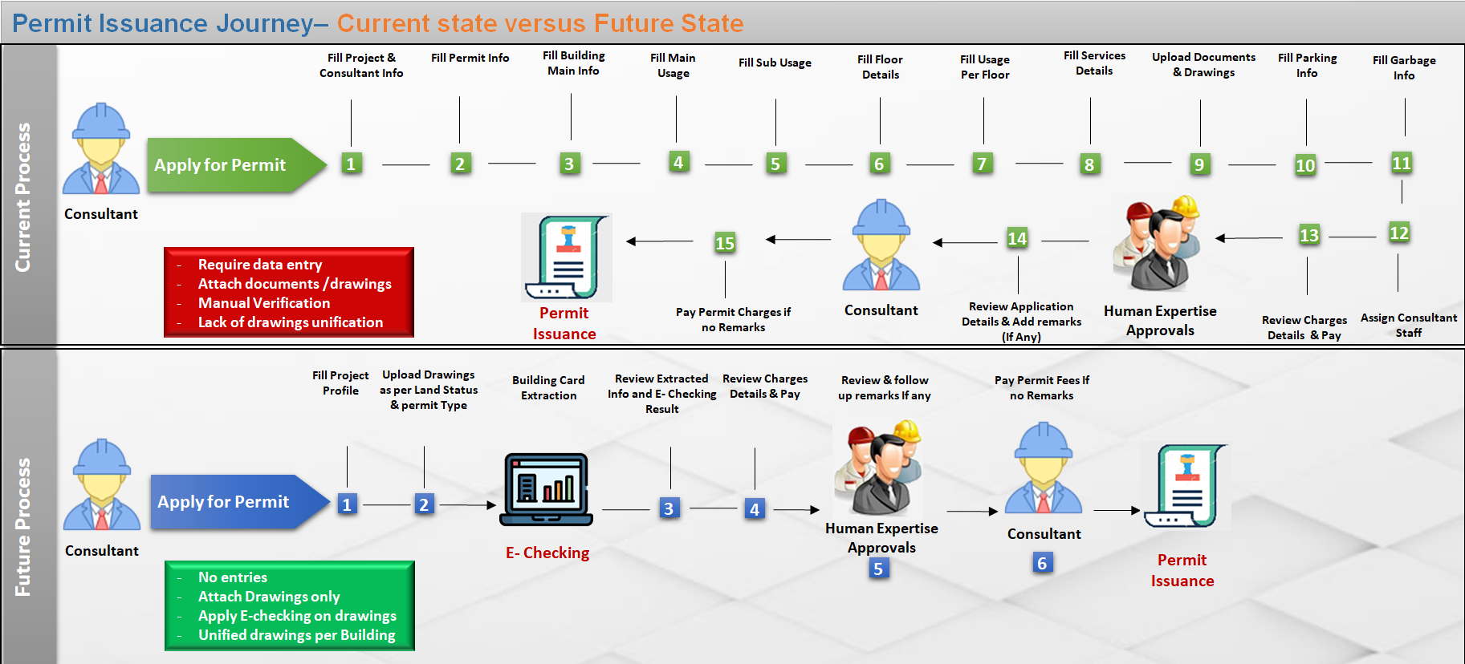

**Permit Issuance Journey– Current state versus Future State**

* Solution Brief

Introducing unified service to obtain building permit without entries or documents, just upload drawings in few steps. In addition to *#E-checking* verification for uploaded drawings on submission level, through configurable checklists based on permit type, building types, and usages to increase alignment with DM regulations.

As zone regulation specifies allowed usages for buildings, also Land status specifies type of drawings and allowed permit types for this Land:

**Case Empty land:** Applicant will have the flexibility to upload CAD or BIM drawings and to apply for the below permit types:

* Fencing
* Arrangement and digging
* New Building which include both above.

**Case Occupied Land:** Applicant will have to follow same type of **As Built** drawing, and can apply for the below permit types:

* Modification
* Demolition

Across various building types:

* Private Villa,
* Investment Villa,
* Industrial building,
* Public building,
* Multistory,
* Building service blocks.
* Actors
* Applicant (Consultant, Contractor or Owner)
* Smart Agent (System)
* Human Expertise (configurable whether internal or external Engineers)
* Product
* Active Building Permit Valid for 6 months
* Electronic Stamped and Approved Building Drawings
* Unified Building Cards/Drawings per Building.
* Prerequisites
* Applicant Self Assignment to the Land with acceptance to the Terms and conditions of assignment
* Design Drawings according to the approved standards by DM and using building classified object in addition to the design guide lines (layers) for each building.
* Fill project profile with the permit type , building type and usages
* Terms and conditions

Applicant will not be able to start work on site unless the below conditions are fulfilled:

* Insurance deposit paid by the assigned contractor
* Demarcation visit clearance.
* Channels

New Customer portal / New Employee portal.

* Solution Details

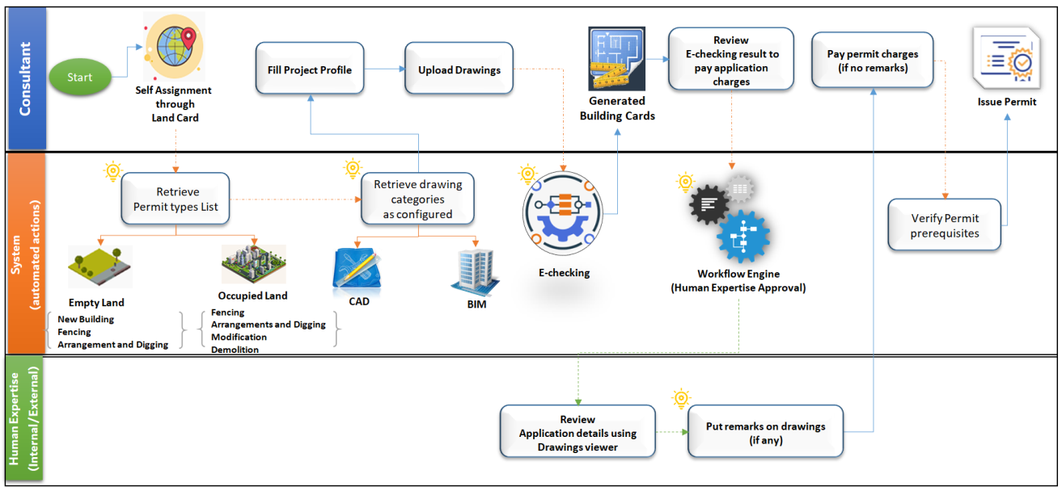

Building Permit Process flow

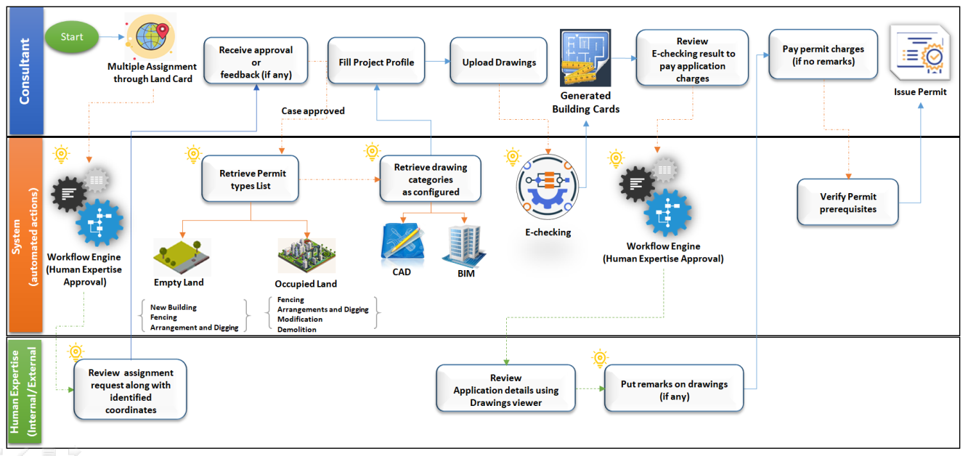

Building Permit Process flow- (in case of multiple consultants on same Land)

Once the applicant selects a certain land, and accepts legal responsibility, Terms and Conditions of self-assignment, the system automatically notifies Landowner(s) using *#Notification&Communication*.

According to Self-assignment, the applicant will be able to get prepared before applying for permit application through:

* Access all land information using *#Land Card*
* Define Project profile, identify permit type #*Project Profile*
* Design detailed drawing according to above findings.

Once the Drawings are prepared, the Applicant can apply for permit application as in the below steps:

**Step1:** **Upload drawings for each building**

The applicant will be able to add or select building for modification or demolition according to land status. For certain buildings, it is required to upload drawings only according to specified type and modification type, if any:

***Case CAD Drawings***: Upload the below categories in case of new building, or upload only categories changed in case of modification:

* Architectural Drawing
* Structure Drawings
* Mechanical Drawings
* Plumbing Drawings
* Electrical Drawings
* Water Supply Drawings
* Telecommunications Drawings
* Fire Detection, Alarm, Emergency Lighting, Fire Fighting
* Fire Life Safety Drawings
* Interior Drawings

***Case BIM***, Upload one model per building in case of new building or modification.

Once the building drawing(s) are uploaded, the system automatically verifies the drawing(s) against expected version using *#Archiving and document version control*, and alignment with DM regulation using *#E-Checking*through automated checklists configurable based on building type, usage, and permit type.

*#E-Checking* is also responsible for creating Building Card information from Building drawing(s) based on DM approved standards for building classified object and design guidelines (Layers) for both CAD and BIM Models.

Moreover, *#E-Checking* is also responsible for automatic verification on Drawings using configured checklists based on building types, usage and permit type

System will display the below to the applicant:

* + The automatic Generated building Card
  + The E- checking verification result with clear and detailed error messages. In case of error, identify what is the error and in which drawing file.

**Step2: Review Generated Building Card**

In this step, the applicant will be able to review the generated building card, and then go forward, either to add/modify another building or to go to **Step3***.*

Moreover, in case of any error returned from the *#E-Checking* verification with a clear and detailed errors identifying the error description and the drawing file containing the errors that will help the applicant to update the drawings and fix the error then re-upload them and the system will reevaluate the updated drawings and regenerate the correct building cards.

**Step3:** **Review Application Summary & Pay Application Fees**

Applicant will be able to view the application summary to make sure that there is nothing missed, and then proceed to payment.

In this step, the applicant will be able to view payment details identified by *#Dues Management* and select from the payment methods available using *#Integration* then pay.

**Step4:** **Review Application and Follow up remarks (If any )**

Once the voucher is paid, the system issues the permit immediately, or passes it for Human expertise verification level according to *#Digital Process Automation*, based on building type, usage, and permit type.

On Human expertise verification, the system will initiate task for each verification point, whether internal or external using *#Digital Process Automation* and *#Integration*.

These tasks will be handled and monitored by *#Task Management*, *#Staff Availability Monitoring*, *#Employee allocation and utilization* components.

Human Expertise will be able to verify their requests easily through:

* Consolidated Land Information
* Unified Building profile [Building Card, Drawing(s)]
* Drawings Viewers for both CAD and BIM

Moreover, they can request for a conference call with the applicant and staff using *#Appointments*, *#Scheduler management* components in case a clarification is required.

Based on the verification result, the applicant will be notified using *#Notification & Communication* to proceed for payment **Step5**.

**Step5:** **View and Pay Permit Fees**

Once the Applicant receives the notification of application approval, he/she will be able to view the permit fees payment details identified by *#Dues Management*, and select from the payment methods available using *#Integration* then pay.

##### Once the permit is issued, the system automatically issues Demarcation Visit Request using *#Integration*, so that the applicant can start work onsite.