

Version: 3.0

Buildings Permits System

Business Requirements Specification

Dubai Municipality

Information Technology Department

# Statement of Confidentiality

This document and all associated attachments mentioned therein are the intellectual property of DM. This document shall be used only by persons authorized by DM, for the purpose of carrying out their obligations under a specific contract with DM. Unauthorized copying, printing, disclosure to third party and transmission of this document to any other destination by any media will constitute an unlawful act, attracting appropriate

All information presented in this document or shared with the addressee, as part of the proposing process is considered strictly confidential. As such, the addressee should not disclose this document or any attachments in whole, or in part to any third party without the prior written consent of Dubai Municipality (DM).

The addressee also acknowledges that information shared here within is the intellectual property of Dubai Municipality and is subject to a disclosure agreement as recognized by the copyright and intellectual property protection regulations.

# Copyright Information

Copyright © DM, 2020

This document and all associated attachments mentioned therein are the intellectual property of DM. This document shall be used only by persons authorized by DM, for the purpose of carrying out their obligations under a specific contract with DM. Unauthorized copying, printing, disclosure to third party and transmission of this document to any other destination by any media will constitute an unlawful act, attracting appropriate legal actions.

# Control Document Notification

This is a controlled document. Unauthorized access, copying, replication and usage for a purpose other than for which this is intended are prohibited.

This document is being maintained on electronic media. Any hard copies of it are uncontrolled and may not be the latest version. Ascertain the latest version from the Document Master List available with ISOFT Emirates Project Manager.

Document Control Sheet

|  |  |  |  |  |  |
| --- | --- | --- | --- | --- | --- |
| Document Information | | | | | |
| **Document Title:** | | Business Requirements Specification | | | |
| **Owner:** | | DM | | | |
| **Document Reference:** | | BRS | | | |
| Document Change History | | | | | |
| **Version** | **Date** | **Description of Change** | | | **Author** |
| 1.0 | 09 Mar 2020 | Document Initiation | | | Isoft |
| 1.1 | 30 May 2020 | Service Details | | | Hani Imran |
| 1.1 | 30 May 2020 | Service Details | | | Assmaa Hussien |
| 1.1 | 30 May 2020 | Service Details | | | Mohamed Elshourbagy |
| 1.1 | 30 May 2020 | Service Details | | | Ahmed Hashem |
| 1.1 | 30 May 2020 | Service Details | | | Omnia Mostafa |
| 1.1 | 30 May 2020 | Service Details | | | Mai Rashed |
| 1.1 | 22 Jun 2020 | Review | | | Hani Imran |
| 1.1 | 24 Jun 2020 | Review | | | Assmaa Hussien |
| 1.2 | 26 Jun 2020 | Update Service Details | | | Mohamed Elshourbagy |
| 1.2 | 26 Jun 2020 | Update Service Details | | | Ahmed Hashem |
| 1.2 | 26 Jun 2020 | Update Service Details | | | Omnia Mostafa |
| 1.2 | 26 Jun 2020 | Update Service Details | | | Mai Rashed |
| 1.3 | 29 Jun 2020 | Review | | | Maha Gabr |
| 1.4 | 30 Jun 2020 | QA Review | | | Eman Alayyat |
| 1.5 | 31 Aug 2020 | Divide BRS into two files one for each department  Update business owners feedback based on Meeting A | | | Omnia Mostafa |
| 1.6 | 01 Sep 2020 | Review Updates | | | Assmaa Hussein |
| 1.7 | 09 Sep 2020 | Update business owners feedback based on Meeting B | | | Omnia Mostafa |
| 1.8 | 10 Sep 2020 | Review Updates | | | Assmaa Hussein |
| 1.9 | 17 Sep 2020 | Update business owners feedback based on Meeting C | | | Omnia Mostafa |
| 2.0 | 20 Sep 2020 | Review Updates | | | Assmaa Hussein |
| 2.1 | 28 Sep 2020 | Update as per business feedback | | | Omnia Mostafa |
| 2.2 | 01 Oct 2020 | Update BRS with Survey results | | | Omnia Mostafa |
| 2.3 | 05 Oct 2020 | Review updates | | | Assmaa Hussein |
| 2.4 | 06 Oct 2020 | Review highlighted sections | | | Maha Osama |
| Document Sign Off | | | | | |
| **Version** | **Date** | **Person** | **Role** | **Comments** | |
| 1.0 | 24 Jun 2020 | Assmaa Hussein | Product Manager |  | |
| 2.0 | 17 Sep 2020 | Assmaa Hussein | Product Manager |  | |
| 3.0 | 07 Oct 2020 | Assmaa Hussein | Product Manager |  | |
| 4.0 | 14 Oct 2020 | Assmaa Hussein | Product Manager |  | |

**Table of Contents**

1 Introduction 6

1.1 Document Purpose 6

1.2 Intended Audience 6

1.3 Scope 6

2 Business Process Overview 8

2.1 Proposed Business Process 8

GEO Consolidated Information Hub 8

Business Domain Model 10

Smart Modules 13

2.2 Smart Modules 14

User Management 14

Customer Management 14

Staff Management 14

Dynamic Dashboard 15

KPIs Evaluation & Monitoring 15

Web Analytics 17

Business Intelligence 17

E-Checking 17

BIM 18

Notification & Communication 19

Appointments Module 19

Chatbot 20

Scheduler Management 20

Employees Allocation and Utilization 20

Staff Availability Monitoring 21

Task Management 21

Dues Management 21

Digital Process Automation 22

Dynamic Business Rule Engine 22

Audit Trail 23

Services’ SLA 23

Reporting Utility 23

2.3 Permit Services 24

2.3.1 Core Components 26

Land Card 26

Project Profile 27

Fast Track Inquiry 31

2.3.2 Core Services 32

Building Permit 32

Concept Design Approval 37

2.3.3 Supporting Services 40

Building Exception 40

Land Procedures 46

3 Dependencies 50

4 Risks 51

5 Assumption 52

6 Appendices 53

6.1 References 53

6.2 Survey Result 0

##### 

##### Concept Design Approval

* Solution Brief

Introducing optional service to obtain NOC Concept Design without entries or documents, just upload drawings in few steps. In addition to *#E-checking* verification for the uploaded drawings on submission level through configurable checklists, based on permit type, building types, and usages to increase alignment with the DM regulations.

As the zone regulation specifies allowed usages for buildings, the Land status also specifies type of drawings and allowed permit types for this Land:

**Case Empty Land:** The applicant will have the flexibility to upload CAD or BIM drawings, and can apply for the below permit types:

* New Building

**Case Occupied Land**: Theapplicant will have to follow the same type of **As Built** drawing, and will be able to apply for the below permit types:

* Modification

Across various building types:

* Private Villa,
* Investment Villa,
* Industrial building,
* Public building,
* Multistory,
* Building service blocks.
* Actors
* Applicant (Consultant, Contractor)
* Smart Agent (System)
* Human Expertise (configurable whether internal or external Engineers)
* Product

NOC for Proposed Concept Design

* Prerequisites
* Applicant Self Assignment to the Land with acceptance to the Terms and Conditions of assignment.
* Design Drawings according to the approved standards by DM and using building classified object in addition to the design guidelines (layers) for each building.
* Define project profile with the permit type , building type and usages
* Terms and Conditions

Applicant cannot start work on Land.

* Channels

New Customer portal / New Employee portal

* Solution Details

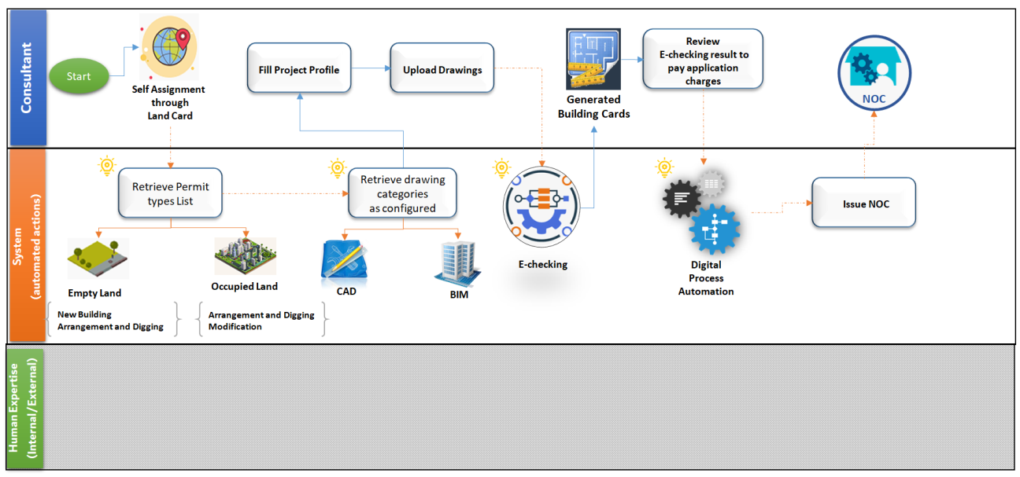

Concept Design Approval Process Flow

Once the applicant selects certain land, and approves on legal responsibility and terms and conditions of self-assignment, the system automatically notifies the Landowner(s) using *#Notification&Communication*.

According to Self-assignment, the applicant will be able to get prepared before applying for the NOC Concept Design through:

* Access all land information using *#Land Card*
* Define Project profile, identify application type #*Project Profile*
* Design detailed drawing according to above findings.

Once the Drawings are prepared, the applicant can apply for the NOC Concept Design application through the below steps:

**Step1:** **Upload Drawings for each Building**

The applicant will be able to add or select building for modification according to land status; it is required to upload drawings only based on specified building type and modification type.

***Case CAD Drawings***, Upload below categories in case of new building, or upload only categories changed in case of modification:

* Electrical Drawings
* Water Supply Drawings
* Telecommunications Drawings

***Case BIM***, Upload one model per building in case of new building or modification.

Once the building drawing(s) are uploaded, the system automatically verifies the drawing(s) against expected version using *#Archiving and document version control*, and alignment with DM regulation using *#E-Checking*through automated checklists configurable based on building type, usage, and permit type on the scope of Concept Design Approval.

*#E-Checking* is also responsible for creating Building Card information from Building drawing(s) based on DM approved standards for building classified object and design guidelines (Layers) for both CAD and BIM Models that configured for Concept Design Approval service.

Moreover, *#E-Checking* is also responsible for automatic verification on Drawings using configured checklists based on building types, usage and permit type.

The system will display the below to the applicant:

* + The automatic Generated building Card
  + The E- checking verification result with clear and detailed error messages. In case of error, identify what is the error and in which drawing file.

**Step2: Review Generated Building Card**

In this step, the applicant will be able to review the generated building card, then go forward, either to add/modify another building or go to **Step3**.

Moreover, in case of any error returned from the *#E-Checking* verification with a clear and detailed errors identifying the error description and the drawing file containing the errors that will help the applicant to update the drawings and fix the error then re-upload them, and the system will reevaluate the updated drawings and regenerate the correct building cards.

**Step3:** **Review Application Summary & Pay Application Fees**

Applicant will be able to view the application summary to make sure that there is nothing missed, and then proceed to payment.

In this step, the applicant will be able to view payment details identified by *#Dues Management* and select from the payment methods available using *#Integration*, then pay.

**Step4:** **Issue the NOC**

Once the voucher is paid, the system issues the NOC immediately based on *#E-Checking* throughthe DM/NOC’s checklists to verify the application automatically without consuming human expertise capacity or effort in such service.