

Version: 3.0

Buildings Permits System

Business Requirements Specification

Dubai Municipality

Information Technology Department

# Statement of Confidentiality

This document and all associated attachments mentioned therein are the intellectual property of DM. This document shall be used only by persons authorized by DM, for the purpose of carrying out their obligations under a specific contract with DM. Unauthorized copying, printing, disclosure to third party and transmission of this document to any other destination by any media will constitute an unlawful act, attracting appropriate

All information presented in this document or shared with the addressee, as part of the proposing process is considered strictly confidential. As such, the addressee should not disclose this document or any attachments in whole, or in part to any third party without the prior written consent of Dubai Municipality (DM).

The addressee also acknowledges that information shared here within is the intellectual property of Dubai Municipality and is subject to a disclosure agreement as recognized by the copyright and intellectual property protection regulations.

# Copyright Information

Copyright © DM, 2020

This document and all associated attachments mentioned therein are the intellectual property of DM. This document shall be used only by persons authorized by DM, for the purpose of carrying out their obligations under a specific contract with DM. Unauthorized copying, printing, disclosure to third party and transmission of this document to any other destination by any media will constitute an unlawful act, attracting appropriate legal actions.

# Control Document Notification

This is a controlled document. Unauthorized access, copying, replication and usage for a purpose other than for which this is intended are prohibited.

This document is being maintained on electronic media. Any hard copies of it are uncontrolled and may not be the latest version. Ascertain the latest version from the Document Master List available with ISOFT Emirates Project Manager.

Document Control Sheet

|  |  |  |  |  |  |
| --- | --- | --- | --- | --- | --- |
| Document Information | | | | | |
| **Document Title:** | | Business Requirements Specification | | | |
| **Owner:** | | DM | | | |
| **Document Reference:** | | BRS | | | |
| Document Change History | | | | | |
| **Version** | **Date** | **Description of Change** | | | **Author** |
| 1.0 | 09 Mar 2020 | Document Initiation | | | Isoft |
| 1.1 | 30 May 2020 | Service Details | | | Hani Imran |
| 1.1 | 30 May 2020 | Service Details | | | Assmaa Hussien |
| 1.1 | 30 May 2020 | Service Details | | | Mohamed Elshourbagy |
| 1.1 | 30 May 2020 | Service Details | | | Ahmed Hashem |
| 1.1 | 30 May 2020 | Service Details | | | Omnia Mostafa |
| 1.1 | 30 May 2020 | Service Details | | | Mai Rashed |
| 1.1 | 22 Jun 2020 | Review | | | Hani Imran |
| 1.1 | 24 Jun 2020 | Review | | | Assmaa Hussien |
| 1.2 | 26 Jun 2020 | Update Service Details | | | Mohamed Elshourbagy |
| 1.2 | 26 Jun 2020 | Update Service Details | | | Ahmed Hashem |
| 1.2 | 26 Jun 2020 | Update Service Details | | | Omnia Mostafa |
| 1.2 | 26 Jun 2020 | Update Service Details | | | Mai Rashed |
| 1.3 | 29 Jun 2020 | Review | | | Maha Gabr |
| 1.4 | 30 Jun 2020 | QA Review | | | Eman Alayyat |
| 1.5 | 31 Aug 2020 | Divide BRS into two files one for each department  Update business owners feedback based on Meeting A | | | Omnia Mostafa |
| 1.6 | 01 Sep 2020 | Review Updates | | | Assmaa Hussein |
| 1.7 | 09 Sep 2020 | Update business owners feedback based on Meeting B | | | Omnia Mostafa |
| 1.8 | 10 Sep 2020 | Review Updates | | | Assmaa Hussein |
| 1.9 | 17 Sep 2020 | Update business owners feedback based on Meeting C | | | Omnia Mostafa |
| 2.0 | 20 Sep 2020 | Review Updates | | | Assmaa Hussein |
| 2.1 | 28 Sep 2020 | Update as per business feedback | | | Omnia Mostafa |
| 2.2 | 01 Oct 2020 | Update BRS with Survey results | | | Omnia Mostafa |
| 2.3 | 05 Oct 2020 | Review updates | | | Assmaa Hussein |
| 2.4 | 06 Oct 2020 | Review highlighted sections | | | Maha Osama |
| Document Sign Off | | | | | |
| **Version** | **Date** | **Person** | **Role** | **Comments** | |
| 1.0 | 24 Jun 2020 | Assmaa Hussein | Product Manager |  | |
| 2.0 | 17 Sep 2020 | Assmaa Hussein | Product Manager |  | |
| 3.0 | 07 Oct 2020 | Assmaa Hussein | Product Manager |  | |
| 4.0 | 14 Oct 2020 | Assmaa Hussein | Product Manager |  | |

**Table of Contents**

1 Introduction 6

1.1 Document Purpose 6

1.2 Intended Audience 6

1.3 Scope 6

2 Business Process Overview 8

2.1 Proposed Business Process 8

GEO Consolidated Information Hub 8

Business Domain Model 10

Smart Modules 13

2.2 Smart Modules 14

User Management 14

Customer Management 14

Staff Management 14

Dynamic Dashboard 15

KPIs Evaluation & Monitoring 15

Web Analytics 17

Business Intelligence 17

E-Checking 17

BIM 18

Notification & Communication 19

Appointments Module 19

Chatbot 20

Scheduler Management 20

Employees Allocation and Utilization 20

Staff Availability Monitoring 21

Task Management 21

Dues Management 21

Digital Process Automation 22

Dynamic Business Rule Engine 22

Audit Trail 23

Services’ SLA 23

Reporting Utility 23

2.3 Permit Services 24

2.3.1 Core Components 26

Land Card 26

Project Profile 27

Fast Track Inquiry 31

2.3.2 Core Services 32

Building Permit 32

Concept Design Approval 37

2.3.3 Supporting Services 40

Building Exception 40

Land Procedures 46

3 Dependencies 50

4 Risks 51

5 Assumption 52

6 Appendices 53

6.1 References 53

6.2 Survey Result 0

### Supporting Services

##### Building Exception

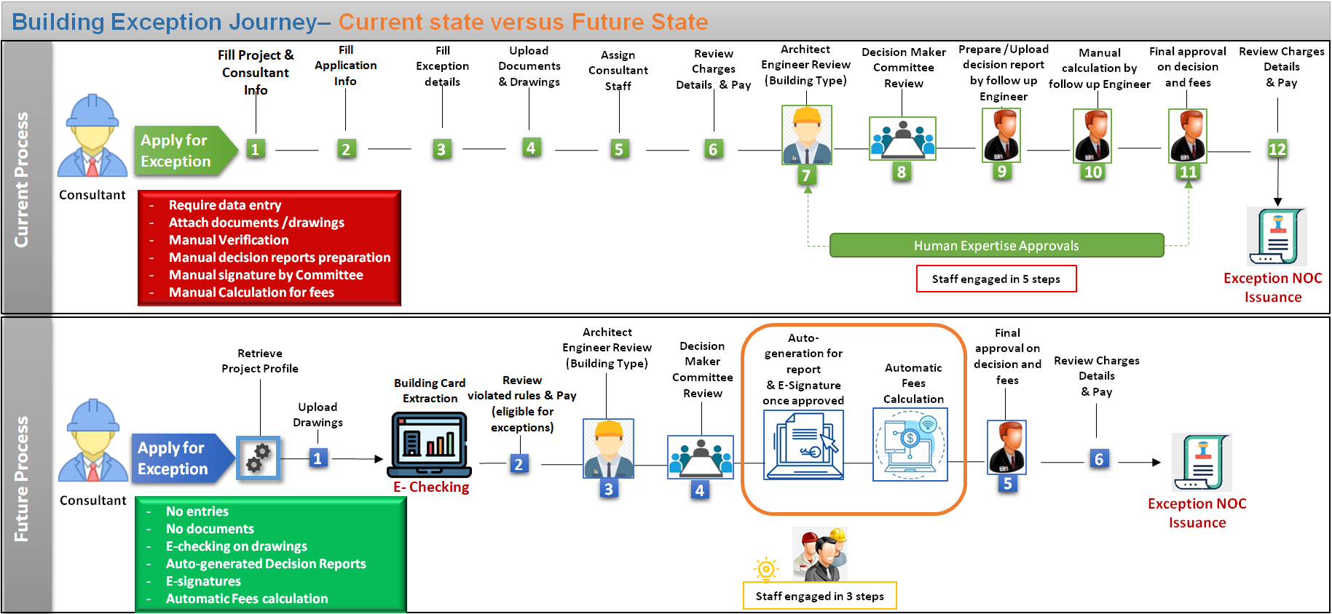

**Building Exception Journey– Current State versus Future State**

* Solution Brief

Introducing service to obtain an exception to carry out some of the building construction work that does not meet configured regulations, within acceptable standards or technical configured requirements.

* Actors
* Applicant (Consultant, Contractor or Owner)
* Smart Agent (System)
* Human Expertise (configurable whether internal or external Engineers)
* Product

Approved Building exception.

* Prerequisites
* Applicant Self-Assignment to the Land.
* Provide required drawings based on the approved standards by DM and using building classified object in addition to the design guidelines (layers) for each building.
* Define project profile with the permit type, building type, usages and exception details.
* Terms and conditions

Applicant will not be able to use this exception more than once.

* Channels

New Customer portal / New Employee portal

* Solution Details

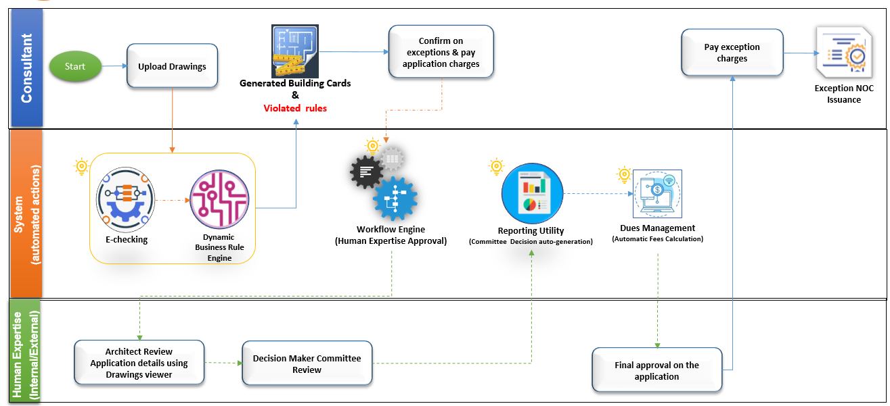

Building Exception Process Flow

Once the applicant applies for exception, the system automatically will retrieve the exception information entered in the project profile earlier.

Exception application can be applied separately or within the permit application.

**Case1: Exception applied separately**

**Step1: Upload Drawings**

Applicant will upload the required drawings (CAD or BIM) related to the exception type/sub type specified in project profile.

***Case CAD Drawings***, Upload the below categories:

* Architectural
* Electrical
* Fire Protection
* Interiors
* Mechanical
* Plumbing
* Structural
* Survey/Mapping

***Case BIM***, Upload one model per building

Once the drawing(s) are uploaded, the system automatically verifies the drawing(s) against:

* Expected version using *#Archiving and document version control*,
* The alignment with DM regulation using *#E-Checking*through the automated checklists which are configured based on building type, usage and service type considering that there is no violated rules rather than the specified exception types in project profile.

**Step2:** **Review Request summery and pay application fees**

Once the information are extracted and the E-Checking verification result is displayed along with exception summary, the applicant will review details and view application charges and expected exception fees, which will be calculated automatically by *#Dues Management* to make sure that the applicant is aware of exception fees in case of approval.

Then the applicant will select from the payment methods available using *#Integration* to pay the application fees.

**Step3:** **Exception Review (Level1) by** Architect Engineer

According to *#Dynamic Business process*, the system routes the request to the human expertise concerned with this type of applications (Architect Engineer) considering building type and Exception type.

The Architect Engineer reviews the application details and add feedback to be presented to the Committee of Exception to take the decision **Step4**

**Step4:** **Decision Maker Committee Review (Level2)**

Once the Architect engineer adds feedback, the system will automatically generate the report that include the following information to be reviewed by the Committee and help them take the decision:

* Exception Details
* Architect engineer Feed back
* Uploaded drawings in viewers

Once the Committee takes the decision and confirms it, the system will automatically apply electronic signature on the generated report along with approved decision then *#Dues Management* will directly calculate the exception fees based on the configured equations according to exception type and the calculated area for the exception, in addition to the Land Price which will be evaluated based on below information retrieved though *#Integration*:

* **Case Land not rented**; the latest active evaluation/pricing certificate from Land department (issue new request if none).
* **Case Land rented**; the contract information from RERA (contract value)

**Step5:** **Final approval on decision and fees (Level 3)**

Once the Exception fees are calculated by the system automatically, the request will be routed to next level of approval based on configuration through *#Dynamic Business process* to review final Decision and Fees.

Moreover, all Verification tasks will be handled and monitored by *#Task Management*, *#Staff Availability Monitoring*, *#Employee allocation and utilization* components.

**Step6:** **Pay Exception Fees**

In this step, the applicant will be notified with final decision and can also view the payment details and select from the available payment methods using *#Integration*, and then pay in case of approval.

Once the voucher is paid, the system issues exception E-certificate immediately, and the applicant can use it according to DM regulations.

In case the Applicant did not use the exception and want to cancel it, the system will automatically use the *#Integration* with **Finance Department** to make Electronic Refund with the approved percentage of exception fees in case on cancellation approved from DM.

**Case2: Exception applied within building permit application:**

**Step1: Upload Drawings**

The applicant will upload the drawings for each building as same as Demonstrated in the *#Building Permit Service*.

Once the drawing(s) are uploaded, the system automatically verifies the drawing(s) against:

* Expected version using *#Archiving and document version control*,
* The alignment with DM regulation using *#E-Checking*through the automated checklists which are configured based on building type, usage and service type considering that there is no violated rules rather than the specified exception types in project profile.

And *#E-Checking*will also generate building cards.

**Step2:** **Review Request summery and pay application fees**

Once the information are extracted and the E-Checking verification result is displayed along with exception summary, the applicant will review details and view application charges and expected exception fees which will be calculated automatically by *#Dues Management* to make sure that the applicant is aware of exception fees in case of approval.

Then the applicant will select from the available payment methods using *#Integration* to pay the application fees.

**Step3:** **Application Review**

According to *#Dynamic Business process*, the system routes the request to the human expertise concerned with both *#Building Permit Service* and *#Building Exception Service* as same as demonstrated before in **Step4** and **Step5** but parallelly.

**Step6:** **Pay Exception Fees**

In this step, the applicant will be notified with final decision and can also view the payment details for both Permit and related exception, then select from the available payment methods using *#Integration*, to pay in case of approval.

Once the voucher is paid, the system issues permit E-certificate along with related exception and the applicant can use it according to DM regulations.