

Version: 3.0

Buildings Permits System

Business Requirements Specification

Dubai Municipality

Information Technology Department

# Statement of Confidentiality

This document and all associated attachments mentioned therein are the intellectual property of DM. This document shall be used only by persons authorized by DM, for the purpose of carrying out their obligations under a specific contract with DM. Unauthorized copying, printing, disclosure to third party and transmission of this document to any other destination by any media will constitute an unlawful act, attracting appropriate

All information presented in this document or shared with the addressee, as part of the proposing process is considered strictly confidential. As such, the addressee should not disclose this document or any attachments in whole, or in part to any third party without the prior written consent of Dubai Municipality (DM).

The addressee also acknowledges that information shared here within is the intellectual property of Dubai Municipality and is subject to a disclosure agreement as recognized by the copyright and intellectual property protection regulations.

# Copyright Information

Copyright © DM, 2020

This document and all associated attachments mentioned therein are the intellectual property of DM. This document shall be used only by persons authorized by DM, for the purpose of carrying out their obligations under a specific contract with DM. Unauthorized copying, printing, disclosure to third party and transmission of this document to any other destination by any media will constitute an unlawful act, attracting appropriate legal actions.

# Control Document Notification

This is a controlled document. Unauthorized access, copying, replication and usage for a purpose other than for which this is intended are prohibited.

This document is being maintained on electronic media. Any hard copies of it are uncontrolled and may not be the latest version. Ascertain the latest version from the Document Master List available with ISOFT Emirates Project Manager.

Document Control Sheet

|  |  |  |  |  |  |
| --- | --- | --- | --- | --- | --- |
| Document Information | | | | | |
| **Document Title:** | | Business Requirements Specification | | | |
| **Owner:** | | DM | | | |
| **Document Reference:** | | BRS | | | |
| Document Change History | | | | | |
| **Version** | **Date** | **Description of Change** | | | **Author** |
| 1.0 | 09 Mar 2020 | Document Initiation | | | Isoft |
| 1.1 | 30 May 2020 | Service Details | | | Hani Imran |
| 1.1 | 30 May 2020 | Service Details | | | Assmaa Hussien |
| 1.1 | 30 May 2020 | Service Details | | | Mohamed Elshourbagy |
| 1.1 | 30 May 2020 | Service Details | | | Ahmed Hashem |
| 1.1 | 30 May 2020 | Service Details | | | Omnia Mostafa |
| 1.1 | 30 May 2020 | Service Details | | | Mai Rashed |
| 1.1 | 22 Jun 2020 | Review | | | Hani Imran |
| 1.1 | 24 Jun 2020 | Review | | | Assmaa Hussien |
| 1.2 | 26 Jun 2020 | Update Service Details | | | Mohamed Elshourbagy |
| 1.2 | 26 Jun 2020 | Update Service Details | | | Ahmed Hashem |
| 1.2 | 26 Jun 2020 | Update Service Details | | | Omnia Mostafa |
| 1.2 | 26 Jun 2020 | Update Service Details | | | Mai Rashed |
| 1.3 | 29 Jun 2020 | Review | | | Maha Gabr |
| 1.4 | 30 Jun 2020 | QA Review | | | Eman Alayyat |
| 1.5 | 31 Aug 2020 | Divide BRS into two files one for each department  Update business owners feedback based on Meeting A | | | Omnia Mostafa |
| 1.6 | 01 Sep 2020 | Review Updates | | | Assmaa Hussein |
| 1.7 | 09 Sep 2020 | Update business owners feedback based on Meeting B | | | Omnia Mostafa |
| 1.8 | 10 Sep 2020 | Review Updates | | | Assmaa Hussein |
| 1.9 | 17 Sep 2020 | Update business owners feedback based on Meeting C | | | Omnia Mostafa |
| 2.0 | 20 Sep 2020 | Review Updates | | | Assmaa Hussein |
| 2.1 | 28 Sep 2020 | Update as per business feedback | | | Omnia Mostafa |
| 2.2 | 01 Oct 2020 | Update BRS with Survey results | | | Omnia Mostafa |
| 2.3 | 05 Oct 2020 | Review updates | | | Assmaa Hussein |
| 2.4 | 06 Oct 2020 | Review highlighted sections | | | Maha Osama |
| Document Sign Off | | | | | |
| **Version** | **Date** | **Person** | **Role** | **Comments** | |
| 1.0 | 24 Jun 2020 | Assmaa Hussein | Product Manager |  | |
| 2.0 | 17 Sep 2020 | Assmaa Hussein | Product Manager |  | |
| 3.0 | 07 Oct 2020 | Assmaa Hussein | Product Manager |  | |
| 4.0 | 14 Oct 2020 | Assmaa Hussein | Product Manager |  | |

**Table of Contents**

1 Introduction 6

1.1 Document Purpose 6

1.2 Intended Audience 6

1.3 Scope 6

2 Business Process Overview 8

2.1 Proposed Business Process 8

GEO Consolidated Information Hub 8

Business Domain Model 10

Smart Modules 13

2.2 Smart Modules 14

User Management 14

Customer Management 14

Staff Management 14

Dynamic Dashboard 15

KPIs Evaluation & Monitoring 15

Web Analytics 17

Business Intelligence 17

E-Checking 17

BIM 18

Notification & Communication 19

Appointments Module 19

Chatbot 20

Scheduler Management 20

Employees Allocation and Utilization 20

Staff Availability Monitoring 21

Task Management 21

Dues Management 21

Digital Process Automation 22

Dynamic Business Rule Engine 22

Audit Trail 23

Services’ SLA 23

Reporting Utility 23

2.3 Permit Services 24

2.3.1 Core Components 26

Land Card 26

Project Profile 27

Fast Track Inquiry 31

2.3.2 Core Services 32

Building Permit 32

Concept Design Approval 37

2.3.3 Supporting Services 40

Building Exception 40

Land Procedures 46

3 Dependencies 50

4 Risks 51

5 Assumption 52

6 Appendices 53

6.1 References 53

6.2 Survey Result 0

##### Land Procedures

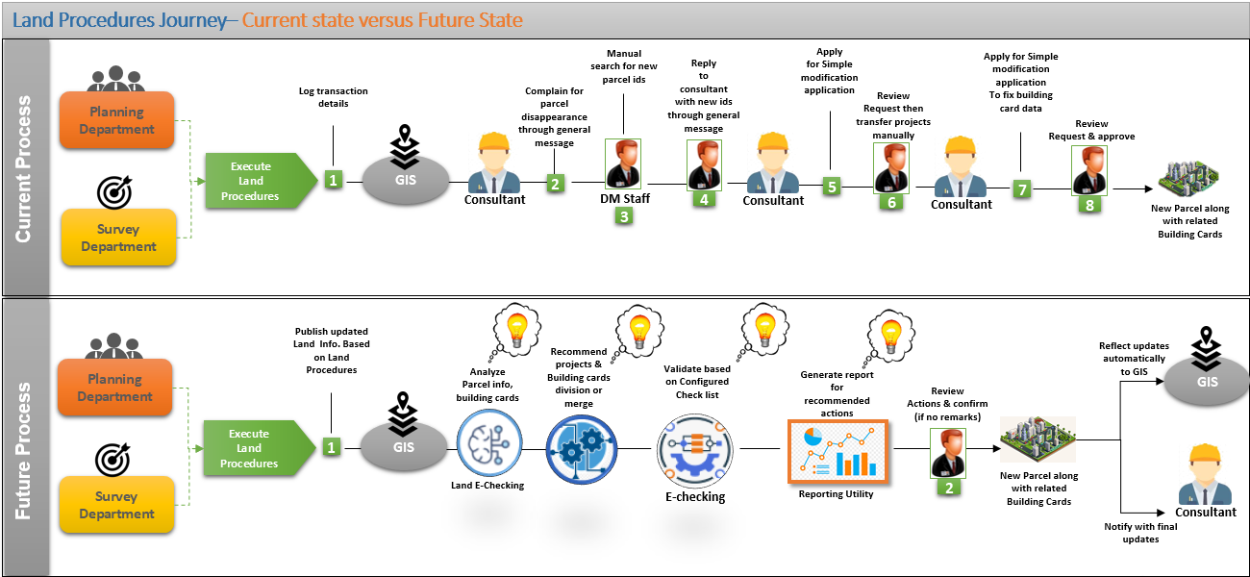

**Land Procedure Journey– Current State versus Future State**

* Solution Brief

Introduce automated process in which Lands information will be updated automatically based on published land procedures (split, merge or change coordinates) that have been executed in Planning and Survey department systems. This process will be triggered automatically using #Integration between GIS and internal departments (Planning, and Demarcation departments). Based on analyzing current and new status and information of the impacted lands using #BI & Data Analysis, the system will recommend required actions to apply published procedure on the targeted lands/Projects and Buildings, along with recommended corrective actions that should be resolved by the Consultant if any.

This automation will be applied for both non-vacant and under construction Lands.

* Actors
* Smart Agent (System)
* Permit Engineer
* Product
* Land procedures accomplished
* Land information updated accordingly
* Prerequisites

Land procedure request triggered by planning and demarcation departments for non-vacant or under construction Lands.

* Channels

New Employee portal

* Solution Details

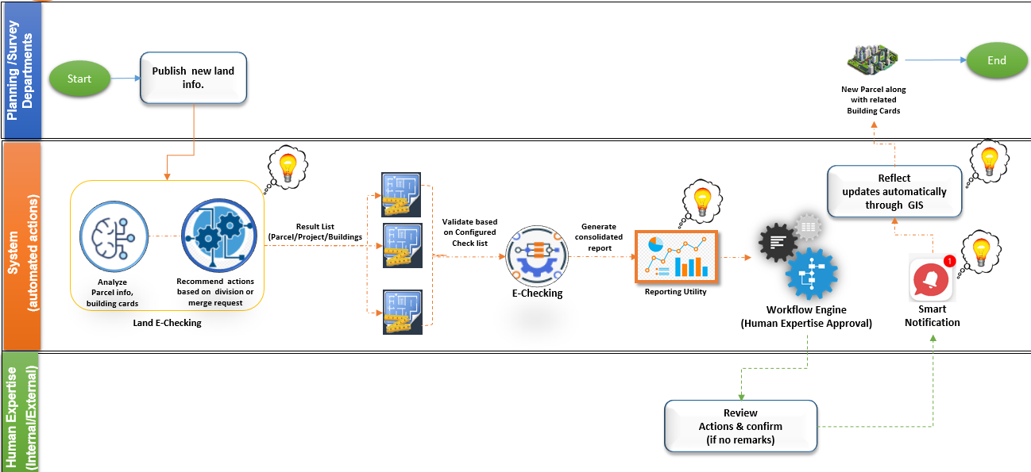

Land Procedures Process Flow

***Step1: Receive Land Procedure Request***

The system will receive published Land procedure from Planning and Demarcation departments through the integration between them and GIS using #Integration.

Accordingly, the system will analyze the below information (current land status/info and the new changes) using #Land E-Checking:

* Land information,
* Land affection plans,
* Plot coordinates,
* Impacted projects,
* Unified buildings profiles (building card and drawings)

Based on the #Land E-Checking , the system will decide projects/buildings reallocation. Then, the system will assist buildings profiles (building card, drawings) against new land regulations and recommend corrective actions that should be resolved by the Consultant - if any - based on #E-Checking.

As a result, the system will generate consolidated report of all decided actions required to reflect published land procedure using *#Reporting Utility* to be reviewed and verified by relevant Staff, as configured for this procedure using *#Dynamic Business process*.

Verification tasks will be handled and monitored by *#Task Management*, *#Staff Availability Monitoring*, *#Employee allocation and utilization* components.

***Step2: Review Actions and Confirm (if no Remarks).***

Staff will be able to review and modify recommended actions demonstrated in the consolidated report if needed.

Once the request is confirmed, thesystemautomatically notifies all relevant authorities and Landowner(s)/assigned consultants with the approved actions using *#Notification&Communication*.

Approved Land information updates will be published automatically to GIS to be shared with relevant internal and external authorities as per their accessibility.

In case of corrective actions required from the Consultant side, the permit will remain on hold till all required actions applied by the consultant and verified from Permit section within configured grace period approved by the Permit section.

**Innovation idea:** The above-automated process can be used as reconciliation procedure that will be executed automatically/periodically at the backend to ensure the continuous integrity of data based on continuous updates applied through the system and also received from internal or external authorities through GIS.

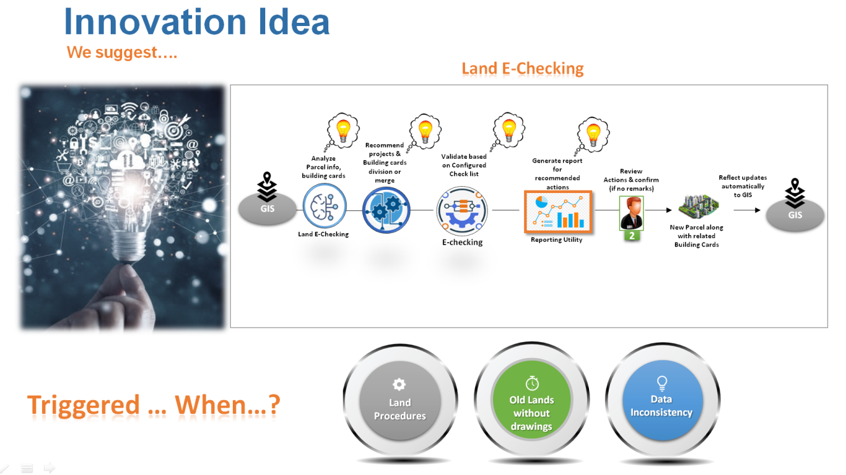

Innovation idea- Reconciliation Procedure