**Phase 1**

|  |  |
| --- | --- |
| **Name:** | ID |
| Rana Ehab | 20206106 |
| Khaled Ahmad | 20206020 |
| Omar Abdelmoneam Riyad | 20206045 |
| Shorouk Anssary | 20206125 |

**-GitHub Repo link:** [**https://github.com/khaleddkassab/Maintenance-Assignment**](https://github.com/khaleddkassab/Maintenance-Assignment)

**-Jira link:**

<https://cairounii.atlassian.net/jira/core/projects/FIRST/board>

**-Static Analysis Report:**

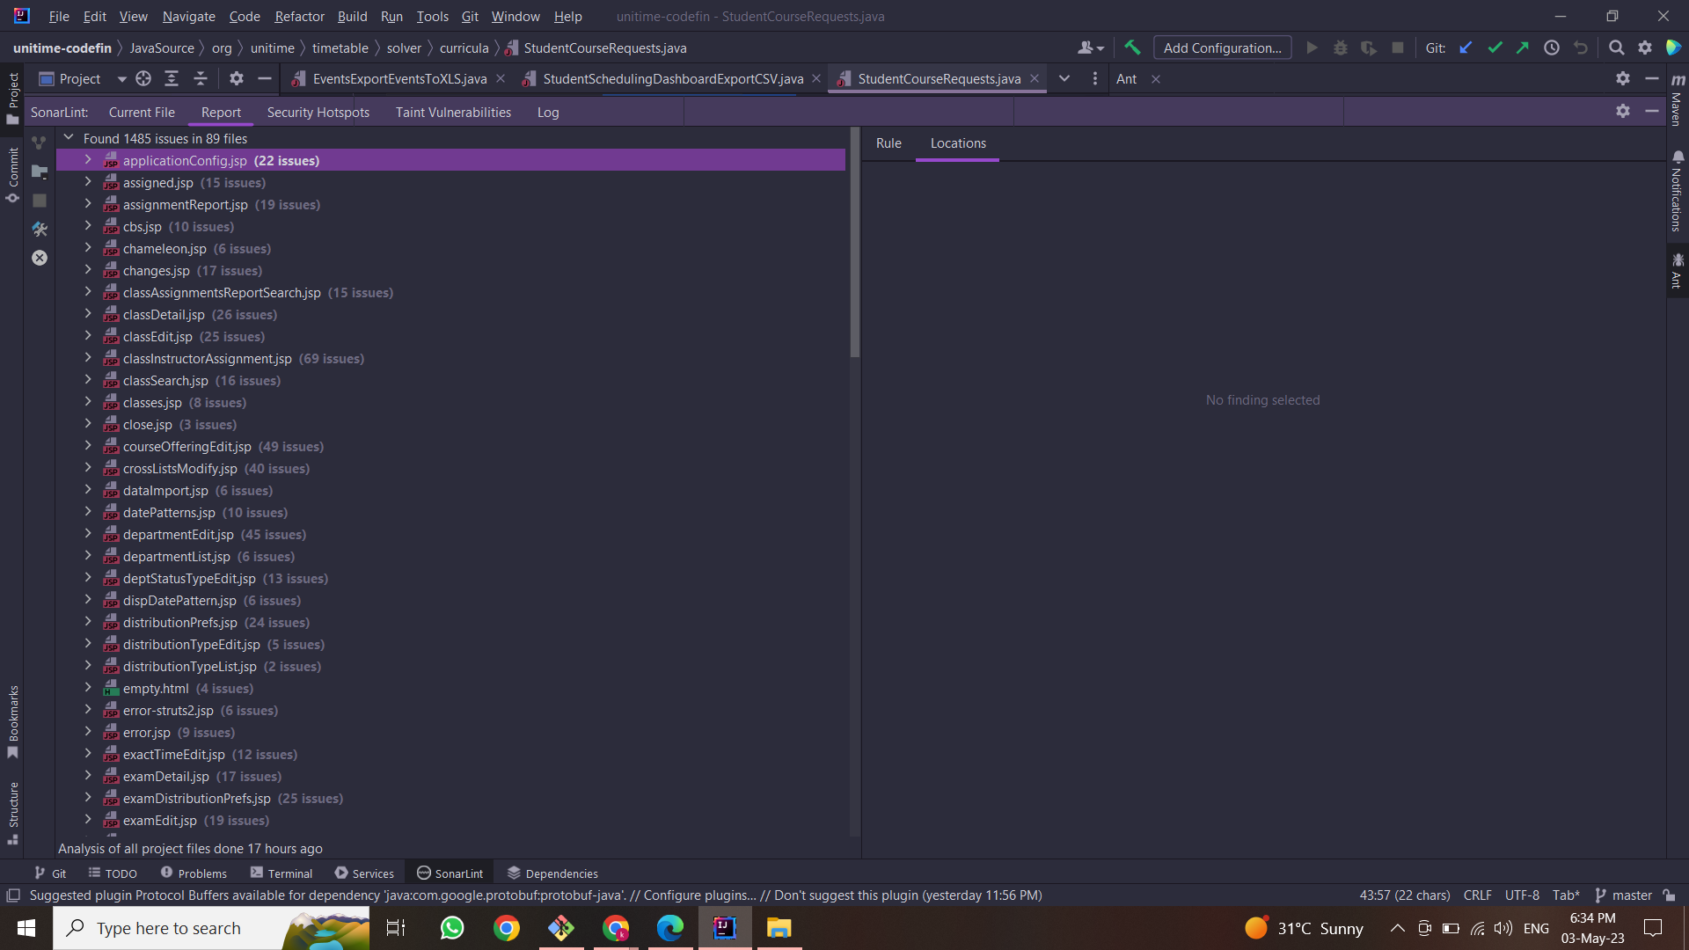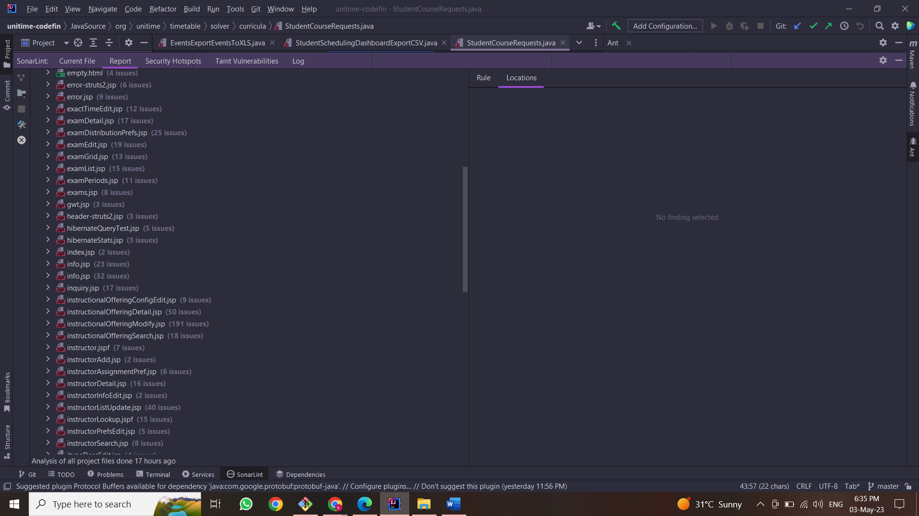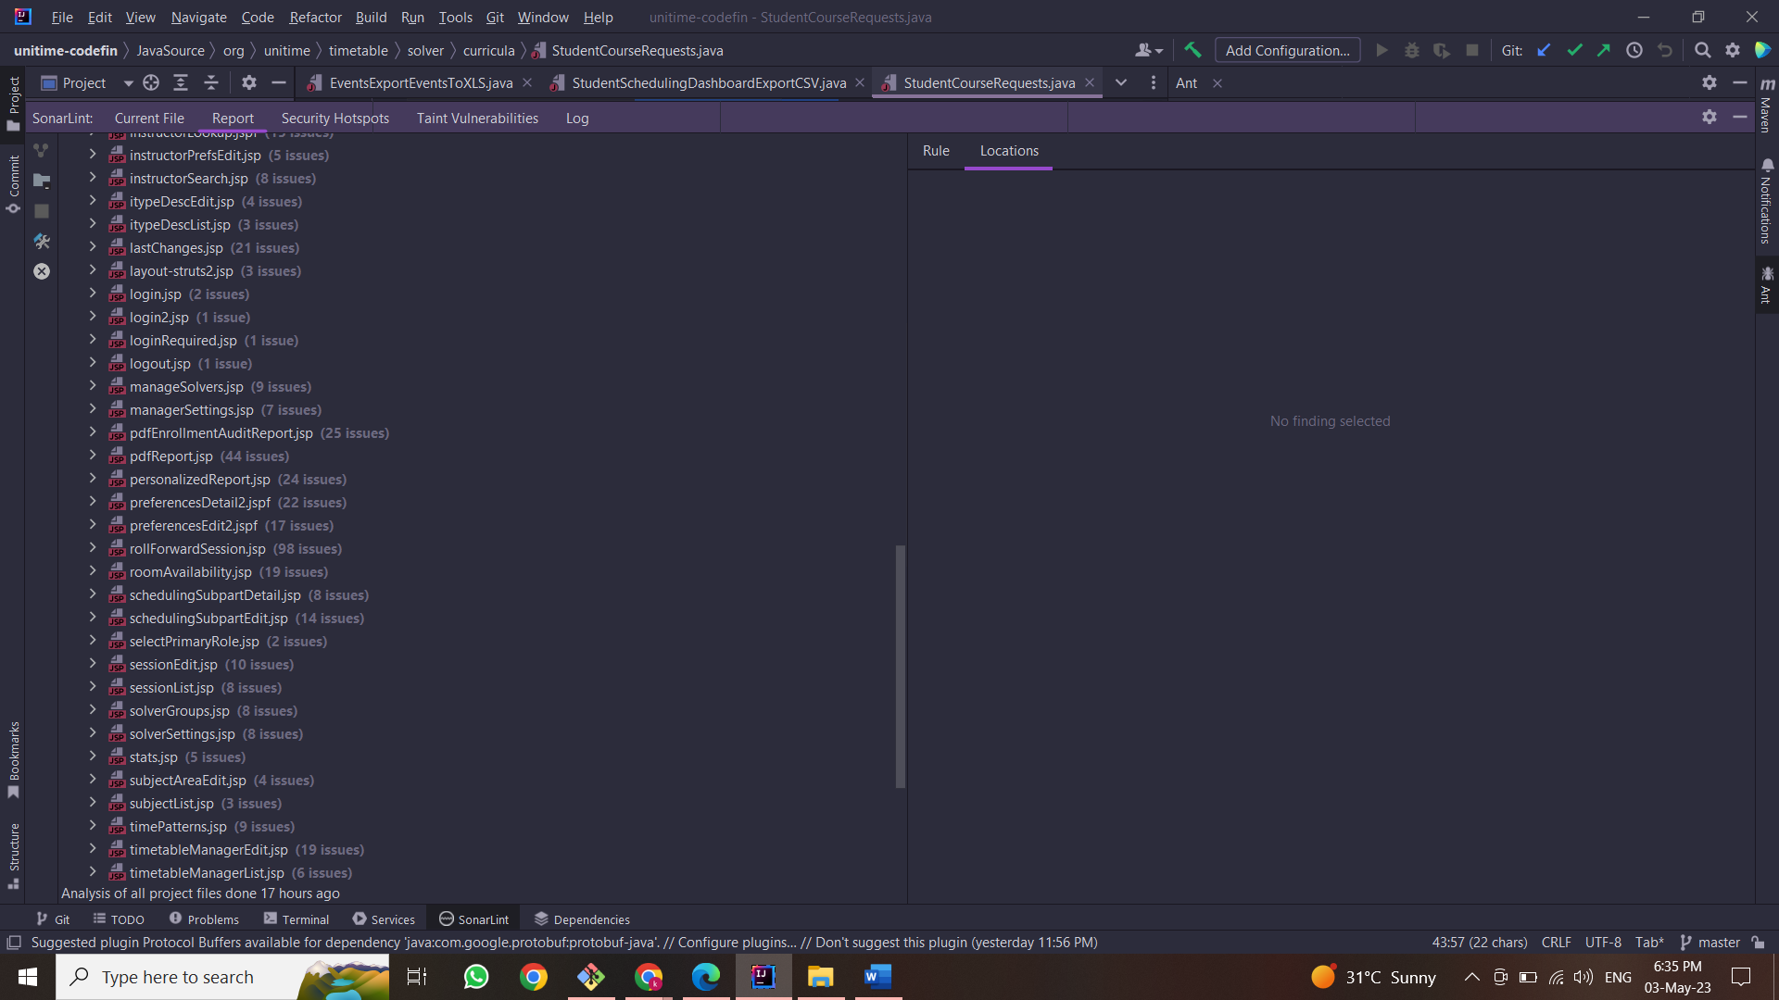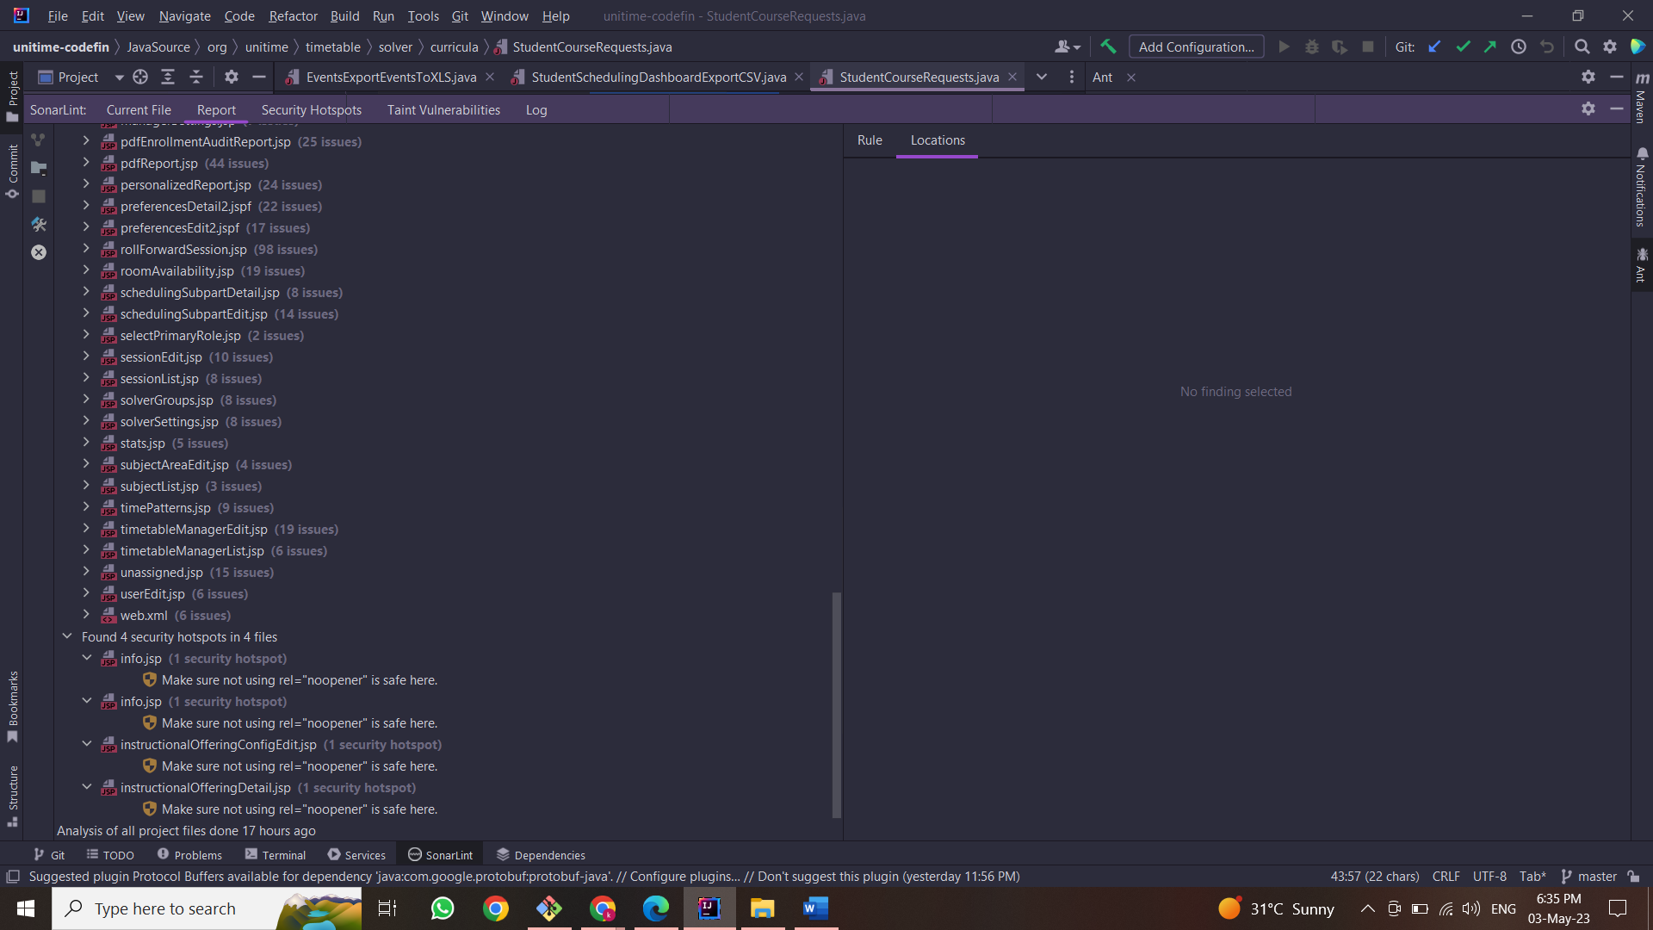

**-Description of Project:**

UniTime is a comprehensive educational scheduling system that supports developing course and exam timetables, managing changes to these timetables, sharing rooms with other events, and scheduling students to individual classes. It is a distributed system that allows multiple university and departmental schedule managers to coordinate efforts to build and modify a schedule that meets their diverse organizational needs while allowing for minimization of student course conflicts. It can be used alone to create and maintain a school's schedule of classes and/or exams, or interfaced with an existing student information system.

Features

* course timetabling
* examination timetabling
* event management
* student scheduling

**Techniques used in this description:**

We used Bottom-up comprehension strategy as it includes analyzing the subtle elements of a package and building up a higher-level understanding of the framework from these subtle elements. This approach is utilized in our program support when working with complex and ineffectively documented legacy codebases and programs we are unfamiliar with, while performing bottom-up comprehension , we begin by looking at the system's basic elements, such as its individual functions and algorithms and developing a picture of how these parts combine to produce bigger software modules, and how the modules themselves interact to construct the entire system.

**Description of the feature:**

A student scheduling feature that allows students to input their course preferences and generate a personalized schedule can help to reduce scheduling conflicts and improve the student experience. Classes to be modified- student course request, student scheduling dashboard.