

1st

Sales (sales num , sales name, item order, description , quantity, unit price, total)

Sal_cust (sales num, cust num, cust name, cust add)

2nd

Sales (sales num , sales name, item order, description , quantity, unit price, total)

Customer (cust num, cust name, cust add)

Sales_cust (sales num, cut num, clerk num ,clerk name)

3rd

Sales (sales num , sales name, item order, quantity, unit price, total)

Customer (cust num, cust name, cust add)

Sales_cust (sales num, cut num, clerk num ,clerk name)

Item_des (item order, description)

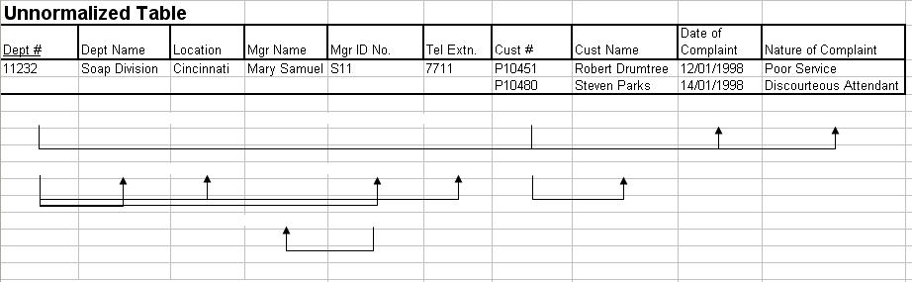

1st

Department ( d.no, d.name, location, mgr name, mgr id, cust id, cust name, doc, noc)

D_Telephone ( d.no, telephone)

2nd

Department ( d.no, d.name, location, cust id, cust name)

D_Telephone ( d.no, telephone)

D_mgr (d.dno , mgr id, mgr name)

3rd

Department ( d.no, d.name, location, cust id, cust name)

D_Telephone ( d.no, telephone)

D_mgr (d.dno , mgr id, mgr name)

D_cm( d.no,doc, noc)