Group -A4
name | id | email
Khaled walid | 222109 | Khaled222109@bue.edu.eg
Ahmed waleed | 222147 | Ahmed222147@bue.edu.eg
Ahmed hesham | 227846 | Ahmed227846@bue.edu.eg

Introduction:
Project Summary: This report analyzes a Tic-Tac-Toe game implementation powered by an AI opponent. The game utilizes the Pygame library for its graphical interface and incorporates the Minimax algorithm (with alpha-beta pruning) to provide a challenging AI player.
Objective: The project demonstrates the following:
1-Creation of an interactive and visually engaging game using a well-known graphical library (Pygame).
2-Implementation of an AI opponent capable of providing a challenging and strategic gaming experience.
3-Understanding of fundamental game AI concepts and their application in a classic game environment.

Tic-Tac-Toe AI game description:

Tic-Tac-Toe is a classic two-player, zero-sum, perfect information game played on a 3x3 grid. Players alternate placing their marks (X or O) with the goal of achieving three of their marks in a row (horizontally, vertically, or diagonally). If no player can form a winning combination and the board fills up, the game results in a draw.

Game Design and Implementation
Technologies:
Python: The primary programming language for game logic and AI implementation.
Pygame: Provides a framework for creating the game's visual interface, handling graphics, and user input.
NumPy: Used for its efficient array data structure to represent the Tic-Tac-Toe board.
Gameplay Mechanics:
Board Representation: The game board is modeled as a 3x3 NumPy array. Squares are initialized with the value '0' to indicate empty, '1' for the human player (X), and '2' for the AI player (O).
Turn-Taking: The game follows turn-based mechanics. The human player selects an open square on the grid using mouse input. The AI determines and executes its optimal move following the player's turn.
Win Conditions: The game continuously checks for winning combinations (three in a row horizontally, vertically, or diagonally). When a win is detected for either player, the game ends and declares a winner.
Draw Condition: If the board fills up without a winning combination, a draw is declared.
Graphical User Interface (GUI):
Pygame is used to render the following elements:
-The 3x3 Tic-Tac-Toe game grid.
-Visual representations of X and O marks to indicate player moves.
-On-screen messages to display the game's status (e.g., winner, draw).

Features:
Clear Visual Interface: Utilizes Pygame to create a user-friendly graphical display of the Tic-Tac-Toe board.
Intuitive Gameplay: Provides straightforward turn-taking mechanisms for both the human player and AI opponent.
Challenging AI: The Minimax-powered AI offers a stimulating opponent that can thwart players' strategies.
AI Implementation:
Minimax Algorithm: The heart of the AI is the Minimax algorithm, a recursive decision-making algorithm ideal for turn-based, zero-sum games. Key concepts include:
Game Tree: The algorithm envisions all potential game states as a branching tree structure. The initial board state is the root, and each possible move by each player leads to new child states.
Evaluation Function: To assess potential moves, the algorithm employs an evaluation function. This function assigns a numerical score to terminal board states (win, loss, or draw), indicating how favorable the state is for the AI.
Maximizing/Minimizing Player: The AI acts as the maximizing player, aiming to achieve the highest possible score. The human opponent is assumed to be the minimizing player, seeking to minimize the AI's score.
Backpropagation: The Minimax algorithm recursively computes scores from the terminal nodes upwards. Each level selects the move that leads to the best outcome for the respective player.
Alpha-Beta Pruning: To improve efficiency, the Minimax implementation uses alpha-beta pruning. This optimization technique reduces the number of game tree branches that need to be explored by pruning off sections that cannot influence the final decision.
AI Strategy Prioritization:
Winning Move: The AI prioritizes finding a move that immediately guarantees a win.
Blocking Move: If no winning move exists, the AI thwarts the human player by blocking a potential winning line.
Center Move: The AI strategically aims to occupy the center square if available.
Best Move: If none of the above apply, the AI uses the Minimax evaluation function to assess all possible moves and select the one with the highest potential score.
Random Move: As a last resort, the AI chooses from available squares at random.

Tic tac toe AI solution definition:
Our team is focused on creating an AI tic-tac-toe player using the Pygame library to make it behave as if it were intelligent against a human being and give it a chance to win against the player.

Tic scope and limitations for the tic-tac-toe ai player:
Scope:
1. The project will involve using the Pygame library to create a graphical interface for playing Tic Tac Toe.
2. An AI opponent will be developed using the Minimax algorithm, providing a challenging gameplay experience.
3. The game will allow users to play against the AI player.
4. Feedback on the game outcome (winner or draw) will close the program indicating the three terminal cases
5. User inputs will be handled, and the game state will be updated accordingly.
6. Basic game logic will be implemented, including checking for win conditions and available moves.
Limitations:
1. The game will be limited to a simple 3x3 Tic Tac Toe grid, which may become predictable after repeated plays.
2. The Minimax algorithm implemented in the AI opponent may not be optimized for larger game trees, leading to performance issues with deeper search depths.
3. The game will not include advanced features, such as difficulty levels, customizable game boards, or alternative rule sets.
4. The graphical interface will be relatively basic and may lack polish compared to more sophisticated game interfaces.
5. The game will not support multiplayer over a network or online gameplay.
6. The AI opponent will not have adaptive learning capabilities and may not always provide the most optimal moves.
7. The game will have limited error handling and input validation, which may result in unexpected behavior if users provide invalid inputs.
8. Due to its relatively small scope and simple architecture, the game may not scale well for larger teams or complex game features.

For a project involving Tic Tac Toe AI, several AI algorithms, heuristics, and evolutionary approaches have been explored in the literature:
- The Minimax Algorithm: a well-known AI algorithm that is utilized for decision-making in games that involve two players and perfect information. A good example of such a game is Tic Tac Toe. The algorithm evaluates all possible moves recursively to determine the best possible strategy, while also assuming that the opponent will also play optimally.
- Alpha-Beta Pruning: a method used together with the Minimax algorithm to decrease the number of nodes analyzed in the game tree. It aids in enhancing the efficiency of the search process by eliminating branches that are certain to be worse than branches that have already been examined.
- Heuristic Evaluation Functions are employed to assess the value of a game state without completely exploring the game tree. In the game of Tic Tac Toe, uncomplicated heuristics such as tallying the number of possible winning lines for each player or gauging the proximity of pieces to winning positions can prove to be effective.
- Convolutional neural networks (CNNs), which are deep learning techniques, have been applied to learn the most effective methods for games such as Tic Tac Toe. To achieve this, a vast dataset of game states and their corresponding optimal moves are used to train the network. As a result, the network is able to base its decisions on learned patterns.
- Evolutionary Algorithms can be utilized to develop strategies for playing Tic Tac Toe. Genetic Algorithms (GA) and Genetic Programming (GP) are some of the evolutionary approaches that can be employed. The approach involves the evolution of populations of potential strategies over several generations using selection, crossover, and mutation operations.
- Reinforcement Learning (RL): RL algorithms, such as Q-learning or Deep Q-Networks (DQN), can learn optimal policies through trial and error by interacting with the game environment. RL has been applied to various board games, including Tic Tac Toe, with promising results.
- Ensemble Methods: Combining multiple AI techniques, such as Minimax with heuristics or neural networks with MCTS, can result in stronger game-playing agents. Ensemble methods leverage the strengths of different approaches to improve overall performance

In the context of a Tic Tac Toe AI project, various AI algorithms and techniques can be applied to create intelligent game-playing agents. Here's how some of these approaches can be applied:

Minimax Algorithm:
Application: The Minimax algorithm is a fundamental approach for developing AI players in games with perfect information, such as Tic Tac Toe. It can be used to determine the optimal move for the AI player by evaluating all possible future game states and selecting the move that maximizes the AI's chances of winning while minimizing the opponent's chances.
Implementation: The Minimax algorithm can be implemented recursively to traverse the game tree, evaluating each possible move and selecting the best one based on a heuristic evaluation function. Alpha-Beta pruning can also be applied to improve efficiency by eliminating suboptimal branches.
Heuristic Evaluation Functions:
Application: Heuristic evaluation functions are used to estimate the value of a game state without fully exploring the game tree. In Tic Tac Toe, simple heuristics such as counting the number of possible winning lines for each player, evaluating the proximity of pieces to winning positions, or assessing the control of the center square can guide the AI player's decision-making process.
Implementation: Heuristic evaluation functions can be implemented to assign scores to different game states based on specific criteria relevant to Tic Tac Toe. These scores can then be used by the Minimax algorithm to guide the search towards promising moves.
In the context of game-playing scenarios like Tic Tac Toe, different strategies and algorithms can be employed by intelligent agents to make optimal decisions. Let's analyze and compare some of these strategies:

Brute Force Search:
Description: Brute force search involves exhaustively examining all possible moves and their consequences to determine the best course of action.
Application: In Tic Tac Toe, where the game tree is relatively small, brute force search can be feasible. It ensures optimal play by considering every possible move and selecting the one that leads to victory or prevents the opponent from winning.
Limitations: While effective in Tic Tac Toe, brute force search becomes computationally infeasible in games with larger search spaces, such as chess or Go, due to the exponential growth of the game tree.
Minimax Algorithm:
Description: Minimax is a decision-making algorithm that aims to minimize the possible loss for a worst-case scenario while maximizing the potential gain.
Application: In Tic Tac Toe, Minimax can be applied to evaluate each possible move recursively, considering the opponent's best response at each step. It ensures optimal play by selecting the move that leads to the highest likelihood of winning or drawing.
Limitations: Minimax's effectiveness relies on the ability to accurately evaluate game states and predict opponents' responses. In complex games with deep search trees, such as chess, Minimax alone may not be sufficient without enhancements like alpha-beta pruning.
Heuristic Evaluation Functions:
Description: Heuristic evaluation functions provide an approximate assessment of a game state's desirability without exhaustive search.
Application: In Tic Tac Toe, simple heuristics like counting the number of player's pieces in winning positions or blocking the opponent's potential winning moves can guide decision-making. These heuristics enable faster evaluation of game states and can be integrated with algorithms like Minimax to improve efficiency.
Limitations: Heuristic evaluation functions may not capture all relevant aspects of a game state, leading to suboptimal decisions. Designing effective heuristics requires domain knowledge and experimentation.
Monte Carlo Tree Search (MCTS):
Description: MCTS is a heuristic search algorithm that focuses on exploring promising regions of the search space through random sampling.
Application: In Tic Tac Toe, MCTS can be applied to simulate random games from the current state and update the search tree based on the outcomes. It balances exploration and exploitation, gradually focusing on more promising moves.
Limitations: MCTS may require a large number of simulations to converge to optimal play, making it less suitable for games with short decision horizons like Tic Tac Toe. However, it can be effective in games with larger search spaces and complex decision-making processes.
Neural Networks:
Description: Neural networks use learned representations to approximate complex functions, including game strategies.
Application: In Tic Tac Toe, neural networks can be trained to predict optimal moves based on board configurations and game states. By learning from large datasets of game outcomes, neural networks can generalize patterns and make decisions without explicit search.
Limitations: Training neural networks requires substantial computational resources and data. Additionally, neural networks may lack transparency and interpretability compared to traditional algorithms like Minimax or MCTS.

In this project of creating an AI player for Tic Tac Toe, the choice of algorithms and methodologies depends on several factors, including the complexity of the game, computational resources available, and the desired level of performance. Here's a justification for the chosen algorithms and methodologies:
- Minimax Algorithm:
Justification: Minimax is a natural choice for Tic Tac Toe due to its relatively simple game state and limited branching factor. It ensures optimal play by exhaustively searching through all possible moves and their outcomes.
Advantages: Minimax guarantees optimal play when the game tree is shallow, as in Tic Tac Toe. It's straightforward to implement and provides a clear strategy for decision-making.
Limitations: While effective in Tic Tac Toe, Minimax can become computationally expensive in games with larger search spaces. However, given the simplicity of Tic Tac Toe, this is not a significant concern.
- Heuristic Evaluation Functions:
Justification: Heuristic evaluation functions complement Minimax by providing a more efficient way to evaluate game states. In Tic Tac Toe, simple heuristics like counting the number of player's pieces in winning positions can guide decision-making without exhaustive search.
Advantages: Heuristic evaluation functions enable faster evaluation of game states, reducing the computational complexity of Minimax. They can capture relevant aspects of the game state and guide decision-making towards favorable outcomes.
Limitations: Heuristic evaluation functions may not always lead to optimal decisions, especially if the heuristics are not well-designed or fail to capture all relevant factors. However, in Tic Tac Toe, simple heuristics can be effective.
- Minimax with Alpha-Beta Pruning:
Justification: Alpha-Beta pruning is an enhancement to the Minimax algorithm that reduces the number of nodes evaluated in the search tree, leading to faster computation.
Advantages: Alpha-Beta pruning significantly reduces the search space by eliminating irrelevant branches, allowing deeper search within the same computational resources. This enhancement improves the efficiency of the Minimax algorithm without sacrificing optimality.
Limitations: While Alpha-Beta pruning is highly effective in reducing search time, its benefits may diminish in games with highly unpredictable outcomes or when the branching factor is already small, such as in Tic Tac Toe. However, its inclusion adds robustness to the algorithm.
pseudo code for the tic tac toe ai player
1. Define constants:
- Width and height of the screen
- Size of each square in the grid
- Width of lines for the grid
- Radius and width for drawing circles
- Width for drawing crosses
- Offset for drawing Xs
- Colors for background, lines, circles, and crosses
- Number of rows and columns on the board

2. Import necessary libraries: sys, pygame, numpy

3. Initialize Pygame

4. Define a class for the game board:
- Initialize the board as a 3x3 array with zeros
- Method to check for the final state of the game (win, draw, or ongoing)
- Method to mark a square on the board
- Method to check if a square is empty
- Method to check if the board is full
- Method to get a list of empty squares on the board

5. Define a class for the AI player:
- Initialize with the player number
- Method to implement the Minimax algorithm for AI decision making
- Methods to find the best move, winning move, blocking move, center move, and random move

6. Define a class for the game:
- Initialize the game with a new board and AI player
- Method to draw grid lines on the board
- Method to draw X or O on the board
- Method to switch to the next player's turn
- Method to display a message on the screen
- Method to display the winner or draw message

7. Define the main function:
- Create a new game instance
- Enter the game loop:
- Handle events (quit event, mouse click)
- If it's the player's turn:
- Handle player's move
- Check for winner or draw
- Switch to AI's turn
- If it's the AI's turn:
- Determine AI's move (winning move, blocking move, center move, best move, or random move)
- Update the board and draw the figure
- Check for winner or draw
- Switch to player's turn
- Update the display
- Check for the end of the game or draw condition

Flow charts for ai tic tac toe player
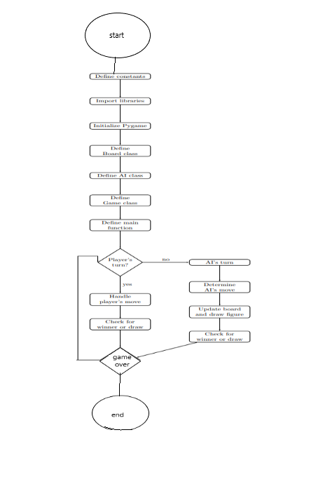
Minimax algorithm
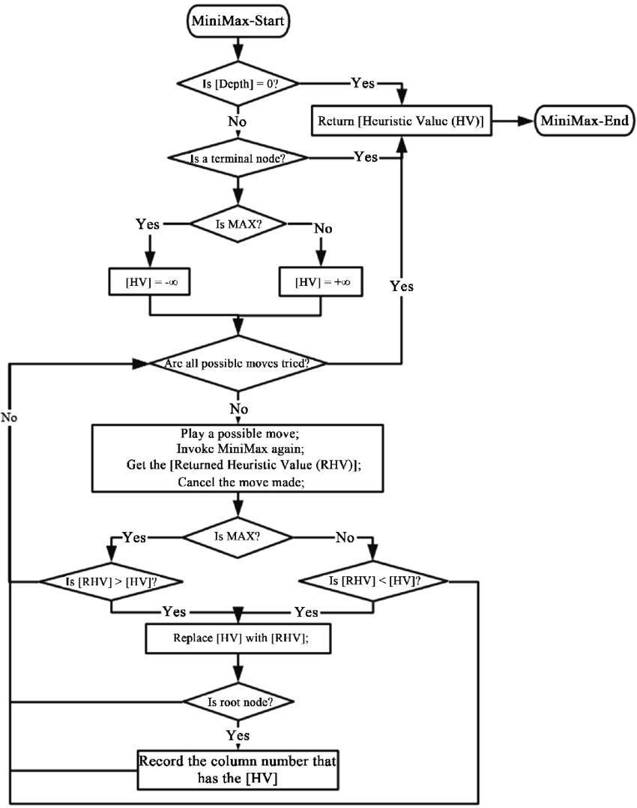
Heuristic function flow chart
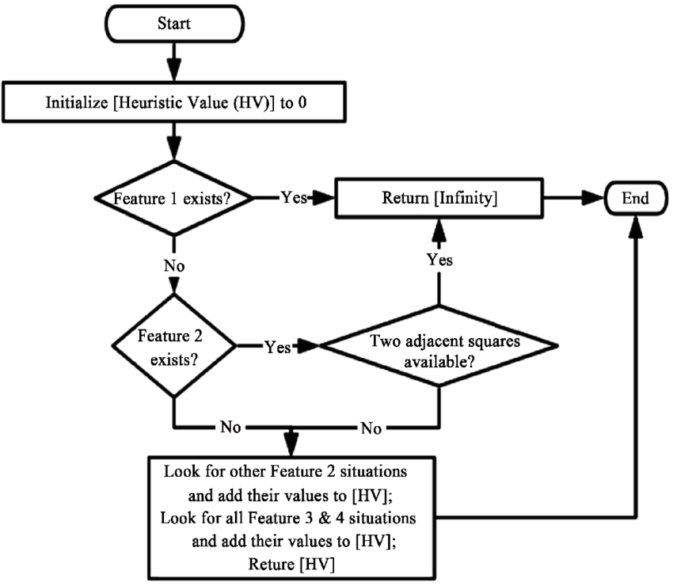
Understranding minimax with alpa beta pruning
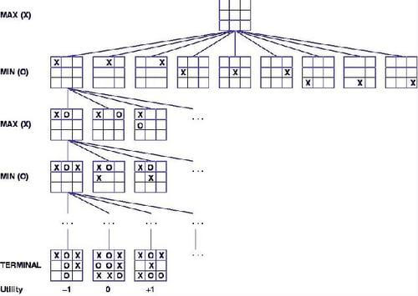
References
1-https://www.researchgate.net/figure/Flowchart-for-minimax-algorithm_fig1_331552609
2- https://www.researchgate.net/figure/Flowchart-for-heuristic-function_fig4_331552609
3- https://www.hackerearth.com/blog/developers/minimax-algorithm-alpha-beta-pruning/

