1-1

الجـــــامعــــة الســـــــورية الخاصــــــــة
كليـــــة هندســـة الذكــــاء الاصطنـــاعي
قسم هندسة البرمجيات ونظم المعلومات

Intelligent geolocation-based information system to support drug search and inventory in pharmacies

A Junior Project Submitted in Partial Fulfillment of the Requirements for the Bachelor’s Degree in Informatics Engineering, Software Engineering and Intelligent Information Systems.

Prepared by

عبدالقادر نشاوي
عماد الدين الرباط
إبراهيم خميس
خالد حمود

Supervision
د. كادان الجمعة
م. مايا الأحمد

I. Dedication ((الإهداء

We dedicate this work to our parents, whose continuous support, encouragement, and sacrifices have been the foundation of our academic journey.

We would also like to express our sincere gratitude to our professors and instructors at the Syrian Private University for providing us with the knowledge, guidance, and inspiration necessary to complete this project.

Special thanks are extended to our colleagues and friends who supported us throughout the development of this project and contributed to its success.

Finally, we dedicate this work to everyone who has encouraged and motivated us throughout our educational and professional development.

The Project Team

II. Arabic Abstract

يهدف هذا المشروع إلى تطوير نظام معلومات ذكي قائم على الموقع الجغرافي يساعد المستخدمين على البحث عن الأدوية المتوفرة في الصيدليات القريبة اعتماداً على موقعهم الحالي. تنبع أهمية المشروع من الحاجة المتزايدة إلى وسيلة سريعة وفعالة للوصول إلى الأدوية، خاصة في الحالات الطارئة التي يواجه فيها المرضى صعوبة في معرفة أماكن توفر الدواء المطلوب.

تم تطوير النظام باستخدام تقنيات ويب حديثة، حيث تم اعتماد إطار العمل Vue.js لتطوير الواجهة الأمامية، وإطار Laravel لتطوير الواجهة الخلفية، مع استخدام MySQL لإدارة قاعدة البيانات. يوفر النظام مجموعة من الوظائف الأساسية تشمل تسجيل المستخدمين، تسجيل الدخول، البحث عن الأدوية، عرض الصيدليات القريبة، وإظهار حالة الصيدلية (مفتوحة أو مغلقة)، بالإضافة إلى تمكين الصيادلة من تحديث بيانات الأدوية والمخزون بشكل مستمر.

تم اتباع منهجية Agile في تطوير المشروع لما توفره من مرونة في التعامل مع المتطلبات المتغيرة وتحقيق التطوير التدريجي للنظام. أظهرت النتائج قدرة النظام على تحسين عملية البحث عن الأدوية وتقليل الوقت والجهد اللازمين للوصول إليها.

كما تم تصميم النظام بحيث يدعم التوسع المستقبلي من خلال دمج تقنيات الذكاء الاصطناعي لتحسين ترتيب نتائج البحث والتنبؤ بتوفر الأدوية، مما يجعله خطوة نحو بناء أنظمة صحية ذكية تدعم اتخاذ القرار وتحسن جودة الخدمات الصحية.

الكلمات المفتاحية:
نظام معلومات ذكي، الموقع الجغرافي، الأدوية، الصيدليات، الذكاء الاصطناعي، Vue.js، Laravel، الرعاية الصحية الرقمية.

III. Abstract
This project aims to develop an intelligent information system for geographically searching medicines, enabling users to find available drugs in nearby pharmacies based on their current location. The importance of this system arises from the increasing need for a fast and efficient way to access medications, especially in urgent situations where users struggle to identify pharmacies that have the required medicine in stock.
The system is built using modern web technologies, where the frontend is developed باستخدام Vue.js and the backend using Laravel, with MySQL as the database management system. The system provides several core functionalities, including user registration, login, medicine search, displaying nearby pharmacies, and showing pharmacy status (open/closed). It also allows pharmacists to update medicine availability and inventory data continuously.
An Agile development methodology was adopted, enabling iterative development and continuous improvement throughout the project lifecycle. The implemented system demonstrated its ability to enhance the process of searching for medicines while reducing the time and effort required by users.
The system is designed to be scalable and can be enhanced in the future by integrating artificial intelligence techniques to improve search ranking and predict medicine availability. This project represents a step toward building smart healthcare systems that support decision-making and improve service quality.
Keywords:
Information System, Geolocation, Medicines, Pharmacies, Intelligent Systems, Vue.js, Laravel

IV. TABLE OF CONTENTS

Dedication ............................................................. I
Arabic Abstract .............................................................. II
Abstract .............................................................. III
Table of Contents ..................................................... IV
List of Figures ....................................................... V
List of Tables ........................................................ VI
Glossary of Terms and Definitions ..................................... VII

Chapter 1: General Introduction ........................................ 11
1.1 Project Overview and Background .................................... 11
1.2 Problem Statement and Importance ................................... 12
1.3 Project Objectives ................................................ 13
1.4 Project Scope, Constraints, and Assumptions ........................ 14
1.5 Project Contribution to the Field ................................. 15
1.6 Research Methodology .............................................. 16
1.7 Document Structure ............................................... 17
1.8 Definitions and Basic Concepts .................................... 18

Chapter 2: Project Development and Management Methodology ............. 21
2.1 Development Methodology ........................................... 21
2.2 Project Timeline Plan (Gantt Chart) ............................... 22
2.3 Team Management and Task Distribution ............................. 23
2.4 Project Workflow ................................................. 23
2.5 Sprint Planning and Iterations .................................... 23
2.6 Risk Management .................................................. 24
2.7 Quality Management ............................................... 24
2.8 Project Management Tools .......................................... 24
2.9 Monitoring and Evaluation Mechanisms .............................. 25
2.10 Software Configuration Management (SCM) .......................... 25

Chapter 3: Literature Review and Previous Studies ..................... 26
Chapter 4: Requirements Analysis and Modeling ......................... 31
Chapter 5: System Architectural Design ................................. 43
Chapter 6: Implementation Environment and Tools ....................... 51
Chapter 7: Software Implementation ................................... 67
Chapter 8: Testing and Evaluation .................................... 71
Chapter 9: Results and Analysis ...................................... 84
Chapter 10: Conclusion and Recommendations ............................ 96

V. LIST OF FIGURES

Figure 2.1 Project Timeline (Gantt Chart)

Figure 4.1 Use Case Diagram

Figure 4.2 Activity Diagram – Medicine Search

Figure 4.3 Activity Diagram – Pharmacy Location Display

Figure 4.4 Activity Diagram – Medicine Availability Update

Figure 4.5 Sequence Diagram – Medicine Search Process

Figure 4.6 Sequence Diagram – User Authentication Process

Figure 4.7 Sequence Diagram – Medicine Availability Update

Figure 5.1 System Block Diagram

Figure 5.2 Entity Relationship Diagram (ER Diagram)

Figure 5.3 Relational Database Schema

Figure 6.1 Backend Project Structure

Figure 6.2 Frontend Project Structure
VI. LIST OF TABLES

Table 2.1 Project Risk Management Table

Table 3.1 Comparative Analysis of Existing Systems

Table 4.1 Stakeholders Analysis

Table 4.2 Functional Requirements

Table 4.3 Non-Functional Requirements

Table 4.4 MoSCoW Requirements Prioritization

Table 4.5 Requirements Traceability Matrix

Table 4.6 Initial Test Cases

Table 5.1 User Roles and Permissions

Table 8.1 Test Cases Table

Table 8.2 Test Results Summary

VII. GLOSSARY OF TERMS AND DEFINITIONS

AI (Artificial Intelligence)
Computer systems designed to simulate human intelligence and decision-making processes.

API (Application Programming Interface)
A set of protocols and tools that enable communication between software systems.

MVC (Model-View-Controller)
A software architectural pattern that separates data, business logic, and user interfaces.

Geolocation
The process of determining a user's geographic position using GPS or network services.

REST API
A web service architecture that uses HTTP methods for communication between systems.

Frontend
The user-facing part of a software application that users interact with directly.

Backend
The server-side component responsible for data processing, business logic, and database operations.

Database
An organized collection of data stored electronically and managed through a database management system.

Vue.js
A JavaScript framework used for building interactive and responsive user interfaces.

Laravel
A PHP framework used for developing web applications and RESTful APIs.

MySQL
A relational database management system used for storing and managing structured data.

Agile
A software development methodology based on iterative development, continuous feedback, and incremental delivery.

ORM (Object Relational Mapping)
A programming technique that enables developers to interact with databases using objects instead of SQL queries.

Authentication
The process of verifying the identity of a user before granting access to a system.

Authorization
The process of determining what resources and actions an authenticated user is allowed to access.

Healthcare Information System
A computerized system designed to manage, process, and analyze healthcare-related information.

Section One: Project Introduction
Chapter One: General Introduction

1.1 Project Overview and Background
In recent years, the world has witnessed rapid development in the field of Intelligent Information Systems, especially those that rely on integrating geospatial data with modern web technologies to provide accurate and personalized services to users. Among the vital sectors that can benefit from these technologies is the healthcare sector, particularly services related to medicine search and medicine availability in pharmacies.

A large group of users, especially patients, face difficulties in finding the required medicines quickly and effectively, particularly during emergency situations or when a medicine is unavailable in a specific pharmacy. Users are often forced to move between multiple pharmacies or make numerous phone calls without any guarantee that the medicine is available, resulting in wasted time and effort, and potentially negatively affecting the patient’s health condition.

Based on this problem, this project aims to develop an Intelligent Geographic Drug Search System that enables users to search for medicines and identify nearby pharmacies that actually provide them, depending on location-based services and continuous inventory updates from pharmacies.

1.2 Problem Statement and Importance
The main problem can be summarized as follows:
The absence of a reliable and integrated system that enables users to know the real-time and accurate availability of a specific medicine in nearby pharmacies.
This problem can be further divided into several points:
- Lack of updated information regarding medicine inventory in pharmacies.
- Dependence on manual searching or phone calls.
- Waste of time and effort, especially in urgent situations.
- Absence of integration between geographic location and medicine availability.
Importance of Solving the Problem:
- Practical Importance:
Improving the user experience and reducing the time and effort required to search for medicines, especially in emergency cases.
- Health Importance:
Accelerating access to the appropriate treatment, which positively impacts patients’ health conditions.
- Technical Importance:
Providing a model for an intelligent system that relies on integrating geospatial data with healthcare information systems.

1-3 Project Objectives
Main Objective:
To develop an intelligent information system that enables users to search for medicines and identify nearby pharmacies that provide them based on their geographic location.
Sub-Objectives:
- Enabling users to create accounts and log into the system.
- Providing a fast and easy medicine search feature.
- Displaying pharmacies that provide the medicine, sorted according to geographic proximity.
- Displaying the pharmacy status (open / closed).
- Enabling pharmacies to continuously update medicine inventory information.
- Providing a simple and user-friendly interface (User-Friendly Interface).
- Designing the system in a way that supports future expansion through the integration of Artificial Intelligence (AI) technologies.
The objectives were formulated according to the SMART principle (Specific, Measurable, Achievable, Relevant, and Time-bound).

1-4 Project Scope, Constraints, and Assumptions
First: Project Scope
The project includes the development of:
- A web application (Web Application).
- A user management system (patients, pharmacists, and manager).
- A medicine search system connected to the geographic location.
- A pharmacy dashboard for managing medicines and inventory.

Second: Constraints
- Limited time allocated for implementing the project.
- Lack of real data from all pharmacies.
- Dependence on manual data entry by pharmacies.
- Limited technical resources (servers and hosting).
Third: Assumptions
- The user owns a device connected to the Internet.
- Participating pharmacies will update their data periodically.
- Availability of accurate geographic data (GPS or Location APIs).
1-5 Project Contribution to the Field
This project contributes to the field of healthcare information systems through:
- Integrating geolocation search with actual medicine availability.
- Providing an interactive system that allows pharmacies to participate in updating data.
- Improving the process of accessing medicines compared to traditional systems.
- Preparing the foundation for integrating Artificial Intelligence technologies in the future.

1-6 Research Methodology
This project is based on the Engineering Approach for system development, where the following steps are applied:
- Analyzing the problem and identifying the requirements.
- Designing the system using UML models.
- Implementing the system using modern technologies.
- Testing the system and evaluating its performance.
In addition, the Descriptive Method was used in studying and analyzing similar systems.

1-7 Document Structure
This thesis is organized as follows:
- Chapter One: General introduction to the project.
- Chapter Two: Project development and management methodology.
- Chapter Three: Related works and comparative analysis.
- Chapter Four: Requirements analysis and modeling.
- Chapter Five: System architectural design.
- Chapter Six: Implementation environment and used tools.
- Chapter Seven: Software implementation.
- Chapter Eight: Testing and evaluation.
- Chapter Nine: Results and analysis.
- Chapter Ten: Conclusion and recommendations.

1-8 Definitions and Basic Concepts
- Geolocation: Determining the user’s geographic location using GPS or network services.
- API (Application Programming Interface): A software interface that enables communication between systems.
- MVC (Model-View-Controller): An architectural pattern used to separate application logic from the user interface.
- Real-time Data: Data that is updated instantly or near instantly.
- Agile: A software development methodology based on iteration and incremental delivery.
- Database: A system used for storing and managing data in an organized manner.

Chapter Two
Project Development and Management Methodology

1-2- Development Methodology
The Agile methodology was adopted in developing the system due to its flexibility and its ability to adapt to continuous changes in requirements.
Reasons for Choosing Agile:
- Requirements may change during system development.
- The need for incremental system development.
- The ability to obtain early feedback from users.
- Improving product quality through continuous iteration.
Characteristics of the Adopted Methodology:
- Continuous Iteration:
The work is divided into short development cycles (Sprints).
- Incremental Delivery:
Parts of the system are released gradually instead of delivering the entire system at once.
- Continuous Interaction:
Continuous review of progress and adjustment of priorities as needed.

2-2 Project Timeline Plan (Gantt Chart)
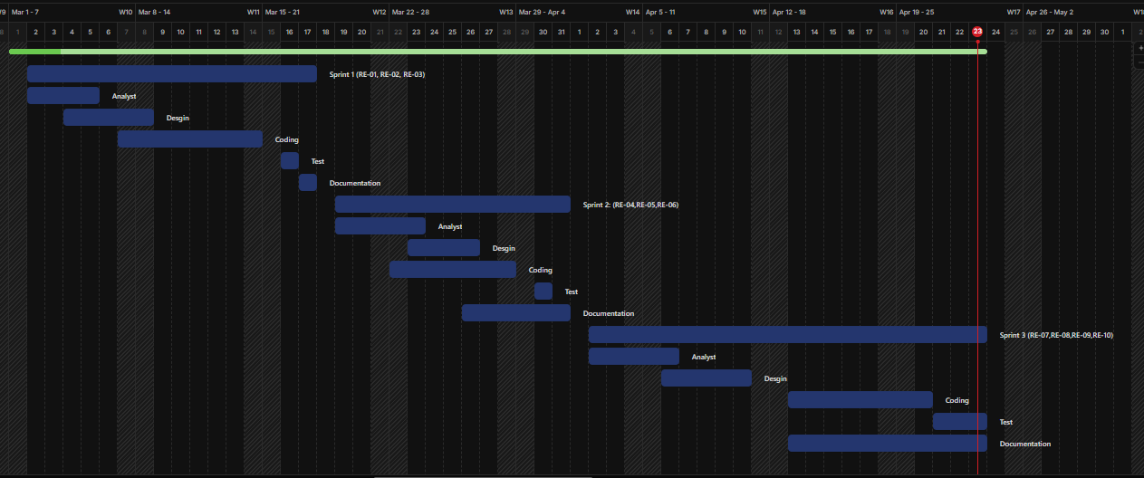

2-3 Team Management and Task Distribution
Sprint 1: Analysis and Design
- عماد: Requirements Analysis
- ابراهيم: System Design (UML)
- عبدالقادر: Database Design
- خالد: Review and Documentation

Sprint 2: Development
- عبدالقادر: Backend Development
- خالد: Frontend Development
- إبراهيم: Database Integration
- عماد: Integration Testing

Sprint 3: Testing and Delivery
- عبدالقادر: Bug Fixing and Performance Improvement
- خالد: User Interface Enhancement
- إبراهيم: Data Testing
- عماد: Comprehensive Testing, Documentation, and Delivery

2-6 Risk Management
A set of potential risks that may affect the project was identified, along with plans to handle them:
الخطر | الاحتمال | التأثير | خطة المعالجة
عدم توفر بيانات حقيقية | متوسط | عالي | استخدام بيانات تجريبية
تأخر تنفيذ بعض المزايا | متوسط | متوسط | إعادة جدولة المهام
أخطاء برمجية | عالي | متوسط | اختبار مستمر وتصحيح
ضعف أداء النظام | منخفض | متوسط | تحسين الاستعلامات وقاعدة البيانات

2-7 Quality Management
To ensure system quality, the following procedures were applied:
- Performing periodic testing during development.
- Conducting code reviews (Code Review).
- Using clear acceptance criteria for functionalities (Acceptance Criteria).
- Ensuring system usability and ease of use (Usability).

2-8 Project Management Tools
A set of tools was used to support the development and management process of the project, including:
- Git / GitHub: For Version Control.
- Trello (or similar tools): For task organization and management.
- Visual Studio Code: For software development.
- XAMPP: For running a local development environment.

2-9 Monitoring and Evaluation Mechanisms
Project progress was monitored through:
- Weekly review of completed tasks.
- Comparing actual progress with the planned schedule.
- Adjusting priorities when necessary.
- Testing each completed component immediately after implementation.

2-10 Software Configuration Management (SCM)
Git was used as the source code management system, where the following practices were applied:
- Organizing the code within a repository.
- Using multiple versions.
- Saving modifications continuously.
- Providing the ability to return to previous versions when needed.

Section Two: Theoretical Study and Analysis
Chapter Three: Reviewing the Literature and Previous Studies

3-1 Previous Studies in Intelligent and Similar Systems

المعيار / التطبيق | المشروع المقترح | GoodRx | NowRx | WebMD | Epocrates |  | Pharmacy Marketplace  (Athena AI) | Medisafe | CVS Caremark
البحث الجغرافي عن الصيدليات | ✅ نعم (خرائط + ترتيب حسب المسافة) | ✅ نعم (يعرض صيدليات قريبة) | ❌ لا (صيدلية واحدة رقمية) | ❌ لا  (يركز على معلومات الصحة) | ❌ لا | ❌ لا (B2B للمشتريات( |  | ❌ لا | ✅ نعم (عرض مواقع الصيدليات)
عرض توفر الدواء الفعلي | ✅ نعم (بيانات لحظية من الصيدليات) | ❌ لا (يعرض السعر فقط) | ✅ نعم (في صيدليته الخاصة) | ❌ لا | ❌ لا | ❌ لا |  | ❌ لا | ❌ لا (يظهر فقط إذا كان الدواء في المخزون المركزي للسلسلة)
تحديث المخزون لحظياً | ✅ نعم (بواسطة الصيدليات) | ❌ لا (بيانات أسعار ثابتة) | ✅ نعم (في صيدليته الخاصة) | ❌ لا | ❌ لا | ❌ لا (تحليل طلب لكن لا تحديث لحظي من الصيدليات) |  | ❌ لا | ❌ لا (مخزون مركزي يحدّث بشكل غير لحظي)
مشاركة الصيدليات في تحديث البيانات | ✅ نعم (لوحة تحكم للصيدليات) | ❌ لا (تعتمد على اتفاقيات مع سلاسل) | ❌ لا (نموذج صيدلية واحدة) | ❌ لا | ❌ لا | ❌ لا (موجه لتجار الجملة) |  | ❌ لا | 🟡 جزئياً (للسلاسل الكبيرة فقط)
دعم اللغة العربية بالكامل | ✅ نعم (أولوية كاملة) | ❌ لا (إنجليزية فقط) | ❌ لا (إنجليزية) | ❌ لا (إنجليزية) | ❌ لا (إنجليزية) | ❌ لا (إنجليزية) |  | ❌ لا (إنجليزية) | ❌ لا (إنجليزية)
الذكاء الاصطناعي / تحليل البيانات | 🟡 مقترح للتنبؤ بالطلب وتحسين نتائج البحث | ❌ لا | ❌ لا | ❌ لا | ❌ لا | ✅ نعم (Athena AI لتحليل الطلب وتحسين الشراء( |  | ❌ لا | ❌ لا
توفر معلومات الأسعار / التخفيضات | ❌ لا (مرحلة أولى) | ✅ نعم (قوية جداً) | ✅ نعم (مع التأمين) | ❌ لا | ❌ لا | ✅ نعم (بين تجار الجملة) |  | ❌ لا | ✅ نعم (لمشتركي التأمين)
خدمات إضافية (استشارات، تذكيرات، توصيل) | ❌ لا (يمكن إضافتها مستقبلاً) | ❌ لا | ✅ نعم (توصيل سريع، استشارات فيديو) | ✅ نعم (فحص أعراض، تذكيرات) | ✅ نعم (تفاعلات دوائية، حاسبة جرعات) | ❌ لا |  | ✅ نعم (تذكيرات، تقارير) | ✅ نعم (إعادة تعبئة تلقائية، تتبع طلبات)
التغطية الجغرافية | محلية (قابلة للتوسع) | وطنية (الولايات المتحدة) | محلية (كاليفورنيا، تكساس) | عالمية | عالمية | وطنية (الولايات المتحدة) |  | عالمية | وطنية (الولايات المتحدة)
3-2 Modern Technologies and Frameworks Used
Modern systems in this field rely on a set of technologies, including:
- Frontend Frameworks: such as Vue.js and React.
- Backend Technologies: such as Laravel and Django.
- Databases: such as MySQL and PostgreSQL.
- REST APIs: for system integration and communication.
- Geolocation APIs: for determining the user’s location.
- Cloud Computing: for expanding and scaling the system.
These technologies represent the foundation upon which the current project was built.

3-3 Comparative Analysis of Systems
A comparison was conducted between the proposed project and several existing systems. The results can be summarized as follows:
In terms of geographic search:
- Current Project: ✔ Supports location-based search with distance-based sorting.
- Most Existing Systems: ❌ Limited or no support.
In terms of medicine availability:
- Current Project: ✔ Displays actual medicine availability.
- Other Systems: ❌ Display prices or general information only.
In terms of data updates:
- Current Project: ✔ Real-time updates from pharmacies.
- Other Systems: ❌ Static or indirect data.
In terms of pharmacy participation:
- Current Project: ✔ Allows pharmacies to update their own data.
- Other Systems: ❌ Depend on centralized sources.
In terms of language support:
- Current Project: ✔ Supports the Arabic language.
- Other Systems: ❌ Depend mainly on English only.

3-4 Research Gap
Through analyzing previous systems, the research gap can be identified as follows:
There is no system that combines accurate geographic search with real-time medicine availability while also involving pharmacies in updating the data.
Most existing systems:
- Focus only on prices.
- Or provide general information.
- Or operate within a limited scope (single pharmacy).
Meanwhile, the current project provides:
- An interactive system.
- A system based on real data.
- Direct connection between users and pharmacies.

3-5 Innovation in the Project
The current project is distinguished by several innovative aspects, including:
- Integrating geographic location with actual medicine availability.
- Providing a dashboard for pharmacies to update data.
- Designing the system to be scalable and expandable.
- Supporting future integration of Artificial Intelligence technologies to improve:
  - Search result ranking.
  - Prediction of medicine demand.

3-6 Future Trends in the Field
This field is moving toward the adoption of advanced technologies such as:
- Artificial Intelligence (AI):
For analyzing user behavior and predicting needs.
- Data Analytics:
For improving inventory management.
- Cloud Systems:
For expanding the service scope.
- Integration with Healthcare Systems:
Such as hospitals and insurance companies.

Chapter Four: Modeling and Analysis of Requirements

4-1 Feasibility Study
4-1-1 Technical Feasibility
The project is technically feasible for the following reasons:
- Availability of modern technologies such as Vue.js and Laravel.
- Availability of powerful database systems such as MySQL.
- إمكانية استخدام خدمات تحديد الموقع (Geolocation APIs).
- Availability of a local development environment such as XAMPP.

4-1-2 Economic Feasibility
- The cost is relatively low since the project is academic.
- Using open-source tools reduces costs.
- There is no need for complex infrastructure at the current stage.

4-1-3 Operational Feasibility
- The system is easy to use.
- Pharmacies can use it without requiring advanced technical experience.
- The system directly supports end users.

4-2 Requirements Gathering
The requirements were collected using the following methods:
- Theoretical Analysis: Studying similar systems.
- Problem Analysis: Identifying user needs.
- Practical Experience: Relying on understanding the healthcare work environment.

4-3 Stakeholders
الفئة | الوصف | الاحتياجات
المستخدم (المريض) | الباحث عن الدواء | سرعة الوصول للدواء
الصيدلاني | مسؤول عن تحديث البيانات | إدارة الأدوية
المدير | مسؤول عن النظام | إدارة المستخدمين والصيدليات

4-4 Functional Requirements
Table of Requirements:  ID | الفاعل | المتطلب
RE-01 | المستخدم | إنشاء حساب
RE-02 | المستخدم | تسجيل الدخول
RE-03 | المستخدم | البحث عن دواء
RE-04 | المستخدم | عرض الصيدليات التي توفر الدواء
RE-05 | المستخدم | عرض حالة الصيدلية
RE-06 | المستخدم | عرض موقع الصيدلية
RE-07 | الصيدلاني | إضافة الأدوية
RE-08 | الصيدلاني | تحديث بيانات الصيدلية
RE-09 | المدير | إضافة صيدلية
RE-10 | المدير | إدارة المستخدمين

4-5 Non-Functional Requirements

النوع | الوصف
الأداء | زمن استجابة أقل من 3 ثواني
الأمان | حماية البيانات وتسجيل الدخول
قابلية الاستخدام | واجهة سهلة وبسيطة
التوفر | النظام متاح معظم الوقت
التوسع | إمكانية إضافة ميزات مستقبلية

4-6 Requirements Priorities (MoSCoW)

النوع | المتطلبات
Must | تسجيل الدخول، البحث، عرض الصيدليات
Should | عرض الحالة والموقع
Could | إشعارات
Won’t | ميزات AI حالياً

4.7 Modeling Requirements Using UML

4.7.1 Use Case Diagram

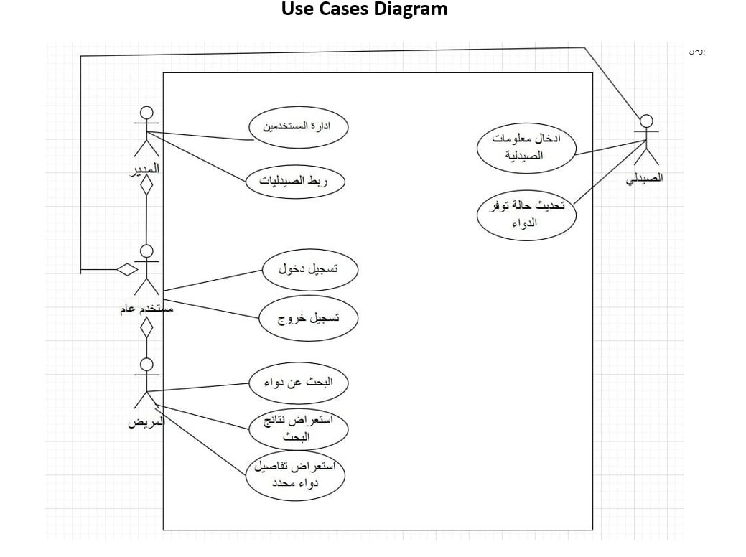

4.7.2 Use Case Description

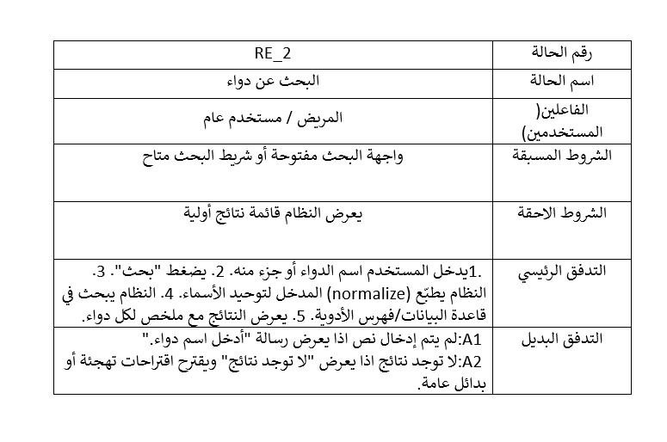

4.7.3 Activity Diagram
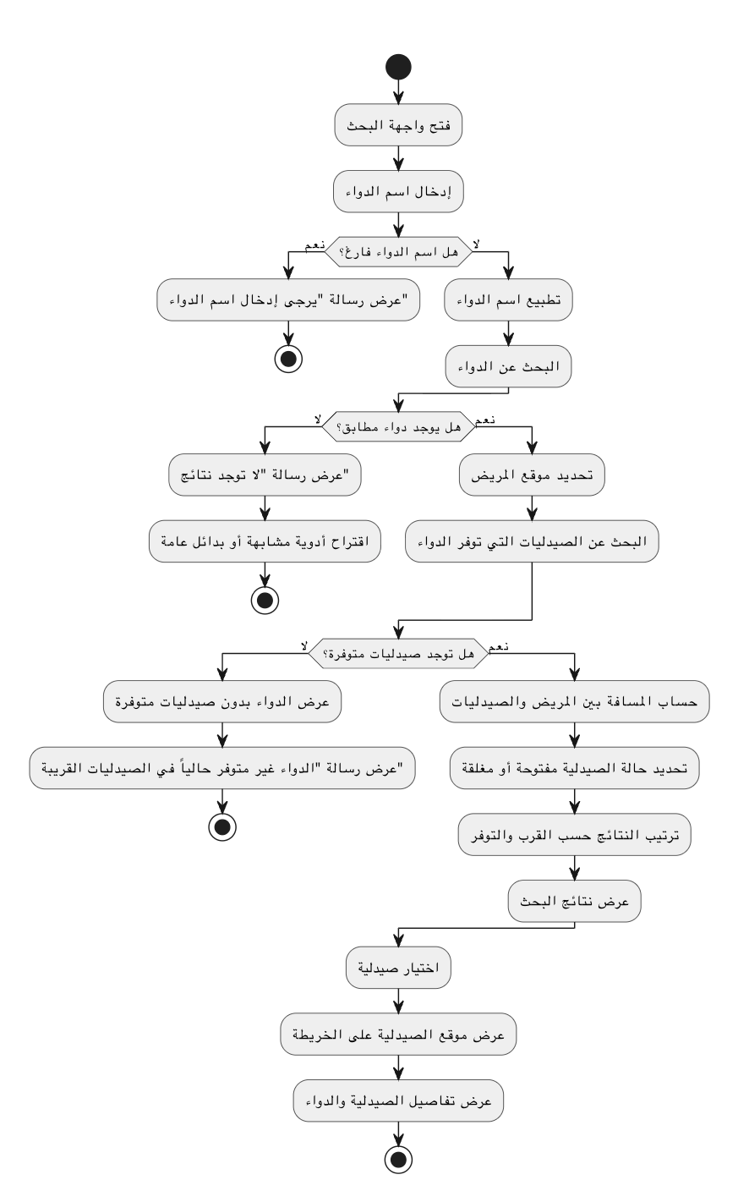

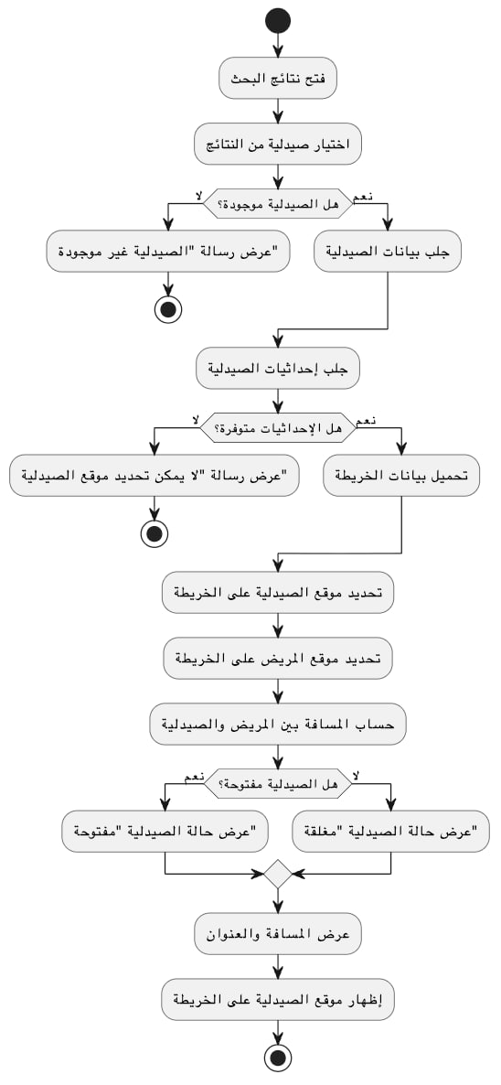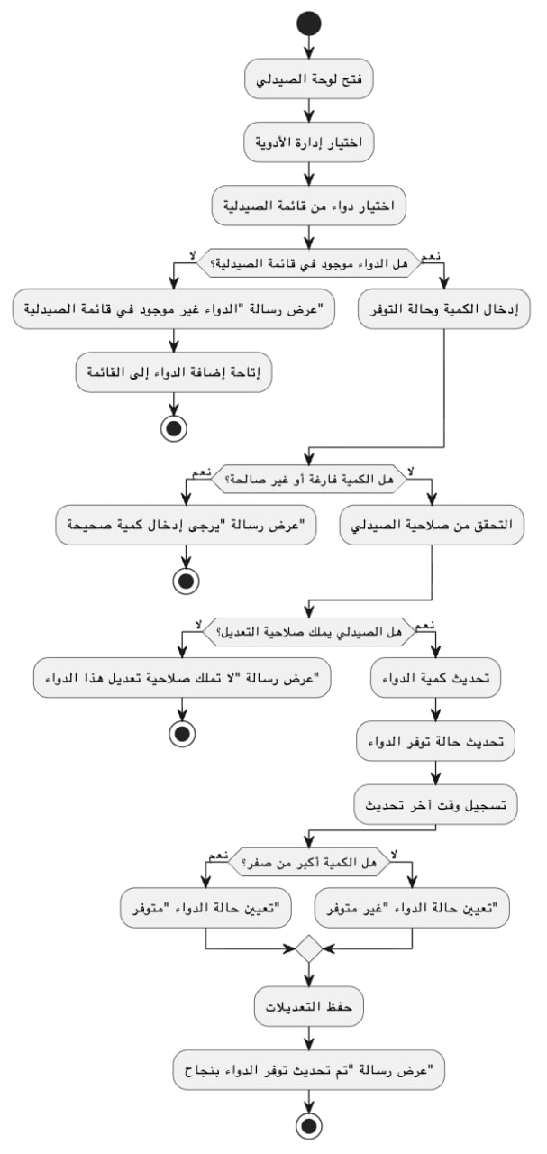

4.7.4 Sequence Diagram

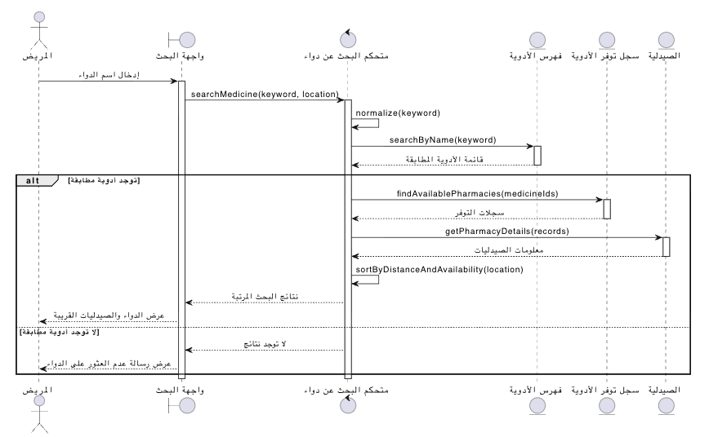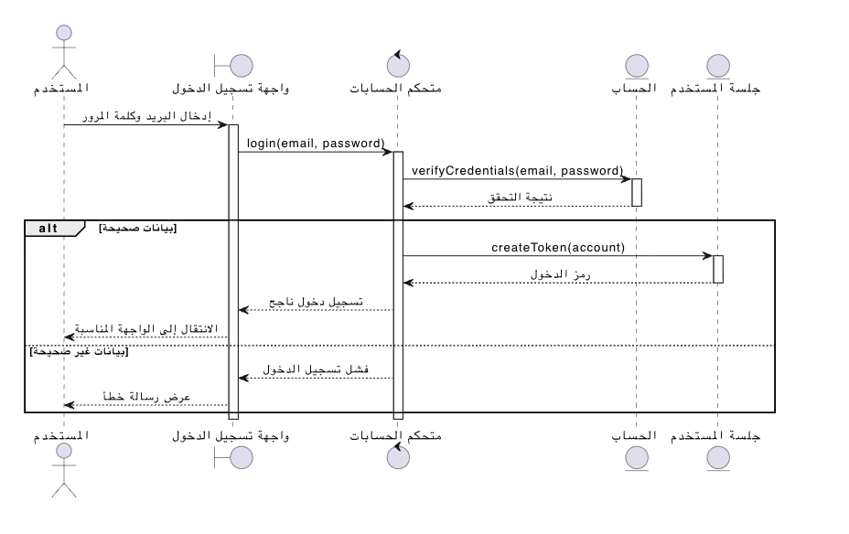
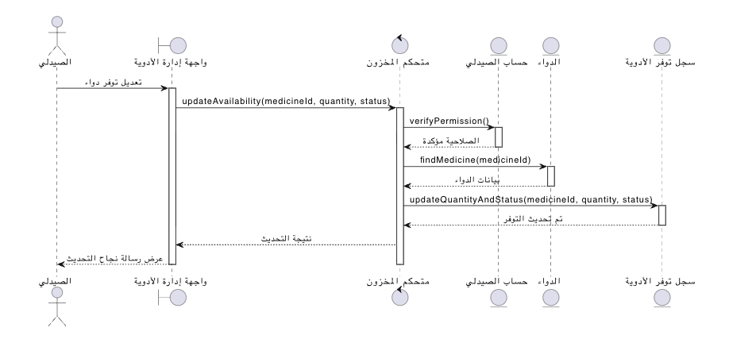

4.7.5 Test Case Descriptions

Testing plays an important role in ensuring that the proposed Intelligent Geolocation-Based Information System satisfies its specified requirements and performs as expected. During the requirements analysis phase, a preliminary set of test cases was identified to verify the correctness of the main system functionalities.

The purpose of these test cases is to provide an early validation mechanism for the most important features of the system, including user registration, user authentication, medicine search, pharmacy discovery based on geographic location, inventory management, and administrative operations. By defining test cases at this stage, a clear relationship is established between system requirements and their corresponding verification activities.

These preliminary test cases serve as a foundation for the testing process and help ensure that each functional requirement can be evaluated after implementation. Detailed test scenarios, execution procedures, expected outcomes, and testing results will be presented and analyzed in Chapter Eight (Testing and Evaluation).

4.8 Modeling According to the Adopted Methodology
Since the project was developed using the Agile methodology, Agile modeling techniques were adopted to organize requirements, prioritize development activities, and support iterative implementation. The following artifacts were used during the project development process.

4.8.1 Product Backlog
The Product Backlog represents the prioritized list of system requirements and features that were planned for implementation throughout the project lifecycle.
ID | Product Backlog Item | Priority
PB-01 | User Registration | High
PB-02 | User Authentication and Login | High
PB-03 | Medicine Search | High
PB-04 | Display Nearby Pharmacies | High
PB-05 | Display Pharmacy Status (Open/Closed) | High
PB-06 | Display Pharmacy Location | Medium
PB-07 | Add Medicines to Inventory | High
PB-08 | Update Medicine Availability | High
PB-09 | Pharmacy Management | Medium
PB-10 | User Management | Medium
PB-11 | Search Result Sorting by Distance | High
PB-12 | Password Recovery | Medium
PB-13 | Profile Management | Low
PB-14 | Future AI-Based Recommendations | Low

4.8.2 User Stories
User Stories were used to describe system requirements from the perspective of end users and stakeholders.
ID | User Story
US-01 | As a patient, I want to create an account so that I can access system services.
US-02 | As a patient, I want to log in securely so that I can access my account.
US-03 | As a patient, I want to search for a medicine so that I can find where it is available.
US-04 | As a patient, I want to view nearby pharmacies so that I can obtain the medicine quickly.
US-05 | As a patient, I want to view the pharmacy status so that I know whether it is open or closed.
US-06 | As a patient, I want to view the pharmacy location so that I can navigate to it easily.
US-07 | As a pharmacist, I want to add medicines to the inventory so that users can find them.
US-08 | As a pharmacist, I want to update medicine availability so that inventory information remains accurate.
US-09 | As a manager, I want to manage pharmacies so that the system data remains organized.
US-10 | As a manager, I want to manage users and permissions so that system access remains secure.

4.8.3 Story Mapping
The Story Mapping technique was used to organize user activities and system functionalities according to user workflows.

User Activity | Tasks
Account Management | Register Account, Login, Logout
Medicine Search | Enter Medicine Name, Search Medicine, View Results
Pharmacy Discovery | View Nearby Pharmacies, Sort by Distance, View Pharmacy Status
Navigation | View Pharmacy Location
Inventory Management | Add Medicine, Update Medicine Availability
System Administration | Manage Users, Manage Pharmacies

4.9 Requirements Analysis and Documentation
4.9.1 Traceability Matrix

المتطلب | التصميم | التنفيذ | الاختبار
RE-03 | Use Case | Search Module | Test Case 1
RE-04 | UI + DB | Display Module | Test Case 2

4.9.2 Initial Test Cases

As part of the requirements analysis process, preliminary test cases were defined to establish an early connection between system requirements and software testing activities. These test cases provide an initial verification mechanism for validating whether the implemented system satisfies the specified functional requirements.

Table 4.X presents a set of initial test cases corresponding to the most important system functionalities.
Test Case ID | Related Requirement | Description | Expected Result
TC-01 | RE-01 | Create a new user account | User account is successfully created
TC-02 | RE-02 | Login using valid credentials | User is authenticated and redirected to the system
TC-03 | RE-03 | Search for a medicine | Matching medicine records are displayed
TC-04 | RE-04 | View pharmacies that provide a medicine | Relevant pharmacies are displayed
TC-05 | RE-05 | View pharmacy status | Pharmacy status is correctly shown
TC-06 | RE-06 | View pharmacy location | Pharmacy location is displayed on the map
TC-07 | RE-07 | Add a medicine to inventory | Medicine is successfully added
TC-08 | RE-08 | Update medicine availability | Inventory information is updated
TC-09 | RE-09 | Add or manage a pharmacy | Pharmacy information is stored successfully
TC-10 | RE-10 | Manage user accounts | User management operation is completed successfully

These initial test cases serve as a foundation for the comprehensive testing activities that will be conducted during the implementation and evaluation phases. Detailed test procedures, execution results, and analysis are provided in Chapter Eight.

Chapter Five: Architectural Design of the System

5.1 High-Level Design
5.1.1 System Block Diagram
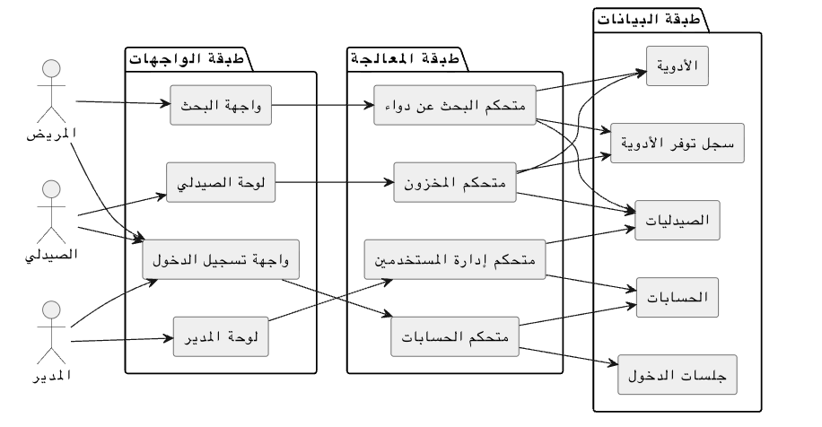

5-1-2 Adopted Architectural Pattern
The MVC (Model-View-Controller) pattern was adopted for the following reasons:
- Separating application logic from the user interface.
- Facilitating maintenance and development.
- Improving code organization.
MVC Components:
- Model:
Represents the data and the database.
- View:
Represents the user interface.
- Controller:
Connects the Model and the View and controls the flow of data.

5-1-3 Architectural Design Description
The system is based on a Client-Server Architecture, where:
- The user interacts with the frontend (Client).
- Requests are sent to the server (Server).
- Data is handled through RESTful APIs.
This architecture allows:
- Separation of layers.
- Support for future scalability.
- The possibility of easily converting the system into a mobile application.

5-2 Database Design
5-2-1 Entity Relationship Model (ER Diagram)
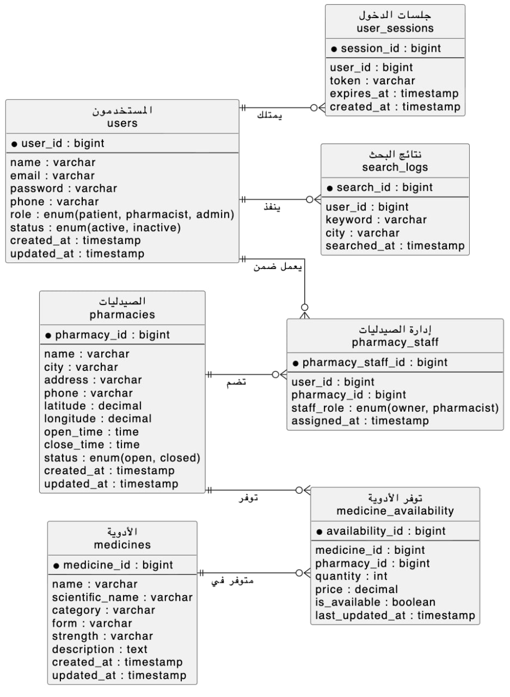

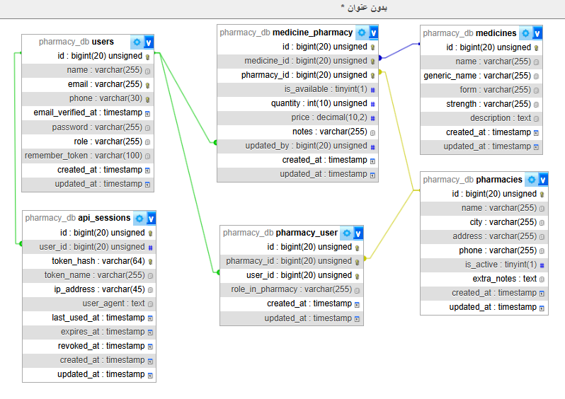
5-2-2 Relational Scheme

5-2-3 Constraints
- Primary Key for each table.
- Foreign Keys:
  - Inventory → Pharmacies
  - Inventory → Medicines
- Unique Constraint:
  - Email field in the Users table.
- Check Constraint:
  - Quantity ≥ 0

5-3 API Design
The system relies on RESTful APIs. The main APIs include:
- Login
- POST /login
- Inputs: Email, Password
- Outputs: Token

- Medicine Search
- GET /medicines/search
- Inputs: Medicine name
- Outputs: List of medicines and pharmacies

- Display Pharmacies
- GET /pharmacies
- Outputs: List of pharmacies with location information

- Add Medicine (For Pharmacist)
- POST /medicines
- Inputs: Medicine data

5-4 Security and Authorization Design
5-4-1 Authentication Mechanism
- Using a Login System.
- Storing passwords securely as Hashed Passwords.
- Using Tokens for user verification and authentication.

5-4-2 Authorization Management
Users were divided into the following roles:
الدور | الصلاحيات
المستخدم | البحث فقط
الصيدلاني | إدارة الأدوية
المدير | إدارة النظام بالكامل

5-4-3 System Protection
- Applying input validation.
- Preventing attacks such as SQL Injection.
- Using HTTPS in case of deployment.

5-5 Scalability and Future Development
The system was designed to support future scalability through:
- The possibility of adding Artificial Intelligence (AI).
- Supporting mobile applications.
- Integration with other systems.
- Improving performance using caching.

Chapter 6: Implementation Environment and Tools

6-1 Software Tools and Libraries Used
The development of the proposed intelligent medicine search system relied on a set of modern software tools and libraries to support both frontend and backend implementation.

Development Tools
- Visual Studio Code (VS Code): Used as the primary source code editor for frontend and backend development.
- Postman: Used for testing RESTful APIs and validating HTTP requests and responses.
- Git and GitHub: Used for version control and collaborative development.
- XAMPP: Used to run the local Apache server and MySQL database during development.
- Google Chrome Developer Tools: Used for debugging frontend interfaces and monitoring API requests.

Frontend Libraries and Frameworks
- Vue.js: Used for building interactive user interfaces.
- Axios: Used for handling HTTP requests between frontend and backend.
- Vue Router: Used for page navigation within the application.
- Bootstrap / Tailwind CSS: Used for responsive UI design.

Backend Libraries and Frameworks
- Laravel Framework: Used for backend API development and business logic implementation.
- Laravel Sanctum / JWT Authentication: Used for secure authentication and token management.
- Eloquent ORM: Used for database interaction and object-relational mapping.

6-2 Development Environment and Project Structure
The system was developed in a local development environment before deployment to a production-ready server.

Development Environment
- Operating System: Windows 11
- Web Server: Apache (via XAMPP)
- Database Server: MySQL
- Backend Environment: PHP 8.x with Laravel
- Frontend Environment: Node.js and Vue.js

Project Structure
The project was organized into separate frontend and backend modules to improve maintainability and scalability.

Backend Structure
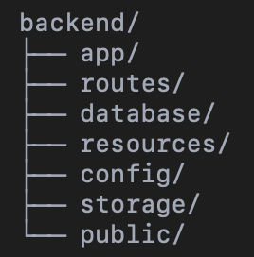

Frontend Structure
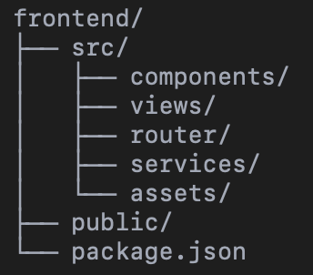

6-3 Programming Languages and Frameworks
The implementation of the system utilized several programming languages and frameworks.

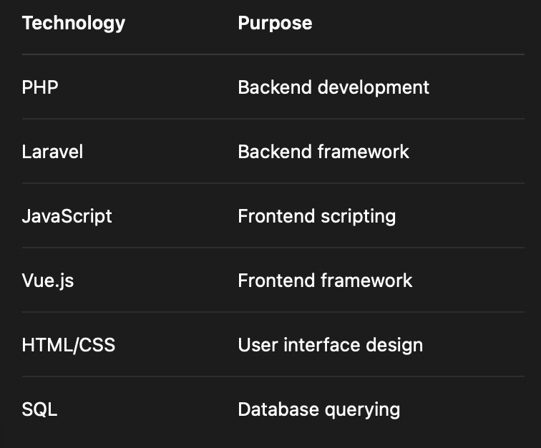

The Laravel framework was selected due to its support for MVC architecture, security features, and RESTful API development. Vue.js was selected for its reactive component-based architecture and efficient frontend rendering.

6-4 Database Server and Operating System
The database management system used in this project was MySQL due to its reliability, simplicity, and compatibility with Laravel.

Server Configuration
- Database Server: MySQL
- Local Server Environment: XAMPP
- Operating System: Windows 11
The system can also be deployed on Linux servers such as Ubuntu for production environments.

6-5 Dependencies and Libraries
The project relied on several external dependencies managed through package managers.

Backend Dependencies
Installed using Composer: composer install
Main dependencies:
- laravel/framework
- laravel/sanctum
- guzzlehttp/guzzle

Frontend Dependencies
Installed using npm:
npm install
Main dependencies:
- vue
- vue-router
- axios
- bootstrap
Dependency configurations were managed using:
- composer.json
- package.json

6-6 Version Control and Source Management
Version control was implemented using Git to track changes and manage source code versions.

Tools Used
- Git
- GitHub

Source Control Practices
- Separate branches for frontend and backend features
- Frequent commits during development
- Backup of stable versions
- Collaborative change tracking
GitHub repositories were used to store the project remotely and support version recovery.

6-7 Continuous Integration and Deployment Tools (CI/CD)
Basic CI/CD concepts were applied during development to automate parts of the workflow.

Tools
- GitHub Actions
- GitHub Repository Workflows

CI/CD Features
- Automatic dependency installation
- Code validation checks
- Automated build testing
- Continuous backup of source code
The deployment process can later be expanded to support automated cloud deployment.

6-8 Testing Environment
The system was tested in a local development environment before deployment.

Testing Environment
- Localhost environment using XAMPP
- Browser-based manual testing
- API testing using Postman

Testing Devices
- Desktop computers
- Different browser sizes for responsive UI testing

Types of Testing Performed
- Functional testing
- API testing
- User interface testing
- Database interaction testing
The testing environment ensured that all core functionalities operated correctly before final deployment.

Chapter 7: Software Implementation

7-1 Project and File Structure
The project follows a modular architecture separating frontend and backend components.

Main Structure
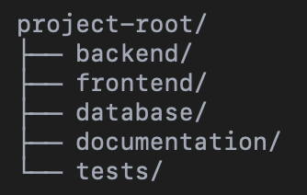

Backend Components
- Controllers
- Models
- Middleware
- API Routes
- Services

Frontend Components
- Pages
- Reusable Components
- API Services
- Routing System
This structure improves maintainability and scalability.

7-2 Modules Implementation
The system was divided into several main modules.

Authentication Module
Responsible for:
- User registration
- Login
- Session management
- Role verification

Medicine Search Module
Responsible for:
- Searching medicines by name
- Filtering by city
- Retrieving available pharmacies
- Sorting results

Pharmacy Management Module
Responsible for:
- Updating medicine availability
- Managing pharmacy information
- Updating stock quantities

Admin Module
Responsible for:
- Managing users
- Managing pharmacies
- Monitoring system data

7-3 APIs Implementation
The system was implemented using RESTful APIs.

Example API: Medicine Search

Endpoint


Request Parameters
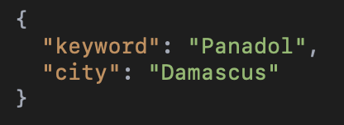

7-4 Data Access Layer Implementation
The Data Access Layer was implemented using Laravel Eloquent ORM.

ORM Advantages
- Simplified database operations
- Improved readability
- Reduced SQL complexity
- Better maintainability
Relationships between entities were implemented using Laravel model relationships.

7-5 Business Logic Layer Implementation
The business logic layer handles the main application rules and processing logic.

Main Responsibilities
- Validating medicine searches
- Filtering pharmacies by city
- Determining medicine availability
- Checking pharmacy status
- Sorting search results
- The system also prioritizes pharmacies based on medicine availability and location relevance.

7-6 User Interface Implementation
The user interface was implemented using Vue.js and responsive design principles.

Main Interfaces
- Login page
- Search page
- Pharmacy dashboard
- Admin dashboard
- Medicine details page

UI Features
- Responsive design
- Simple navigation
- Search filtering
- Interactive components

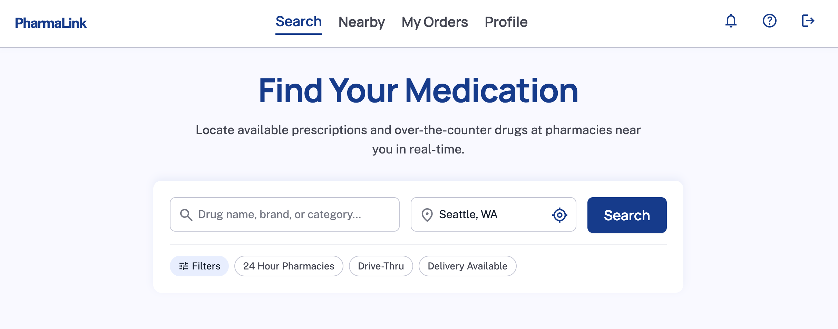
The search page

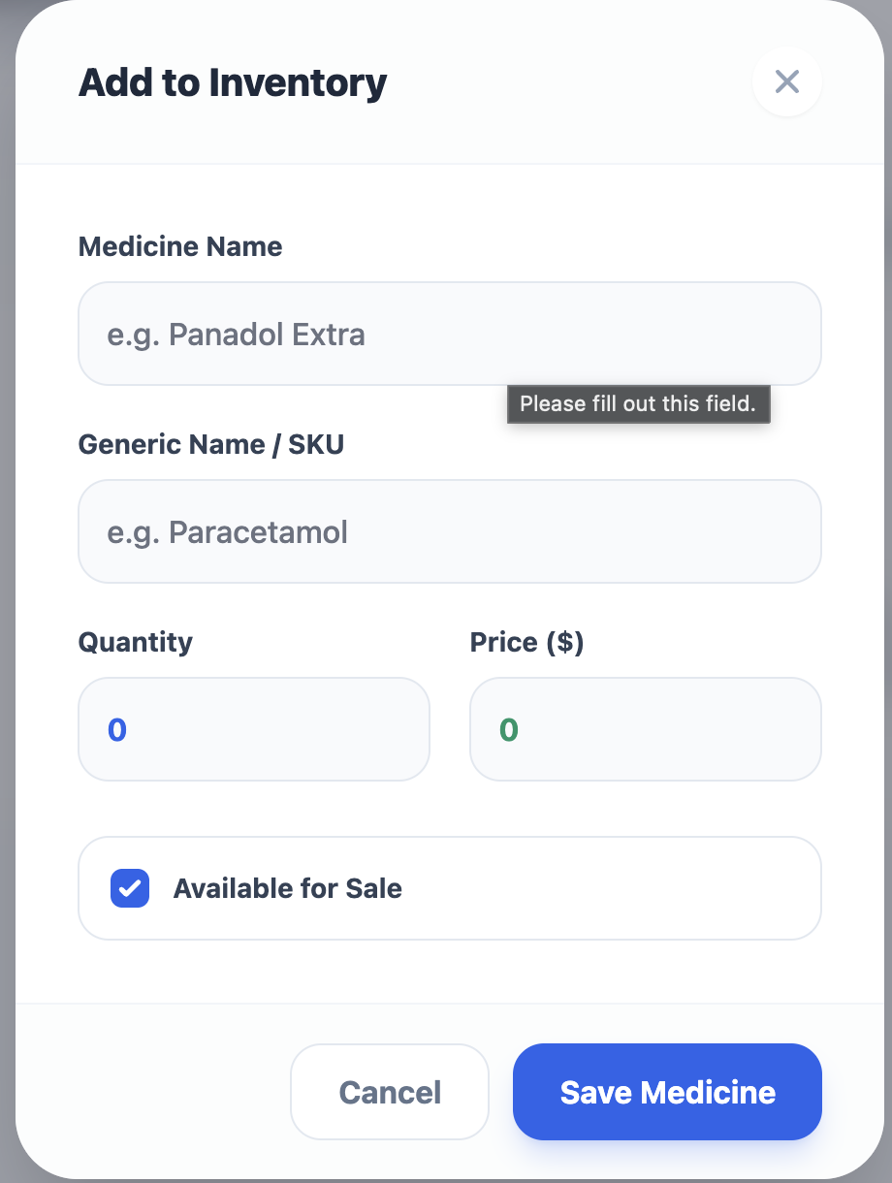
Pharmacist Add Medicine Form

7-7 Smart Algorithms Implementation
Although the current implementation focuses mainly on geographical medicine search, the system was designed to support future intelligent features.

Proposed Intelligent Features
- Predicting medicine demand
- Smart ranking of search results
- Suggesting alternative medicines
- Data analytics for pharmacy inventory

Example Ranking Logic
score = (availability * 0.6) + (distance * 0.4)

This logic can later be expanded using machine learning algorithms and data analysis models.

Chapter 8: Testing and Evaluation

8-1 Test Plan
The testing phase was conducted to verify that the system works according to the functional and non-functional requirements defined in the analysis chapter. The main objective of testing was to ensure that the medicine search system, authentication module, manager module, pharmacist module, and user interface navigation operate correctly.
The system was tested in a local development environment using XAMPP, Laravel, Vue.js, and MySQL. API testing was performed using Postman, while user interface testing was performed manually through the browser.
The testing dataset contained approximately 300 registered users, 500 pharmacies, and 10,000 medicine records. The users were distributed among patient, pharmacist, and manager roles. This dataset was used to simulate a realistic academic testing environment.

8-2 Types of Testing
The system was evaluated using unit testing, integration testing, system testing, acceptance testing, performance testing, security testing, usability testing, and compatibility testing.
Unit testing focused on individual functions such as validation logic and authentication checks. Integration testing verified communication between the frontend, backend, and database layers. System testing validated the complete workflow of the application.
Performance testing measured response times for login, medicine search, and medicine availability updates. Security testing focused on authentication, authorization, and route protection. Usability testing evaluated ease of use and interface clarity.

8-4 Testing Results and Analysis
A total of 42 test cases were executed across the main modules of the system. Out of these test cases, 40 passed successfully and 2 failed, resulting in an overall functional success rate of 95.2%.
Authentication testing achieved a 100% success rate. Medicine search testing achieved an 88.9% success rate due to a minor filtering issue with uncommon keywords. The manager module achieved a 100% success rate, while the pharmacist module achieved an 87.5% success rate due to one validation issue related to invalid stock quantities.
Overall, the system demonstrated stable and reliable behavior suitable for academic demonstration and local deployment.

8-5 Quality Metrics
The quality of the system was evaluated using several measurable indicators. The average medicine search response time was 1.4 seconds, while the average login response time was 0.6 seconds. The average medicine availability update response time was 0.9 seconds.
No critical errors were detected during testing. Two minor issues related to search filtering and invalid quantity validation were identified for future improvement.

8-3-1 Test Cases Table
Test Case ID | Tested Feature | Input / Action | Expected Result | Actual Result | Status
TC-01 | Login | Valid email and password | User is authenticated | Login successful | Passed
TC-02 | Login | Invalid password | Display error message | Error displayed | Passed
TC-08 | Medicine Search | Keyword and city | Display matching medicines | Results displayed | Passed
TC-12 | Pharmacy Results | Search existing medicine | Display pharmacies | Pharmacies displayed | Passed
TC-24 | Availability Update | Update quantity | Availability updated | Update successful | Passed
TC-25 | Availability Validation | Invalid quantity | Validation error | Minor issue detected | Failed

8-3-2 Test Results Summary
Test Category | Total | Passed | Failed | Success Rate
Authentication Tests | 8 | 8 | 0 | 100%
Medicine Search Tests | 9 | 8 | 1 | 88.9%
Manager Module Tests | 10 | 10 | 0 | 100%
Pharmacist Module Tests | 8 | 7 | 1 | 87.5%
UI and Navigation Tests | 7 | 7 | 0 | 100%
Total | 42 | 40 | 2 | 95.2%

Chapter 9: Results and Analysis

9-1 System Results
The developed system successfully demonstrated the ability to:
- Search medicines geographically
- Display nearby pharmacies
- Show pharmacy availability status
- Manage medicine inventory

9-2 Comparative Analysis with Existing Systems
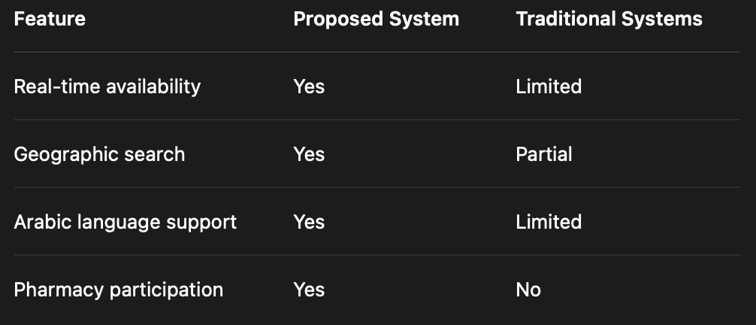

9-3 Achievement of Objectives
The majority of project objectives were achieved successfully.

Achieved Objectives
- Medicine search functionality
- Geographic pharmacy filtering
- Pharmacy inventory management
- User account management

Future Objectives
- AI-based recommendations
- Mobile application support

9-4 Strengths and Weaknesses Analysis

Strengths
- Simple and responsive design
- Real-time medicine availability
- Geographic filtering support
- Expandable architecture

Weaknesses
- Limited real pharmacy data
- No AI implementation yet
- Requires continuous pharmacy updates

9-5 Key Performance Indicators (KPIs)

Main KPIs
- Response time
- Search accuracy
- User satisfaction
- System stability

Chapter 10: Conclusion and Recommendations

10-1 Project Summary and Main Achievements
This project presented the design and implementation of an intelligent geographical medicine search system that helps users find nearby pharmacies providing required medicines. The system successfully integrated geographical search, pharmacy availability tracking, and inventory management within a modern web-based architecture.

10-2 Challenges and Difficulties
Several challenges were encountered during development.

Technical Challenges
- Integrating frontend and backend components
- Managing medicine availability updates
- Handling location-based filtering

Organizational Challenges
- Limited development time
- Lack of real-world pharmacy datasets

10-3 Future Improvements
Future development can significantly improve the system.

Suggested Enhancements
- Mobile application development
- AI-powered medicine recommendations
- Predictive inventory analytics
- Integration with healthcare systems
- Real-time notification system

10-4 Recommendations

Recommendations for Future Students
- Use real-world datasets whenever possible
- Focus on scalable system architecture
- Perform extensive usability testing

Recommendations for Organizations
- Encourage pharmacies to update inventory continuously
- Integrate the system with healthcare providers
- Support Arabic healthcare technologies

