Digital Communications  Modulation  Project  Due on 5 June 2021 |  | Cairo University  Faculty of Engineering  Electronics and Communications Dept.  3rd Year

Project Details
The purpose of the project is to introduce the students to the simulation of the single carrier communication systems. The requirements of the project are described in the following sections.

Single Carrier System
Data bits
Mapper
Channel
Demapper
BER Calculator
Figure 1 Single carrier communication system.

The Mapper
The first block in the communication system under consideration is the mapper. The mapper takes the I/P data bits and produces the symbols to be transmitted on the channel.
The modulation schemes under consideration are the BPSK, QPSK, 8PSK, and 16QAM systems. Figure 2 shows the constellations.

The channel
The channel is an AWGN channel. In this model, the channel just adds noise to the transmitted signal. In MATLAB, the command “randn” should be used to generate the AWGN.

The Demapper
The simple demapper in the model under consideration will take the output of the channel and decide on the symbol transmitted. The output bit stream of the receiver is compared to the input bit stream and the BER is calculated.

000
001
011
010
110
111
101
100
8PSK
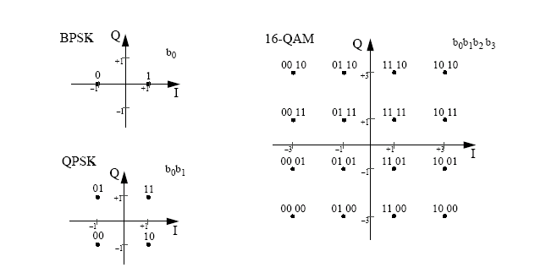
Figure 2 8PSK, BPSK, QPSK, and 16-QAM constellations

Tasks
- All simulations are done on the baseband equivalent system, with no carriers.
- It is required to plot curves for the BER Vs Eb/No for the four modulation schemes. On the same graph, the theoretical BER or a tight upper bound should be drawn for each one of the 4 modulation schemes.

