

Name: Khaled Eman Ahmed

Position: UI/UX Specialist

Month: August 2025

Joining date: 8th of April 2025

|  |  |  |  |
| --- | --- | --- | --- |
| Day | Date | Time In | Time Out |
| Saturday | 2025-08-16 | Weekend | Weekend |
|  |  |  |  |
|  |  |  |  |
|  |  |  |  |
|  |  |  |  |
|  |  |  |  |
|  |  |  |  |
|  |  |  |  |
|  |  |  |  |
|  |  |  |  |
|  |  |  |  |
|  |  |  |  |
|  |  |  |  |
|  |  |  |  |
|  |  |  |  |
|  |  |  |  |
|  |  |  |  |
|  |  |  |  |
|  |  |  |  |
|  |  |  |  |
|  |  |  |  |
|  |  |  |  |
|  |  |  |  |
|  |  |  |  |
|  |  |  |  |
|  |  |  |  |
|  |  |  |  |
|  |  |  |  |
|  |  |  |  |

Approved line Manager

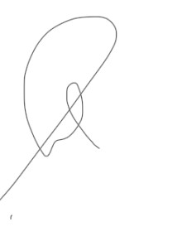IT Technical Support Section Head