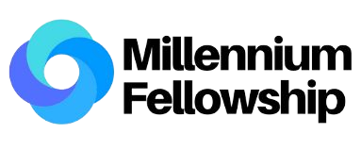
SOCIAL IMPACT TOUR
CleanFlow
Khaled Jibril Muhammad
Teammates - Individual Project

Bayero University Kano

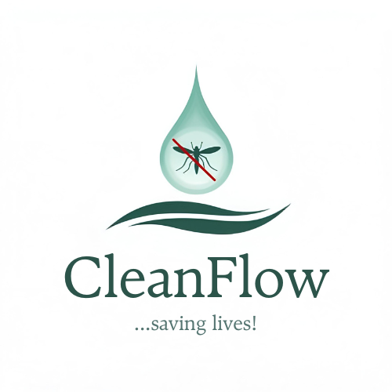
- Overview of Your Social Impact Initiative:
CleanFlow is a community-driven initiative tackling malaria at its source by addressing the environments where mosquitoes breed. The project focuses on creating sustainable solutions for cleaning and maintaining drainage systems in high-risk urban areas. Stagnant water in blocked drains serves as the perfect breeding ground for mosquitoes, leading to unacceptably high malaria rates in our community. Our mission is clear: reduce malaria transmission by ensuring proper drainage flow and eliminating stagnant water. This approach not only minimizes mosquito habitats but also reduces flooding risks, contributing to overall healthier, safer, and more resilient communities.
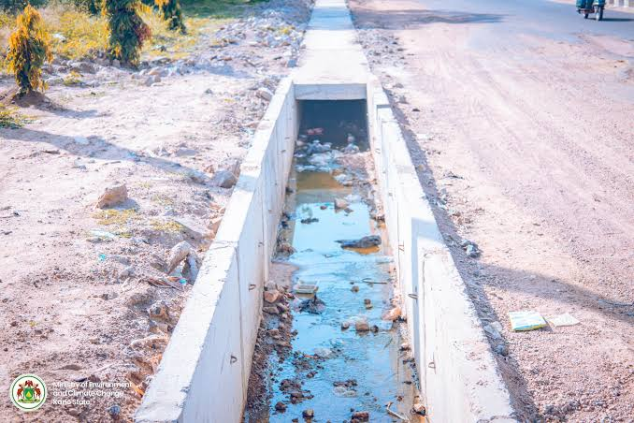
CleanFlow creates social impact by directly addressing a critical public health challenge through environmental management, community education, and local collaboration, which directly aligns with the United Nations Sustainable Development Goal 3: Good Health and Well-being.
Fig1.1: A picture of a poor drainage system snapped by Kano State Govt.
- Why is this important to you?
My commitment to CleanFlow stems from deeply personal experiences growing up in Kano. I have witnessed firsthand the devastating impact of malaria on families, friends, and neighbors. Every year, countless community members suffer from this preventable disease, trapped in a cycle often caused by poor drainage systems that enable mosquito proliferation. I really and strongly believe that waiting for external solutions is not sufficient; creating a better society requires taking responsibility and actively solving our local challenges. The long-term vision for CleanFlow is a community liberated from the preventable burden of malaria. We envision a future where children can play without high infection risk, where families avoid the financial and emotional strain of malaria treatment, and where overall community health and productivity flourish. The change we seek represents a fundamental shift from treatment to prevention, empowering residents with the knowledge and tools to maintain a healthier environment for generations to come.
- Project Activities & Impact:
CleanFlow was executed in such a way that it employs a dual strategy combining direct environmental action with community empowerment which made it more impactful.
The Key Activities:
- Drainage Maintenance: Physical cleaning and maintenance of identified high-risk drainage systems that are most prone to blockages and mosquito breeding
- Community Outreach: Educational events raising awareness about the connection between stagnant water, drainage maintenance, and malaria prevention
Tangible Outcomes & Milestones (Projected for Aug-Nov 2025):
- Environmental Impact: 68% reduction of stagnant water and mosquito breeding habitats in maintained drainage systems
- Public Health Impact: 50% reduction in local mosquito populations in implementation areas
- Community Reach: Direct education and engagement with approximately 150 residents through targeted outreach events
- Lives Impacted: Positive health and well-being impact projected for 380 community members during the Fellowship period

- Your Millennium Fellowship experience (Lessons learned):
The Millennium Fellowship has been instrumental in refining my approach to social impact. The most significant lesson has been understanding the crucial importance of proximity and empathetic leadership. The program's emphasis on Bryan Stevenson's philosophy reinforced my conviction that sustainable solutions emerge not from a distance, but through deep, respectful engagement with the communities we serve.
This has shaped my leadership to be more inclusive, ensuring community voices are not just heard but are central to CleanFlow's planning, and even execution.

Advice for Future Fellows:
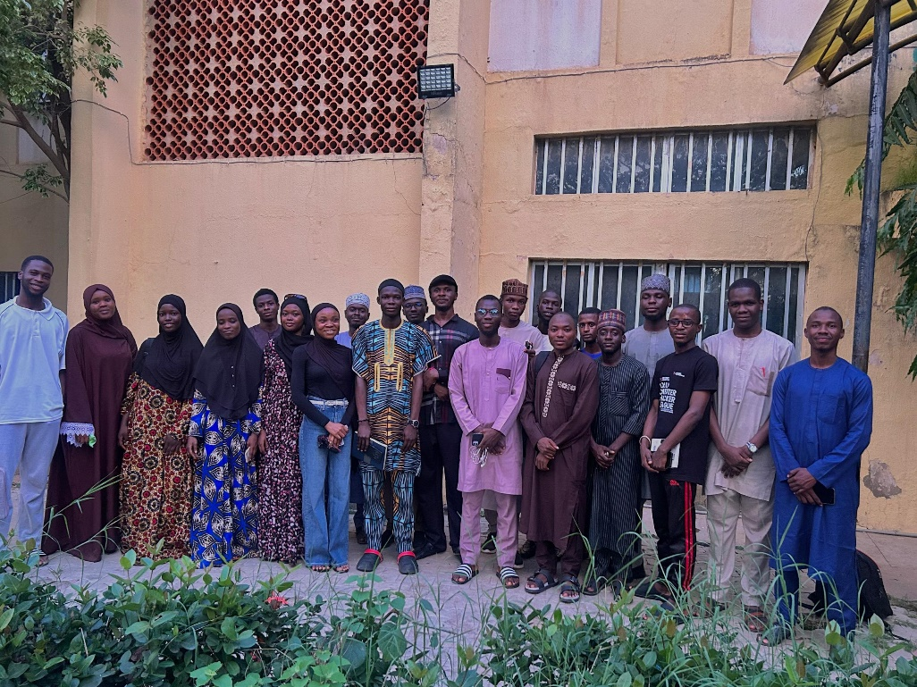
- Begin with Empathy, Not Solutions: Truly listen to community needs before designing interventions. Your ideas provide the framework, but local experience makes them effective and more realistic.

Fig 4.1: a picture snapped after a fellowship session

- Leverage the Network: The Fellowship connects you to a global community of change-makers. Engage actively with peers, share challenges openly, and embrace collaborative opportunities these relationships become invaluable assets that strengthen both your project and personal growth. The Millennium fellowship offers a platform where you can collaborate with other fellows across the world, this is one of the mind-blowing opportunities the fellowship offers, do well to utilize.

- Call to Action:
CleanFlow represents more than just a project, it's a movement toward healthier communities, beginning with the essential step of environmental management for disease prevention. Our work demonstrates how targeted local actions can significantly contribute to global goals like SDG 3. We cannot achieve this vision alone. To expand our impact and employ this model in more communities, we need your support.
How You Can Help:
- Volunteering: Contribute time and energy to cleaning initiatives and outreach programs
- Partnering With Us: Collaborate with us if you represent local businesses, NGOs, or health authorities
- Amplifying Our Voices: Follow our journey and share our story to raise awareness
- Advise and Recommendations: Provide expertise in public health, environmental engineering, or sustainable project management
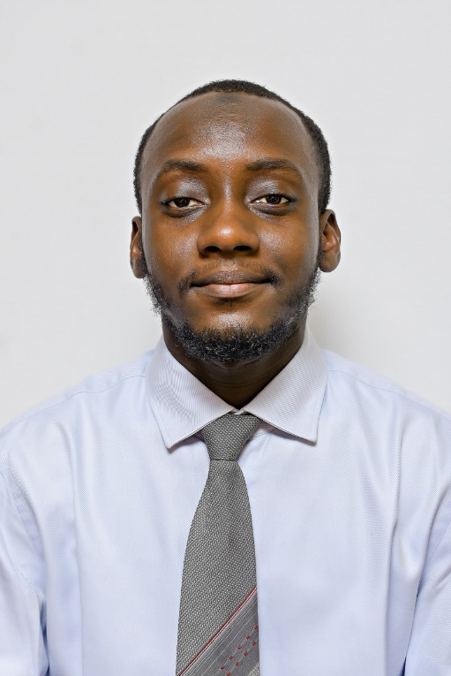
Together, we can eliminate malaria, by not just treatment but through prevention and building a cleaner, safer future for all.

Khaled J. Muhammad
Founder CleanFlow
Khaledblings@gmail.com

