**Unit 1: Technology in Use**

**Explaining How Technology Works (Page 8)**

|  |
| --- |
| **6a. In pairs, look at the picture and discuss the following questions:** |

1. **How do you think a space elevator would work?**
2. **What could it be used for?**
3. ." Satellites, components for spaceships, supplies for astronauts in space stations, and even astronauts themselves are examples of payloads
4. **What technical challenges would it face?**

the altitude of orbital space—a colossal 35,790 km above the earth—is a measure of the challenge facing engineers

1. **How seriously do you think the concept of space elevators is being taken at present?**

|  |
| --- |
| **b. Space Elevators: preparing for take off** |

In his 1979 novel The Fountains of Paradise, Arthur C. Clarke wrote about an elevator connecting the earth's surface to space. Three decades later, this science-fiction concept is preparing to take off in the real world.

**novel**: a long fictional narrative that tells a story about human experiences.

**connecting:** joining

**decade:** a period of 10 years

**Science fiction** is a genre=type that imagines stories about the future, space, technology, and other scientific ideas. It often includes things like spaceships, robots, time travel, and aliens, even if these things aren’t possible yet.

**concept**: idea

**take off:** begin or start becoming successful.

When it says the space elevator concept is "preparing to take off," it means the idea is getting closer to becoming a reality or gaining attention and progress.

NASA has launched the Space Elevator Challenge, a competition with a generous prize fund, and several teams and companies are working on serious research projects aimed at winning it.

**NASA**: **National Aeronautics and Space Administration**

**Launched:** started or introduced

Challenge: competition

Generous: large; plentiful; substantial

Fund: finance; supply

Serious: important; solemn

A **"generous prize fund"** means that the competition offers a large or substantial amount of money or rewards to the winners. In the case of the Space Elevator Challenge, it indicates that the prize for the competition is significant, encouraging teams and companies to participate and put in their best effort.

As its name suggests, a space elevator is designed to "raise things into space." Satellites, components for spaceships, supplies for astronauts in space stations, and even astronauts themselves are examples of payloads that could be transported into orbit without the need for explosive and environmentally unfriendly rockets, however, the altitude of orbital space—a colossal 35,790 km above the earth—is a measure of the challenge facing engineers. How could such a height be reached?

Suggest: put forward an idea, offer a possibility, or imply something indirectly.

Designed: created; planned to serve the purpose of

Raise into: lift; make something go up

Components: parts; pieces; elements

Supplies: provisions; materials or resources needed for a particular purpose

Astronauts: trained professionals who travel and work in space

Payloads: items; cargo

Transported: carried over a distance

Measure: extent

Challenge: difficulty

**Explosive** refers to a substance or device that is capable of causing a violent burst of energy, typically resulting in an explosion. In the context of the text, **explosive rockets** refer to rockets that use highly reactive fuels, which can be dangerous and environmentally harmful due to their violent nature when ignited.

Unfriendly (adjective): harmful

Altitude: **the** height of something above the Earth's surface. For example, how high something is in the sky.

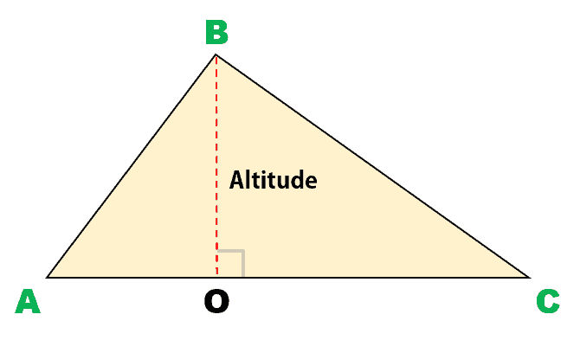

Orbital space: **It** refers to the area around Earth where objects, like satellites, can orbit or travel in a path around the planet due to its gravity. It’s typically at a high altitude above the Earth’s surface.

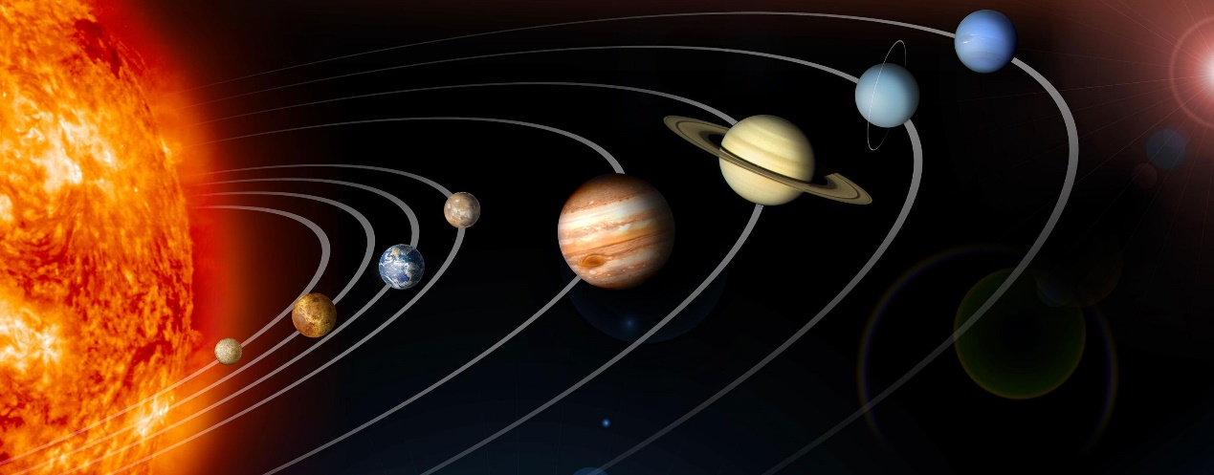

**Colossal** means extremely large or huge. For example, a **colossal** 35,790 km altitude refers to an enormous height.

The answer is by using an incredibly strong and lightweight cable, strong enough to support its own weight and a heavy load. The design of such a cable is still largely theoretical. This would be attached to a base station on earth at one end and a satellite in geostationary orbit (fixed above a point on the equator) at the other. Lift vehicles would then ascend and descend the cable, powered by electromagnetic force and controlled remotely.

Incredibly: exceptionally

Lightweight: very light in weight; not heavy

Support: hold up; bear the weight of, provide assistance

Load: weight

Theoretical: based on ideas, not yet fully realized in practice.

Attached to: fixed

A **base station** is a central location or structure that supports and controls operations for a specific system. In the context of the space elevator, the **base station** is the facility on Earth where the cable is anchored and where lift vehicles would start their journey to space.

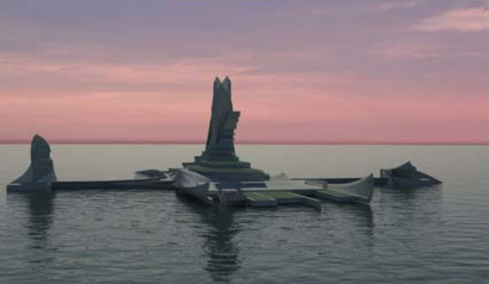

A **geostationary orbit** is an orbit around Earth where a satellite moves at the same speed as the Earth’s rotation. This means the satellite stays fixed over the same point on the Earth’s surface, usually above the equator. This type of orbit is often used for communication satellites because it allows them to maintain a constant position relative to the Earth.



The **equator** is an imaginary line around the middle of the Earth, equidistant from the North and South Poles. It divides the Earth into the Northern and Southern Hemispheres and is located at 0° latitude.

**Lift vehicles** are vehicles designed to carry payloads (such as satellites or astronauts) up and down, typically along a structure like a cable. In the context of the space elevator, **lift vehicles** would ascend and descend the cable, transporting objects into space or bringing them back to Earth. They are powered by electromagnetic force and controlled remotely.

Ascend: climb up

Descend: climb down

**Electromagnetic force** is a fundamental force of nature that causes interactions between charged particles. It is responsible for electric and magnetic fields and their effects, such as attraction or repulsion between objects with electric charge. In the context of the space elevator, **electromagnetic force** would be used to power the lift vehicles, allowing them to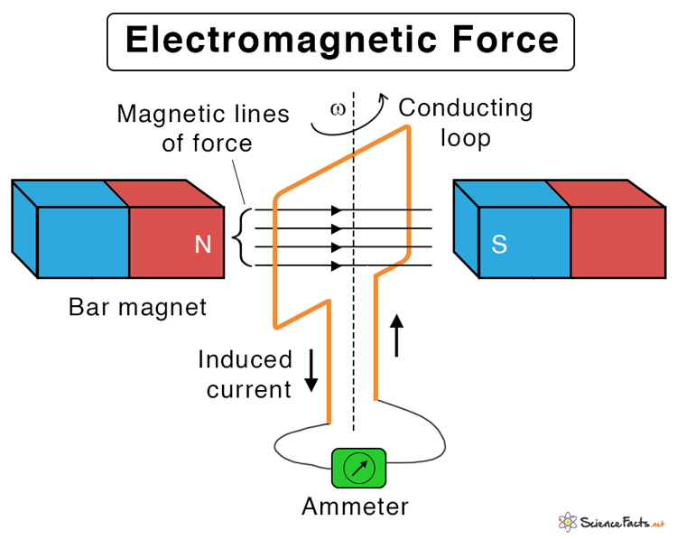 move along the ca ble without physical contact.

Controlled: managed; directed

Remotely: from a distance

**Remotely** means from a distance, without physical presence or direct contact. In the context of the space elevator, **controlled remotely** means that the lift vehicles would be operated and guided from a location far away, such as from Earth, without anyone being physically inside or near the vehicle.

|  |
| --- |
| **C. Match the verbs (l -9) from the text in Exercise 6 b to the definitions (a-i).** |

1. **Connecting**  - **e** joining
2. **Raise**  - **i** lift / make something go up
3. **Transported** - **a** carried (objects, over a distance)
4. **support** - **b** hold something firmly / bear its weight
5. **attached** - **g** fixed
6. **ascend** - **h** climb up
7. **descend**  - **c** climb down
8. **powered** - **d** provided with energy / moved by a force
9. **controlled** - **f** driven / have movement directed