CSCI 4560/6560 Evolutionary Computation

Assignment Number 4: Due 10/28/2024 on elC

Purpose The purpose of this assignment is to demonstrate:

1. The robustness of evolutionary computation in difficult optimization domains with many local optima.
2. The stochastic nature of evolutionary computation (i.e. each run yields a different result.
3. Part 1 [60 points] Consider the following continuous variable optimization problem:

*minimize f* (*x, y*) = (|*x*| + |*y*|) · (1 + |*sin*(|*x*| · *π*)| + |*sin*(|*y*| · *π*)|) *subject to* :

−60 ≤ *x* ≤ 40

−30 ≤ *y* ≤ 70

The objective function surface plot is shown in the figure below.

* 1. Use an Evolutionary Algorithm (Genetic Algorithm or any suitable Evolutionary Computation method of your choice) to find the optimum. Your EA should use no more than 2000 fitness function evaluations (NOT 2000 generations!) every run. Run the EA 10 times (with different random initial populations) and report in a table [25 points] the best point found in each time and give two screenshots. You may download and use an existing EA or implement your own.
  2. Repeat the above experiment and produce a new table [10 points] after you change the function to:

*f* (*x, y*) = (|*x*| + |*y*|) · (1 + |*sin*(3 · |*x*| · *π*)| + |*sin*(3 · |*y*| · *π*)|)

This increases the number of local optima approximately 10 times. You should still use no more than 2000 evaluations in each optimization run.

* 1. Discuss the results comparing the EA’s performance before and after the increase in the number of local optima. How much did the performance suffer due to the increase? [10 points]

You should try to experiment with your EAs to get the best results. In all problems, the global minimum is Zero.

Include your code if you implement your own. If you use a package include the package name and the parts you modified such as the fitness function [10 points] You should also include a brief description of your problem formulation (represen-

tation, parenthood selection, mutation, crossover, survival selection) for each part.

[5 points]

(abs(x)+abs(y))\*(1+abs(sin(abs(x)\*pi))+abs(sin(abs(y)\*pi)))

f(X,Y) 200

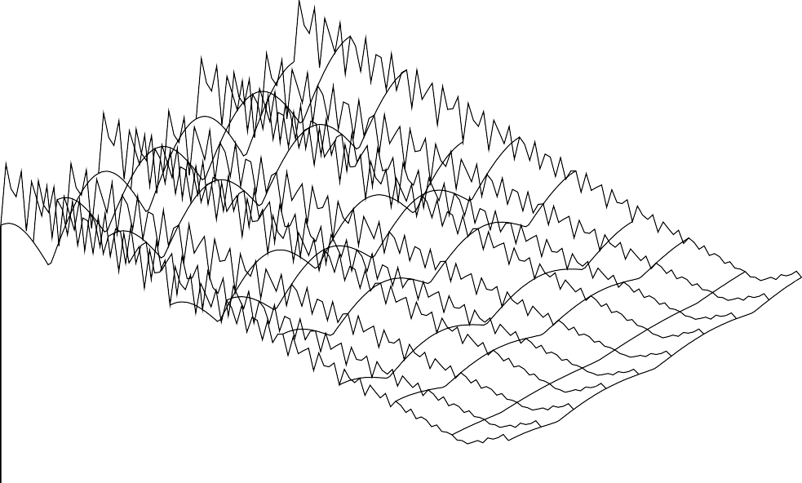

150

100

50

0

-50

-50 -40

-30

X

-20 -10

-1

0 -1.5

0

-0.5

1

0.5

Y

1.5

1. Part 2 [40 points]

Consider Ackley’s function with 30 dimensions and range from -30 to 30 for each dimension. This function is described in the text book page 268. Use an Evolutionary Algorithm to find the optimum. Your EA should use no more than 200000 fitness function evaluations every run. Run the EA 10 times (with different random initial populations) and report in a table [25 points] the best point found in each run and give two screenshots. You may download and use an existing EA or implement your own. You may also use the same EA for this problem that you used for the above problem (and I strongly recommend it because to do otherwise would be a waste of your time) but this is up to you.

You should try to experiment with your EAs to get the best results. In all problems, the global minimum is Zero.

Include your code if you implement your own. If you use a package include the package name and the parts you modified such as the fitness function [10 points]

You should also include a brief description of your problem formulation (representation, parenthood selection, mutation, crossover, survival selection) for each part. [5 points]