MACHINE LEARNING APPROACHES FOR BIOMATERIAL MODELLING
by
DIPTEE MEHTA
(Under the Direction of Dr. Khaled Rasheed)
ABSTRACT

INDEX WORDS:
MACHINE LEARNING APPROACHES FOR BIOMATERIAL MODELLING

by

DIPTEE MEHTA
B.Tech, SNDT University, 2001

A Thesis Submitted to the Graduate Faculty of The University of Georgia in Partial Fulfillment of the Requirements for the Degree

MASTER OF SCIENCE

ATHENS, GEORGIA
2003

© 2003
Diptee Mehta
All Rights Reserved
MACHINE LEARNING APPROACHES FOR BIOMATERIAL MODELLING

by

DIPTEE MEHTA

Major Professor: Dr. Khaled Rasheed

Committee: Dr. Liming Cai
Dr. Don Potter

Electronic Version Approved:

Maureen Grasso
Dean of the Graduate School
The University of Georgia
December 2003

DEDICATION

To my parents
ACKNOWLEDGEMENTS

I would like to thank my advisor Dr. Khaled Rasheed for his constant guidance, patience and advice and for encouraging me throughout my research. Dr. Rasheed has been very generous with his time. I would like to thank Dr. Don Potter and Dr. Liming Cai for being a part of my committee. I would also like to thank my entire family and my friends for their support. A special thanks to my brother Dinesh and my husband Amit for their constant encouragement.

TABLE OF CONTENTS
Page
ACKNOWLEDGEMENTS v
LIST OF TABLES vii
LIST OF FIGURES viii
CHAPTER
1 INTRODUCTION
1.1. MACHINE LEARNING
1.2. BIOMATERIAL MODELLING
1.3. RELATED WORK
1.4. GOALS OF THIS THESIS
2 FEATURE SELECTION
2.1. INTRODUCTION
2.2. GENETIC ALGORITHM AS THE WRAPPER APPROACH
2.3. THE FILTER APPROACH
2.3.1. CORRELATION BASED FEATURE SELECTOR
2.3.2. RELIEF-F FEATURE SELECTOR
2.3.3 PRINCIPAL COMPONENT ANALYSIS
2.3.4. DECISION TREES
3 MACHINE LEARNING ALGORITHMS
3.1. MODEL TREES
3.2. REGRESSION TREES
3.3. NEURAL NETWORKS
3.4. RADIAL BASIS FUNCTION NETWORKS
3.5. LOCALLY WEIGHTED REGRESSION
4 UNCERTAINTY HANDLING
5 IMPLEMENTATION
5.1. GENETIC ALGORITHM
5.2. CORRELATION BASED FEATURE SELECTOR
5.3. RELIEF-F FEATURE SELECTOR
5.4. PRINCIPAL COMPONENT ANALYSIS
5.5. DECISION TREES
5.6. MACHINE LEARNING SCHEMES
6 EVALUATION AND RESULTS
6.1. EVALUATION
6.2. RESULTS
7 CONCLUSION
7.1. CONCLUSION
7.2. FUTURE WORK
REFERENCES
APPENDICES

CHAPTER 1

INTRODUCTION

1.1 MACHINE LEARNING

A popular definition of learning is "Any change in a system that allows it to perform better the second time on repetition of the same task or on another task drawn from the same population" (Simon, H 1983). According to this definition, the most important feature of a learning system is its improvement in performance or skill refinement. In living systems this is achieved through experience. Machine Learning is the study of computer algorithms that improve performance automatically through experience. So to improve performance it has to improve its prediction capability.

At the heart of performance is prediction. An algorithm that—when presented with data that exemplifies a task—improves its ability to predict key elements of the task can be said to have learned. So machine learning can be thought of as a search through a space of possible hypotheses for one that fits the given data. The input to a machine learning algorithm takes the form of concepts, instances and attributes. The thing to be learned is called a concept description, the information that the algorithm is given takes the form of a set of instances. So each instance is an independent example of the concept to be learned. Each instance is characterized by the values of attributes or features that measure different aspects of the instance.

Based on the training data provided, machine learning can be broadly of two types: supervised and unsupervised learning.
The supervised learning notion is very much similar to learning from labeled examples. After defining classes, a number of positive and negative examples of objects belonging to these classes are provided to the learning system. The system is then to find out common properties of the different classes, and what separates them, in order to make correct classification for other objects. This is called classification learning. If the learning system has to predict a numeric quantity based on the given examples and their numerical outcomes, it is called numeric prediction. Both classification learning and numeric prediction are types of supervised learning.
In the case of unsupervised learning, no classes are defined a priori. Thus, the system itself must find some way of clustering the objects into classes, and also find descriptions for these classes. This type of learning is also called association learning.
This thesis concentrates on supervised type of learning.

  - BIOMATERIAL MODELLING

Biomaterials are defined as “A biocompatible material that is used to construct artificial organs, rehabilitation devices, or prostheses and replace natural body tissues.”

Biomaterials are employed in plastic and reconstructive surgery, used to make the tools needed to examine the human body, and are expected to improve the deficiency of an organ. Hence, biomaterials must be biologically compatible with the organism and need to integrate well with the body tissue. Dental crowns and contact lenses that we see in our everyday life use biomaterials.

Polymers are very widely used as biomaterials. In implant applications, typically involving tissue regeneration, adsorption of protein to these polymer surfaces is critical in cell attachment and hence a major determinant of the suitability of the material (Magnani, A 2002). There are several techniques for modeling protein adsorption. But conducting these experiments is computationally expensive and these methodologies do not provide details concerning the molecular-scale properties of biomaterials relevant to protein/surface interactions. So a semi empirical model for selecting the materials for detailed studies would be very useful and helpful.

Applying machine learning techniques to predict the amount of protein adsorption on polymer surfaces would then lead to making a selection of materials which could further be analyzed and tested in detail. The polyarylate library, that forms the training dataset for the machine learning algorithms, has been developed by Fiordeliso et al . Each polyarylate is described with the help of 108 molecular-level descriptors of polymer chain structure.

1.3 RELATED WORK

1.4 GOAL OF THIS THESIS

This thesis aims at applying machine learning techniques to predict the amount of protein adsorption in biomaterials based on their molecular and chemical properties. Each biomaterial is described with the help of 108 descriptors and the amount of different proteins adsorbed by it. The number of training examples is very less. Feature subset selection can dramatically improve the performance of a machine learning algorithm. So coming up with the right number and the right feature subset for a machine learning algorithm is very important.

Also, the actual value of the protein adsorption of the training examples is based on the outcomes of several experiments and hence this problem domain has uncertainty in the values of the target attribute. Any machine learning algorithm needs to avoid over fitting or under fitting of the data and should be evaluated on the basis of its ability to predict unseen data not involved in the training process.

Specifically, the objectives of this thesis were:
- Analyzing the data and coming up with the right feature subset using different methods.
- Finding the machine learning algorithms that would be useful in the problem domain of biomaterial modeling.
- Implementing the proposed machine learning algorithms.
- Evaluating the ability of the proposed machine learning algorithms to handle uncertainties in the data.
- Evaluating the predictive accuracy of the proposed machine learning models on the basis of their ability to predict unseen data not involved in the training process.

CHAPTER 2

FEAture selection

2.1 INTRODUCTION

For a prediction problem, the number of independent pieces of information that go into the estimate of a parameter is called the degrees of freedom (df). Degrees of freedom is defined as the number of independent components (number of instances) minus the number of parameters estimated (number of attributes or features). When the number of variables in a dataset is larger than the number of observations or instances, this dataset is said to lack degrees of freedom and thus is over-fit. So degrees of freedom is the number of pieces of useful information in the dataset.

In the biomaterials dataset, each polymer is described with the help of 102 attributes and the number of polymers in the dataset is around 70. So in this case, we have negative degrees of freedom (70 -102). Thus feature subset selection is very important for this problem. By doing feature selection, we can identify the most salient features for learning and the machine learning algorithm could then focus on those aspects of the data most useful for analysis and prediction. The benefits of feature selection for learning can include a reduction in the amount of data needed to achieve learning, improved predictive accuracy, learned knowledge that is more compact and easily understood, and reduced execution time.

Feature subset selection algorithms fall into two broad categories: One is to make an independent assessment of the feature subset based on the general characteristics of the data and the other is to assess the subset using the machine learning algorithm that will be used on the data. The former approach is called a filter approach because the irrelevant attributes get filtered out and the filtered data is then presented to the machine learning algorithm. The latter approach is called a wrapper approach, because the machine learning algorithm is involved and wrapped in the feature selection process.

  - GENETIC ALGORITHM AS THE WRAPPER APPROACH

Feature subset selection involves searching the space of all possible feature subsets to find the subset that gives the optimal performance for a machine learning algorithm. The number of possible attribute subsets increases exponentially with the number of attributes, making exhaustive search impractical even for problems with small number of features. Genetic algorithms, developed by Holland, are a form of inductive learning strategy and have proven to give substantial improvement over several random and local search methods. So they would be very ideal to be used for feature subset selection for biomaterial modeling.

Genetic algorithms
Genetic algorithms are a class of algorithms that imitate natural selection and genetics. A genetic algorithm has five main components: representation of a solution (or individual), genetic operators i.e. crossover and mutation operators, selection of individuals for mating or parent selection strategy, a fitness function and replacement of the individuals.

Genetic algorithms start by maintaining a population of solutions, also called individuals. Each individual is represented by a genetic string and is associated with a fitness value, which represents the quality of the solution or the individual. The concept that fittest (or best) individuals in a population will produce fitter offspring is then implemented in order to reproduce the next population by using genetic operators like mutation and crossover on the individuals of the population.

The crossover operator takes two selected individuals and combines them about a crossover point thereby creating two new individuals. The new individual generated gets some portion of its genes from each of its parent.

The mutation operator randomly modifies the genes of an individual introducing further randomness into the population and leading to exploring new areas of the search space of all possible solutions.

There are two flavors of genetic algorithms based on the replacement strategy: Steady state genetic algorithms and generational genetic algorithms.

  - THE FILTER APPROACH

This approach is also called unsupervised feature selection as the feature selection process is done independently of the machine learning algorithm to be applied. Some of the filter approaches only give the ranking of the attributes and the optimal number of attributes to be used for learning is left to the user. In such cases, different values for the number of attributes were tried. The following filter approaches for feature selection were tried in the problem of biomaterial modeling:

2.3.1 CORRELATION BASED FEATURE SELECTOR

It is a filter approach for feature selection that uses a correlation based heuristic to evaluate the merit of features. It gives the optimal feature subset using a search algorithm. The hypothesis on which feature selection is based as follows (Hall, M 1999): “Good feature subsets contain features highly correlated with (predictive of) the class, yet uncorrelated with ( not predictive of) each other.”

The following equation formalizes the heuristic.
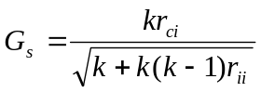
Where k is the number of features in the subset, r_{ci} is the mean feature correlation with the class and r_{ii} is the average feature intercorrelation and Gs is the goodness of a feature subset.

So in this method irrelevant features will be filtered out as they will be poor predictors of the class and redundant features will be filtered out as they will be highly correlated with some other features. In this method a way to measure the feature-feature correlation and feature-target class is needed and we need to decide on some method for searching the space of feature subsets.

Different information based measures of association were tried for feature-feature and feature-class correlations. Best results were achieved by using the gain ratio for feature-class correlations and symmetrical uncertainty coefficient for feature intercorrelations. All the continuous features were converted to nominal by binning before proceeding with the correlation calculations. If the target value in the dataset was a continuous value, that was also converted into a nominal value by binning.

The information gain, Gain(S,A) of an attribute A relative to a collection of examples S is defined as

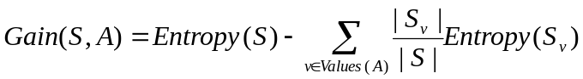
Where Values(A) is the set of all possible values for attribute A and Sv is the subset of S for which attribute A has value v.
Here the entropy is the purity or impurity of a collection of samples and is defined as

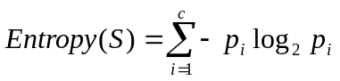

Where p_{i} is the proportion of S belonging to class i.

Information gain is biased in favor of attributes with more values. The gain ratio (Quinlan, J, 1986) is a measure that tries to compensate for this bias.
The gain ratio, GainRatio(S,A) of an attribute A relative to a collection of examples S is defined as
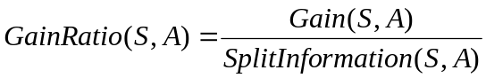
Here SplitInformation is the term that decreases the value of GainRatio for attributes with many uniformly distributed values and is defined as
_
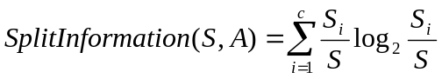
where S₁ through S_{c} are the c subsets of examples resulting from partitioning S by the c-valued attribute.

Symmetry is a desirable property for a measure of feature-feature intercorrelation to have.
For a nominal feature Y, a probabilistic model can be formed by estimating the probabilities of the different values of Y from the training data. If this model is used to predict the value of Y for some other instance, then the entropy of this model and hence the attribute is

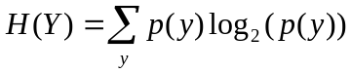
If the observed values of Y in the training data are partitioned according to the values of a second feature X, the entropy of Y after observing X is given by

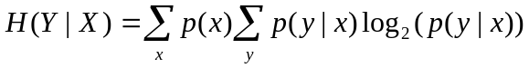
The amount by which the entropy of Y decreases reflects additional information about Y provided by X. This is again biased for features with greater number of values. Symmetrical uncertainty coefficient (Press W, 1998) is a measure that tries to compensate for the bias in information gain and normalizes its values in between 0 and 1 and is defined as follows

Both gain ratio and symmetrical uncertainty coefficient lie between 0 and 1. A value of 0 for gain ratio indicates that the particular feature is a poor predictor of the class and a value of 1 indicates that it is a very good predictor of the class. Similarly a value of 0 for symmetrical uncertainty coefficient indicates that the two features have no correlation and a value of indicates that the knowledge of one completely predicts the other.

Searching the space of all feature subsets in an exhaustive way is impractical for most of the problems as the number of possible feature subsets increases exponentially with the number of attributes. Various heuristic search strategies such as hill climbing and Best First (Rich and Knight, 1991) are often applied to search the feature subset space in a reasonable amount of time. Two forms of hill climbing: forward selection and backward elimination can be used. In forward selection, we start with no attributes and add them one at a time and in backward elimination, we start with the full set and delete attributes one at a time. Whenever an attribute is added or removed, the resulting feature subset is evaluated using the above discussed measure. In forward selection, the effect of adding each possible attribute to the subset is evaluated and the one with the best evaluation is chosen and the search continues. The same thing is done analogously in backward elimination. However if no attribute addition or deletion produces an improvement, the search ends. In best first search we start with an empty set of features and generate all possible single feature expansions. The subset with highest evaluation is chosen and is expanded in the same manner. If expanding a feature subset does not result in an improvement, it revisits the best unexpanded feature subset and proceeds the search from there. To prevent it from doing an exhaustive search, it is common to limit the number of subsets expanded that result in no improvement.

    - RELIEF-F FEATURE SELECTOR

RELIEF is a feature selection method found by Kira and Rendell. It produces a ranking of all the attributes. The basic idea is to measure the relevance of features in the neighborhoods around target samples.

The original algorithm of RELIEF( Kira & Rendell, 1992) is the following

Set all weights W[A]= 0.0
For i = 1 to m do
Begin
Randomly select an instance R;
Find nearest hit H and nearest miss M
For A = 1 to all_attributes do
W[A] = W[A] – diff (A, R, H)/m + diff (A, R, M )/m
End

Where diff(Attribute, Instance1, Instance2 ) calculates the difference between the values of Attribute for two instances.

For discrete attributes
Diff (Attribute, Instance1, Instance2) = 0 if val (Attribute, Instance1) = val (Attribute, Insatcne2)
Diff (Attribute, Instance1, Instance2) = 1 if val (Attribute, Instance1) != val (Attribute,Instance2)

For continuous attributes
Diff(Attribute,Instance1,Instance2)=[val(Attribute,Instance1)val(Attribute,Instance2)]/RangeOfAttribute

We divide this with the value of m , so that all the weights are in the interval of [-1,+1] .
If the training set is small, instead of using only m instances, the same procedure can be repeated for all the instances. The larger the value of m, the more reliable approximation we get.

The original RELIEF described above can deal with both discrete and continuous attributes, but is limited to only two class problems.

The basic algorithm was extended by Kononenko to deal with multi-class and continuous prediction problems. The extended algorithm called ReliefF is more robust to incomplete and noisy data. Instead of finding a single nearest hit and a single nearest miss, ReliefF finds k nearest hits and k nearest misses and averages their contribution to W[A].

Thus relevant features start accumulating high positive weights and less relevant features retain their weight close to zero.

In continuous prediction problems, the notion of nearest hits or nearest misses cannot be used as the value to be predicted is not divided into discrete classes, but is a continuous value. So the probability that the predicted values of two instances are different is used. This probability is modeled with the relative distance between the predicted values of two instances.

The modified ReliefF algorithm (Sikonja & Konenko, 1997) is as follows:

Set all N_{dC} ,N_{dA}[A] ,N_{dC&dA}[A], W[A] to 0
For i = 1 to m do
Begin
Randomly select instance Ri
Select k instances I_{j} nearest to R_{i}.
For j=1 to k do
Begin
N_{dC} = N_{dC} + |f( R_{i} )- f( I_{j} )| .d(i,j)
For A = 1 to allAttributes do
Begin
N_{dA}[A] = N_{dA}[A] + diff (A, R_{i}, I_{j} ) .d(i, j)
N_{dC&dA}[A] = N_{dC&dA}[A] + |f( R_{i} )–f( I_{j} )|.diff (A,R_{i},I_{j}).d(i,j)
End
End
End
For A=1 to allAttributes do
W[A] = N_{dC&dA}[A] / N – (N_{dA}[A}-N_{dC&dA} [A]) / (m-N_{dC} )

In the above algorithm, N_{dC} stands for the probability that two instances have different prediction or different class, N_{dA} stands for the probability that two instances have different values for attribute A , N_{dC&dA} stands for the probability that two instances have different prediction and have different values for the attribute A, f(instance1) is the prediction or the target value for instance1 and d(i,j) is the distance between two instances whose indexes are i and j.

2.3.3 PRINCIPAL COMPONENT ANALYSIS

Feature selection could also be done by grouping of attributes or features into clusters. Associated with each cluster is a linear combination of the variables in the cluster. So we would effectively have to use lesser number of features, one for each of the cluster. The original large number of features would be transformed into a lesser number of features. Principal component analysis can be used for this purpose. Principal Component Analysis is a way of identifying patterns in data and expressing the data in such a way as to highlight their similarities and differences. Once these patterns are found in the data, we can compress the data, without much loss of information.

The main steps in performing principal component analysis are as follows:
a) After getting the data, calculate the mean value for each of the features. We then have to subtract this mean from the attribute values for all the instances. This produces a dataset whose mean is zero.

b) The next step is to calculate the covariance matrix. If we have n features, we get a n X n covariance matrix. The (i,j) th element of this matrix denotes the covariance between feature i and feature j. Covariance is a measure to find out how much the two features vary from the mean with respect to each other. It is calculated with the help of the following formula

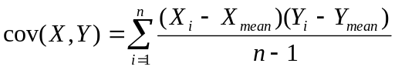
Where Xi is the value of the attribute X for instance i, Yi is the value of the attribute Y for instance i, Xmean is the mean of attribute values of X for all the instances, Ymean is the mean of attribute values of Y for all the instances and n is the number of instances in the dataset.
The exact value of it is not as important as its sign (i.e. positive or negative). If the value is positive, then the values for both the features increase together. If the value is negative, then as the value for one feature increases, the other decreases. If the value is zero, it indicates that the two features are independent of each other. Since cov(X,Y) is same as cov(Y,X), the covariance matrix is symmetric about the main diagonal.

c) We then have to calculate the eigenvectors and eigenvalues of the covariance matrix. Eigenvectors can be found only for square matrices and are always perpendicular to each other. So by this process of taking the eigenvectors, we are able to express the data in terms of these perpendicular eigenvectors.

d) We now have to transform the data using the eigenvectors and eigenvalues found in the previous section. After finding the eigenvectors we have to order them by eigenvalues highest to lowest, which gives us the components in order of significance. By ignoring the components of lesser significance, we get the final dataset with reduce number of features.

e) The final step is transforming the dataset using the components selected in the earlier step. We first form a matrix with the selected eigenvectors placed in the rows, the most significant eigenvector at the top. This matrix is then multiplied on the left with the mean-adjusted dataset transposed (each row holding values for a feature).

    - DECISION TREES

Machine learning schemes can also be used for feature selection. So decision trees were first applied to the full dataset and only the attributes occurring in the top portion of the tree were selected for use by other machine learning schemes. In this scheme the user has to determine how many attributes to be selected from the top portion of the decision tree.

Decision tree learning is a method for approximating discrete valued target functions, in which the learned function is represented by a decision tree. To classify an unseen instance, the tree is followed down to a leaf and the classification at that leaf is assigned to the unseen instance. Decision tree algorithms follow a top-down, greedy search through a space of possible decision trees. They are based on the divide-and conquer strategy. Nodes in a decision tree involve testing a particular attribute. Leaf nodes give a classification that applies to all instances that reach the leaf.

The algorithm of constructing a decision tree can be expressed recursively. We first select an attribute to place at the root node and make one branch for each possible value. This spits up the example set into subsets, one for every value of the attribute. We then repeat the process recursively for each branch, using only those instances that actually reach the branch. When all instances at a node have the same classification, we stop developing that part of the tree.

The most important part is selecting which attribute to test at each node in the tree. A statistical property called information gain is used for this purpose.
The information gain, Gain(S,A) of an attribute A relative to a collection of examples S is defined as

Where Values(A) is the set of all possible values for attribute A and Sv is the subset of S for which attribute A has value v.
Here the entropy is the purity or impurity of a collection of samples and is defined as
Where Pi is the proportion of S belonging to class i.

The information gain measure described above has one drawback; it tends to select attributes with larger number of possible values. A measure called gain ratio (Quinlan, J, 1986) compensates for this bias. The gain ratio, GainRatio(S,A) of an attribute A relative to a collection of examples S is defined as
Here SplitInformation is the term that decreases the value of GainRatio for attributes with many uniformly distributed values and is defined as
_
where S1 through Sc are the c subsets of examples resulting from partitioning S by the c-valued attribute.

CHAPTER 3

MACHINE LEARNING ALGORITHMS

We tested the following machine learning algorithms for biomaterial modeling

3.1 MODEL TREES

Model trees are decision trees with linear regression functions at the leaf nodes instead of terminal class value. So they are a useful approach for predicting numeric quantities. Model trees are particularly useful when most of the attributes are numeric. The M5 algorithm (Quinlan, J, 1992) proposed by J. R. Quinlan for model trees is described below. When a model tree is used to predict the target value for an unseen instance, the tree is followed down to a leaf in the same way as in a decision tree, using the instance’s attribute values to make routing decisions at each node. The leaf will contain a linear model based on some of the attribute values, and this is evaluated for the test instance to yield a predicted value. But instead of using this value directly a smoothing process is used to compensate for the sharp discontinuities that will inevitably occur between adjacent linear models at the leaves of the pruned tree, particularly for some models constructed from a smaller number of training examples.
Smoothing can be accomplished by producing linear models for each internal node, as well as for the leaves, during the time the trees is built. A linear model is created at each node of the tree, using standard regression techniques, but using only the attributes that are tested in the sub tree below this node. Then, once the leaf model has been used to obtain the raw predicted value for a test instance, that value is filtered along the path back to the root, and is combined with the value predicted by the linear model for that node.
To combine the values at all nodes, the following smoothing calculation is used
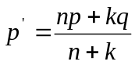
where p' is the prediction passed up to next higher node, p is the prediction passed to this node from below, q is the value predicted by the model at this node, n is the number of training instances that reach the node below, and k is a smoothing constant (default value=15, By Quinlan). Experiments show that smoothing substantially increases the accuracy of predictions. Model trees can have multivariate linear models at the leaves and therefore resemble piecewise linear functions.
Model trees, like the decision trees are constructed by the divide-and-conquer approach. The set of training examples, T is either associated with a leaf, or some test is chosen that splits T into subsets corresponding to the test outcomes and the same process is applied recursively to the subsets.
The first step in building the tree is computing the standard deviation of the target values of the training examples in T. This is used as a measure of the error at that node. We then calculate the expected reduction in this error as a result of testing an attribute at that node. The attribute which maximizes the expected error reduction is chosen for splitting at that node.
The expected error reduction, also called standard deviation reduction (SDR), is calculated by,

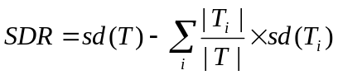
Where T₁, T₂,.. are the sets that result from splitting the node according to the chosen attribute.
The splitting process terminates when the target values of the instances that reach a node vary only slightly, or when just a few instance reach the node.

3.2 REGRESSION TREES
Regression trees may be considered as a variant of decision trees, designed to approximate real-valued functions instead of being used for classification tasks. They were developed by Breiman (Breiman , 1984).
The inner nodes of regression trees are marked with tests as in decision trees.
The difference is, that the leaves of regression trees may be marked with arbitrary real values, whereas in decision trees the leaves may only be marked with elements of a finite set of nominal values. So the leaves in a regression tree do not contain a nominal value, but contain a numeric value which is the average of all the training set values that reach that leaf. The term regression means computing an expression that predicts a numeric quantity. So the decision trees with averaged numeric values at the leaves are called regression trees.
Decision trees do not contain a nominal value, but contain a numeric value which is the average of all the training set values that reach that leaf. The term regression means computing an expression that predicts a numeric quantity. So the decision trees with averaged numeric values at the leaves are called regression trees.
Regression trees are built the same way as model trees, but the linear regression step at the leaves is omitted and the target value at the leaf is taken to be the average target value of the training examples that reach this leaf.
3.3 NEURAL NETWORKS

Artificial neural networks is a common method used for predicting numeric quantities. The back propagation algorithm is the most commonly used Artificial Neural Networks learning technique.
The multilayer networks learned by the Back propagation algorithm are capable of expressing a rich variety of non linear decision surfaces. The sigmoid unit forms the basic unit of multilayer networks.
A sigmoid unit is a type of threshold unit that has a smooth threshold function, rather than a step function. This unit takes as input the weighted sum, S, of the values coming from the units connected to it. The function inside sigmoid units calculates the following value, given a real-valued input S:
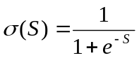
The advantage of the sigmoid transfer function is that it is differentiable. This makes it suitable for use in multi-layer networks.

Multilayer networks are formed by connecting several sigmoid units together. The attribute values of the training examples is applied to the input layer and the output layer gives the output of the whole network. In addition to these input and output layer, there are hidden layers. The following figure shows two neural networks, one which has a single hidden layer and the other which has two hidden layers.
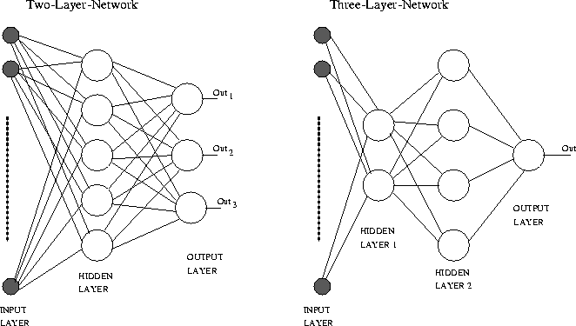

The Backpropagation algorithm
The task of the algorithm is to learn a multilayer ANN to correctly categorize the unseen examples. The training occurs in a supervised style. The basic idea is to present the input vector to the network; calculate in the forward direction the output of each layer and the final output of the network. For the output layer the desired values are known and therefore the weights can be adjusted as for a single layer network; in the case of the BP algorithm according to the gradient decent rule. To calculate the weight changes in the hidden layer the error in the output layer is back-propagated to these layers according to the connecting weights. This process is repeated for each sample in the training set. One cycle through the training set is called an epoch. The number of epoches needed to train the network depends on various parameters, especially on the error calculated in the output layer.

  - LOCALLY WEIGHTED REGRESSION

Locally weighted regression is a type of instance based method. Learning in these algorithms consists of simply storing the presented training data. When a new query instance is encountered, a set of similar related instances is retrieved from memory and used to classify the new query instance. Such methods are also known as lazy learning methods, because they delay the processing until a query instance has to be classified.

Locally weighted regression attempts to approximate a real valued target function over a local region surrounding a query instance. The method is called “locally weighted regression” as it tries to approximate the function based only on data near the query point i.e. “local”, it weighs the contribution of each training example from the query point by its distance i.e. “weighted” and it is trying to approximate real-valued function, i.e. “regression”.

Given a new query instance, the general approach in locally weighted regression is to find the training examples in the neighborhood of the query instance based on some distance measure and then constructing an approximation that fits this neighborhood surrounding the query instance. While constructing an approximation, it weights the training instances according to their distance to the query instance. Thus, training instances close to the test instance receive a high weight and those far away a low one. The approximation is then used to calculate the target value for the query instance.

In order to use locally weighted regression, it is necessary to decide upon a distance based weighting scheme for the training instances. A common choice for finding the distance between instances is the Euclidean distance. There are several choices for the weighing function also. The requirements of a good weighing function are (Atkeson, 1996): The maximum value of the weighting function should be at zero distance and the function should decay smoothly as the distance increases. Some of the commonly used weighing schemes are as follows:
- Inverse: This weighting function is as follows
K(d)= 1 / (1 + d^{p} )
Here p decides how local the regression will be and d is the distance between two instances.
- Gaussian: The weighting function is as follows
K(d) = exp(-d² )
Here d is the distance between two instances.

The selection of a “smoothing parameter” that is used to scale the distance function is critical. The smoothing parameter defines the scale or range over which generalization is performed. If it is set to a small value, only instances very close to the query instance will receive significant weight; if it is large, more distant instances will also have a significant impact on the model.

  - RADIAL BASIS FUNCTION NETWORKS

Radial basis function networks (RBF networks) are an interesting bridge between instance-based and neural network learning algorithms. In this approach the learned hypothesis is a function that is a linear combination of a set of m fixed functions, often called basis functions. It is of the following form:
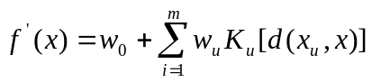
The flexibility of f’, its ability to fit many different functions, derives only from the freedom to choose different values for the weights. The basis functions and any parameters that they might contain are fixed. If the basis functions move or change, the radial basis function network is non-linear.

The basis function is defined so that it decreases as the distance d(x_{u} ,x) increases. So even though f’(x) is a global approximation to f(x), the contribution from each of the basis functions is localized to a region nearby the point x_{u}. It is common to choose each of the basis function to be a Gaussian function centered at point x_{u} with some variance σ_{u}².

Radial basis function networks have been traditionally associated with radial functions in a single-layer network as shown in the figure. Each attribute of the instances in the training data feed forward to the m basis functions whose outputs are linearly combined with weights into the network output f(x).

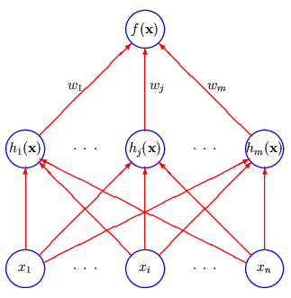

Given a set of training instances of the target function, RBF networks are trained in a two-stage process. In the first stage the number m of hidden units or basis functions is determined and each hidden unit is defined by choosing the values of x_{u} and σ_{u}². In the second stage the network is trained and the weights are determined to maximize the fit of the network to training data and minimizing the squared error between the actual and predicted values of the target attribute.

The number of basis functions can be kept less than the number of training examples. Clustering is applied to instances to identify group of similar instances and a basis function can be added centered at each cluster. Thus training in the RBF networks is done in two stages.

CHAPTER 4

UNCERTAINTY HANDLING

The dataset used by the machine learning schemes consisted of several polymers. Each polymer was described with the help of 108 descriptors and the average and standard deviation values for amount of protein adsorption. The average values were given for the target attributes as there is lot of experimental uncertainty in this problem domain. So all the machine learning results should be robust to this uncertainty in the data. In order to take this into account, the following approach was used: Several datasets were generated by varying the value of fibrinogen adsorption measured for each polymer in a random fashion, but within a normal distribution defined by the experimental mean and standard deviation. The machine learning schemes were tried with all these datasets to find the sensitivity of the machine learning scheme to the uncertainty in the measurements of the data.

CHAPTER 5

IMPLEMENTATION DETAILS

5.1 GENETIC ALGORITHM AS THE WRAPPER APPROACH

A genetic algorithm was written in JAVA whose details are given below:
Representation
Each individual in a genetic algorithm is a solution to the problem. We are using genetic algorithm to find the best feature subset for a given machine learning scheme and for a given number of features. So each individual is a subset of features and is represented by an array of floating point numbers. The length of the array is equal to the total number of features i.e. 108. Each number in this array can take a value between 0 and 1. If we are using the genetic algorithm to find the best feature subset containing say 10 features, the 10 largest numbers from the array is selected and the features corresponding to these will form the feature subset. If we are using the genetic algorithm to find the best feature subset containing 20 features, the features corresponding to the 20 largest numbers are used. Different values for the number of features was tried to find the best feature subset giving the most optimal performance.

Parent selection strategy
Tournament selection strategy is used for this purpose. In this method, two individuals are first randomly selected from the population and the fitter of the two is selected as the first parent. The same procedure is repeated for selecting the second parent, taking care that both the parents selected are distinct individuals in the population.

Crossover operators
Two crossover operators are used. At every iteration, heuristic crossover was used with a probability of 20% and whole arithmetic recombination otherwise.
Heuristic crossover
This operator (Wright, A, 1991) is a bit greedy. It takes the fitness of the parents into account and tries to generate the new individual in the vicinity of the better individual. Suppose X and Y represent the two individuals and x’ and y’ represent the floating point array of the two individuals respectively. Then the child is generated as follows:
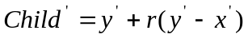
Here r is a uniform random variable between 0 and 1.
Whole arithmetic recombination
This operator (Schwefel, 1981) creates the child by taking the weighted sum of the two parents for each gene.
Suppose X and Y represent the two individuals and x’ and y’ represent the floating point array of the two individuals respectively. Then the child is generated as follows:
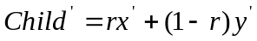
Commonly, r is a uniform random variable between 0 and 1. But with this approach there is no way to get beyond the maximum and minimum values present in the initial population. That’s why we are taking r as a uniform random variable between -1 and 2. By doing so we are no longer restricted by the convex hull.
Mutation operators
A mutation operation is followed on every child generated by the crossover operator. A random number between 0 and length of the floating point array is selected. The floating point number at this position undergoes mutation. An adaptive non-uniform mutation (Michalewicz, 1994) was used. This mutation operator is adaptive in the sense that, it is uniform in the first iteration and the change is zero in the last iteration. Thus as the number of iterations increase, it shrinks the range from which values are drawn.
Suppose x_{i} is the floating point number that we wish to mutate. It is then replaced by x_{new} which is calculated as follows:
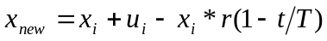
Where r is a uniform random variable between 0 and 1, t is the current iteration, T is the maximum number of iterations, u_{i} is the upper limit of the range of values that x_{i} can take. In our case, it is equal to 1.
Replacement strategy
A steady state genetic algorithm was used. In order to maintain diversity, similarity based replacement was used. But the most similar individual to the individual being newly introduced could be the fittest individual. So we are replacing the most similar individual from the one-fourth of the worst population.
Fitness evaluation function
We are using genetic algorithm as a wrapper approach for feature selection. In the wrapper approach, the usefulness of a feature subset is evaluated with the help of a machine learning scheme that will be used for learning. Each individual in the population is a feature subset. So the fitness of the individual is calculated by evaluating the machine learning scheme using only those features. To evaluate a machine learning scheme, 10 tenfold cross-validations are performed and the correlation coefficient is averaged over all runs. So higher the correlation coefficient, fitter is the individual.
Initialization
As each individual is an array of floating point numbers between 0 and 1, the initial population of 500 individuals is created by randomly generating floating point numbers in the range 0 to 1.
Stopping Criterion
The genetic algorithm is allowed to run for 10000 iterations.

5.2 RELIEF-F FEATURE SELECTOR

An implementation of the Relief-F feature selector is available as a part of weka-3-4 package. Both equal influence nearest neighbors and weighted nearest neighbors was tried. The number of nearest neighbors used was 10. A ranking of all the attributes in the dataset was obtained. The number of features to be used from this ranking was also to be decided. Different values for the number of features for both the above mentioned options were tried.

5.3 CORRELATION BASED FEATURE SELECTOR

An implementation of the Correlation based feature selector is available as a part of the weak-3-4 package. The search method for searching the feature subset had to be specified as a user defined parameter. Experiments were done using forward selection, backward elimination and best first as the search methods and results were obtained. This feature selector produces an optimal feature subset.

5.4 PRINCIPAL COMPONENT ANALYSIS

An implementation of Principal Component Analysis is available as a part of the weak-3-4 package. This method transforms the original feature space into a new reduced feature space. This new reduced feature space was then used by the different machine learning schemes and results were obtained.

5.5 DECISION TREE

The See5 program written by J.R Quinlan was used as the decision tree learning software. In biomaterial modeling, we are trying to predict the amount of protein adsorption, which is a continuous value. So it was necessary to discretize the target attribute of the training examples. So the range of the target attribute was divided into 6 bins. The range of these bins was decided with the help of two methods:
- Equal-interval-binning
In this method, all the bins had equal range. This method often distributes the instances unevenly.
- Equal-frequency-binning
In this method, all the bins have almost equal number of instances in them. But the range for each of the bin would be different.
After the discretization of the target attribute, the program was run to get a decision tree. The winnowing option was used which discards the irrelevant attributes before constructing the decision tree. After the decision tree is created, global pruning was applied that looks at the tree as a whole and prunes relatively weaker sub trees. The attributes occurring in the globally pruned decision tree were then used as the result of this feature selection method.

5.6 MACHINE LEARNING SCHEMES

The machine learning algorithms used in this thesis are: Regression trees, model trees, radial basis function networks, neural networks and locally weighted regression. The implementations for these machine learning schemes are available in the WEKA package provided by the department of Computer Science at University of Waikato, New Zealand. All the machine learning schemes available in Weka are written in Java and is a open source software issued under the GNU General Public License.

CHAPTER 6

EVALUATION AND RESULTS

6.1 PERFORMANCE EVALUATION OF A MACHINE LEARNING SCHEME

Performance evaluation of a machine learning scheme is a very important issue for comparing the performance of different machine learning schemes as well as in the evaluation of an individual of the population in the genetic algorithm based approach of feature selection. To evaluate a machine learning scheme, we have to predict the error rate of the learning technique given a fixed sample of data. If the performance is tested on the same dataset that was used for training, an over optimistic performance measure will be obtained. Hence the performance of the learning scheme should be tested on the dataset that did not take part in the training process. Since we had limited data, testing was done using tenfold cross validation. The data is divided randomly into approximately 10 equal parts. Each part is held out in turn and the learning scheme trained on the remaining nine-tenths, then its error rate is calculated on the holdout set. The ten error estimates are averaged to yield an overall error estimate. A single tenfold cross-validation might not be enough to get a reliable error estimate. Different tenfold cross-validation experiments with the same learning scheme and dataset often produce different results, because of the effect of random variation in choosing the folds themselves. To get an accurate error estimate, the tenfold cross-validation procedure is repeated ten times and the results are averaged. In order to compare the performance of the different machine learning schemes, it is necessary that the results be obtained on the same partitions of the datasets. So the same folds in all the cross-validations are used by all the learning schemes and for all the feature subsets.

Different measures of the error estimate could be used. We have selected to use correlation coefficient. It is defined as measure of the degree to which the actual and the predicted values of the target attribute tend to move together. The coefficient has a value between plus and minus 1, which indicates the strength and direction of association. It takes a value between -1 and +1. A value of 0 means that there is no correlation between the actual and the predicted values, a value of +1 means that the results are highly correlated and a value of -1 means that the results are negatively correlated.

  - FEATURE SELECTION RESULTS

Both filter based and wrapper based approaches of feature selection were tried. The feature subset obtained by a feature selection method was used by all the machine learning schemes and the results thus obtained were compared. To obtain a fair comparison of the results, the same folds were used by all the machine learning schemes.
We begin by comparing the feature selection methods that produce a ranking of the features with the genetic algorithm based approach. Relief-F and decision trees are such feature selection methods. Relief-F was tried with both the options: equal influence nearest neighbors and weighted nearest neighbors and the number of nearest neighbors used was set to 10. With decision trees, it was consistently found that equal interval binning gave better results than equal frequency binning and hence the attributes obtained by the equal interval binning were tried with different machine learning schemes. Different number of features was tried for each of the above mentioned feature selection method and for each machine learning scheme and the results are depicted below. The X axis denotes the number of features used and the Y axis denotes the correlation coefficient obtained by the machine learning scheme involved.

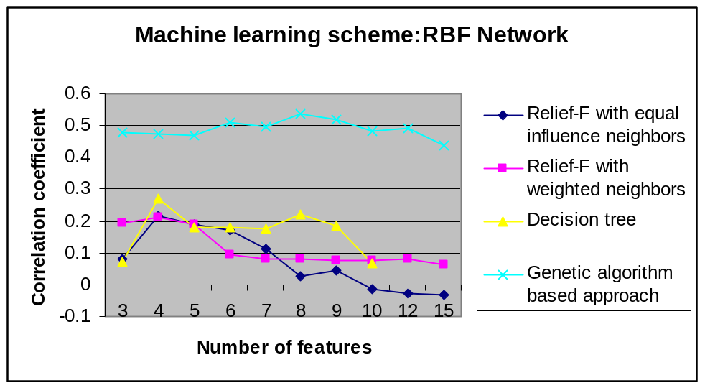

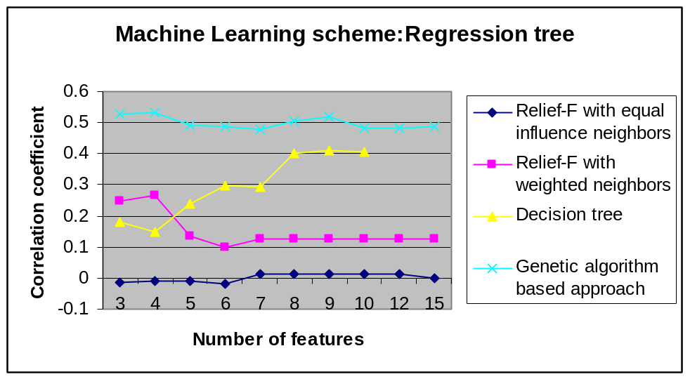

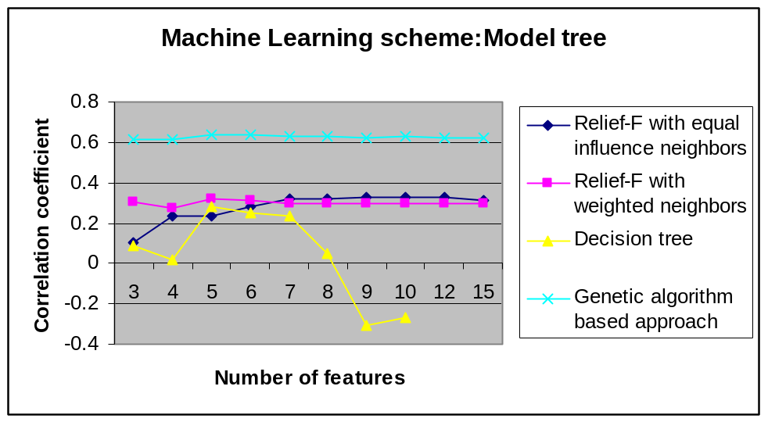

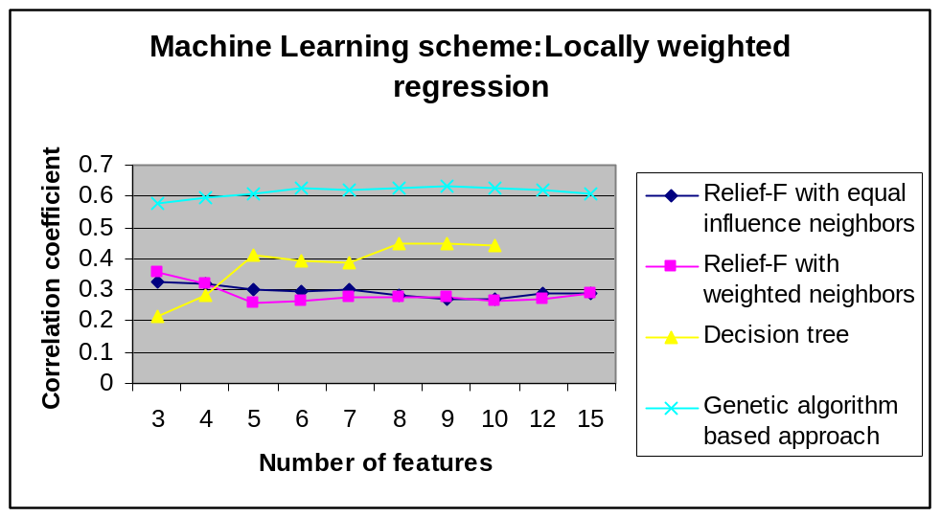

Thus, we can see that amongst Relief-F, decision trees and genetic algorithm based approach, with all the machine learning schemes, the genetic algorithm based approach gives the best results.

We will next be comparing the feature selection methods that produce an optimal feature subset with the genetic algorithm based approach. Correlation based feature selection and Principal Component Analysis are such feature selection methods. Both best first search and forward selection were tried with correlation based feature selection. For a given machine learning scheme, the best result obtained by the genetic algorithm was used for the comparison. The results obtained are depicted below. The X axis denotes the various machine learning schemes used and the Y axis denotes the correlation coefficient obtained by the machine learning scheme involved.
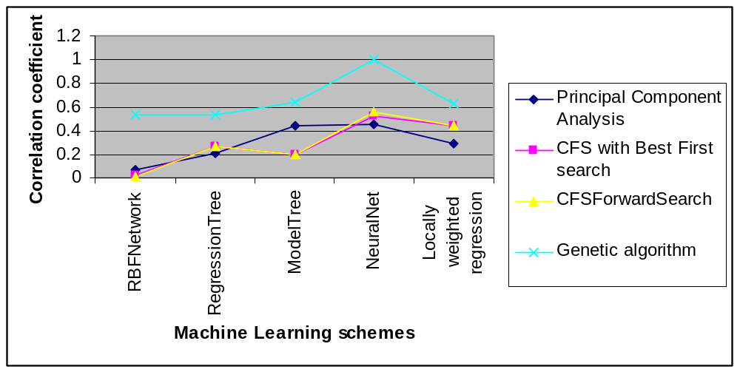

Thus, we can see that amongst Principal Component Analysis, correlation based feature selection and genetic algorithm based approach, for all the machine learning schemes, the genetic algorithm based approach gives the best results.
From the above two comparisons, it can be deduced that the wrapper based approach with genetic algorithm was the most appropriate feature selection method in this problem domain. Moreover, it was also found that the optimal number and the best feature subset found by the genetic algorithm were heavily dependent on the underlying machine learning scheme.

  - MACHINE LEARNING SCHEME RESULTS

In order to compare the performance of different machine learning schemes, feature selection using the genetic algorithm based approach is done and the best feature subset found for a given machine learning scheme is used and the performance of the machine learning scheme is evaluated using this feature subset and performing 10-fold cross validation. To make a fair comparison, the same folds are used for all the machine learning schemes. The comparison of the performance of all the machine learning schemes is shown below.

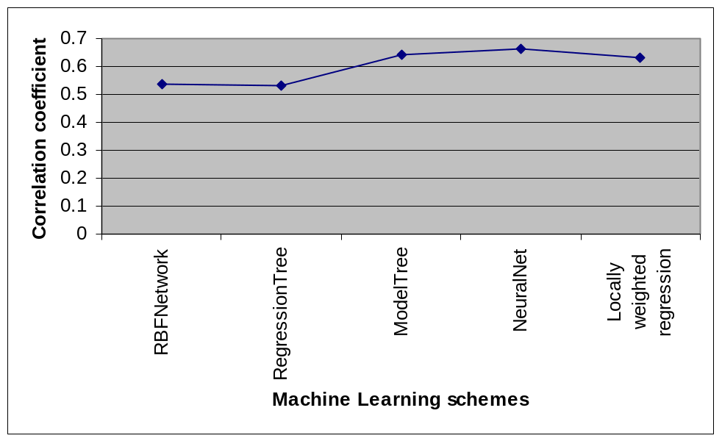

Thus we can see that among all the five machine learning schemes compared, the neural networks give the highest correlation coefficient and hence the best results.

  - UNCERTAINTY HANDLING RESULTS

CHAPTER 6

EVALUATION AND RESULTS

  - CONCLUSION

  - FUTURE WORK

REFERENCES
[1] Simon, H., (1983), “Why Should Machines Learn?”, Machine Learning: An Artificial Intelligence Approach, Vol. 1, Michalski, R.S.; Carbonell, J.G.; Mitchell, T.M., (Eds.), Tioga, Palo Alto/CA.

[2] Magnani, A.; Peluso, G.; Maragarucci, S.; Chittur, K. K.(2002) Integrated Biomaterials Science; Kluwer Academic/Plenum: New York, pp 669-689.
[3] Fiordeliso, J.; Bron, S.; Kohn, J. Biomaterials in Solution, as Interfaces and as Solids; VSP Publisher: Utrecht, The Netherlands, 1995, pp 695-708.

[4] Hall M.A, Correlation-based Feature Selection for Machine Learning, Ph.D. thesis, Department of Computer Science, Waikato University, New Zealand, 1999.

[5] Quinlan J.R, (1986) Induction of decision trees. Machine Learning, 1(1), 81-106,

[6] W. H. Press, B. P. Flannery, S. A. Teukolsky, andW. T. Vetterling. Numerical
Recipes in C. Cambridge University Press, Cambridge, 1988.

[7] Rich, E., Knight, K. (1991). Artificial Intelligence. McGraw-Hill.

[8] Michalewicz, Z, T.D. Logan and S. Swaminathan (1994) “Evolutionary Operators for continuous convex Parameter Spaces” In Proceeding of 3rd Annual Conference on Evolutionary Programming eds. A.V. Sebald and L.G. Fogel, River Edge, NJ, World Scientific Publishing, 98-108.

[9] Wright, A.H, (1991), “Genetic Algorithms For Real Parameter Optimization” , Foundations of Genetic Algorithms, Morgan Kaufman, pp205-218.

[10] Schwefel, H.-P,(1981) , Numerical Optimization for Computer Models, Chichester,UK, Wiley.

[11] Marko Robnik Sikonja, Igor Kononenko: An adaptation of Relief for attribute estimation on regression. In D.Fisher (ed.): Machine Learning, Proceedings of 14th International Conference on Machine Learning ICML'97, Nashville, TN, 1997.
[12] Kira, K. and Rendell, L. A. (1992). A practical approach to feature selection. In D. Sleeman and P. Edwards, editors, Proceedings of the International Conference on Machine Learning, pages 249-256. Morgan Kaufmann.
[13] Quinlan J.R, (1992), “Learning with continuous classes”, Proceeding Australian Joint Conference on Artificial Intelligence (pp. 343-348), World Scientific, Singapore.

[14] Breiman, L., Friedman, J.H., Olshen, R.A. and Stone C.J (1984). “Classification and regression trees”, Belmont, CA:Wadsworth.

[15] Atkeson, C., A. Moore, and S. Schaal (1996) “Locally weighted learning”

