Improving the Genetic Algorithm Performance in
Aerial Spray Deposition Management

L. Wu; University of Georgia; Athens, GA
W.D. Potter; University of Georgia; Athens, GA
K. Rasheed; University of Georgia; Athens, GA
J. Ghent; USDA Forest Service; Asheville, NC
D. Twardus; USDA Forest Service; Morgantown, WV
H. Thistle; USDA Forest Service; Missoula, MT
M. Teske; Continuum Dynamics; Princeton, NJ

Keywords: Genetic Algorithm, Neural Network, Aerial Spray Deposition, Parameter Optimization

ABSTRACT

Determining the parameter value settings to use as input to AGDISP in order to produce a desired spray material deposition is considered an instance of the parametric design problem. SAGA was developed to solve this problem. In this paper, we describe several approaches to improve the performance of SAGA. First, we replace the original generational genetic algorithm with a steady-state genetic algorithm, and the original roulette wheel selection with tournament selection. We call the new system SAGA2. Second, we apply a neural network to improve the initial population, crossover, and mutation. We call this version SAGA2NN. Then, we apply GADO, a general-purpose approach to solving the parametric design problem. The integrated GADO version is called SAGADO. Finally, we compare the performance of SAGA, SAGA2, SAGA2NN and SAGADO.

1. INTRODUCTION

AGDISP (Aerial Spray Simulation Model) is used to predict the deposition of spray material released from an aircraft. The prediction is based on a well-defined set of input parameter values as well as constant data [1]. It has always been a difficult problem to identify ideal spray parameters to achieve a desired deposition, reduce spray material evaporation or drift, and save the time and money devoted to the spray process [2]. The difficult part lies in that there are dozens of spray parameters in spray practice and each of them has many possible values. The total combination of possible spray parameters generates a huge search space (NP hard).
SAGA (Spray Advisor using Genetic Algorithm) was developed to heuristically search for an optimal or near-optimal set of input parameters needed to achieve a certain aerial spray deposition [3]. SAGA sends a set of spray parameters to the AGDISP simulation model. AGDISP calculates and sends back the spray results for each parameter set. Based on the fitness function values mapped from the spray results, the GA attempts to evolve an improved set of parameters.
There are eleven input parameters: aircraft ID number, block width, boom height, boom length, relative humidity, number of nozzles, nonvolatile fraction, swath width, temperature, volume median diameter input and wind speed (the details are in Table 1). In practical spray applications, some of them can be fixed based on requirements.

Table 1. Spray Parameters and Their Range

Spray Parameters | Lower | Upper
Aircraft ID | 1 | 124
Block Width (m) | 50.0 | 1000.0
Boom Height (m) | 8.0 | 15.0
Boom Length | 0.3 | 1.0
Humidity (%) | 15.0 | 100.0
Nozzles | 1 | 60
Nonvolatile Fraction | 0.001 | 1
Swath Width | 0.3 | 3.0
Temperature (C) | 1.0 | 30.0
VMD Input (μm) | 100.0 | 400.0
Wind Speed (m/s) | 0.23 | 4.47

AGDISP returns three spray output values: VMD (the deposition composed of Volume Median Diameter), drift fraction, and COV (the Coefficient of Variance). VMD is a measure of spray material droplet size. Drift fraction identifies the amount of spray material deposited outside the spray block. COV gives an indication of the uniformity of the deposited spray material. The goal is to minimize the drift fraction, minimize the COV, and minimize the difference between the output VMD and the desired VMD. That is, get the exact amount of spray material evenly distributed over the spray block with the least loss due to evaporation and attrition. This is actually a multi-objective optimization problem. Here a weighted-sum approach is applied, which assigns weights to each objective function and combining them into a single-objective function [4]. The fitness function suggested by the USDA Forest Service experts is eqn. (1). (VMDCenter is the desired VMD value specified by the user, usually an entomologist, before the run.)

Fitness = 100 × [50 × (1.0 – DriftFraction) + 25 × (1 -COV) + 25 × VMDTerm], where
VMDTerm = 1.0 – abs(1.0 – VMD/VMDCenter) (1)

As can be seen, this is a typical parametric design problem, in which the genetic algorithm evolves the spray parameters in a continuous domain, and the simulation engine (AGDISP) evaluates the solution. The search space is rather huge, so the simple GA has difficulty converging to a global optimum. The simulation engine takes 2-5 seconds (on a Pentium III 600 MHZ PC) to evaluate the input parameters for an individual, so the total number of simulations cannot be too high in order to get the result in a reasonable time (normally SAGA allows 5000 to 7000 simulations).

2. FROM SAGA TO SAGA2

We developed SAGA2 (Spray Advisor using Genetic Algorithm version 2) from SAGA. The original SAGA uses a generational genetic algorithm, replacing an entire set of parents by offspring [5]. The convergence speed of this scheme is rather slow. Actually, after 5000 evaluations (100 individuals × 50 generations) as specified by the program, the population has typically not converged. SAGA2 uses a steady-state genetic algorithm, replacing only the n worst parents by offspring [6]. We hope it can speed up the convergence process and reach a better result.
The original selection method was roulette wheel selection, which determines selection probability for each chromosome proportional to the fitness value [7]. In SAGA2, we replace roulette wheel selection with tournament selection, which randomly chooses a set of chromosomes and picks out the best chromosome for reproduction [8]. According to Goldberg and Deb, tournament selection is robust and less prone to premature convergence [9].
Instead of using a single type of crossover and mutation operator, in SAGA2 we combine several kinds of crossover and mutation operators and apply them with respective probabilities. The three kinds of crossover operators are blend crossover, direction-based crossover, and uniform crossover [10 - 12]. The three kinds of mutation operators are greedy mutation, shrinking window mutation and nonuniform mutation [13, 14]. By improving the crossover and mutation methods, we hope it can enlarge the genetic algorithm’s searching scope.
The main interface of SAGA2 is shown in Figure 1. The user can press the button “Preset Parameters” to preset certain spray parameters by selecting the ones to preset and fill in appropriate values. The rest of the parameters are left open to evolution by the genetic algorithm. The interface to preset spray parameters is shown in Figure 2. Depending on the user’s knowledge of the genetic algorithm and the application purpose, the user can press the button “Customized Parameters“ to modify a set of genetic algorithm parameters and the value of VMDCenter. The interface to customize SAGA2 parameters is shown in Figure 3.

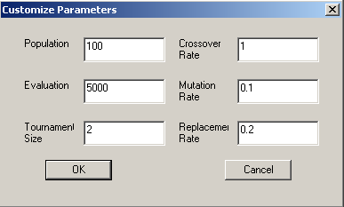

Figure 3. The Interface to Customize SAGA2 Parameters
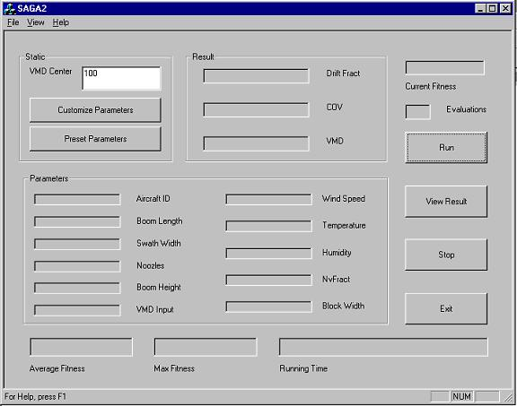

Figure 1. The Main Interface of SAGA2

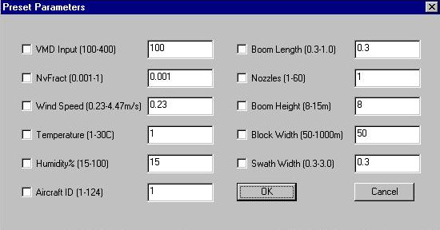
Figure 2. The Interface to Preset Spray Parameters

3. FROM SAGA2 TO SAGA2NN

We developed SAGA2NN (Spray Advisor using Genetic Algorithm version 2 with Neural Network) from SAGA2. SAGA2 uses random numbers to produce the initial population, so the average fitness of the initial population is not high and the individuals are rather diverse. If it can be improved, the GA will require fewer simulations to converge. SAGA2NN generates the initial population from a large pool of individuals. For example, if the population size is 100, then the GA randomly produces 2000 individuals and selects 100 individuals with the highest fitness as its initial population. Now the problem is how to get the fitness of these 2000 individuals. In order to save the computation time, SAGA2NN uses a neural network to approximate the fitness in the process of generating the initial population. SAGA2NN also applies this method in the process of crossover and mutation. For each crossover and mutation, it actually does twenty crossover and mutation operations, uses the neural network to approximate the results’ fitness, and selects the one with the highest fitness as the candidate. This idea comes from [15].
We developed a program to collect the data. The input variables are the eleven spray parameters (randomly generated, different in each evaluation), and the output variables are drift fraction, COV and VMD, which are computed by the simulation engine AGDISP. We run 26000 evaluations, and use 20000 as the training and testing set (saved in file NNData.txt), and 6000 as the production set (saved in file NNProduction.txt). It took 24 hours to collect these data (on a Pentium III 600 MHZ PC). The cost is worthwhile since the genetic algorithm will run many times for different spray parameter settings in the future (every run needs about 4 hours).
We developed a program named ANN (Artificial Neural Network) to train the neural network. The learning rule is backpropagation with momentum [16]. The main interface of ANN is shown in Figure 4.
We use 75% of the data (in file NNData.txt) as the training set, 0.1 as the learning rate, and 0.8 as the momentum. The neural network tries to minimize the MSE (median squared error) of the three output values in the production set (in file NNProduction.txt). It turns out that the number of hidden nodes has a great influence on the performance of the neural network. It can be seen that in this case 50 hidden nodes will produce the best result (the details are in Table 2).
The weights of the neural network are saved in file Weight.txt, which will be read by SAGA2NN. Without using the expensive simulation engine, SAGA2NN relies on the weights to map the values of drift fraction, COV and VMD from a set of spray parameters. Originally, the range of fitness values in the initial population was from 1000 to 8500. After applying the neural network to select individuals with high fitness from a large pool, the range of fitness values in the initial population is greatly improved (from 8000 to 9300).
The main interface of SAGA2NN, the interface to preset spray parameters, and the interface to customize SAGA2NN parameters are similar to those of SAGA2.

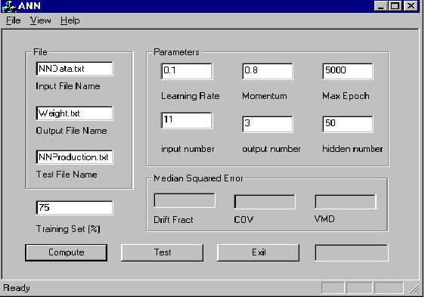
Figure 4. The Main Interface of ANN

Table 2. Influence of hidden nodes on neural network

Hidden Nodes | 20 | 30 | 40 | 50 | 60
MSE of Drift Fraction | 0.000840 | 0.001077 | 0.000843 | 0.000768 | 0.001071
MSE of COV | 0.015327 | 0.015289 | 0.015317 | 0.013275 | 0.016260
MSE of VMD | 465.59 | 462.39 | 448.93 | 438.88 | 458.27
Learning Epochs | 2524 | 711 | 1002 | 3471 | 352

4. APPLYING GADO IN THIS PROBLEM

GADO (Genetic Algorithm for Design Optimization) was developed to solve the general type of engineering design optimization problem [15, 17]. It uses a steady-state GA. One offspring is produced from two parents selected from the population via some selection scheme, and replaces an existing individual in the population via some replacement strategy. The selection scheme is ranking selection, which sorts the population from best to worst and assigns the selection probability of each chromosome not according to its raw fitness but according to its ranking. The replacement strategy is a crowding technique, which takes into consideration both the fitness and the proximity of the points in the population. Several crossover and mutation operators are used, in which the most important one is guided crossover. The idea of guided crossover is to form different search directions by joining pairs of previously evaluated points, rank these directions, and take a small step in the best direction. It endows the GA with gradient-like capabilities without actually computing any gradients.
We applied GADO in this problem, and developed a program named SAGADO (Spray Advisor using Genetic Algorithm for Design Optimization). Besides passing the set of spray parameters needed to GADO, we added some routines to calculate the fitness of an individual, update the evolution process, and save the result. The main interface of SAGADO, the interface to preset spray parameters are similar to those of SAGA2. The interface to customize SAGADO parameters is shown in Figure 5. The meanings of these parameters are described in [13].

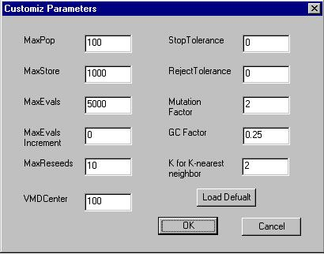

Figure 5. The Interface to Customize SAGADO Parameters

5. RESULTS

In order to test the performance of these methods, we ran them on three practical spray parameter specifications provided by Forest Service managers (the details are in Table 3). The convergence criterion is avgfitness / maxfitness > 0.999, where avgfitness is the average fitness in the population and maxfitness is the maximum fitness in the population. The GA will stop when it meets the convergence criterion, otherwise it stops after 5000 evaluations. Crossover rate is 1, mutation rate is 0.1 and population size is 100, which are the same for SAGA, SAGA2, SAGA2NN and SAGADO. The other parameters of SAGA2 and SAGA2NN are in Figure 3. The other parameters of SAGADO are in Figure 5.

Table 3. Detail of Spray Parameter Settings

Parameter  Settings | VMD  Center | Variables Constraint
Parameter  Setting I | 100 | None
Parameter  Setting II | 100 | Aircraft ID=6, Swath Width=1.2  VMD=100, Block Width=400
Parameter  Setting III | 200 | Aircraft ID=106, Swath Width=2.25
Parameter  Setting IV | 200 | Aircraft ID=5, Swath Width=2.3

The comparison of the best results from SAGA, SAGA2, SAGA2NN and SAGADO is in Table 4, Table 5, Table 6 and Table7. The “max fitness” row in each table indicates the performance of each system. From the tables, we can see that the maximum fitness values SAGA2 and SAGADO achieved are better than SAGA in every parameter setting. In Parameter Setting I, II and IV, the performance of SAGADO is the best. In Parameter Setting III, the performance of SAGA2 is the best. From the maximum fitness values, it is hard to tell whether SAGA or SAGA2NN is better (SAGA2NN is better than SAGA in Parameter Setting III and IV, but worse in Parameter Setting I and II). However, SAGA2NN converges much faster, which can be seen from the evolution process, so it can effectively save the time.

Table 4. Results of Spray Parameter Setting I

Item | SAGA | SAGA2 | SAGA2NN | SAGADO
Aircraft ID | 21 | 4 | 124 | 26
Block Width | 703.67 | 943.61 | 883.39 | 997.68
Boom Height | 8.00 | 8.23 | 8.08 | 9.79
Boom Length | 1.00 | 1.00 | 0.30 | 0.88
Humidity | 83.28 | 66.35 | 23.55 | 41.92
Nozzles | 1 | 1 | 56 | 1
NV Fraction | 0.84 | 0.87 | 0.36 | 0.89
Swath Width | 0.30 | 0.30 | 0.30 | 0.30
Temperature | 10.86 | 6.73 | 29.82 | 18.74
VMD Input | 100.28 | 100.28 | 118.44 | 100.24
Wind Speed | 0.23 | 0.40 | 0.23 | 0.25
Drift Fraction | 0.0003 | 0.0009 | 0.0036 | 0.0005
COV | 0.0187 | 0.0121 | 0.0256 | 0.0097
VMD | 100.66 | 100.01 | 99.98 | 100.00
Max Fitness | 9935 | 9965 | 9918 | 9973

Table 5. Results of Spray Parameter Setting II

Item | SAGA | SAGA2 | SAGA2NN | SAGADO
Aircraft ID | 6 | 6 | 6 | 6
Block Width | 400.00 | 400.00 | 400.00 | 400.00
Boom Height | 8.00 | 8.00 | 8.00 | 8.00
Boom Length | 0.33 | 0.33 | 0.78 | 0.35
Humidity | 42.31 | 15.00 | 49.19 | 51.00
Nozzles | 10 | 10 | 60 | 9
NV Fraction | 0.83 | 0.80 | 0.75 | 0.80
Swath Width | 1.20 | 1.20 | 1.20 | 1.20
Temperature | 9.91 | 1.00 | 30.00 | 28.52
VMD Input | 100.00 | 100.00 | 100.00 | 100.00
Wind Speed | 0.23 | 0.23 | 0.23 | 0.23
Drift Fraction | 0.0230 | 0.0235 | 0.0354 | 0.0239
COV | 0.0924 | 0.0907 | 0.1091 | 0.0887
VMD | 101.12 | 100.01 | 100.12 | 99.99
Max Fitness | 9626 | 9655 | 9547 | 9658

Table 6. Results of Spray Parameter Setting III

Item | SAGA | SAGA2 | SAGA2NN | SAGADO
Aircraft ID | 106 | 106 | 106 | 106
Block Width | 1000.00 | 995.69 | 995.81 | 971.91
Boom Height | 15.00 | 13.80 | 15.00 | 12.93
Boom Length | 0.78 | 0.45 | 1.00 | 0.46
Humidity | 100.00 | 78.58 | 15.00 | 90.73
Nozzles | 48 | 10 | 9 | 18
NV Fraction | 0.21 | 0.58 | 0.99 | 0.73
Swath Width | 2.25 | 2.25 | 2.25 | 2.25
Temperature | 30.00 | 1.62 | 30.00 | 19.51
VMD Input | 192.60 | 179.73 | 194.38 | 185.11
Wind Speed | 0.89 | 0.95 | 1.79 | 1.03
Drift Fraction | 0.0295 | 0.0275 | 0.0548 | 0.0246
COV | 0.1973 | 0.0999 | 0.1397 | 0.1199
VMD | 202.01 | 200.01 | 201.54 | 200.00
Max Fitness | 9334 | 9613 | 9357 | 9577

Table 7. Results of Spray Parameter Setting IV

Item | SAGA | SAGA2 | SAGA2NN | SAGADO
Aircraft ID | 5 | 5 | 5 | 5
Block Width | 1000.00 | 1000.00 | 1000.00 | 999.59
Boom Height | 14.49 | 15.00 | 15.00 | 15.00
Boom Length | 1.00 | 1.00 | 1.00 | 1.00
Humidity | 100.00 | 98.41 | 15.00 | 74.37
Nozzles | 12 | 10 | 60 | 10
NV Fraction | 0.25 | 0.97 | 0.09 | 0.88
Swath Width | 2.30 | 2.30 | 2.30 | 2.30
Temperature | 29.65 | 30.00 | 17.68 | 12.30
VMD Input | 191.48 | 192.68 | 139.74 | 197.71
Wind Speed | 1.03 | 0.76 | 0.23 | 0.75
Drift Fraction | 0.0458 | 0.0333 | 0.0248 | 0.0328
COV | 0.1507 | 0.1375 | 0.1738 | 0.1301
VMD | 202.01 | 200.18 | 199.09 | 200.00
Max Fitness | 9370 | 9487 | 9430 | 9510

In order to see the evolution process, we recorded the maximum fitness of each method every one hundred evaluations. The evolving graphs for the four spray parameter settings are shown in Fig. 6-Fig. 9 (the x-coordinate is the evaluation number divided by 100, and the y-coordinate is the maximum fitness value). From the graphs, we can see that SAGA2NN obtains much better maximum fitness values in the first few hundred evaluations, and takes far fewer evaluations to converge.

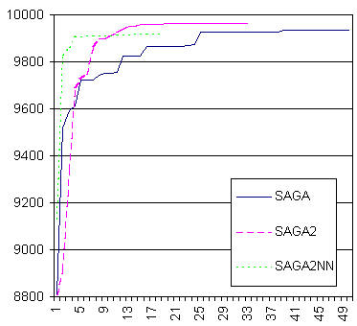
Fig 6. Evolution Process of Parameter Setting I

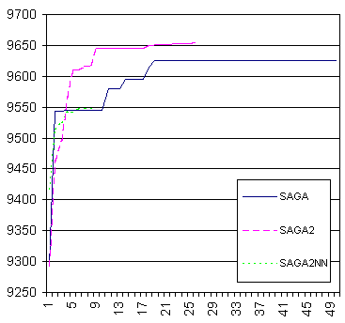
Fig 7. Evolution Process of Parameter Setting II

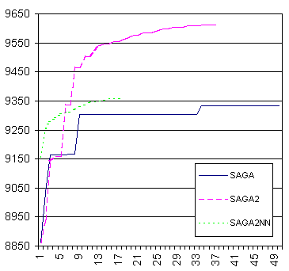
Fig 8. Evolution Process of Parameter Setting III

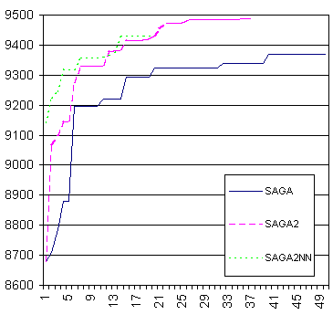
Fig 9. Evolution Process of Parameter Setting IV

6. CONCLUSION

In this paper, we described several genetic algorithm methods to deal with the spray parameter optimization problem, and compared them with the original heuristic method SAGA. SAGA2 and SAGADO outperform SAGA in all experiments. It proves that exquisite choice of type of GA, selection, crossover and mutation operator can boost GA performance. In this problem, the steady-state GA plus tournament selection is preferred over the generational GA plus roulette wheel selection. By applying a neural network to the genetic algorithm, we hoped SAGA2NN could achieve even better results than SAGA2 and SAGADO, but our experiments don’t show it. We think the reason is that the advantage of the neural network is counteracted by premature convergence of the genetic algorithm. However, SAGA2NN converges very fast, which is useful in real aerial spray applications because it can get the near-optimal result by far fewer simulations. Currently we are working to apply other heuristic search approaches, such as simulated annealing, in aerial spray deposition management, and plan to compare their performance with SAGA2, SAGADO and SAGA2NN.

REFERENCES

- A.J. Bilanin, M.E. Teske, J.W. Barry and R.B. Ekblad (1989), “AGDISP: the Aircraft Spray Dispersion Model, Code Development and Experimental Validation”, Transactions of the ASAE 32(1): 327-334.
- M.E. Teske, T.B. Curbishley (1989), Forest Service Aerial Spray Computer Model 4.0 User Manual, C.D.I. Report No. 90-06.
- W.D. Potter, W. Bi, D. Twardus, H. Thistle, M.J. Twery, J. Ghent, M. Teske (2000), “Aerial Spray Deposition Management Using the Genetic Algorithm”, IEA-EIA Conference 2000.
- L. Zadeh (1963), “Optimality and non-scalar-valued performance criteria”, IEEE Transactions on Automatic Control, vol. 8, no 59.
- J.J. Grefenstette (1986), “Optimization of control parameters for genetic algorithms”, IEEE Trans SMC, 16:122-128.
- L. Davis (1991), Handbook of Genetic Algorithms, Van Nostrand Reinhold, New York.
- J. Holland (1975), Adaptation in Natual and Artificial Systems, University of Michigan Press, Ann Arbor, MI.
- D.E. Goldberg, B. Korb, and K. Deb (1989), “Messy genetic algorithms: motivation, analysis, and first results”, Complex Systems, vol.3: 493-530.
- D.E. Goldberg, and K. Deb (1991), “A comparative analysis of selection schemes used in genetic algorithms”, Foundations of Genetic Algorithms: 69-93, Morgan Kaufman, San Mateo, CA.
- L. Eshelman and J. Schaffer (1993), “Real-coded genetic algorithms and interval-schemata”, Foundations of Genetic Algorithms, Vol. 2: 187-202, Morgan Kaufman, San Francisco, CA.
- Z. Michalewicz, T. Logan, and S. Swaminathan (1994), “Evolutionary operators for continuous convex parameter spaces”, Proceedings of the 3rd Annual Conference on Evolutionary Programming: 84-97, World Scientific Publishing, River Edge, NJ.
- G. Syswerda (1989), “Uniform crossover in genetic algorithms”, Proceedings of the 3rd International Conference on Genetic Algorithms: 2-9, Morgan Kaufman, San Francisco, CA.
- K. Rasheed (1998), “GADO: A Genetic Algorithm for Continuous Design Optimization”, Ph.D. Thesis, Department of Computer Science, Rutgers University, New Brunswick, NJ, 1998.
- Z. Michalewicz (1996), Genetic Algorithm + Data Structure = Evolution Progams, 3rd Edition, Springer-Verlag, New York.
- K. Rasheed, H. Hirsh (2000), “Informed operators: Speeding up genetic-algorithm-based design optimization using reduced models”, Genetic and Evolutionary Computation Conference 2000.
- S. I. Gallant (1993), Chapter 11, Neural Network Learning and Expert Systems, the MIT Press, Cambridge, MA.
- K. Rasheed, H. Hirsh (1999), “Learning to be Selective in Genetic-Algorithm-Based Design Optimization”, Artificial Intelligence for Engineering Design, Analysis and Manufacturing, 13:157-169.

BIOGRAPHIES

Lei Wu
Artificial Intelligence Center
University of Georgia
Athens, GA 30602 USA

Lei Wu is currently a graduate student in the Artificial Intelligence Center at the University of Georgia, where he plans to graduate with the M.S. in A.I. degree this summer. He received his B.S. degree (2000) in Computer Science from Nanjing University in China. His research interests include artificial intelligence and genetic algorithms.

Walter. D. Potter
Artificial Intelligence Center
University of Georgia
Athens, GA 30602 USA

Walter. D. Potter is a Full Professor of Computer Science and the Graduate Coordinator for the Artificial Intelligence Center at the University of Georgia. He received his B.S. from the University of Tennessee in Management Science (1974), and the M.S. and Ph.D. degrees from the University of South Carolina in Computer Science (1980 and 1987, respectively). His research includes the application of artificial intelligence techniques to aid decision-making in practical domains such as aerial spray application.

Khaled Rasheed
Department of Computer Science
University of Georgia
Athens, GA 30602 USA

Khaled Rasheed is an Assistant Professor of Computer Science at the University of Georgia. He received both his Ph.D. (1998) and M.S. (1995) degrees from Rutgers University in Computer Science, and his B.S. (1990) degree in Computer Science and Automatic Control from Alexandria University in Egypt. His research interests include artificial intelligence, genetic algorithms, design optimization, and machine learning.

John Ghent
USDA Forest Service
Asheville, NC, USA

John Ghent is a Forest Entomologist with the USDA Forest Service, where he has worked for the past 26 years, primary in Forest Health Protection. He received his B.S. degree in biology from Catawba College in 1973. In 1975, he completed his M.F. in Forest Protection from Duke University.

Daniel Twardus
USDA Forest Service
Morgantown, WV, USA

Daniel Twardus is a Group Leader, Forest Health Protection, USDA Forest Service, where he has worked for the past 25 years, primarily in forest pest management. He has a Bachelor’s Degree from Gettysburg College and a Master’s Degree in Forest Protection from Duke University.

Harold Thistle
USDA Forest Service
Missoula, MT, USA

Harold Thistle holds a Ph.D. in Plant Science with a specialty in Forest Meteorology from the University of Connecticut (1988). His current title is Engineer and Program Manager of Application Technology for the USDA Forest Service. His current area of research is the dispersion and transport of pesticide in the atmosphere.

Milton E. Teske
Continuum Dynamics
Princeton, NJ, USA

Milton E. Teske is a Senior Associate with Continuum Dynamics, where he has worked for the past 22 years. He earned his B.S. from Iowa State University, M.S. from the California Institute of Technology, and the Ph.D. from the University of Michigan. His primary responsibility has been with the development of the AGDISP, FSCBG, AgDRIFT, Spray Advisor, and Spray Safe Manager computer models for the aerial application of pesticides.

