Program that takes from the user *n* integers and stores them a vector of int.

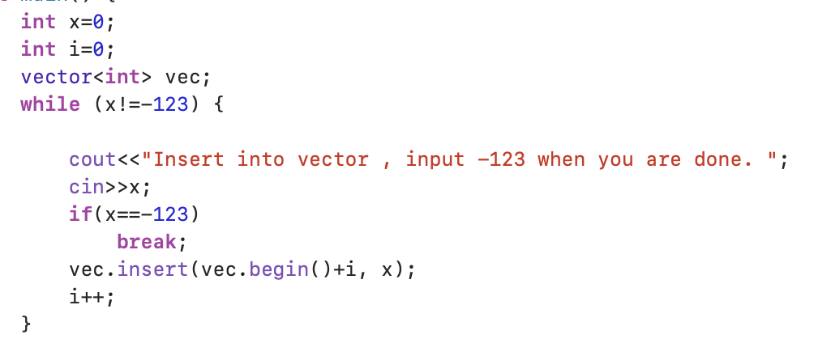

Insert after function.

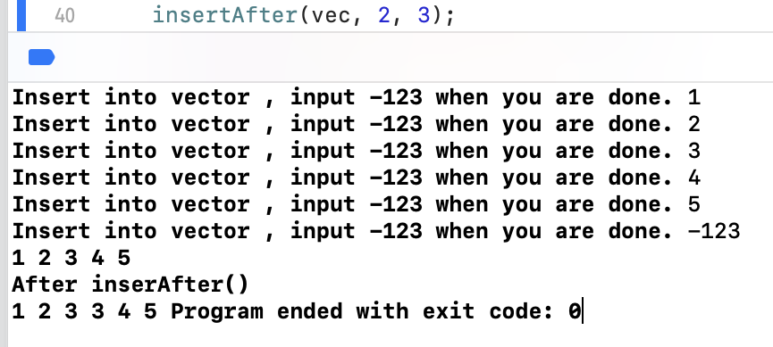

Linked List class.

addNode()

removeNode()

Printlist()

createListFromVector()

findOccurence()

returnSum()

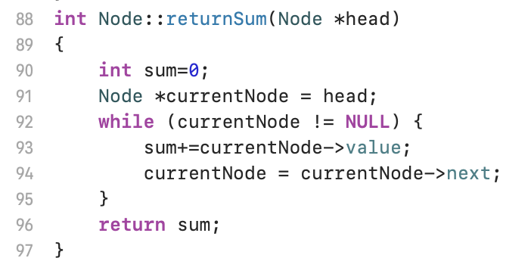

The whole program running:

