**Library Management System**

Is a friendly use software made with JAVA programming language with the JFrame feature that allow us to create GUI with JAVA programming language that allows users to borrow and return a book with SQLITE database

Steps

Open the “Library Application” as a java project and run

The main class is “main_login”

Project structure

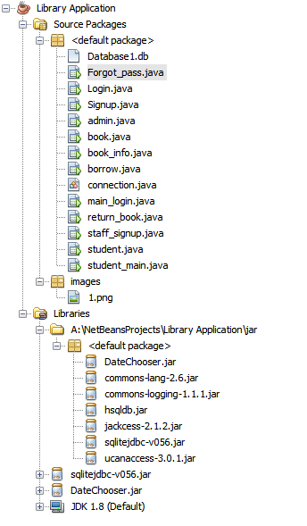

Main Login page is the first page in the program and user must select if he is a staff or student to login in both cases or sign up in student case.

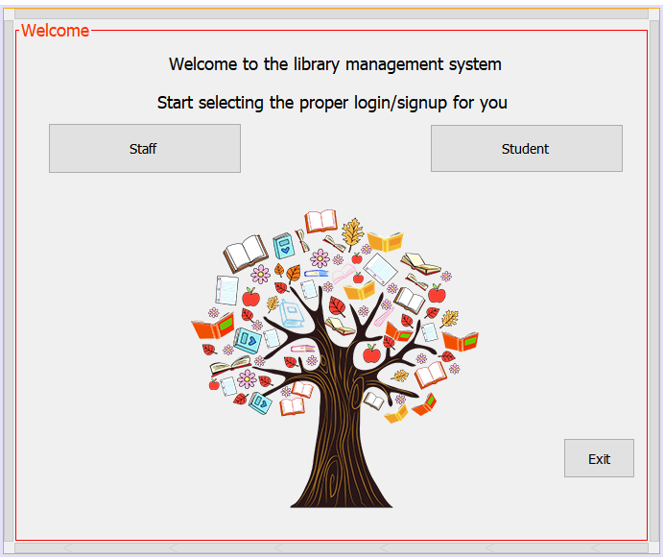

The login page of the student

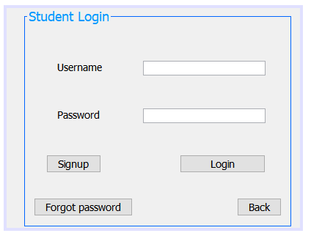

The signup page of the student

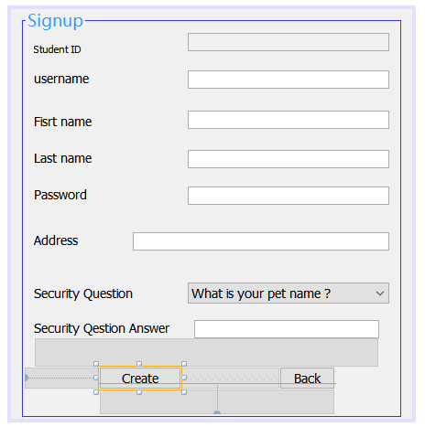

Recover password for student case

Student enters his/her username and it display first name ,last name ,security question

User must enter the right answer for question and hit the retrieve button if is correct the stored password for this account will appear in the last text box

After that he can hit Login to go to login page manually or back if he wants

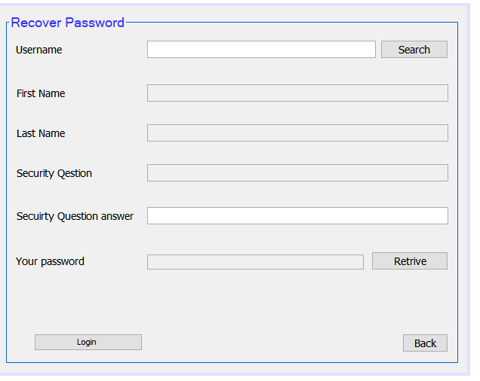

After student logging in he can check if he borrowed a book or not

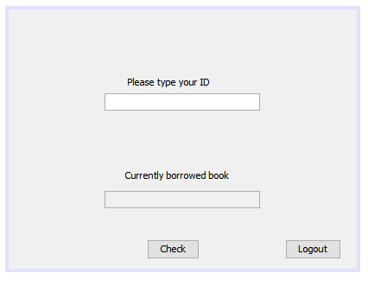

**Staff**

Staff login page

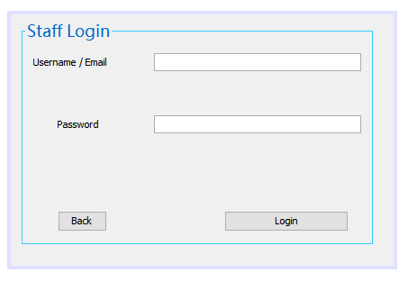

After staff successfully logged the main dashboard comes in

He can add a new staff member ,add a new student to the database ,add a new book

Can make the borrow process for student ,return book after borrowing and display the information of any book in the records

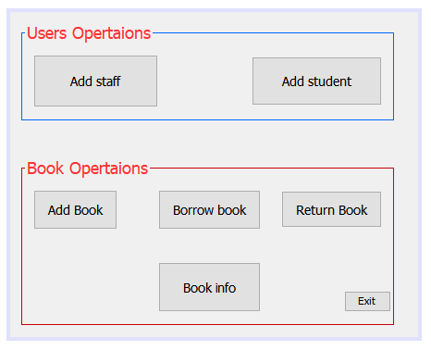

The add book process is below the category list consists of Drama ,fantsy,fiction,fairy tales and biography

And status for Not borrowed and Borrowed as indicator or flag if book is available or not

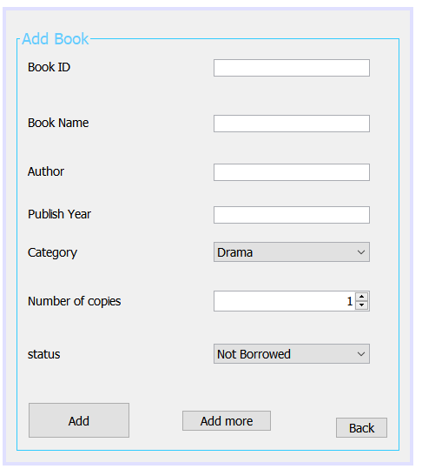

Display book information by book id from the book table

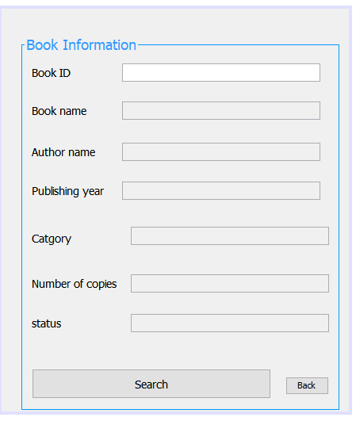

The borrow window that allows the staff member to make a borrow order for student to borrow a specific book

Action ID number is auto generated every time as indicator for the action of the process in record

The stuff must enter student id and check button to ensure that student is un the record same as for the book then book details appears after that staff click on “Make Borrow Action”

Automatically the state of the book changes from Not Borrowed to Borrowed in the book table

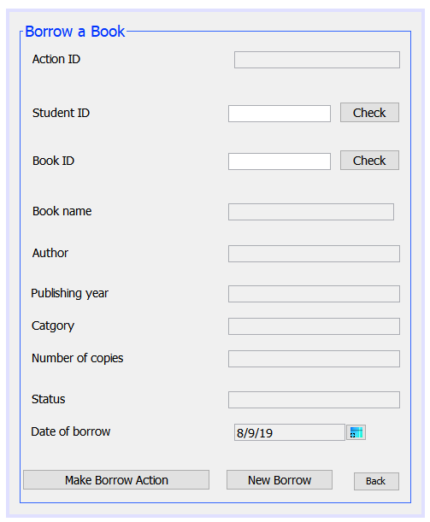

In return book window the same principle for checking student and book is also here

And after return process is success the state of the book changes to Not Borrowed

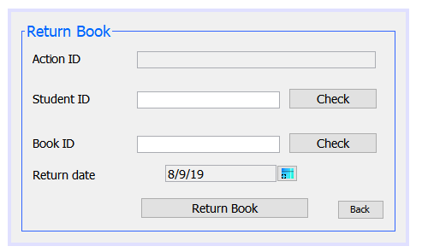

Adding a new stuff

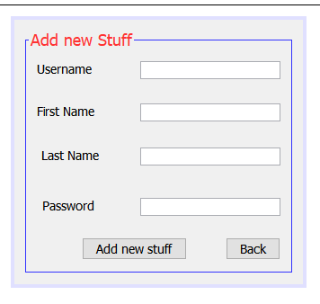

Softwares were used :

1. NetBeans IDE
2. DB Browser (SQLite)
3. GitKraken