The contents on first page are changeable, i.e. in welcome to our meat shop, testimonial, parties and take order and underneath three boxes of short description for meats.

Logo
It will be supplied later.

Rotating images will be supplied later.

Ticker message (leading message) will be given later.

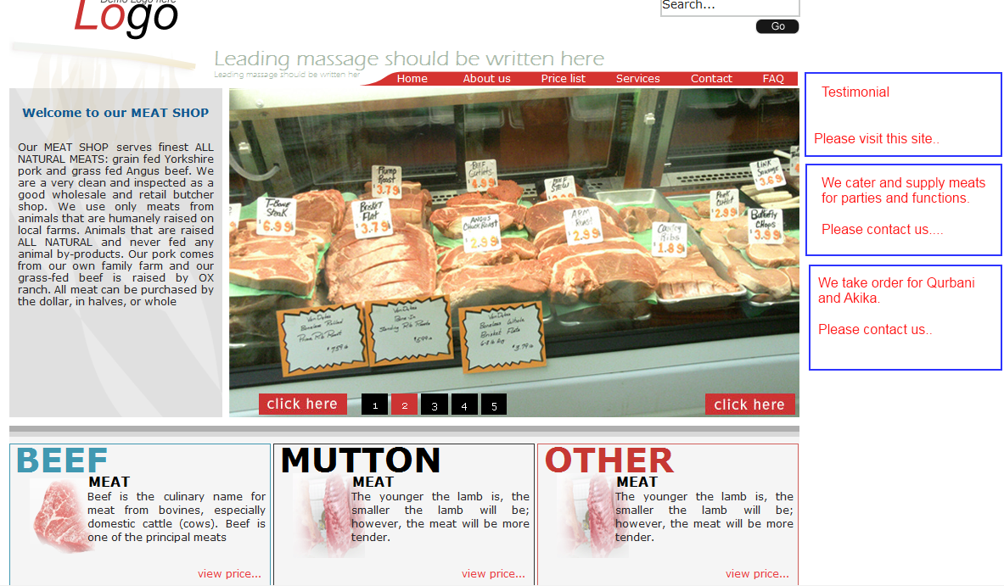

Link “About us”

This page content will be written by shop owner. Color and font code will be supplied by dev team in css file, but initially put some default color and font.

Link “Services”

This page content will be written by shop owner. Color and font code will supplied by dev team in css file, but initially keep some default color and font.

Link “Contact us”

This page content will be written by shop owner. Color and font code will supplied by dev team in css file, but initially keep some default color and font.

This page will have a table with a Row and two columns, e.g.

Here owner will upload address map image. | It will have shop address text, phone number, fax number etc.
Here owner will upload address map image. | Email address: clickable

Link “FAQ”

This page content will be written by shop owner. Color and font code will supplied by dev team in css file, but initially keep some default color and font. E.g.

# | Questions | Answer
1. | What is Halal? | Meats are slaughted in Islamic way
2. | Who is Halal certificate provider in Australia?
. | …… | ..

Link “Price list”

The meat price is updatable at any time. Below the table structure is given, and dev team may change on technical requirements but owner needs as below:

Table : MeatType
Column | Type | Description
meat_type_id | PK, int, auto increment
meat_type_name | String type, not null

Table : MeatPrice
Column | Type | Description
meat_price_id | PK, int, auto increment
meat_name | String type, not null
meat_type_id | Int, not null | FK to MeatType table
unit_type | String, not null | Kg, Block, Pkt, Pcs., Box etc.
unit_price | Currency, not null | Australian dollars A$
comment | String or varchar max, null | Owner may have some comment on this price

Table : SpecialPrice
Column | Type | Description
item_id | PK, int, auto increment
item_name | String type, not null
item_unit_type | String, not null
item_unit_price | Currency, not null | A$
item_comment | String or varchar max, null | Owner may have some comment on this price

As per number of meat type in table “MeatType”, number of table will show for each meat type category, such as if in table “MeatType” beef and goat type only available, then there will be two table to show the prices of beef and goat, and similarly if there are 3 types of meat then there will be 3 tables for meat prices in one page (price list page can go on scrolling no problem).

Link for “Testimonial”

I will send you later.

Link for “Cater and Supply”

I will send you later.

Link for “Take Order”

I will send you later.

