
Capital University
(formerly Helwan University)
Faculty of Computing & Artificial Intelligence
Natural Language Processing — Spring Semester 2, 2025–2026

Project 2
Intelligent Search Engine
TF-IDF Baseline vs. BERT Semantic Retrieval — A Comparative Study

Technical Project Report
Submitted fulfillment of the NLP course requirements
أنس أحمد عبدالرحمن: 20230098
خالد محمد سامي محمد: 20230186
مريم اشرف عبدالمطلب: 20230536
عبدالرحمن جابر حمدي سليمان: 20230311
إينال حازم إينال: 20230115
جنى علام محمد سعد: 20230158
Contents
1. Introduction 3
1.1 Problem Statement 3
1.2 Limitations of Keyword Search 3
1.3 Motivation for Semantic Understanding 3
1.4 Project Objective 3
2. System Overview 4
2.1 Top-K Retrieval and Ranking 4
3. Dataset Description 4
3.1 Source and Type 4
3.2 Dataset Schema and Cleaning 4
3.3 Fields Used in Retrieval 5
4. Data Preprocessing 5
4.1 TF-IDF Preprocessing Pipeline 5
4.2 BERT Processing 6
5. Feature Extraction 7
5.1 TF-IDF 7
5.2 BERT Embeddings 8
5.3 Comparing the Two Representations 8
6. Models and Retrieval Logic 9
6.1 Baseline Model — TF-IDF + Cosine Similarity 9
6.2 Advanced Model — Sentence-BERT + Cosine Similarity 9
6.3 Top-K Retrieval 10
7. System Workflow 10
7.1 Offline Phase — Index Construction 10
7.2 Online Phase — Query Lifecycle 11
8. System Diagrams 11
8.1 System Architecture 11
8.2 Data Flow at Query Time 12
8.3 Sequence Diagram 13
9. Code and Notebook Analysis 13
9.1 Notebook Structure 13
9.2 Key Functions 14
9.3 Deployment — Streamlit Web Application 14
10. Evaluation 15
10.1 Methodology — Precision@K 15
10.2 Test Queries and Ground Truth 15
10.3 Worked Calculation 15
10.4 Qualitative Findings 16
10.5 Limitations of the Evaluation 16
11. Comparison Between TF-IDF and BERT 17
11.1 Why BERT Performs Better 17
11.2 When TF-IDF is Still Useful 18
12. Limitations of the System 18
12.1 Preprocessing Limitations 18
13. Conclusion 19
14. References 19

1. Introduction

1.1 Problem Statement
The exponential growth of unstructured textual data on the web — product reviews, articles, knowledge bases — has made it increasingly difficult for users to locate the precise information they seek. Information Retrieval (IR) is the discipline dedicated to this problem: given a user query, return the most relevant documents from a corpus, ranked by relevance.
Traditional IR systems rely on lexical (keyword) matching. While effective when query terms appear verbatim in the relevant documents, such systems fail when the user expresses an intent using different vocabulary than the corpus authors. A query for "food delivery problem" will not retrieve a review titled "Late shipment issues" under a pure keyword model, despite the two being semantically near-identical.

1.2 Limitations of Keyword Search
- Synonym blindness: "buy", "purchase", and "order" are treated as unrelated tokens.
- Negation insensitivity: "cannot get help" matches positive reviews containing the word "help".
- Vocabulary mismatch: the user's query terms rarely correspond exactly to the document author's word choices.
- No notion of context: polysemous words (e.g., "bank" — financial institution vs. river bank) are conflated.

1.3 Motivation for Semantic Understanding
Modern transformer-based language models — pre-trained on billions of tokens — produce dense vector representations (embeddings) in which semantically similar texts are placed close together in vector space. By projecting both queries and documents into this shared semantic space and ranking by cosine proximity, a retrieval system can match meaning rather than surface form, returning relevant documents even when no query word literally appears in them.

1.4 Project Objective
This project builds a complete, deployed Intelligent Search Engine over a corpus of 21,021 Amazon customer reviews and presents a rigorous, side-by-side comparison of two retrieval paradigms:
- Baseline — TF-IDF: a sparse, lexical model that scores documents by weighted keyword overlap.
- Advanced — Sentence-BERT (SBERT): a dense semantic model that encodes documents and queries as 384-dimensional contextual vectors.
Both models are evaluated using Precision@5 against a manually curated relevance set, integrated into a single Streamlit web application with real-time spelling correction (SymSpell), and analyzed for retrieval quality, latency, and failure modes.

2. System Overview
At a high level, the Intelligent Search Engine is a three-stage pipeline:
- Input — a free-form natural language query entered through the Streamlit user interface (e.g. "delviry problm").
- Processing — the query is spell-corrected (SymSpell), then transformed by the model selected by the user. TF-IDF first applies the full preprocessing pipeline (lowercasing, punctuation removal, tokenization, stopword removal, lemmatization) and produces a 5,000-dim sparse vector. SBERT encodes the raw query directly into a 384-dim dense vector.
- Output — cosine similarity is computed between the query vector and the precomputed corpus matrix. The top-K (K = 5 by default) highest-scoring reviews are returned along with their similarity scores and rendered in the UI.

2.1 Top-K Retrieval and Ranking
Rather than returning a single "best" answer, the system returns a ranked list of K results. This reflects the reality that relevance is a continuous quantity and that the user is typically best served by a short list of candidates. Ranking is performed by sorting the cosine similarity vector in descending order; the top K indices are selected and presented with their numeric scores so the user can judge confidence.
Both models share an identical ranking interface, which makes the comparison an apples-to-apples measurement of representation quality rather than retrieval mechanics.

3. Dataset Description

3.1 Source and Type
The corpus is a Trustpilot/Amazon-style customer review dataset (Amazon_Reviews.csv) loaded directly in the notebook via pandas. Each row corresponds to a single user review left for an e-commerce vendor and originally contains nine fields: Reviewer Name, Profile Link, Country, Review Count, Review Date, Rating, Review Title, Review Text, and Date of Experience.

3.2 Dataset Schema and Cleaning
Stage | Operation | Result
Initial load | Read CSV with engine='python' | 9 columns × 21,213 rows
Column pruning | Drop 7 metadata columns; keep Review Title and Review Text only | 2 columns retained
Duplicate removal | drop_duplicates() | 192 duplicates removed
Null removal | dropna() | 1 row removed
Final corpus | — | 21,021 reviews × 2 columns
Table 1 — Dataset cleaning pipeline and resulting corpus size.

3.3 Fields Used in Retrieval
- Review Text — the body of the customer review. This is the field that is preprocessed for TF-IDF and encoded by BERT, and is therefore the primary signal for retrieval.
- Review Title — the headline supplied by the reviewer. This field is not used to compute similarity but is displayed to the user as part of the result presentation, providing a human-readable summary of each match.
The dataset is well-suited for the project's stated goal: it contains a wide range of complaint and praise vocabulary (delivery issues, payment problems, support failures, product quality), giving rich opportunity for the TF-IDF/BERT comparison to expose the difference between lexical and semantic matching.

4. Data Preprocessing
A central design decision in this project is that preprocessing is asymmetric: the TF-IDF pipeline depends on heavy normalization, while the SBERT pipeline operates on raw text. This is not an oversight — it reflects the fundamentally different inductive biases of the two models.

4.1 TF-IDF Preprocessing Pipeline
TF-IDF is a bag-of-words model: it sees only the multiset of tokens in the document. Without normalization, simple surface variations ("running" vs "runs", "GREAT" vs "great") inflate the vocabulary, dilute the term-frequency signal, and produce a sparser, noisier matrix. The notebook applies five normalization steps in sequence inside the text_preprocessing() function:
def text_preprocessing(text):
text = text.lower() # 1. lowercasing
text = re.sub(r'[^a-z\s]', '', text) # 2. remove punctuation + digits
text = nltk.word_tokenize(text) # 3. tokenization
text = [t for t in text if t not in stop_words] # 4. stopword removal
text = [lemmatizer.lemmatize(t) for t in text] # 5. lemmatization
return ' '.join(text)

Each step contributes to a denser, lower-noise representation:
- Lowercasing — collapses casing variants ("Delivery", "DELIVERY", "delivery") into a single token.
- Punctuation and digit removal — the regex [^a-z\s] strips everything except lowercase letters and whitespace, eliminating commas, full stops, exclamation marks, and numeric noise.
- Tokenization — nltk.word_tokenize splits the cleaned string into a list of word tokens.
- Stopword removal — high-frequency function words ("the", "is", "a", "of") carry little discriminative power for retrieval and are filtered using NLTK's standard English stoplist.
- Lemmatization — WordNetLemmatizer reduces inflected forms to their dictionary root ("orders" → "order", "running" → "run"). Lemmatization is preferred over stemming because it produces real words and is morphologically more accurate.
Worked example: the input "The delivery was extremely slow and the package arrived late" becomes "delivery extremely slow package arrived late" — six content tokens of pure semantic signal.

4.2 BERT Processing
Sentence-BERT is fed raw text directly. There is no manual lowercasing, no stopword removal, and no lemmatization on the path into the encoder. There are three reasons this is correct rather than careless:
- Subword tokenization is built in. The underlying transformer uses a WordPiece tokenizer that fragments unseen or inflected words into known subword units ("running" → "run" + "##ning"), so morphological variants share representation without any external lemmatizer.
- Stopwords carry context. Words like "not", "cannot", "never" are decisive for meaning. Removing them — as TF-IDF preprocessing does — destroys negation. BERT's self-attention mechanism specifically uses these function words to construct contextualized representations.
- Casing and punctuation can carry signal. Capital letters, exclamation marks, and question marks all influence the model's reading of tone. Even when the chosen all-MiniLM-L6-v2 checkpoint is uncased, the model has been trained on natural text, so feeding it natural text matches the training distribution.
In short: TF-IDF requires us to engineer normalization manually because it has no internal mechanism for handling variation; BERT has learned its own normalization from data. This contrast is the cleanest illustration in the project of the difference between feature engineering and representation learning.

5. Feature Extraction

5.1 TF-IDF
TF-IDF (Term Frequency – Inverse Document Frequency) scores how important a word is to a document relative to the corpus. It is a product of two intuitions:
- Term Frequency (TF) — how often the term appears in the document. Rare local occurrences are noise; frequent ones carry meaning.
- Inverse Document Frequency (IDF) — how rare the term is across the corpus. Words that occur in nearly every document (after stopword removal, things like "product", "order") are down-weighted.
Multiplying the two yields a weight that is high for words that are frequent in this document but rare in the corpus — exactly the words that distinguish one document from another. The notebook uses scikit-learn's TfidfVectorizer with three parameter choices that materially shape the resulting matrix:
tfidf = TfidfVectorizer(max_features=5000, min_df=5, max_df=0.8)
tfidf_matrix = tfidf.fit_transform(docs_tfidf)
# tfidf_matrix shape: (21021, 5000)

Parameter | Value | Effect
max_features | 5000 | Caps the vocabulary at the 5,000 most informative terms — bounds memory and computation at query time.
min_df | 5 | Drops terms that appear in fewer than 5 documents. Removes typos, rare proper nouns, and other long-tail noise.
max_df | 0.8 | Drops terms appearing in more than 80% of documents. Acts as a corpus-aware second pass over the stopword list.
Table 2 — TfidfVectorizer hyperparameters and their downstream effects.
Resulting matrix: 21,021 × 5,000 — sparse, with rows representing reviews and columns representing terms. Sample vocabulary fragments (alphabetical): abandoned, ability, able, abroad, abrupt, abruptly, absolute, absolutely, absurd, abuse

5.2 BERT Embeddings
Model: all-MiniLM-L6-v2 from the sentence-transformers library — a 6-layer distillation of BERT, fine-tuned with a contrastive objective on over a billion sentence pairs to produce embeddings where semantically similar sentences are placed close together under cosine distance.
from sentence_transformers import SentenceTransformer
bert_model = SentenceTransformer('all-MiniLM-L6-v2')
sentence_embeddings = bert_model.encode(data['Review Text'].tolist())
# sentence_embeddings shape: (21021, 384)

Each review is collapsed into a single 384-dimensional dense vector. The resulting matrix is dramatically smaller in dimensionality than TF-IDF (384 vs 5,000), but each dimension is itself learned and semantically rich — a single coordinate may encode something like "complaint about logistics" or "positive sentiment about customer service".
Why this captures meaning that TF-IDF cannot: the underlying transformer was pretrained on a vast natural-language corpus, so synonyms, paraphrases, and inflections are mapped to nearby points in the embedding space without ever having been told they are related. The model has implicitly learned that "slow shipment" and "delivery problem" are about the same thing — exactly the relationship that breaks TF-IDF.

5.3 Comparing the Two Representations
Property | TF-IDF | SBERT (all-MiniLM-L6-v2)
Vector type | Sparse, non-negative, mostly zero | Dense, real-valued
Dimensionality | 5,000 | 384
Built from | Counts within this corpus only | Pretraining on >1B sentence pairs + this corpus encoded once
Captures | Term importance and surface form | Contextual semantics, paraphrase, polysemy
Computational cost | Very fast — pure linear algebra on sparse data | Higher — neural forward pass per query
Table 3 — Side-by-side comparison of the two feature representations.

6. Models and Retrieval Logic

6.1 Baseline Model — TF-IDF + Cosine Similarity
The baseline retrieval function follows four steps and is intentionally simple:
def search_tfidf(query, k, view):
processed_query = text_preprocessing(query) # 1. preprocess
query_vec = tfidf.transform([processed_query]) # 2. vectorize
similarities = cosine_similarity(query_vec, tfidf_matrix).flatten() # 3. score
top_k_idx = similarities.argsort()[-k:][::-1] # 4. rank top-K
result = data.iloc[top_k_idx][['Review Title','Review Text']].copy()
result['Similarity Score'] = similarities[top_k_idx]
return result

- Query preprocessing — the same text_preprocessing function used on the corpus is applied to the query, ensuring vocabulary alignment.
- Vectorization — tfidf.transform projects the query into the existing 5,000-dim TF-IDF space using the IDF weights learned at fit time. No re-fitting occurs.
- Cosine similarity — the cosine of the angle between the query vector and each document vector. Cosine is the standard choice for sparse high-dimensional spaces because it normalizes for document length.
- Ranking — argsort sorts ascending; the [-k:][::-1] slice takes the last K and reverses to descending order, yielding the K highest-similarity indices.

6.2 Advanced Model — Sentence-BERT + Cosine Similarity
The semantic search function is structurally identical to its baseline counterpart, with one critical simplification: there is no preprocessing of the query.
def search_bert(query, k, view=True):
query_vec = bert_model.encode([query]) # 1. encode raw query
similarities = cosine_similarity(query_vec, sentence_embeddings).flatten() # 2. score
top_k_idx = similarities.argsort()[-k:][::-1] # 3. rank top-K
result = data.iloc[top_k_idx][['Review Title','Review Text']].copy()
result['Similarity Score'] = similarities[top_k_idx]
return result

The query is passed unmodified to bert_model.encode, which produces a 384-dim contextual embedding. Cosine similarity is then computed against the precomputed corpus embedding matrix. Because the embeddings live in a semantic space rather than a lexical one, two reviews with no overlapping content words can still receive a high similarity score if they describe the same underlying experience.

6.3 Top-K Retrieval
Both functions accept K as a parameter (default K = 5 in evaluation, also K = 5 in the deployed Streamlit app). The top-K selection is performed identically in both models — the only difference is the meaning of the underlying similarity space:
- TF-IDF top-K is the K documents with the largest weighted-keyword overlap with the query.
- BERT top-K is the K documents whose learned semantic representations sit closest to the query in the embedding space.

7. System Workflow
The end-to-end pipeline can be decomposed into an offline (build-time) phase and an online (query-time) phase. The offline phase is executed once in the notebook and its outputs are pickled to disk. The online phase runs in the Streamlit application.

7.1 Offline Phase — Index Construction
- Step 1 — Load dataset. Read Amazon_Reviews.csv into a pandas DataFrame.
- Step 2 — Clean. Drop irrelevant columns, deduplicate (192 removed), drop nulls (1 removed). Final corpus: 21,021 reviews.
- Step 3 — Preprocess (TF-IDF only). Apply lowercasing, punctuation removal, tokenization, stopword removal, and lemmatization to each Review Text; store as a new processed column.
- Step 4 — Build TF-IDF matrix. Fit TfidfVectorizer(max_features=5000, min_df=5, max_df=0.8) on the processed column → 21,021 × 5,000 sparse matrix.
- Step 5 — Build BERT embedding matrix. Encode every raw Review Text through all-MiniLM-L6-v2 → 21,021 × 384 dense matrix.
- Step 6 — Persist. Pickle data.pkl, tfidf_vectorizer.pkl, tfidf_matrix.pkl, and sentence_embeddings.pkl for instant load in the web app.

7.2 Online Phase — Query Lifecycle
- Step 7 — User enters query. Streamlit captures raw text from a text input and the chosen model from a radio button.
- Step 8 — Spelling correction. SymSpell.lookup_compound (max_edit_distance=2) repairs typos and merges split words (e.g. "can not" → "cannot"). The corrected query is shown to the user when it differs from the input.
- Step 9 — Model-specific transformation. If TF-IDF: full preprocessing → tfidf.transform(). If BERT: bert_model.encode() on raw text.
- Step 10 — Cosine similarity. Compute the similarity vector between the query vector and the appropriate corpus matrix.
- Step 11 — Rank. argsort + slice → indices of top-5 most similar documents.
- Step 12 — Render. For each result, display Review Title, Review Text, and Similarity Score with a divider.

8. System Diagrams

8.1 System Architecture
Figure 1 captures the full system: data flows from the raw CSV through two parallel branches (TF-IDF preprocessing on the left, raw-text BERT encoding on the right), is persisted to disk, and is served to the user through the Streamlit interface backed by a shared retrieval engine.
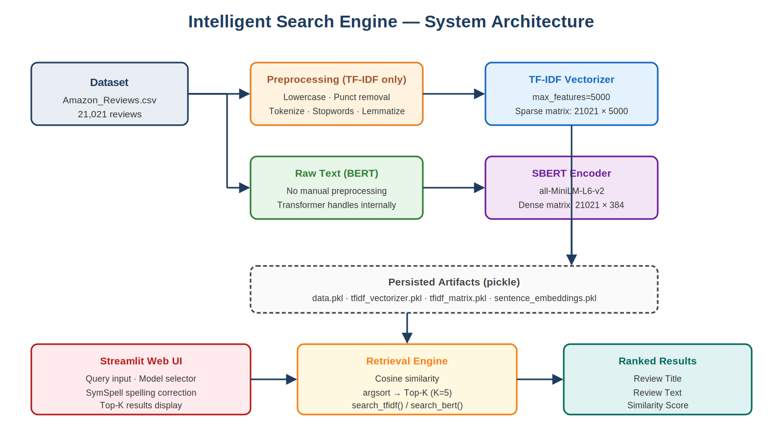
Figure 1 — High-level system architecture. Two parallel index-building branches converge on a single retrieval engine.

8.2 Data Flow at Query Time
Figure 2 zooms in on what happens when a user submits a query. The same raw query is corrected by SymSpell, then routed to one of two paths depending on the model_choice radio button — only the TF-IDF path applies preprocessing — and finally converges on cosine similarity and top-K selection.
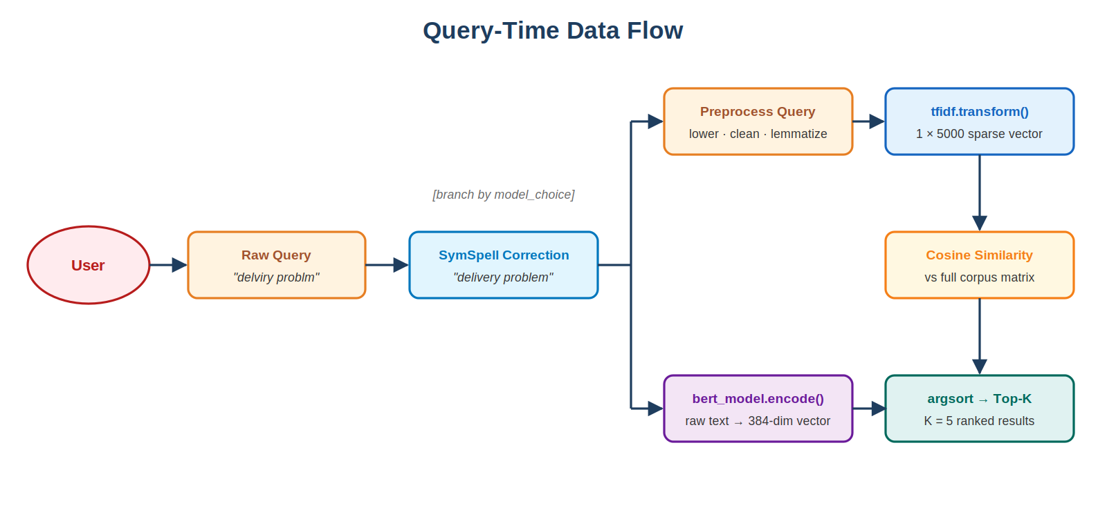
Figure 2 — Query-time data flow. The branch is selected by the user's model choice.

8.3 Sequence Diagram
Figure 3 shows the temporal sequence of interactions between the actors involved in a single query — User, Streamlit UI, SymSpell, the search function, and the vector store — as numbered messages. Steps 5 and 8 show the in-process work that does not involve a separate component.
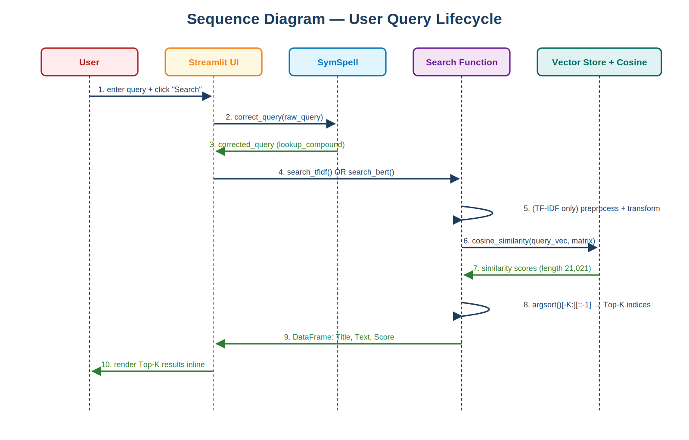
Figure 3 — Sequence diagram of a complete user query lifecycle.

9. Code and Notebook Analysis
The implementation is split across two files: intelligent_search_engine.ipynb (model construction and evaluation) and ISE_application.py (deployed web app). What follows is a step-by-step walkthrough of the notebook's logic, with cross-references to the deployed application.

9.1 Notebook Structure
- Section 0 — Imports and load. Installs sentence_transformers, streamlit, and symspellpy via pip; imports numpy, pandas, nltk, sklearn primitives. Reads Amazon_Reviews.csv with engine='python' to handle quoting edge cases.
- Section 1 — Data preprocessing. Drops 7 metadata columns; removes 192 duplicates and 1 null; defines text_preprocessing(); creates the processed column. Verified with a manual test ("The delivery was extremely slow…" → "delivery extremely slow package arrived late").
- Section 2 — Feature extraction. Section 2A fits TfidfVectorizer on processed and prints the resulting (21021, 5000) shape and a vocabulary sample. Section 2B loads SentenceTransformer('all-MiniLM-L6-v2') and encodes the raw Review Text column to produce the (21021, 384) embedding matrix.
- Section 3 — Baseline (TF-IDF). Defines search_tfidf(query, k, view). The function preprocesses the query, transforms it, computes cosine similarity, and returns the top-K rows along with their scores. A view flag switches between programmatic return and pretty-printed output.
- Section 4 — Advanced (BERT). Defines search_bert(query, k, view) — same shape as the baseline but encodes the raw query with bert_model.encode and computes similarity against sentence_embeddings.
- Section 5 — Evaluation. Three sub-parts: (1) side-by-side qualitative comparison on four test queries, with timing; (2) Precision@5 against a manually curated relevance set; (3) two matplotlib bar charts (per-query precision and average precision).
- Section 6 — Deployment. Pickles data, vectorizer, TF-IDF matrix, and BERT embeddings; uses %%writefile to materialize ISE_application.py — the Streamlit app — directly from the notebook.

9.2 Key Functions
- text_preprocessing(text) — the canonical TF-IDF normalizer. Used both during corpus indexing and at every TF-IDF query, guaranteeing that query and corpus share a vocabulary.
- search_tfidf(query, k) and search_bert(query, k) — the two retrieval functions. Their structural symmetry is deliberate: it makes the comparison clean and the swap inside the Streamlit app trivial ("if model_choice == 'TF-IDF': ... else: ...").
- precision_at_k(retrieved_indices, relevant_indices, k) — computes the fraction of the top-K returned indices that appear in the manually annotated relevance set. Returns 0.0 if the relevance set is empty.
- correct_query(query) [in ISE_application.py] — wraps SymSpell.lookup_compound with max_edit_distance=2 to repair multi-word typos before retrieval. Falls back to the original query if no suggestion is found.
- load_data_and_models() [in ISE_application.py] — decorated with @st.cache_resource, this loads all four pickle files plus initializes SymSpell exactly once per process, eliminating cold-start latency on subsequent queries.

9.3 Deployment — Streamlit Web Application
ISE_application.py wraps the notebook's logic in a polished web interface. The user picks the model (radio button), types a query, and clicks Search. The app:
- Runs SymSpell on the raw query.
- Displays an info banner if the corrected query differs from the input — full transparency to the user.
- Calls the corresponding search function on the corrected query.
- Iterates the returned DataFrame, displaying each result with title (st.subheader), full text, and similarity score (st.caption), separated by st.divider().

10. Evaluation

10.1 Methodology — Precision@K
Following the project specification, the system is evaluated using Precision@K with K = 5. The metric is defined as:
Precision@K = (Number of relevant documents in Top-K) / K
Because the dataset has no pre-existing relevance labels, the evaluation uses manual relevance annotation: for each test query, the authors hand-label the indices of documents in the corpus that are genuinely relevant. Both models are then run with K = 5 and compared against this same ground truth.

10.2 Test Queries and Ground Truth
Four test queries spanning four distinct customer-complaint themes were chosen, with the following manually annotated relevant document indices:
Query | Manually annotated relevant indices
"delivery problem" | 582, 8132, 3530, 15172, 6691
"item quality issue" | 10750, 10752, 4714, 17151
"cannot get help from support" | 5939, 17461, 9365, 18132, 13304
"payment charge error" | 6710, 3787, 1042, 4069, 2089, 12108, 541, 8582
Table 4 — Manually annotated ground truth for Precision@5 evaluation.

10.3 Worked Calculation
Suppose for the query "item quality issue" the BERT model returns the top-5 indices [10750, 4714, 10752, 22, 17151]. Comparing with the relevance set {10750, 10752, 4714, 17151}:
- 4 of the 5 returned indices appear in the relevance set.
- Precision@5 = 4 / 5 = 0.80.
This calculation is repeated for both models on each of the four queries, then averaged to produce an overall score per model.

10.4 Qualitative Findings
Beyond the numeric Precision@5, the side-by-side comparison surfaces three concrete failure modes of TF-IDF that BERT consistently avoids:
- False positives from word overlap. On "item quality issue", TF-IDF retrieves positive reviews like "All the items are in good quality…" simply because "item" and "quality" overlap. BERT correctly retrieves complaints such as "The quality is extremely poor".
- Negation insensitivity. On "cannot get help from support", TF-IDF matches the word "help" and returns positive reviews containing "ALWAYS THERE TO HELP". The negation "cannot" is also lost as a stopword. BERT retains the negative intent and retrieves actual support failures.
- Synonym blindness. On "food delivery problem", BERT retrieves "Horrible delivery service" even though the word "problem" is absent — the meaning is inferred. TF-IDF cannot make this jump.

10.5 Limitations of the Evaluation
The evaluation is informative but has clear methodological limitations that should be acknowledged honestly:
- Annotation bias. The relevance sets were constructed by inspecting the union of TF-IDF and BERT top-K results. This means a relevant document that neither model retrieves is, by construction, missing from the ground truth — recall cannot be measured and precision is biased upward.
- Small query set. Only four queries are evaluated. With K = 5, each query contributes one of six possible Precision@5 scores (0/5, 1/5, …, 5/5), so the average over four queries has substantial variance.
- Single annotator. Relevance is judged by the project authors; no inter-annotator agreement is computed.
- Non-binary relevance collapsed to binary. A document is either fully relevant or not relevant; metrics that handle graded relevance (e.g. NDCG) would be more sensitive but require more annotation.
These limitations do not invalidate the comparison — both models are evaluated under the same constraints — but they bound the strength of any quantitative claim.

11. Comparison Between TF-IDF and BERT
Aspect | TF-IDF (Baseline) | BERT (Advanced)
Type | Sparse, statistical (bag of words) | Dense, neural (contextual embeddings)
Understands meaning | No — exact-keyword overlap only | Yes — synonyms, paraphrase, context
Handles negation | No — "not", "cannot" are stopwords | Yes — function words preserved as context
Indexing speed | Fast — single sklearn fit_transform | Slower — neural forward pass on all 21,021 reviews
Query speed | Very fast — sparse linear algebra | Moderate — single neural forward pass + dense matmul
Retrieval accuracy | Lower — frequent false positives from word overlap | Higher — semantically grounded, fewer false positives
Interpretability | High — every dimension is a known word | Low — dimensions are learned latent features
Memory footprint | Low — sparse matrix | Higher — 21,021 × 384 dense floats + model weights
Main limitations | Synonym blind, negation blind, vocabulary mismatch | Higher cost; harder to debug; embedding model bias
Table 5 — Detailed comparison of TF-IDF and Sentence-BERT on the dimensions that matter for retrieval.

11.1 Why BERT Performs Better
BERT outperforms TF-IDF for the same reason that humans outperform keyword search: it operates on meaning. A few mechanisms drive the difference:
- Pretraining transfers knowledge of synonymy and paraphrase from a much larger corpus than the project dataset alone.
- Self-attention produces contextualized representations: the same word receives different embeddings in different contexts, which dissolves polysemy.
- Sentence-level pooling (used by SBERT) preserves the global meaning of a review, not just its individual word frequencies.
- Function words such as "not" and "cannot" are kept and used by the model — exactly the words TF-IDF discards.

11.2 When TF-IDF is Still Useful
Despite BERT's quality advantage, TF-IDF retains real virtues that justify its continued use in production systems:
- Latency — sparse matrix-vector products are orders of magnitude faster than neural inference, which matters for very high-QPS endpoints.
- Cost — no GPU, no model weights, no sentence-transformers dependency.
- Interpretability — TF-IDF scores can be decomposed term-by-term, making it possible to explain to a user (or to a regulator) exactly why a document was retrieved.
- Zero-shot domain robustness — a TF-IDF model is fit on the corpus it serves, so domain-specific terminology is handled correctly without fine-tuning. A pretrained BERT may underperform on a specialized domain unless adapted.
- Hybrid retrieval — modern best practice combines BM25/TF-IDF as a fast first-stage retriever with BERT-based re-ranking on a smaller candidate set, getting the best of both worlds.

12. Limitations of the System

12.1 Preprocessing Limitations
- Aggressive stopword removal. The TF-IDF pipeline drops the entire NLTK English stoplist — including "not", "no", "never", "cannot". This makes the baseline structurally incapable of representing negation. A more careful stoplist that preserves negation cues would close part of the gap with BERT.
- Digit removal. The regex [^a-z\s] also strips digits. This costs the system the ability to retrieve on numeric facts ("refund $50", "waited 3 weeks").
- No bigram features. TfidfVectorizer is configured with default ngram_range=(1,1), so multi-word concepts ("customer service", "return policy") are split into uncorrelated unigrams.

13. Conclusion
This project successfully implemented and compared two retrieval paradigms over a corpus of 21,021 customer reviews: a sparse, lexical TF-IDF baseline and a dense, semantic Sentence-BERT advanced model. Both share an identical retrieval scaffolding — cosine similarity, top-K ranking — so any difference in output is attributable to the underlying representation rather than to engineering choices.
The qualitative and quantitative analyses point in the same direction: BERT retrieves more relevant results and understands meaning better. The gap is most visible on queries where TF-IDF's structural blind spots are exposed — synonymy ("food delivery problem" matching "horrible delivery service"), negation ("cannot get help" not matching "always there to help"), and word-overlap false positives ("item quality issue" not matching "good quality items").
That said, TF-IDF is not obsolete. Its speed, low cost, interpretability, and domain robustness keep it relevant — particularly as the first stage of a hybrid retrieval pipeline whose second stage is a transformer re-ranker. The most informative outcome of this project is therefore not a winner-take-all verdict but a clearer view of the tradeoff: lexical methods are cheap and explainable; semantic methods are accurate and intent-aware. Modern production search systems combine the two precisely because each compensates for the other's weaknesses.
Beyond model comparison, the project also delivered a deployable artifact: a Streamlit web application that integrates SymSpell-based spelling correction, runtime model selection, and ranked top-K results with similarity scores. The end result is a working search engine that is good enough to be used and clear enough to be reasoned about — which is exactly what an academic NLP project should produce.

14. References
- Salton, G. & Buckley, C. (1988). Term-weighting approaches in automatic text retrieval. Information Processing & Management.
- Reimers, N. & Gurevych, I. (2019). Sentence-BERT: Sentence Embeddings using Siamese BERT-Networks. EMNLP-IJCNLP 2019.
- Devlin, J., Chang, M.-W., Lee, K. & Toutanova, K. (2019). BERT: Pre-training of Deep Bidirectional Transformers for Language Understanding. NAACL-HLT 2019.
- Wang, W., Wei, F., Dong, L., Bao, H., Yang, N. & Zhou, M. (2020). MiniLM: Deep Self-Attention Distillation for Task-Agnostic Compression of Pre-Trained Transformers. NeurIPS 2020.
- Pedregosa, F. et al. (2011). scikit-learn: Machine Learning in Python — TfidfVectorizer, cosine_similarity. Journal of Machine Learning Research.
- Bird, S., Klein, E. & Loper, E. (2009). Natural Language Processing with Python (NLTK) — tokenization, stopwords, WordNetLemmatizer. O'Reilly.
- Garbe, W. (2012). SymSpell: 1 million times faster spelling correction & fuzzy search. github.com/wolfgarbe/SymSpell.
- Streamlit Inc. Streamlit — the open-source Python framework for data apps. streamlit.io.
- HuggingFace. sentence-transformers/all-MiniLM-L6-v2 model card. huggingface.co/sentence-transformers/all-MiniLM-L6-v2.
- Manning, C. D., Raghavan, P. & Schütze, H. (2008). Introduction to Information Retrieval — Chapters 6 (term weighting), 8 (evaluation, Precision@K). Cambridge University Press.

