**TERRAFORM**

**What we will learn in this course?**

1. **Terraform Fundamentals: (5 hrs)**

* **Commands**
* **Providers**
* **Settings**
* **Resource**
* **Variables**
* **Data source**
* **Loops**
* **Meta-arguments**

1. **Real-Time Projects (approx. 25 demos) Incremental setup (20 hrs):**

* **AWS VPC 3-tier architecture**
* **AWS instances and Security group**
* **AWS CLB**
* **AWS ALB**
* **ALB redirections configuration**
* **AWS end to end configuration from route 53 to RDS**
* **AWS Autoscaling**
* **AWS NLB**
* **AWS Cloudwatch alarm for ALB, ASG and CIS**
* **Terraform local modules**
* **Modules build from scratch**
* **Leverage existing terraform modules and change code as per your need**
* **Terraform remote state storage**
* **AWS Iac devops (code pipeline, code build with terraform):**

**We will create two environments: Dev & PROD**

* **Terrafrom with Packer and Jenkins**
* **Terraform with Jenkins ECR and ECS**

**Exam preparation: - HashiCorp Certified: Terraform Associate**

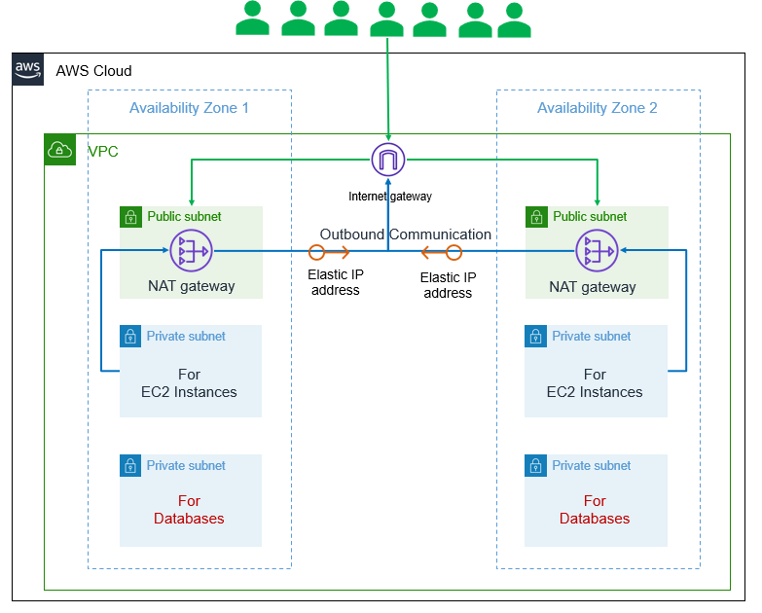

1. **AWSVPC 3-Tier architecture**
2. **AWS VPC + EC2 Instance + Security Groups**
3. **AWS VPC + EC2 Instance + Security Groups +  
   AWS ELB Classic Load Balancer**
4. **AWS VPC + EC2 Instance + Security Groups +  
   AWS ALB Application Load Balancer**
5. **AWS ALB Routing**
6. **From Route 53 to RDS using Terraform**
7. **Autoscaling using Terraform**
8. **Terraform remote state data source**
9. **Iac devops using code pipeline and code build**

