**How to Run the Common Matrix Code**

**Welcome to the instruction of "How to Run the Common Matrix Code" – version 0.2. This code was tested on Windows and Python version 3.8.5 only.**

**If you encourage any problems or something is misunderstood, please contact me –** [**skhalfin@campus.technion.ac.il**](mailto:skhalfin@campus.technion.ac.il)

**Step 1 – download python**

Download python 3: <https://www.python.org/downloads/release/python-385/>

You probably will need the [Windows x86-64 executable installer](https://www.python.org/ftp/python/3.8.5/python-3.8.5-amd64.exe).

In install check the "Add Python 3.8 to Path"

Select "Install Now" and wait till it finished.

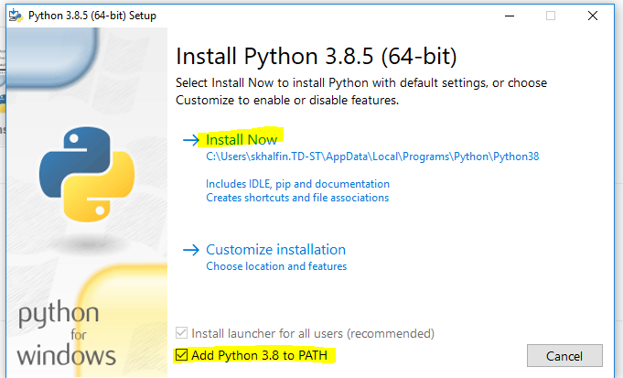

**Step 2 – unzip the code folder**

Inside the unzipped folder:

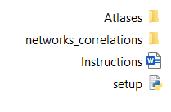

**Step 3 - CMD**

Run windows Command Prompt (cmd) from the unzipped folder

**Step 4 - setup**

Run **setup.py install** inside the Command Prompt window.

You will see the following folders:

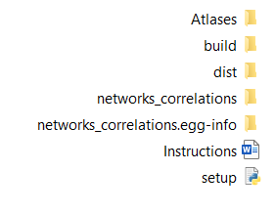

**Step 5**

Enter to networks_correlations folder: run **cd networks_correlations**

**Step 6 – main script**

The simplest variation will create:

1. .png file with common correlation matrix.
2. Excel file with common correlation and covariance matrix
3. Excel file with all between and within correlations

You will also see in the output folder:

**subjects_data.pkl** = Mostly for inner use. dictionary. Each subject contains correlation matrix, covariance matrix and time series.

**error_file_postProcessing.txt** = some of the errors will be written here

Output:

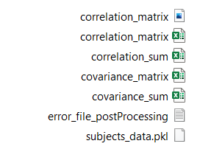

The command:

main.py --preproc_folder **FOLDER WITH NIFTY FILES** --atlas **GORDON or POWER** --out_folder **YOUR OUTPUT FOLDER**

Variables explanation

main.py = the script name

**--preproc_folder** = Insert the folder with your preprocessed nifty files that you want to create the correlation matrix for. The files can be of types .nii or .nii.gz. Other files will be ignored.

**--atlas** = Choose between Gordon and Power atlases. **If you want to add other atlases, please contact the me😊**

**--out_folder** = Insert the path to the output folder.

Another possible variables:

**--networks** = add this variable if you want common matrix for some networks and brain plot with connections within and between these networks. See the networks available for each atlas in the appendix section.

**--min_r** = for the brain plot use. Default is 0.7. Plot only connection with R value greater (or lower for negative correlations) than min_r.

Example:

main.py --preproc_folder **FOLDER WITH NIFTY FILES** --atlas **GORDON** --out_folder **YOUR OUTPUT FOLDER** --networks **Default** --min_r **0.9**

Output:

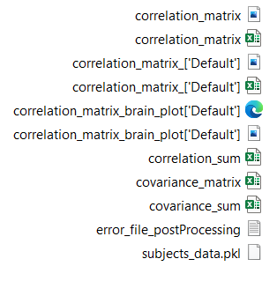

**Step 7 - Other scripts**

The main script can take a while because it is creating the subjects dictionary and calculating the common matrix.

After you run the main script, you can run sub scripts if you want another networks visualizations.

**Visualize_correlation.py**

Will create correlation matrix plot and brain plots with within and between correlations.

Example:

visualize_correlation.py --corr_mat **PATH TO CORRELATION MATRIX EXCEL FILE** --networks **VentralAttn DorsalAttn** --out_folder **YOUR OUTPUT FOLDER** --atlas **..\Atlases\MNI_Gordon.txt** --min_r **0.8**

Variables explanation

visualize_correlation.py = the script name

**--** **corr_mat** = Insert the path to the common correlation matrix from the main script output.

**--networks** = will output plot of correlation matrix and brain correlation only of these networks. Will output also excel file with those networks.

**--out_folder** = Insert the path to the output folder.

**--atlas =** Insert the path to atlas coordinates file: MNI_Power.txt or MNI_Gordon.txt. They are located in the Atlases folder

**--min_r** = for the brain plot use. Default is 0.7. Plot only connection with R value greater (or lower for negative correlations) than min_r.

Output:

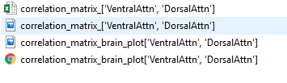

**Visualize_covariance.py**

Will create covariance matrix plot – **will not output with the main script**.

visualize_covariance.py --cov_mat **PATH TO COVARIANCE MATRIX EXCEL FILE** --networks **VentralAttn DorsalAttn** --out_folder **YOUR OUTPUT FOLDER** --vmin **-20** --vmax **20**

Variables explanation

visualize_covariance.py = the script name

**--** **cov_mat** = Insert the path to the common covariance matrix from the main script output.

**--networks** = will output plot of covariance matrix only of this networks. Will output also excel file with those networks.

**--out_folder** = Insert the path to the output folder.

**--vmin and --vmax** = minimum and maximum values for matrix plotting. In contrast to correlation matrix where the values range from -1 to 1, in the covariance matrix values can range at any scale and you must choose how to represent the output.

Output:

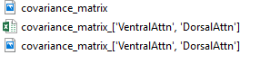

**Appendix**

Networks of Gordon atlas

SMhand, SMmouth, CinguloParietal, Cingulo Operc, Auditory, Default, Visual, FrontoParietal, Salience, VentralAttn, DorsalAttn, None, RetrosplenialTemporal

Networks of Power atlas

SSH, SSM, CO, Auditory, DMN, Memory, Visual, FP, Salience, Subcortical, VAN, DAN, Cerebellum, Uncertain