Diabetes Risk Analysis and Predictive Modeling
Professional portfolio report for a client-style diabetes data analysis project.

Executive Summary
This project identifies the strongest indicators associated with diabetes and compares machine learning models for risk prediction.

Methodology
The workflow includes data quality assessment, invalid-zero treatment, median imputation, outlier capping, exploratory analysis, visualization, model training, and model evaluation.

Key Findings
Glucose is the strongest diabetes risk indicator in the dataset. BMI and age also show meaningful association with diabetes outcome.

Recommendations
Healthcare teams should monitor glucose, BMI, and age-group risk segments, and use predictive models as prioritization tools rather than diagnostic replacements.

Selected Visualizations
03 Correlation Heatmap
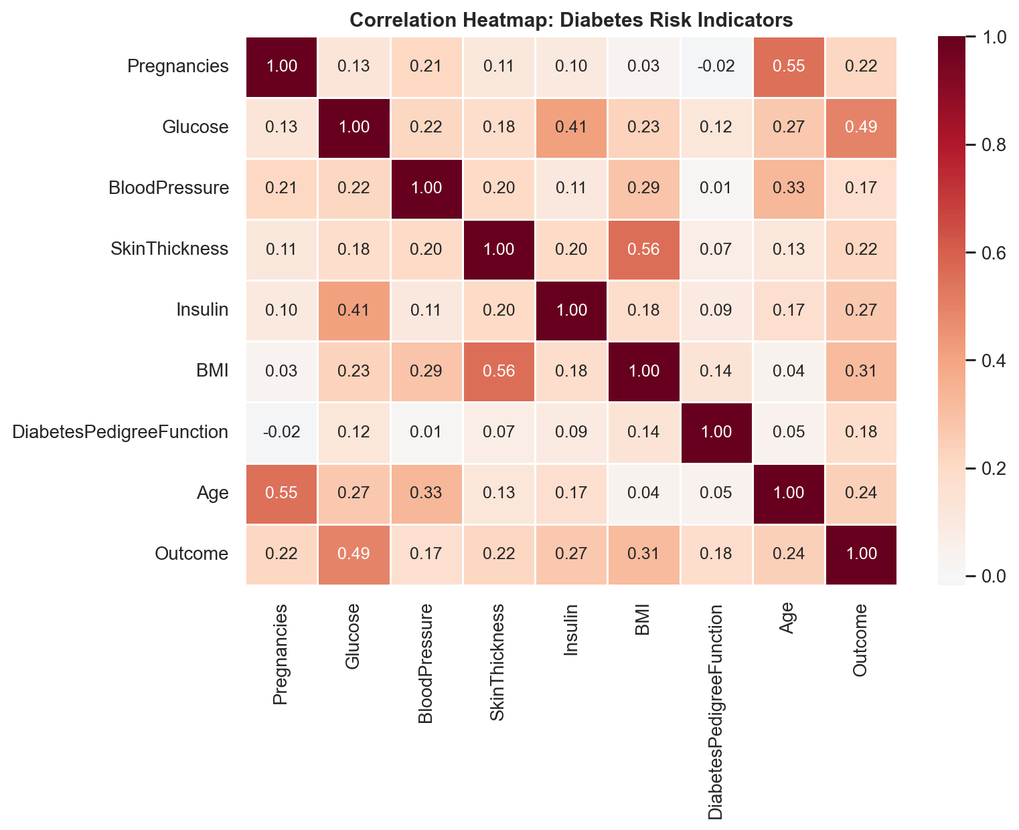
04 Scatter Glucose Bmi
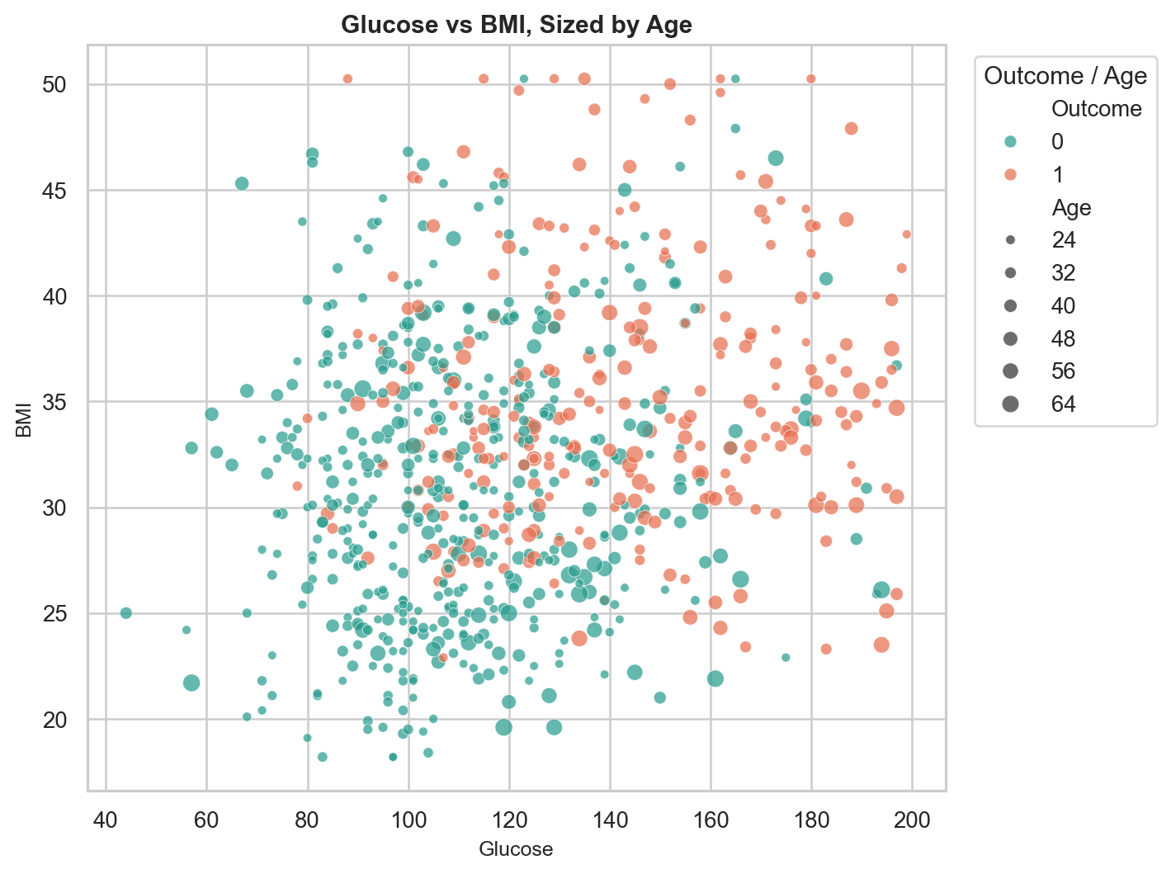
07 Model Performance Comparison
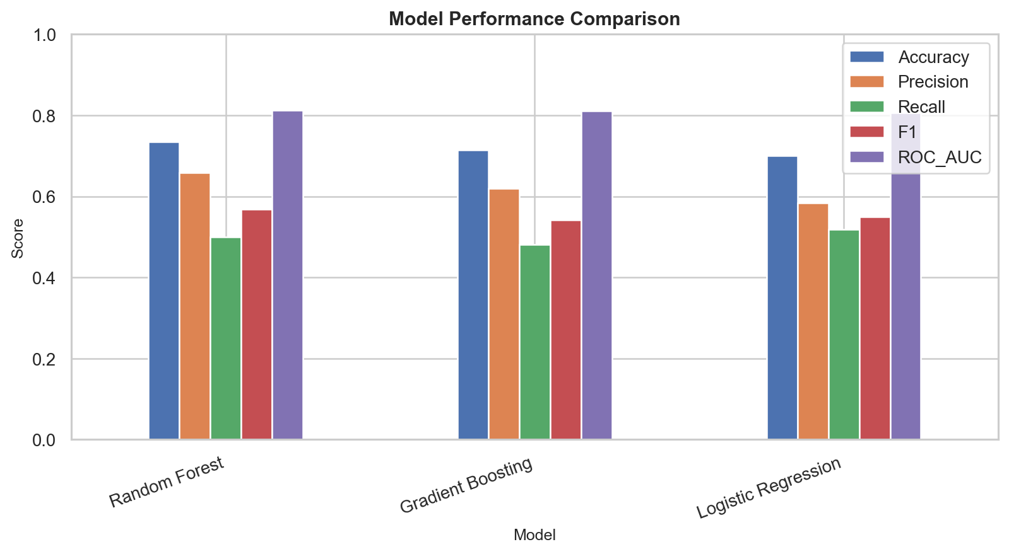
10 Feature Importance
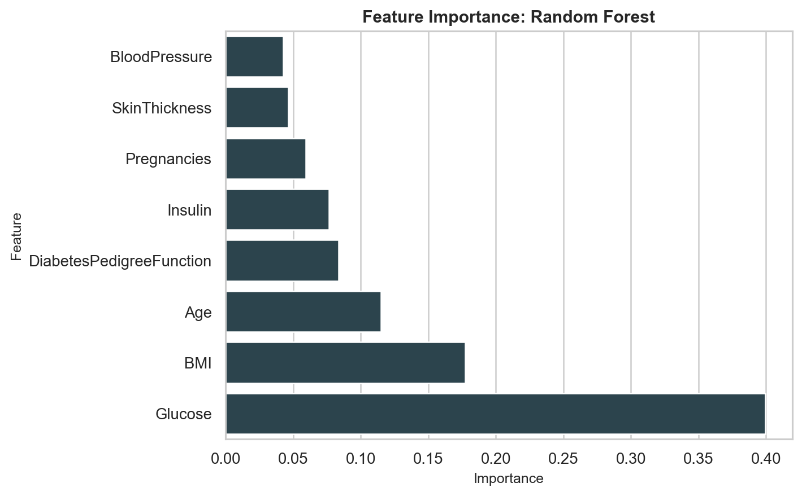

Full Markdown Report
See: Diabetes_Risk_Analysis_Report.md

