Computing Coursework 2 – Solving engineering problems with a programming language
Name: Khalid Aldammak
Student ID: 20715840

Add the relevant parts to the various sections below. Once complete, add this document to the .git repository and submit it together with your code, text files and functions.

Task 1 – read temperature data, plot, and write to a log file
- Include a photograph of the implementation here.
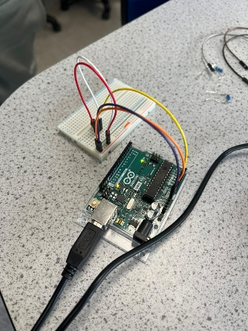
- Include the plot as an image here.

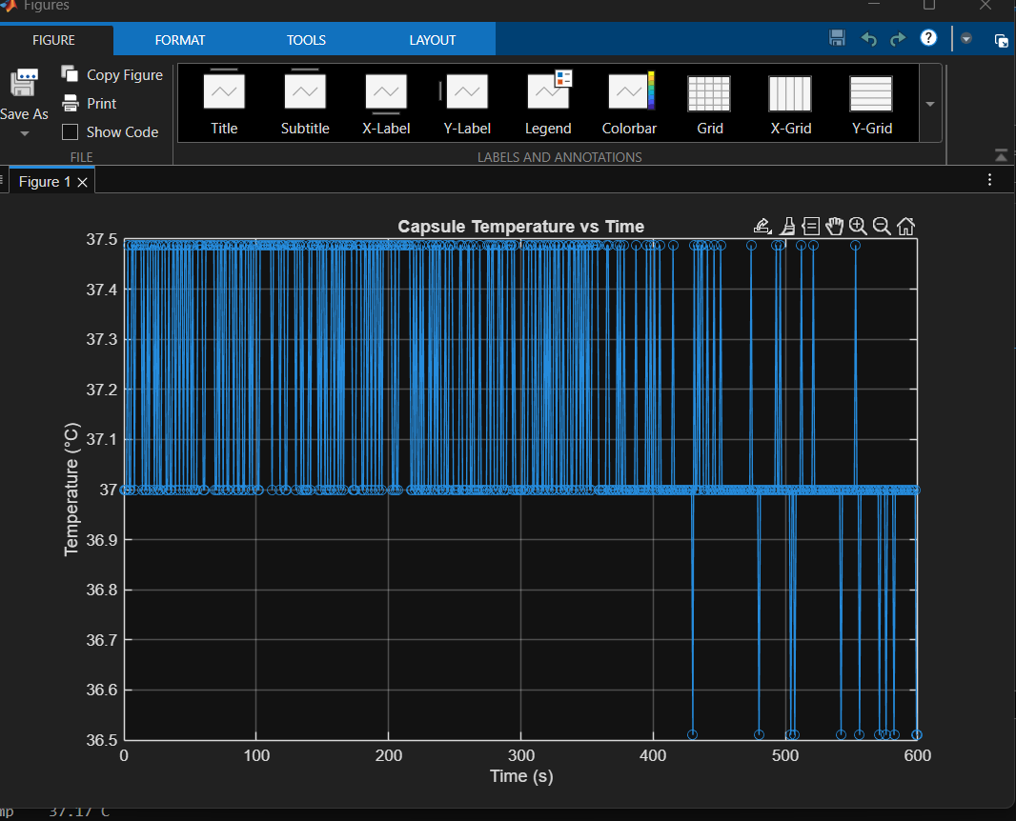

TASK 2 – LED temperature monitoring device implementation
- Include a photograph of the implementation here.
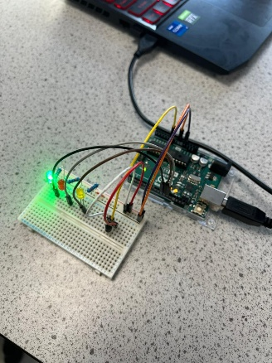
- Include your initial flowchart here.

- Include the plot as an image here.
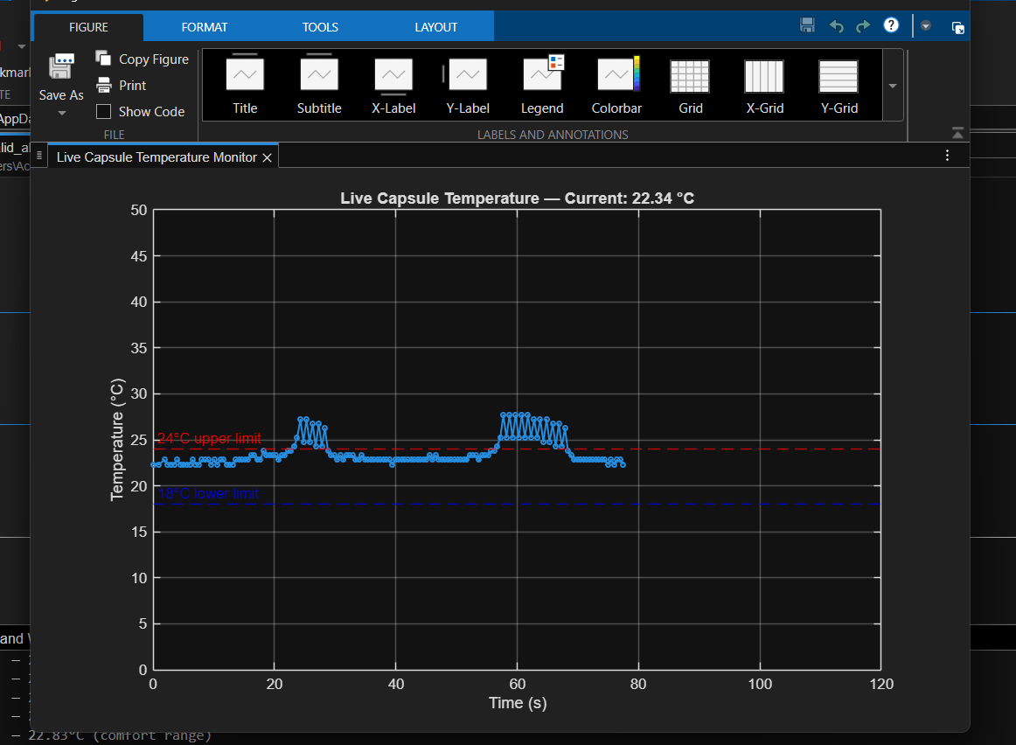
- Include your final flowchart here.

TASK 3 – ALGORITHMS – TEMPERATURE PREDICTION
- Include your initial flowchart here.

Task 4 – reflective statement
- Add your reflective statement here.

This project gave me useful experience using MATLAB programming to tackle a real-world engineering challenge that involved controlling and monitoring temperature in real time. Ensuring dependable communication between MATLAB and the Arduino hardware was one of the biggest obstacles faced during the development process. The connection would occasionally become unstable or need to be reinitialised, necessitating thorough debugging and knowledge of MATLAB's hardware interface functionality.
Hardware implementation presented another difficulty, especially when it came to wiring the LEDs and guaranteeing their operation. Unexpected behaviour was initially caused by problems like improper polarity, loose connections, or mismatched pins, which needed to be fixed by methodical debugging. Additionally, great thought had to be given to controlling timing within loops to guarantee accurate data capture and proper LED flashing behaviour.

The effective integration of hardware and software components was one of the project's main advantages. The system was able to gather temperature data in real time, process it, display it in live graphs, and react with LEDs. The code's structure and readability were enhanced by the usage of distinct functions (such as temperature monitoring and prediction), exhibiting sound programming technique and modular design.

In order to gain a deeper understanding of some MATLAB functions and programming techniques that were not fully covered in lectures, independent study was also done throughout the development of this project. The general quality of the code was enhanced by this added knowledge, especially in areas like debugging, function structure, and more efficient data handling. As a result, methods learned through independent research and outside sources may be reflected in some aspects of the implementation and remarks.

The system's sensitivity to noise in sensor data is one of its limitations; this might have an impact on the prediction algorithm's accuracy as well as the rate of temperature change. More sophisticated filtering methods could increase reliability even while employing many data points helps lessen short-term variations. Furthermore, the prediction model makes the assumption that change will occur at a consistent rate,
Future enhancements can include adding more sensors for redundancy and higher accuracy, creating a graphical user interface (GUI) for better usage, and using digital filtering techniques to reduce noise. Additionally, system performance would be improved by fine-tuning the prediction model to take non-linear temperature variations into consideration.

All things considered, this project greatly enhanced my knowledge of MATLAB programming, real-time data processing, and hardware interface while also honing my problem-solving and debugging abilities in an engineering setting.

