4DK4: Lab 3 Matthew Wong: 1141381, Roy Perez: 1132788

Computer Engineering 4DK4

Computer Communication Networks

Lab 3 Report

Matthew Wong | Roy Perez
1141381 | 001132788



1

4DK4: Lab 3 Matthew Wong: 1141381, Roy Perez: 1132788

Experiments

2. The plot below shows the tradeoffs between the blocking probabilities and the number of channels for various offered loads. We can see from the plot that as we increase the offered load, the number of trunks required to maintain the 1% performance also increases. We also can see that as the offered load increases, the number of trunks does not increase linearly. For example, at an offered load of 4 Erlangs, 9 trunks are needed in order to maintain the 1% probability performance. At an offered load of 9 Erlangs, 16 trunks are needed. This is due to the multiplexing gain or the trunking efficiency. As the system size increases, it becomes more efficient in managing the use of the number of trunks. We have compared our results with an online Erlang B calculator and we can confirm that they are consistent.

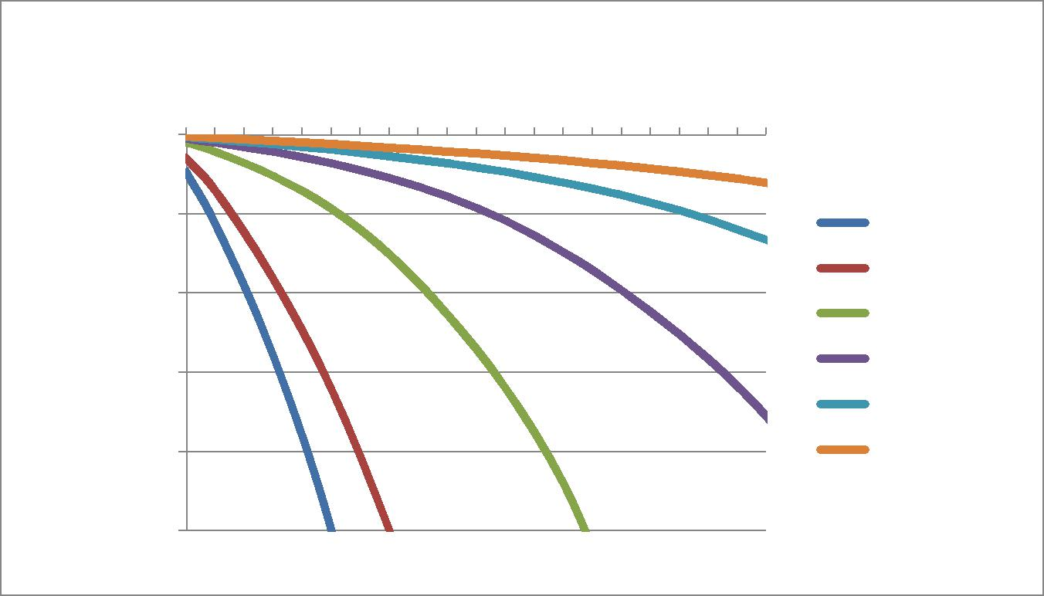

Blocking Probability

Blocking Performance

1 | 1 | 2 | 3 | 4 | 5 | 6 | 7 | 8 | # of Trunks
 |  |  |  |  |  |  |  |  | 9 10 11 12 13 14 15 16 17 18 19 20 21
0.1 |  |  |  |  |  |  |  |  | Offered Loads
0.1 |  |  |  |  |  |  |  |  | A = 0.5 Erlang
0.01 |  |  |  |  |  |  |  |  | A = 1 Erlang
0.01 |  |  |  |  |  |  |  |  | A = 4 Erlangs
0.001 |  |  |  |  |  |  |  |  | A = 9 Erlangs
0.001 |  |  |  |  |  |  |  |  | A = 16 Erlangs
0.0001 |  |  |  |  |  |  |  |  | A = 25 Erlangs

0.00001

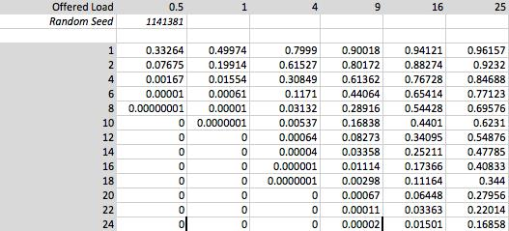

2

4DK4: Lab 3 Matthew Wong: 1141381, Roy Perez: 1132788
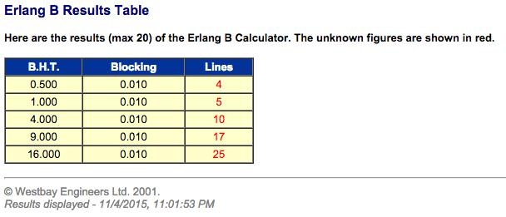

Online Erlang B Calculator: http://www.erlang.com/calculator/erlb/

3. Below is a plot of the maximum offered loading (in Erlangs) versus the number of cellular channels needed to achieve this blocking probability performance. As you increase the number channels, the offered load also increases.
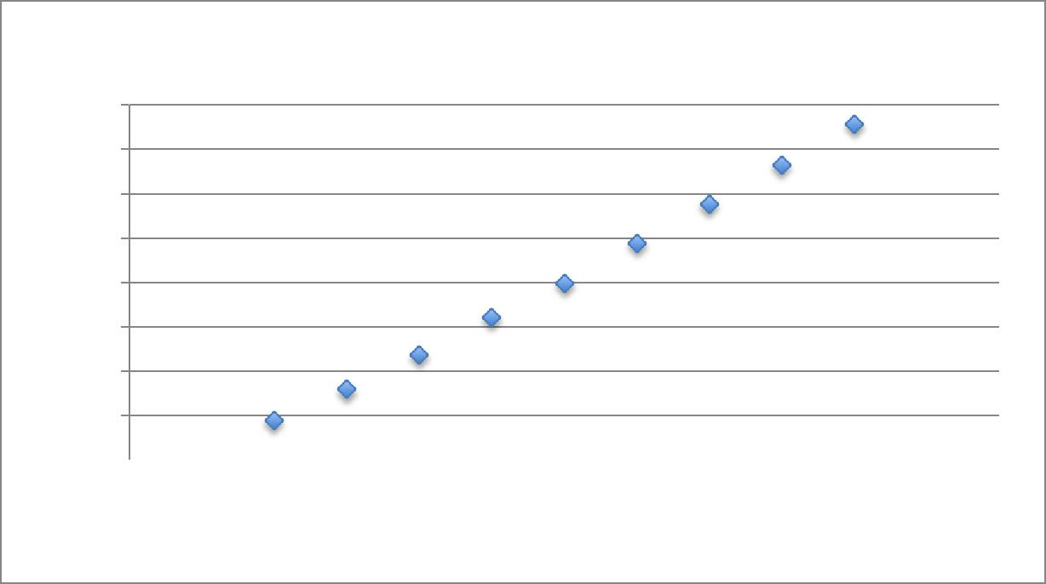

Maximum Load vs. Number of Channels

Offered Load (Number of Erlangs)

40

35

30

25

20

15

10

5

0  0 10 20 30 40 50 60

Number of Channels

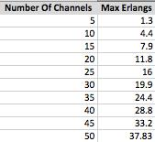

3

4DK4: Lab 3 Matthew Wong: 1141381, Roy Perez: 1132788

4. The plot below shows that as the average time a customer is willing to wait increases, the number of operators required is reduced. This makes sense practically, because if a call center is very busy with few staff to answer calls, customers must wait longer in the queue (or if they don’t want to wait, they will eventually hang up).
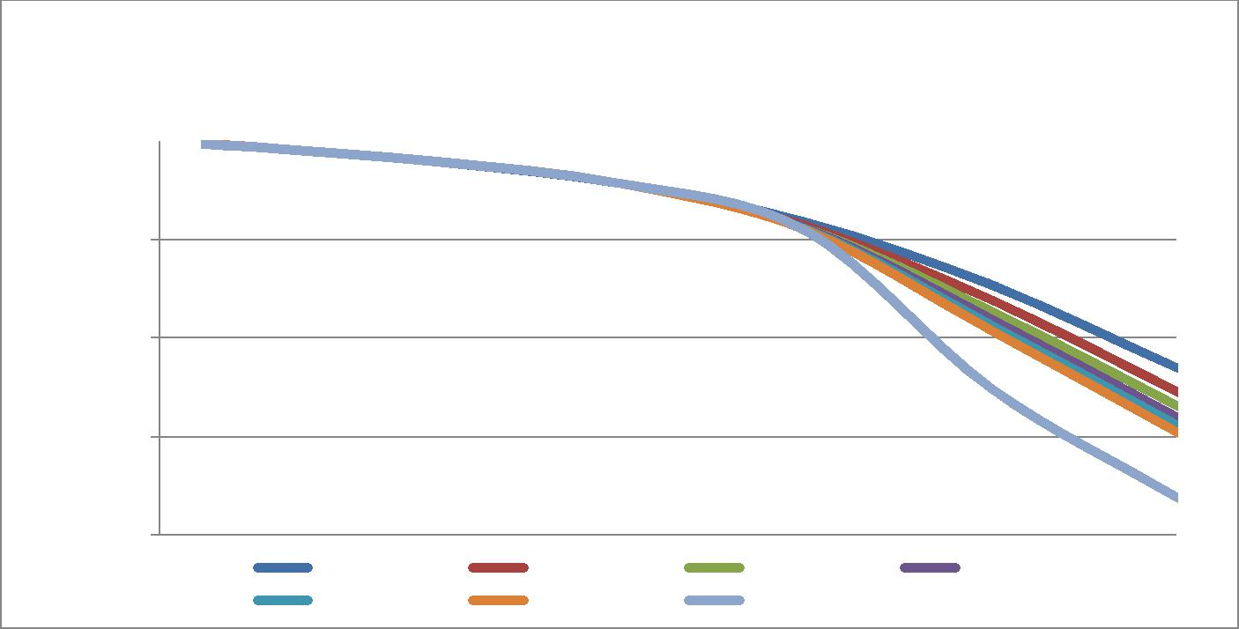

Blocking Performance

Blocking Probability
# of Operators
0 5 10 15 20

1

0.1

0.01

0.001

0.0001

W = 10 | W = 20 | W = 30 | W = 40
W = 50 | W = 60 | W = 300

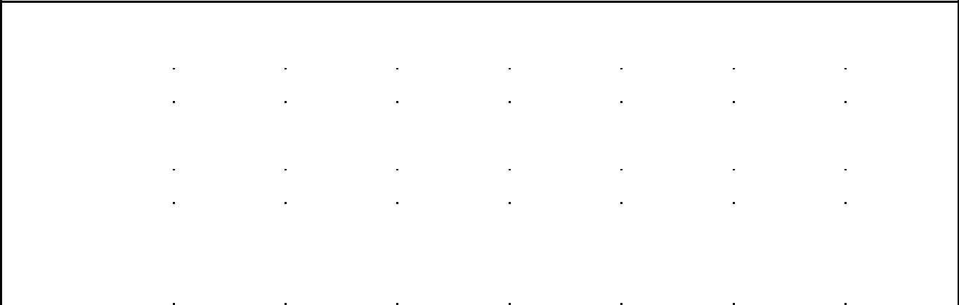
Number of Trunks
 | 1 | 2 | 6 | 10 | 14 | 18 | 22
10 | 0.937605 | 0.87506 | 0.62489 | 0.37448 | 0.150765 | 0.03469 | 0.005015
20 | 0.93761 | 0.874995 | 0.625155 | 0.374885 | 0.137135 | 0.02443 | 0.002895
30 | 0.937575 | 0.87495 | 0.625185 | 0.374875 | 0.131535 | 0.018815 | 0.00208
40 | 0.93757 | 0.87492 | 0.625165 | 0.37499 | 0.129125 | 0.01564 | 0.001595
50 | 0.93758 | 0.874905 | 0.62506 | 0.375025 | 0.127525 | 0.01351 | 0.00133
60 | 0.937545 | 0.874885 | 0.62506 | 0.374905 | 0.12566 | 0.012 | 0.00113
300 | 0.937245 | 0.874365 | 0.624155 | 0.374535 | 0.12279 | 0.00307 | 0.000245

Here we can see that with a low number of channels available, the mean queue waiting time is very close to their respective W value.

4

4DK4: Lab 3 Matthew Wong: 1141381, Roy Perez: 1132788
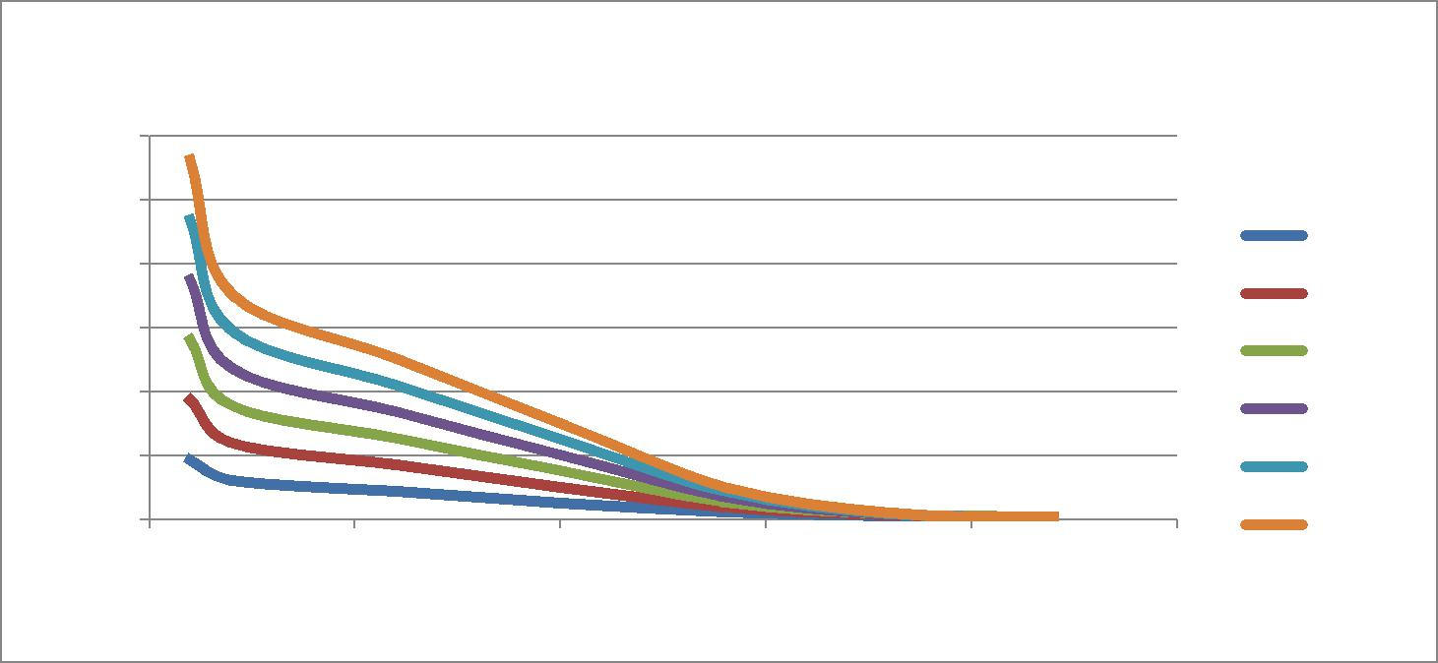

Mean Queue Time vs. Number of Channels

Mean Queue Time

60 |  |  |  |  |  | W = 10
50 |  |  |  |  |  | W = 10
40 |  |  |  |  |  | W = 20
30 |  |  |  |  |  | W = 30
20 |  |  |  |  |  | W = 40
10 |  |  |  |  |  | W = 50
0 | 5 | 10 |  | 15 | 20 | W = 60
0 | 5 | 10 | Number | 15 | 20 | 25
 |  |  |  | of Channels

 | 1 | 2 | 6 | 10 | 14 | 18 | 22
W | Random Seeds: 1141381, 1132788
10 | 9.37908 | 6.124673333 | 4.37159 | 2.628553333 | 1.228503333 | 0.58431 | 0.338293333
20 | 18.7578 | 11.95631667 | 8.539823333 | 5.13042 | 2.017466667 | 0.745233333 | 0.37376
30 | 28.13487 | 17.7885 | 12.70559667 | 7.62629 | 2.798876667 | 0.828066667 | 0.391586667
40 | 37.513545 | 23.62035667 | 16.86833333 | 10.12922667 | 3.594873333 | 0.884236667 | 0.402683333
50 | 46.89222 | 29.45183 | 21.03274333 | 12.63041333 | 4.376983333 | 0.942303333 | 0.406863333
60 | 56.26813 | 35.28242 | 25.19567333 | 15.12881667 | 5.115773333 | 0.989333333 | 0.413063333
300 | 281.25513 | 175.14512 | 124.9948167 | 75.07396667 | 24.62498 | 1.185363333 | 0.43977

5. Using the Erlangs C formula with the following parameters, we get an average failure rate of 15.4% for t = 15 second service target time.

Number of Channels: 55

Mean Call Time: 4 Minutes
Calls per Minute: 12
Erlangs (A) = 4 * 12 = 48
W(t) = 84.6% success, 15.4% failure.

5

4DK4: Lab 3 Matthew Wong: 1141381, Roy Perez: 1132788

In our simulation, we get an output of:
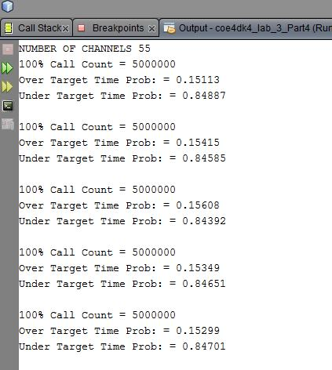

The average if the under target time is the same as expected 84.6%.

Code Changes

Part 2: -Add loop for number of channels used
-add number_of_channels field for sim_data to be fetched instead of constant -change output functions for more easily parsed data

Part 3: -add for loop to increment meanCallTime by small fraction -change output functions for more easily parsed data

Part 4: -add fields to sim data: number_of_hangups, accumulated_queue_time, busyOperatorFifoQueue
-add field to Call_Ptr: giveUpTime -initialize these fields in Main.C
-in call_arrival_event(), if call is blocked, set giveUpTime, place call in queue -in end_call_on_channel_event(), after call leaves channel, check
busyOperatorFifoQueue’s for calls, if it is not timed out, put it in channel and schedule end call on channel.
-change output functions for new variables and more easily parsed data Part 5 (from code in Part 4):
-in end_call_on_channel_event(), check if call has been queued for more than target time, if so, increment failed target time counter
-ignore giveUpTime, always place in channel on departure

6

