McMaster university

3sk3 Course project 2

image Contrast ENHANCEMENT

**Algorithm**:

Khalid asad

1147299

april 3rd 2014

1. Read in image using *imread* and save into variable In.
2. Get histogram of the image and store into variable H.
3. Divide each element of the histogram by the amount of pixels in the image and store into variable P.
4. Use *linprog* function and store result in C.
5. Calculate sum for each pixel and store into variable S.
6. Reshape S into Out using size of input image then convert to 8bit int to get final matrix.
7. Output results.

**Complexity**:

The algorithm complexity is O(n) due to the fact that there are 2 instances of loops; one traversing through color values and one traversing through the individual pixels in the input image.

**Constraints**:

1. Upper bound of a 256x1 matrix filled with threes causes range of each value to be between 0 and 3.

Having a value of 10 as the upper bound causes sparseness:

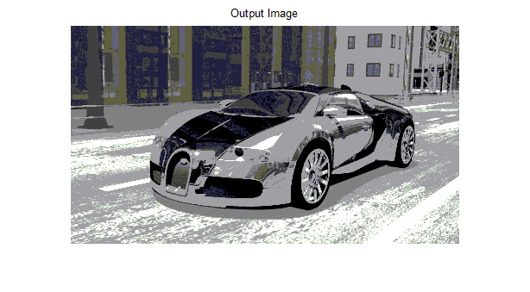

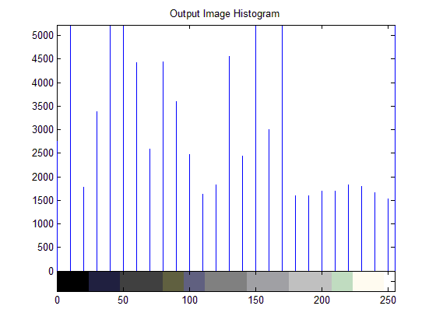

Having a value of 3 as the upper bound limits sparseness for a better image

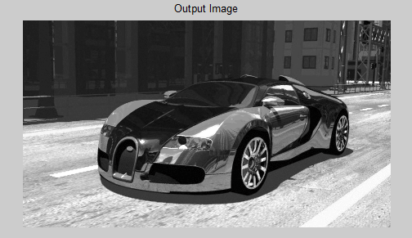

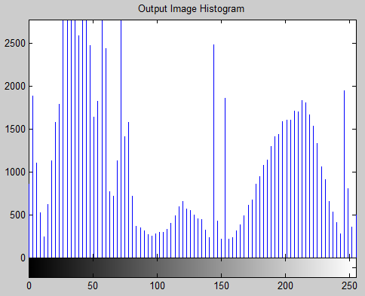

1. Lower bound of a 256x1 matrix filled with zeroes causes a range between 0 and 3  
   increasing this lower bound causes no change from input image  
   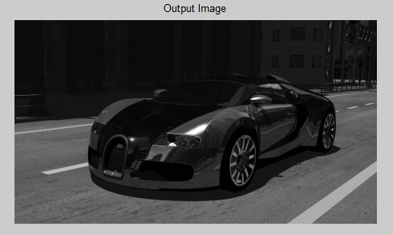  
   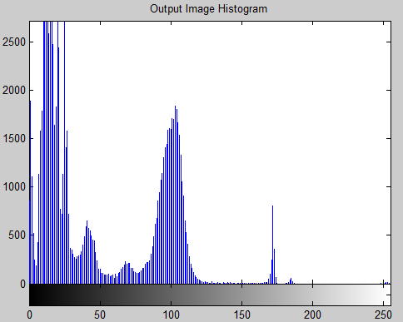
2. Changing the A value to a zero matrix causes higher intensity of whiteness.  
   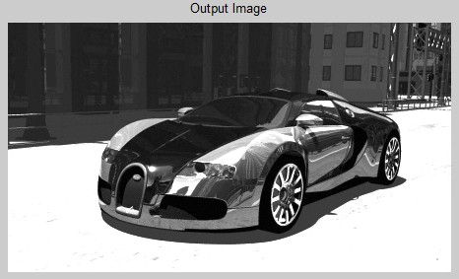  
   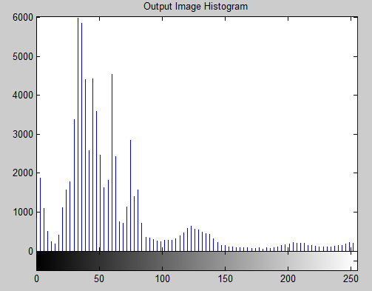
3. Having a b value of 255 causes color ranges to stay in between black and white.
4. We must multiply the P variable by a negative to get the negative of the required image. This is because we used histogram values that were divided by the amount of pixels.
5. Aeq and Beq are set to [] because no equalities exist.

**Results**:

Now we will show an image contrast enhancement using an input image of a car:

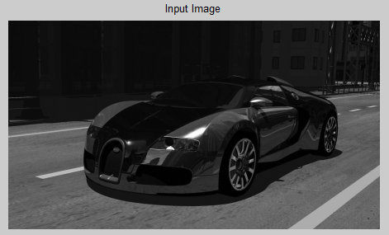 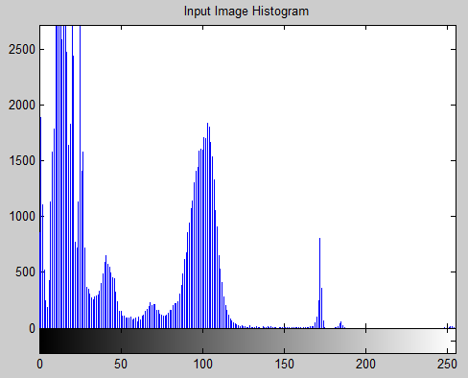 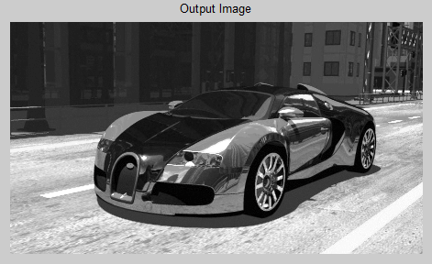 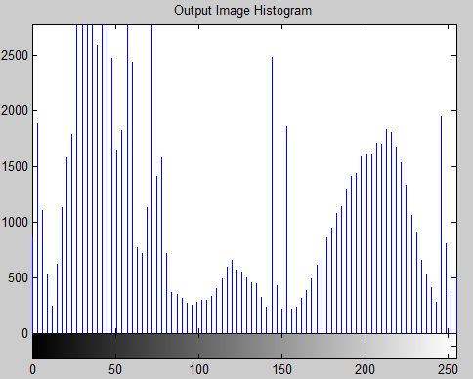

Again using an image of a brain X-ray:

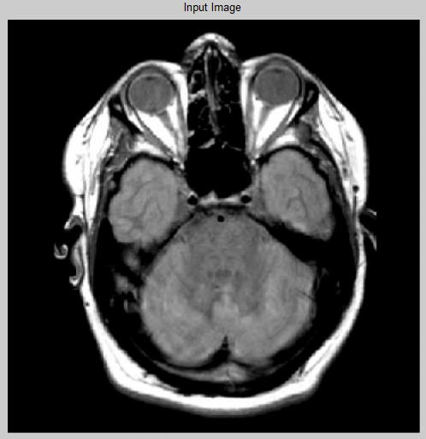 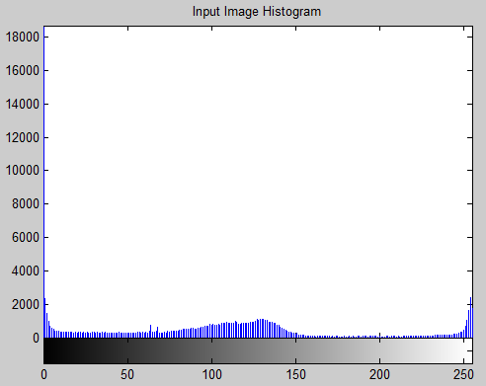 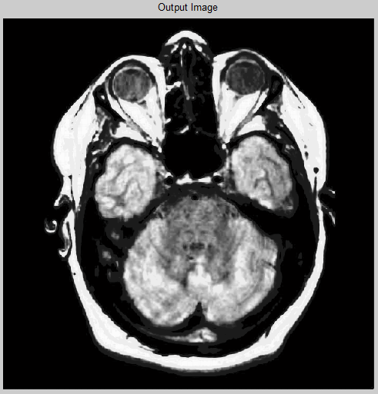 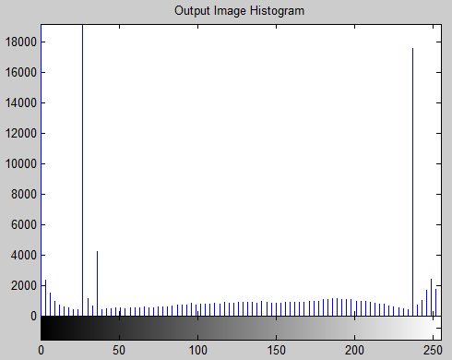

**Conclusion**:

The algorithm produced performs well with all sorts of black and white images. The Monotonicity and range of the mapping function conditions were both met with success. Although this algorithm produced good images, with more refined constraints, possibly a better image than Dr. Wu’s contrast enhancement could be achieved. Using this algorithm, I achieved a run time of 0.884s. This was a very interesting project and much knowledge of contrast enhancement was gained.