**SOFTWARE ENGINEERING**

**PROJECT TITLE:** CharityHub

**SECTION:** C

**COURSE INSTRUCTOR:** MD. SHAMSUR RAHIM

**DATE OF SUBMISSION:** 1st November, 2017

**GROUP MEMBERS:**

1. **Hasan, Khalid Ibne 16-31183-1**
2. **Jenia, Tanjima Nasreen 16-31237-1**
3. **Rahman, S M Afiqur 16-31093-1**
4. **Sarkar, Christine Monisha 16-31255-1**

**PROBLEM STATEMENT:** In Bangladesh, there are thousands of NGOs who work for child in need. To carry out their activities these organizations rely on sponsorships, volunteers and support from different sectors. Although there are people willingly want to help these under-privileged children, many of them can’t decide how to help these children, what NGO they should choose to sponsor, how they can communicate with them. It’s quite a bit of work to go each NGO website and collect information.

**SOLUTION:** We are proposing a mobile app which can work as a portal for NGOs. Prominent NGOs of our country will be enlisted in the app and those who wants to sponsor can decide their preferred NGO visiting respective profile of the NGOs in the app. The core idea is to bring the NGOs under one roof so that a bridge establishes between the sponsor and the NGOs. Using the app donators can donate toys, books, cloths and can track whom they are giving these away.

**FEATURE LIST:**

* Profiles of all prominent NGOs
* Option to sponsor a child
* Option to donate money
* Option to donate cloths
* Option to donate books
* Option to donate toys
* Option to become volunteer
* Donation tracking
* Events of different NGOs
* Login/Signup

**USER STORY:**

The home page has options for login, signup and ongoing activities by different NGOs.

CharityHub has two types of account. One is “Donor” another is “Volunteer”. Both need to login using username and password.

“Donor” page/class has three functions. He can Donate, Track and see history of his donations.

The Donate buttons prompts the user to select Donation Type. They’re:

* Donate Clothes
* Donate Toys
* Donate Money
* Donate Study Materials
* Become a Volunteer

When Donor selects one donation type, then HE’S SHOWN THE ORGANIZATIONS WHO’RE RECEIVING. He then selects his donation organization likewise and the organization then receives the donation from the donor. The receiving organization also provides the donor with a tracking number for certain donations, so that the donor can know where his donations are going, via which organization.

“Track” button for donor helps the donor to know about the present condition of the donation. Donor can see the transition of his donation staring from his donation to the organization, ending in the hands of the donatary.

The “History” button shows the donor about all his previous donations, and their full details with Tracking.

If the donor wants to VOLUNTEER, he’s then prompted to select his favorite VO. The VO then contacts donor for volunteering.

The Volunteer Organization(VO) page/class has three functions. They’re:

* Start Donation Event
* See who’s Donating
* Current Donations
* Recruit Volunteers

VO can start a Donating Event if they’re ready to take donations for different purposes. The need to GIVE A MOTIVE OF THE DONATIONS, FOR WHOM THEY’RE TAKING IT AND WHERE THEY’RE TAKING IT TO DONATE.

VO can see a general view of donors who’re donating, and what they’re donating by pressing the See Who’s Donating button.

Current Donations button helps the VO to see the Donors of their ongoing Donation Events. The VO can contact the donor by pressing the Contact Button in Current Donations page.

By selecting the RECRUIT VOLUNTEER button VO can see those who are interested to work with them, and contacting them eventually.

**USE-CASE DIAGRAM**

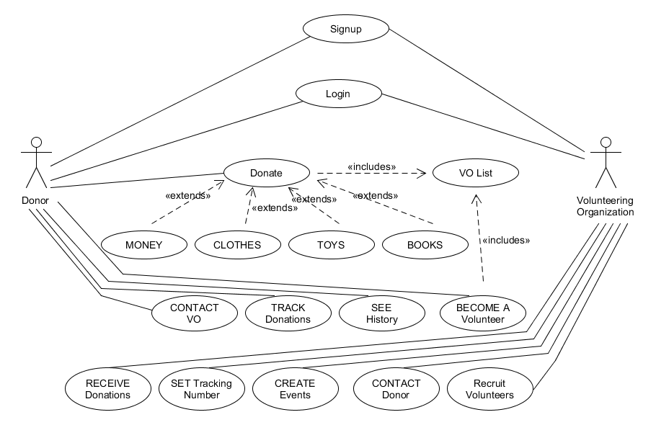

**CLASS DIAGRAM**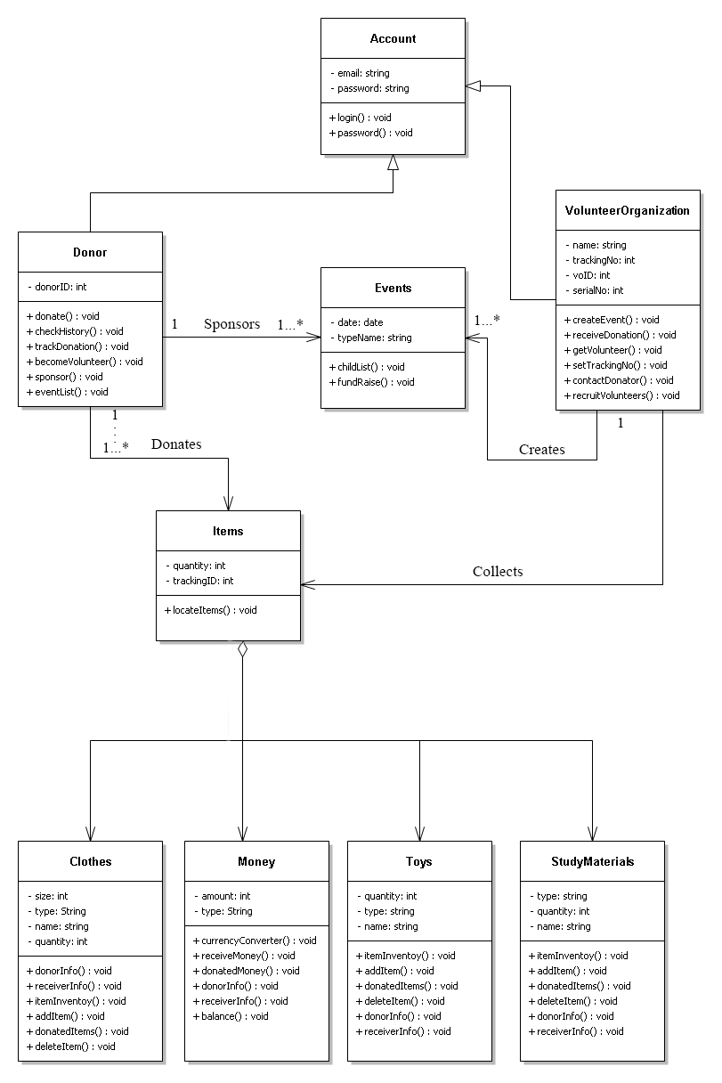

**ACTIVITY DIAGRAM**

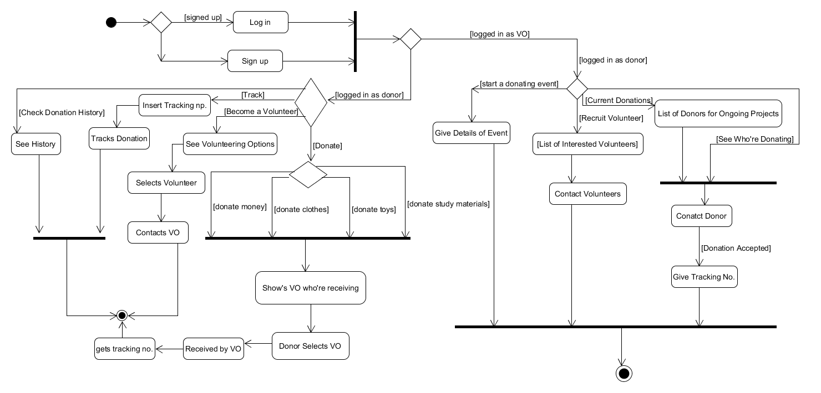

**SEQUENCE DIAGRAM**

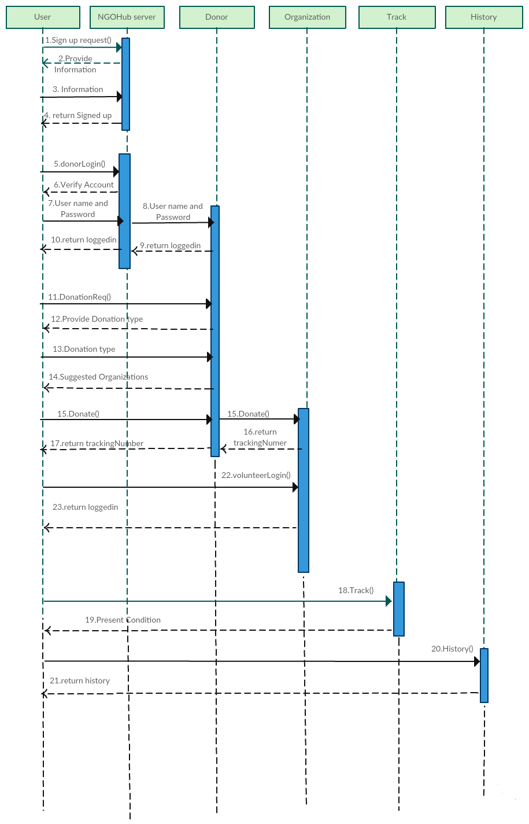

**SOFTWARE PROCESS MODEL FOR CharityHub**

Software process model is a structure set of activities required to develop a complete software. It’s an abstract representation of process. Software development process consists of different phases like Planning, Designing, Implementation, Deployment etc. These processes differ model to model. There are various process models namely Waterfall, Spiral, Agile, RAD etc. Selection of process model solely depends on the characteristics of the software. Here, we’ll be discussing which process model is suitable for developing CharityHub.

As CharityHub will be a mobile application, it may require frequent changes and periodic updates. A process model which allows developers to adjust to frequently changing requirements will be most suitable for this kind of application development. Among all other process models, Agile follows a combination of iterative and incremental approach which allows developers to adapt to the changes rapidly. Agile differs from other process models as it has a more customer-centric viewpoint. Agile process models use customer feedback to refine the software system. Agile is best suitable for mobile application as

* It follows an iterative and incremental approach where iteration lengths are small to cope up with rapidly changing requirements.
* It gives much importance on customer feedback.
* It minimizes overall risk.
* It emphasizes on customer collaboration.
* Ensures reliability through numerous testing.

Agile gives flexibility to choose different methodologies. Among many of them, we’ll be using SCRUM for developing CharityHub application. Main concerns of CharityHub:

* Changes and further feature enhancements expected.
* Emphasize is more User Interface and User Experience.
* Keeping ahead of other competitors.

**WHY SCRUM?**

SCRUM is an Agile framework which includes three phases PRE-GAME, DEVELOPMENT and POST-GAME. The planning and architecture design are done in PRE-GAME phase. In DEVELOPMENT phase system is developed in Sprints. When no more items and issues can be found, project enters into POST-GAME phase where all the requirements are completed. Some key features which make SCRUM suitable for this application development:

* A product backlog list is created containing all known requirements. They are prioritized and efforts for each implementation are estimated.
* Works are divided into small iterative cycles called Sprints where the functionality is developed. Sprint includes requirements, analysis, design, evolution and delivery phases.
* Scrum Team decides necessary actions and organize themselves to achieve the goals of each sprints.
* A Scrum Master is always there to guide and assist the Scrum Team.
* Scrum Team track progress and re-plan in daily 15 minutes stand-up meeting