DATABASE DESIGN II - 1DL400

Assignment 3
Amos II: Extensible database indexing
Group Members
Sathyavakeeswaran Krishnan - Sathyavakeeswaran.Krishnan.2801@student.uu.se
George Chiramel - George.Chiramel.0032@student.uu.se
Abdullah Al Hinai- Abdullah.Al_Hinai.2499@student.uu.se

- Exercise 1

- Complete function getSample to get a wine sample for a given wsID. Then you should run the test some times to see the execution time.
create function getSample(Number wsId) -> Winesample ws as select ws where wsId(ws) = wsId;
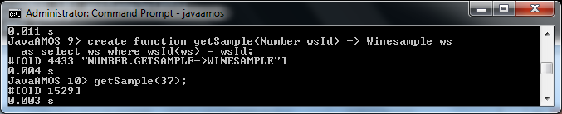
/* Comments on speed? */
/*TODO 1.b How will it scale? Why? */
- Look at the execution plan of function getSample Does it scale? Explain why.
No its doesn't scale, that because there is no index on that function, which scans all tuples every time
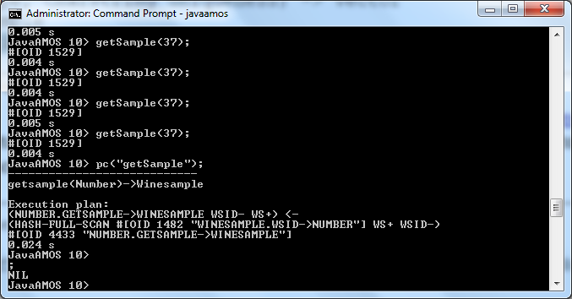

/* Make hash index on WSID to speed up getSample: */
create_index("wsId", "id", "hash", "unique");
recompile(#'getSample');

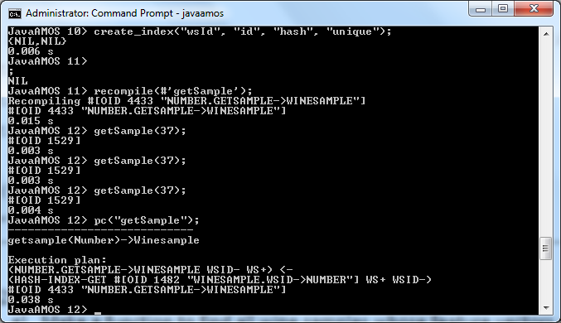

/* Inspect execution plan of getSample: */
pc("getSample");
/**TODO How will it scale? Why? */
Since we have created hash index the retrieve will be faster the single tuple matching the key.
- Exercise 2

- Make a function to find all wine samples whose feature vectors are within a given distance from wine sample ws.

create function closeWineSamples(WineSample ws, Number distance)
-> Bag of WineSample as select closestws from WineSample closestws where euclid(features(ws),features(closestws)) <= distance;

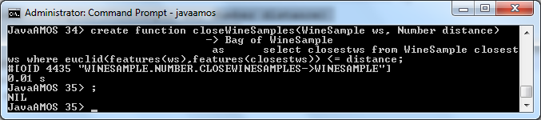
- Look at the execution plan of function closeWineSamples Does it scale? You should give your comments on the speed of the execution.

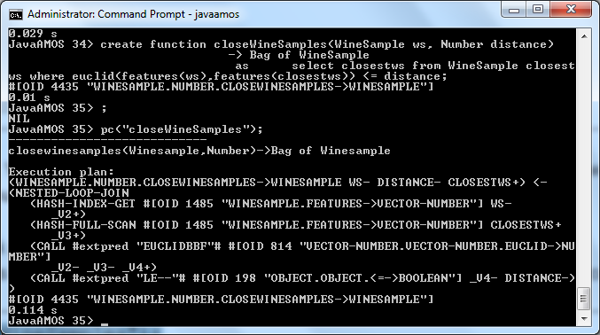

- Exercise 3

- Implement a foreign function in Java to speed up proximity search using the unknown KD-tree package in Java found on the web.

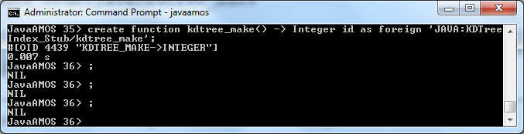
- Call kdtree_make to create new KD-tree index and store it in the function ‘winesampleIndex’
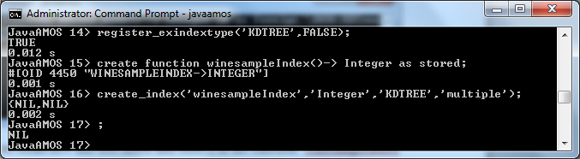
- Implement a foreign function kdtree_put to insert into a KD-tree a feature vector f for a given object o. Its signature follows:
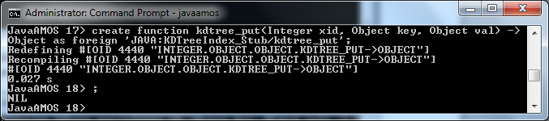

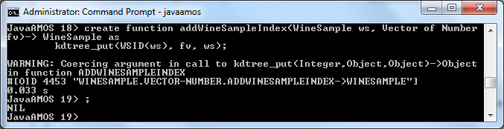

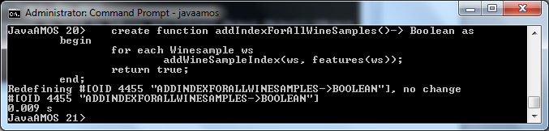
Call addIndexForAllWineSamples();

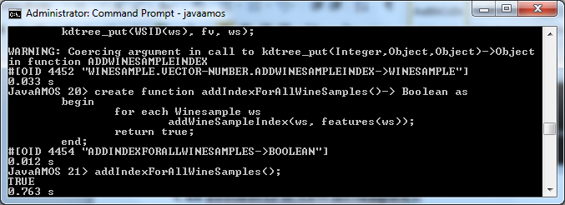
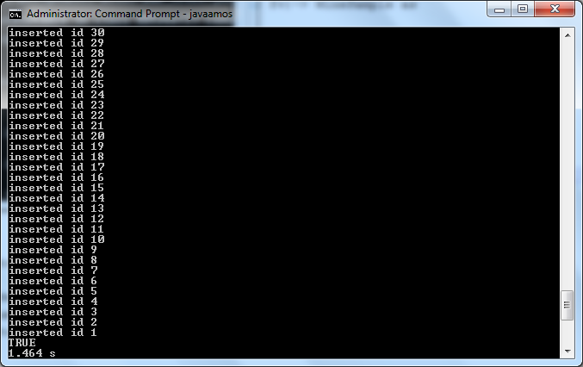

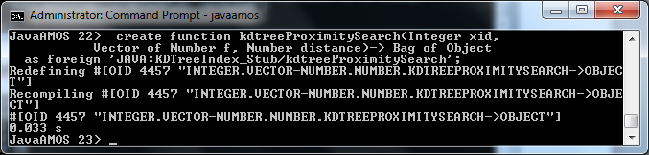

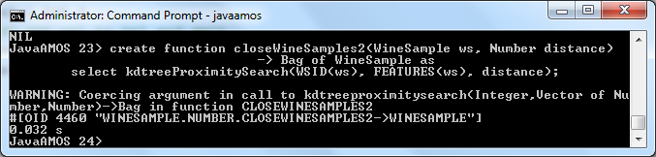

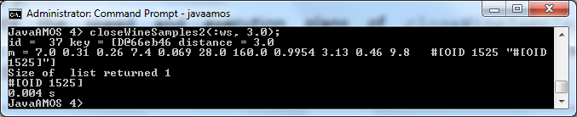

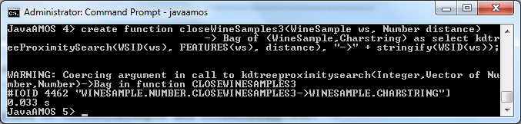

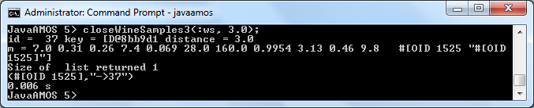

Appendix:
