Uppsala University
Department of Information Technology
Thành Trương

DATABASE DESIGN II - 1DL400
Assignment 3

Extensible database indexing

1 Introduction

The goal of this exercise is to give a practical experience in extending a database system with a new index structure. You will use Meta External Index Manager (Mexima) facility that provides a general mechanism to extend AMOS II with new index implemenations. The exercise consists of writing Java code to implement the new index structure KDTree and add KDTree based indexes to Amos II. You will also investigate the scalability of using KDTree in queries.

1.2 Introduction

1.2.1 Extensible database indexing

Assume a relation R that has a large number of tuples and the SQL query Q:

select * from R where A < 'constant'
Listing 1: A general query to find tuples in a given range
Query Q requires a full scan of the entire table R to select the tuples that match the predicate A < 'constant'. Such a full scan is expensive to perform if R has many rows. In order to speed up the search, one can employ a B-tree index on attribute A, which will find the matching tuples fast. B-trees provide scalable range queries, i.e. scalable matching of an interval of single values against an indexed set of single values stored in the database.

However, applications often require scalable search based on other criteria than indexed interval search. One example is finding those vectors of numbers (e.g. coordinates) in the database that are close to a given vector of numbers. There are other kinds of indexes than B-trees for this; in the exercise we are going to use an index structure called KD-trees. You are not implementing the KD-trees themselves, but instead you are provided a ready complied Java jar package implementing KD-trees.

1.2.2 Adding and removing indexes on stored functions

Basically, Amos II has three kinds of built-in indexes: Linear Hashing, B-trees, and X-trees. A specific kind of index can be defined for a parameter of a stored function by the system function:

create_index(Charstring function, Charstring argname, Charstring indextype, Charstring uniqueness) -> Vector
Listing 2: Signature of AmosQL function create_index
By default, the system defines a unique HASH index on the first argument of stored functions.

1 | /*Define a B-TREE index on the second argument */
2 | create function winequalitysamples(Charstring sp)-> Vector of Number wq as stored;  #[OID 1361 "CHARSTRING.WINEQUALITYSAMPLES->VECTOR-NUMBER"]
3 | /*Define a B-TREE index on the second argument */
4 | /*Examine all defined indexes */
5 | create_index("winequalitysamples", "wq", "MBTREE", "multiple");
6 | indexes(#'winequalitysamples');  {#[OID 1362 "P_CHARSTRING.WINEQUALITYSAMPLES->VECTOR-NUMBER"],0,"hash","unique"}  {#[OID 1362 "P_CHARSTRING.WINEQUALITYSAMPLES->VECTOR-NUMBER"],1,"mbtree","multiple"}
7 | /*Drop a HASH index*/
8 | drop_index('winequalitysamples', 'sp');  0
9 | drop_index('winequalitysamples', 'wq');  Trying to remove last index on CHARSTRING.WINEQUALITYSAMPLES->VECTOR-NUMBER
1 | /* There last index cannot be removed. There is one B-tree index left: */
1 | indexes(#'winequalitysamples');  {#[OID 1362 "P_CHARSTRING.WINEQUALITYSAMPLES->VECTOR-NUMBER"],1,"mbtree","mulitple"}

Listing 3: Example of using indexes on a stored function
Listing 3 illustrates adding and removing indexes on stored functions. The system function call indexes(#'winequalitysamples'); returns the indexes defined for the function winequalitysamples. It first shows that one hash index by default is added by the system on the first argument (position 0). The B-tree index is added on the second argument (position 1). An index can be removed by calling drop_index(Charstring functioname, Charstring argname);. However, the system needs at least one index defined on a stored function. Therefore, one can not remove the last remaining index.

1.2.3 Foreign functions

Amos II users can define foreign functions which are implemented in a conventional programming language such as Java, C, or Lisp. One might want to use C to efficiently handle data structures and Java to visualize query results. Foreign functions allow Amos II to access specialized storage managers, main memory data structures, computational engines, and so on. They provide the basic primitives to extend the DBMS.

Foreign function are documented in section 6.1 ''Foreign and multi-directional functions” in Amos II User Manual (Amos II Release 13 Version 1 2011). There is more documentation of Amos II Java interfaces in sections 3.1 and 3.2 of Amos II Java Interfaces. The following example shows how to implement a foreign function in Java:

1 | /*Import Amos II Java interface packages*/
2 | import callin.*;
3 | import callout.*;
4 | public class KDTreeIndex{  . . .
5 |  | /* PUT puts <key, val> into a KDTREE given its Id. The first PUT always constructs the KDTREE */
7 |  | public void jkdtree_put(CallContext cxt, Tuple tpl) throws AmosException, KeySizeException, KeyDuplicateException {
8 |  | /*Get the id*/
9 |  | int id = tpl.getIntElem(0)
10 |  | /* convert from sequence of numbers to array of floats*/
11 |  | double [] key = toArray(tpl.getSeqElem(1));
12 |  | Oid val = tpl.getOidElem(2);
13 |  | . . .
14 |  | /*Set the result*/
16 |  | tpl.setElem(3, val);
17 |  | cxt.emit(tpl);
18 |  | . . .
19 |  | }
20 | }
Listing 4: Implementation of the foreign function kdtree_put
After a foreign function is implemented in Java as in Listing 4, the signature of that foreign function is defined in AmosQL and mapped to the Java implementation as in Lisiting 5.

create function kdtree_put(Integer xtId, Object f, Object o)-> Object as foreign 'JAVA:KDTreeIndex/jkdtree_put';
Listing 5 Definition of foreign function kdtree_put in AmosQL
A foreign function implementation in Java always has two arguments cxt and tpl. The argument cxt is an instance of class CallContext. It is a data structure managed by Amos II to pass information about the caller. The argument tpl is an instance of class Tuple and represents the arguments and results of the foreign function call. The order of parameters in tpl is the same as in the AmosQL signature.

Knowing the data type and position of a parameter in a foreign function allows us to access tuple elements by using some Amos II Java interface functions. For example, the first input argument xtId is accessed using tpl.getIntElem(0) since its position is 0 and its type is Integer. The implementation sets the value in position 3 by tpl.setElem and emits the result tuple tpl by cxt.emit(tpl).

The following are the methods of Amos II Java interfaces used in the excercise. The rest can be referenced in Amos II Java Interfaces.
- int Tuple.getIntElem(int pos) fetches an integer element at position pos.
- void Tuple.setElem(int pos, int i) sets the element at position pos to integer i.
- Oid Tuple.getOidElem(int pos) fetches an Amos object o representing any kind of data stored in the database.
- void Tuple.setElem(int pos, Oid o) stores Amos object o in element pos of a tuple.
- void CallContext.emit(Tuple) emits a result tuple from a foreign function. To return a bag of values, emit is called interatively.
- Tuple Tuple.getSeqElem(int pos) fetches an object of database type of Vector from position pos of a tuple. The vector is represented in Java as a tuple object.
- void Tuple.setElem(int pos, Tuple tpl) stores the tuple tpl as a vector in position pos of a tuple.

1.2.4 Mexima

Meta External Index Manager (Mexima), a subcomponent of Amos II, provides a generic mechanism to extend the system with new index structures. It allows the index manager in Amos II to call an external index manager (Exima) implemented as a stand-alone program in C or Java. An external index manager handles one specific kind of index structure. To connect an Exima to the Amos II kernel, one needs to implement a few foreign functions, e.g. in Java. These foreign functions reside in a program called the Exima Driver.

For example, in the skeleton code of assignment 3, kd.jar, there is a Java package that publishes an API to interact with the KDTree index structure. The main program KDTreeIndex.java contains skeletons of the Mexima foreign function implementations to access the KD-tree package.

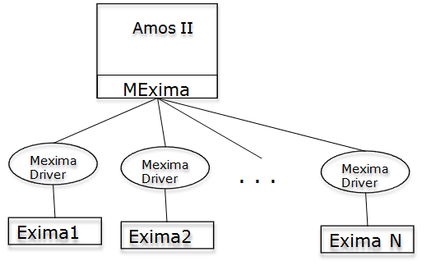
Figure 1 Mexima architecture

Mexima maintains a unique identifer per Exima:xtId. The Exima Driver is responsible for generating an index identifier, xtId, when Mexima requests to make a new index managed by the Exima. Consequently, the Exima Driver maintains a list of xtId identifiers.

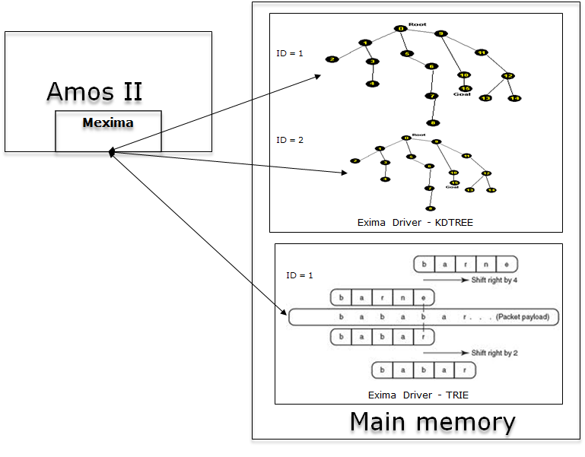
Figure 2 Mexima connects Exima(s) to Amos II

The developer adds a new Exima by defining some foreign functions in two steps. In the first step, the new index type is registered to Mexima using the built-in function:

register_exindextype(Charstring indextype, Charstring langpath, Boolean manualsaver) -> Boolean;
Listing 6: Definition of new index type
Input:
- indextype : Name of new index type
- langpath : Always string ``FOREIGN''
- manualsaver: The user has the option to write special programs to save or restore the external index managed by an Exima by setting the parameter manualsaver to true. If manualsaver is FALSE Mexima will automatically provide saving and restoring the index. In the exercise, manualsaver is alsways FALSE.
Output: Success (TRUE) or failure (FALSE).

The next step is to redefine a set of foreign functions to update and search the new index structure named indextype.
- create function indextype_make() ->Integer as foreign...
creates a new index of the given index type and returns its index identifier.

- create function indextype_put(Integer xtId, Object key, Object val) -> Object as foreign ...
stores a value val associated with key into an index structure whose identifier is xtId. The value is stored as an Amos object (class Oid).

- create function indextype_get(Integer xtId, Object key) -> Object val as foreign...
retrieves the valueval associated with key from an index structure whose identifier is xtId.

- create function indextype_delete(Integer xtId, Object key) -> Object as foreign...
deletes a value val associated with key from an index structure whose identifier is xtId.

- create function indextype_clear(Integer xtId) -> Object as foreign...
removes an index structure whose identifier is xtId.

- create function indextype_save(Charstring filename) -> Boolean as foreign...
This function is optional, and is required only if the parameter manualsaver of function register_exindextype is set to TRUE. It saves all index data named indextype on disk.

- create function indextype_load(Charstring filename) -> Boolean as foreign...
This function is optional, and is required only if the parameter manualsaver of function register_exindextype is set to true. It restores all index data of named indextype from disk.

- create function indextype_mapper(Integer id) -> Bag of Object as foreign...
iterates over the index and emits pairs of keys and values. This function is optional as not all index structures allow iterate over all its data items.

Mexima is transactional which means that it is possible to commit and rollback index updates.

1.2.5 K-dimensional Tree

A K-dimensional search tree (KD-tree) is a main memory data structure which extends binary trees to index multidimensional data. In this assignment, a KD-tree implementation is delivered as a Java package, kd.jar, which has an API documentation available online at (Levy 2011). You need to go through that API to understand which functions should be invoked to make a KD-tree index.

1.3 Preparation

Download skeleton code for assignment 3 from http://www.it.uu.se/edu/course/homepage/dbastekn2/vt11/dbt2-vt2011-assignments.html. and unzip it into your home directory.
There is a readme.txt file containing instructions on how to set up your environment variables and run the skeleton code.

For background reading you are referred to:

- (ELMASRI and NAVATHE, S. B 2010): Chapters 20, 21 and 22.
- (Padron-McCarthy, T and Risch, T. 2005): Chapter 16.
- All material from the lectures on object-oriented and object-relational databases systems and query languages. See also the assignment web page of this course for additional information.
- Amos II User Manual, Section 7.1, 6.1.
- Amos II Java Interfaces, Section 3.1, and 3.2.

There is also a supervised introduction to the assignment.

2 Assignment

The exercise consists of five parts:
- Exercise 1
Task: Register with Amos II a new index type named ‘kdtree’
Instruction: see Listing 6

- Exercise 2
Task: Redefine Mexima foreign function for the KD-tree index structure
Instruction: see Listing 4 and Listing 5
Example:
To redefine a putter that enters a pair (key, value), you should redefine the foreign function kdtree_put:

create function kdtree_put(Integer xtId, Object f, Object o) -> Object as foreign 'JAVA:KDTreeIndex/kdtree_put';
Listing 7: Redefining foreign function kdtree_put
The KD-tree implementation does not allow scanning through all index keys (FULL INDEX SCAN). Therefore, you do not need to implement kdtree_mapper.

- Exercise 3
Task: Define an index of type kdtree for the second parameter of the stored function winequalitysamples.

- Exercise 4
Task: Investigate execution plans and test KD-tree indexing by answering the following questions:
- What kind of index is used in the execution plan of allsamples?
- Why?
- What kind of index is used in the execution plan of get_sample_example?
- Why?

Instruction: The Amos II function call pc('function name') shows the execution plan of an Amos function.

- Exercise 5
Task: Similarity search is a method for finding points within a distance to the search point
in a given data set.

In this exercise, you are provided a function kdtree_similarity(Vector of Number v, Number dist, Bag of Vector of Number bv), which takes v as input point, dist as a distance , and a bag of Vector of Number bv.

Executing kdtree_similarity(:v, 9.0,
(select wq
from Charstring sp, Vector of Number wq
where winequalitysamples(sp)=wq)));
raises an error:
‘Foregin function kdtree_similarity_fn_fn is not yet implemented!!'

In order to utilize a KD-tree index for KNN search, you need to complete implementation of kdtree_similarity in KDTreeIndex.java and then define this foreign function signature:

create function kdtree_similarity_fn(Integer xtId, Vector of Number x, Number distance)-> Object as foreign 'JAVA:KDTreeIndex/kdtree_similarity';
Listing 8: Foreign function kdtree_similarity_fn

Now , you are be able to run
kdtree_similarity(:v, 9.0, (select wq
from Charstring sp, Vector of Number wq
where winequalitysamples(sp)=wq)));

3 Examination

3.1 Hand-in documents

Each exercise requires extending AmosQL code in file kdtree.osql and Java code in KDTreeIndex.java.

Adding descriptive comments is advised in case your solution does not pass a validation script we use. Each group sends only one compressed folder (tar or zip) containing:
- kdtree.osql
- kdtree.lsp : It is included in the skeleton code and you should not modify it.
- KDTreeIndex.java
- group.txt stating your group number, names and emails

3.2 Validation
- We test your solution with a validation script.
- Then we check your answers for exercise 4.
- Finally, we manually investigate the AmosQL and Java code.

Failure on a step means a K is given. You then have to re-submit your solution until it passes that step. G is given when everything is correct.

Bibliography

S.Flodin, M.Hansson, V.Josifovski, T.Katchaounov, T.Risch, M.Sköld, and E.Zeitler: Amos II Release 13 Version 1. Feb 20, 2011. http://user.it.uu.se/ udbl/amos/doc/amos_users_guide.html (accessed Feb 20, 2011).

R. Elmasri and S.B.Navathe: Fundamentals of Databases, 6th edition. Addison-Wesley, 2010.

Simon D. Levy: KD-Tree Implementation in Java and C#. 2011. http://home.wlu.edu/ levys/software/kd/.

T.Padron-McCarthy, and T.Risch: Databasteknik. 2005.

D. Elin and T.Risch: Amos II Java Interfaces. http://user.it.uu.se/~torer/publ/javaapi.pdf Technical report, 2000.

--------------------------------------------------------------------------------------

