Lab 4
Static Data Member

Static data members are class members that are declared using the static keyword. There is only one copy of the static data member in the class, even if there are many class objects. This is because all the objects share the static data member. The static data member is always initialized to zero when the first class object is created.
The syntax of the static data members is given as follows :
static data_type data_member_name;

Example 1:
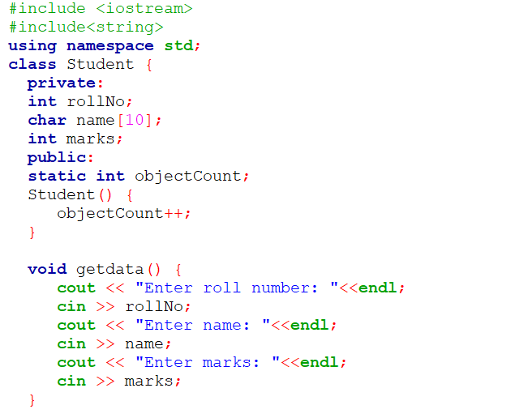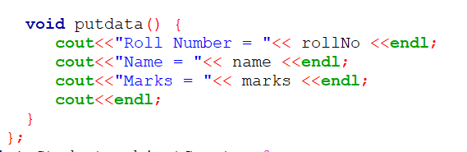
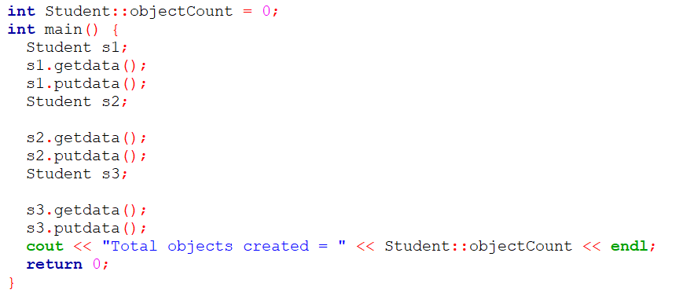
The output of the above program is:
Enter roll number: 1
Enter name: Mark
Enter marks: 78
Roll Number = 1
Name = Mark
Marks = 78

Enter roll number: 2
Enter name: Nancy
Enter marks: 55
Roll Number = 2
Name = Nancy
Marks = 55

Enter roll number: 3
Enter name: Susan
Enter marks: 90
Roll Number = 3
Name = Susan
Marks = 90
Total objects created = 3

Example 2:
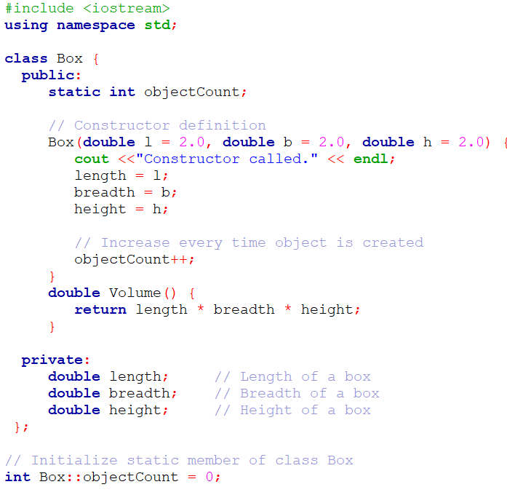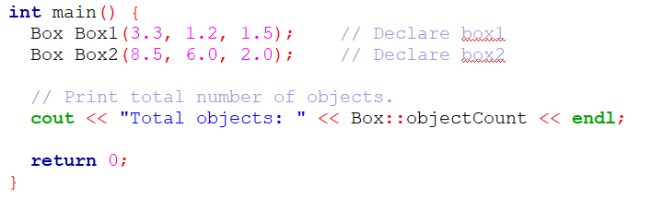
The output of the above program is:
Constructor called.
Constructor called.
Total objects: 2

