***OOPS LAB WEEK 2***

**Question#1:**

#include<iostream>

#include<conio.h>

using namespace std;

main()

{ int Sum,Firstnumber,Secondnumber;

float Average;

cin>>Firstnumber>>Secondnumber;

cout<<"the sum of the two number is"<<Firstnumber+Secondnumber<<endl;

cout<<"the average of two number is "<<(Firstnumber+Secondnumber)/2;

rerurn 0; }

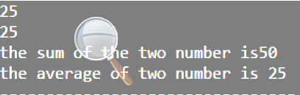

**Question#2:**

#include<iostream>

#include<conio.h>

using namespace std;

main()

{ int inches;

cout<<"enter a height in inches";

cin>>inches;

cout<<"the height is ";

int a=inches/12;

int b=inches%12;

cout<<a<<"'"<<" "<<b<<"''"<< endl;

return 0; }

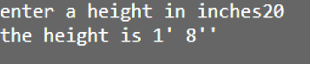

**Question#3:**

#include<iostream>

#include<conio.h>

using namespace std;

int main()

{

int second,hour,min;

int sec;

cout<<"Enter a time in a seconds";

cin>>second;

hour=second/3600;

min=second%3600/60;

sec=second%3600%60;

cout<<"The time is"<<hour<<"hour"<<" "<<min<<"min"<<" "<<sec<<"second";

getch(); return 0; }

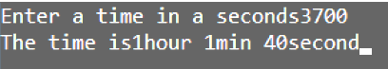

**Question#4:**

#include<iostream>

#include<conio.h>

using namespace std;

int main()

{ int a;

cout<<"Enter a four digit number in rupees ";

cin>>a;

cout<<"The thousad is "<<(a/1000)<<endl;

cout<<"The hundred is "<<((a%1000)/100)<<endl;

cout<<"The fifty is "<<(((a%1000)%100)/50)<<endl;

cout<<"The ten is "<<((((a%1000)%100)%50)/10)<<endl;

cout<<"The five is "<<(((((a%1000)%100)%50)%10)/5)<<endl;

cout<<"The five is "<<((((((a%1000)%100)%50)%10)%5)/2)<<endl;

cout<<"The five is "<<((((((a%1000)%100)%50)%10)%5)%2)<<endl;

getch(); return 0; }

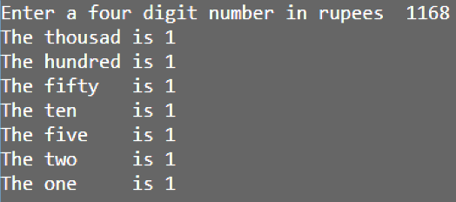

**Question#5:**

#include<iostream>

#include<conio.h>

using namespace std;

int main()

{ float temp,temper;

cout<<"Enter a temperature in farenheit ";

cin>>temp;

cout<<"The temperature in celcius is "<<(temp-32)/1.8;

cout<<temp<<endl;

cout<<"Enter a temperature in celcius ";

cin>>temper;

cout<<"The temperature in farenheit is "<<(1.8*temper)+32;

cout<<temper;

getch(); return 0; }

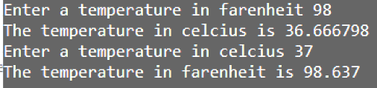

**Question#6:**

#include<iostream>

#include<conio.h>

using namespace std;

int main()

{ int a;

cout<<"Enter a two digit number";

cin>>a;cout<<endl;

cout<<"The enter number is "<<a<<endl;

cout<<"The swaping of the number is "<<a%10<<a/10;

getch(); return 0; }

