***OOPS LAB WEEK 3***

**Question#1:**

#include<iostream>

#include<conio.h>

#include<math.h>

using namespace std;

int main()

{ int x1,x2,y1,y2;

char c1,c2,c3;

cout<<"Enter the two cordinates (x1,y1) and (x2,y2)"<<endl;

cout<<"(x1,y1) =";

cin>>c1>>x1>>c2>>y1>>c3;

cout<<"(x2,y2) =";

cin>>c1>>x2>>c2>>y2>>c3;

int d=(x2-x1)*(x2-x1)+(y2-y1)*(y2-y1);

sqrt(d);

cout<<"the distance between these points is"<<"("<<x1<<","<<y1<<")"<<” "<<"and"<<"("<<x2<<","<<y2<<")"<<" "<< "is"<<" "<<d;

getch(); return 0; }

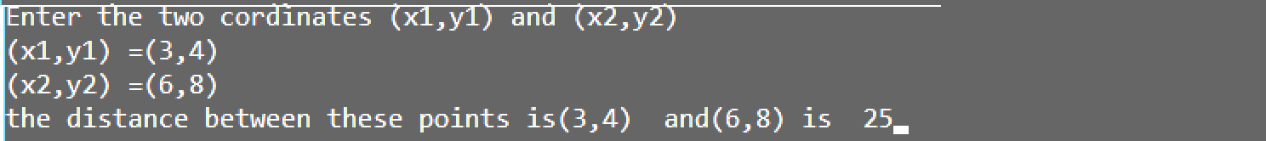

**Question#2:**

#include<iostream>

#include<conio.h>

using namespace std;

int main()

{ int m1[3][3],m2[3][3],m3[3][3],i,j;

cout<<"Enter two matrix of 3x3"<<endl;

cout<<"Enter first matrix"<<endl;

for(i=0;i<=2;i++) { for(j=0;j<=2;j++) { cin>>m1[i][j]; } }

cout<<"Enter second matrix"<<endl;

for(i=0;i<=2;i++) { for(j=0;j<=2;j++) { cin>>m2[i][j]; } }

for(i=0;i<=2;i++) { for(j=0;j<=2;j++) { m3[i][j]=m1[i][j]+m2[i][j]; } }

cout<<"The sum of two matrix are"<<endl;

for(i=0;i<=2;i++) { for(j=0;j<=2;j++) { cout<<m3[i][j]<<" "; } cout<<endl; }

getch(); return 0;}

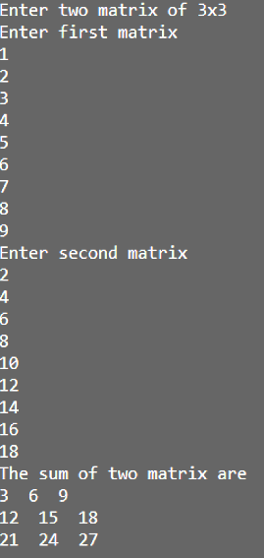

**Question#2A:**

#include<iostream>

#include<conio.h>

using namespace std;

int main()

{ int m1[3][3],m2[3][3],m3[3][3];

int i,j;

cout<<"Enter two matrix of 3x3"<<endl;

cout<<"Enter first matrix"<<endl;

for(i=0;i<=2;i++) { for(j=0;j<=2;j++) { cin>>m1[i][j]; } }

cout<<"Enter second matrix"<<endl;

for(i=0;i<=2;i++) { for(j=0;j<=2;j++) { cin>>m2[i][j]; } }

for(i=0;i<=2;i++) { for(j=0;j<=2;j++)

{ m3[i][j]=m1[i][0]*m2[0][j]+m1[i][1]*m2[1][j]+m1[i][2]*m2[2][j]; } }

for(i=0;i<=2;i++) { for(j=0;j<=2;j++) { cout<<m3[i][j]<<" "; } cout<<endl; }

getch(); return 0; }

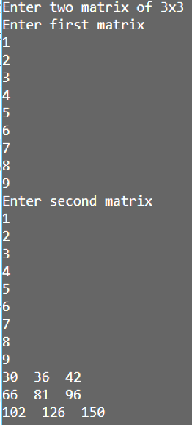

**Question#3:**

#include<iostream>

#include<conio.h>

using namespace std;

struct student

{ char Fname[20];

char lname[20];

int score; };

int main()

{ int i; student s[5];

for(i=0;i<5;i++) { cout<<"Enter first name ,last name and score"<<endl<<" ";

cin>>s[i].Fname>>s[i].lname>>s[i].score; }

cout<<"STUDENTS RECORD"<<endl;

for(i=0;i<5;i++)

{ cout<<"First name ="<<s[i].Fname<<endl;

cout<<"last name ="<<s[i].lname<<endl;

cout<<"scores ="<<s[i].score<<endl; }

getch(); return 0; }

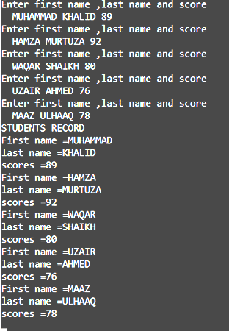

**Question#4:**

#include<iostream>

#include<conio.h>

using namespace std;

struct student

{ char Fname[20];

char lname[20];

int score; };

void Display(student st)

{ cout<<"First name ="<<st.Fname<<endl;

cout<<"last name ="<<st.lname<<endl;

cout<<"scores ="<<st.score<<endl; }

int main()

{ int i;

student s[5];

for(i=0;i<5;i++)

{ cout<<"Enter first name ,last name and score"<<endl<<" ";

cin>>s[i].Fname>>s[i].lname>>s[i].score; }

cout<<"STUDENTS RECORD"<<endl;

for(i=0;i<5;i++) {Display(s[i]);}

getch(); return 0; }



**Question#5:**

#include<iostream>

using namespace std;

struct adress

{ int hno;

char city[10];

int pin; };

struct emp

{ int id;

char name[20];

int sal;

adress add; };

int main()

{ emp e[1];

int i;

for(i=0;i<1;i++)

{ cout<<"\nEnter employee name : ";

cin.get(e[i].name,20);

cout<<"\nEnter employ's id : ";

cin>>e[i].id;

cout<<"\nEnter salary : ";

cin>>e[i].sal;

cout<<"\nEnter House#";

cin>>e[i].add.hno;

cout<<"\nEnter City ";

cin>>e[i].add.city;

cout<<"\nEnter Pin code ";

cin>>e[i].add.pin;

if(e[i].sal<50000)

{

e[i].sal+=5000;

}}

cout<<" EMPLOY'S RECORD"<<endl;

for(i=0;i<1;i++)

{ cout<<"\nemployee name : "<<e[i].name;

cout<<"\nemploy's id : "<<e[i].id;

cout<<"\nsalary : "<<e[i].sal;

cout<<"\nHouse#"<<e[i].add.hno;

cout<<"\nCity "<<e[i].add.city;

cout<<"\nPin code "<<e[i].add.pin;}}

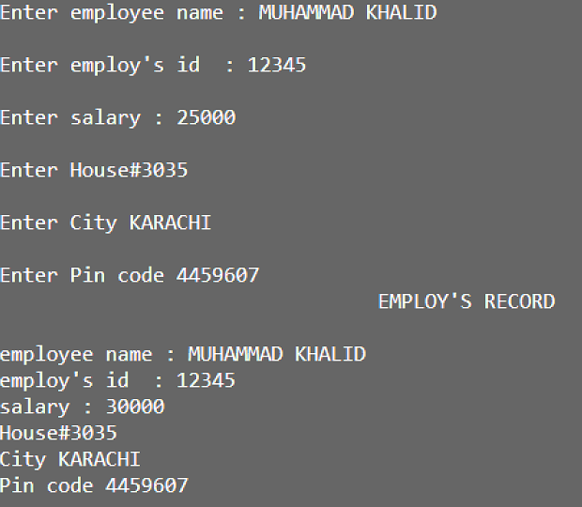

**Question#6:**

#include<iostream>

#include<conio.h>

using namespace std;

main()

{ int a,b,choice;

int *p1,*p2;

float c;

float *p3;

cout<<"\t\t\t\tWELCOME TO CALCULATOR\n";

do

{ cout<<"\n1.Addition\n2.Subraction\n3.Multiplication\n4.Division\n5.Exit\n";

cout<<"\t\t\t\tEnter Your choice : "; cin>>choice;

switch(choice)

{ case 1:

cout<<"Enter 1st value =";cin>>a;

cout<<"Enter 2nd value =";cin>>b;

p1=&a; p2=&b; p3=&c;

*p3=(*p1)+(*p2);

cout<<*p1<<"+"<<*p2<<"="<<*p3<<endl;

break;

case 2:

cout<<"Enter 1st value =";cin>>a;

cout<<"Enter 2nd value =";cin>>b;

p1=&a; p2=&b; p3=&c;

*p3=(*p1)-(*p2);

cout<<*p1<<"-"<<*p2<<"="<<*p3<<endl;

break;

case 3:

cout<<"Enter 1st value =";cin>>a;

cout<<"Enter 2nd value =";cin>>b;

p1=&a; p2=&b; p3=&c;

*p3=(*p1)*(*p2);

cout<<*p1<<"*"<<*p2<<"="<<*p3<<endl;

break;

case 4:

cout<<"Enter 1st value =";cin>>a;

cout<<"Enter 2nd value =";cin>>b;

p1=&a; p2=&b; p3=&c;

*p3=(float)(*p1)/(*p2);

cout<<*p1<<"/"<<*p2<<"="<<*p3<<endl;

break;

case 5:

cout<<"\n\t\t\t\tThankyou! You successfully exit from Calculator.\n\n\n";

exit(0);

break;

default :

cout<<"Error";

} }while(choice!=5);

return 0; }

