***OOPS LAB WEEK#4***

**Question#01:**

#include<iostream>

#include<conio.h>

using namespace std;

int factorial (int *);

int factorial(int *q)

{ int i;

for(i=*q-1;i>0;i--)

{ *q=*q*(i); }

return *q; }

int main()

{ int a,*p,fact;

cout<<"enter a number whose factorial to be calculated"<<endl;

cin>>a;

fact=factorial(&a);

cout<<"the factorial of the given number is "<<" "<<fact;

getch();

return 0; }

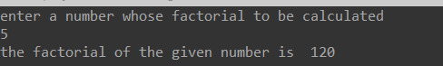

**Question#02:**

#include<iostream>

#include<conio.h>

using namespace std;

int main()

{ float area,radius;

const float p1=3.142;

float *const a=&area;

float *const r=&radius;

const float *const p=&p1 ;

cout<<"enter the radius of circle"<<endl;

cin>>*r;

area=(*p)*(*r)*(*r);

cout<<"the area of the circle is"<<endl;

cout<<*a;

getch();

return 0; }

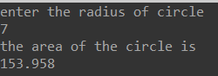

**Question#03:**

#include<iostream>

#include<conio.h>

using namespace std;

void table(int *t)

{ for (int i=1;i<=10;i++)

{ int b=(*t)*i;

cout<<*t<<"*"<<i<<"="<<b<<endl; }

}

int main()

{ int n;

cout<<"enter the number whose table is to be generated"<<endl;

cin>>n;

table(&n);

getch();

return 0; }

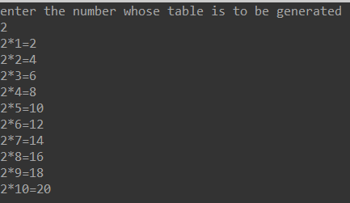

**Question#04:**

#include<iostream>

#include<conio.h>

using namespace std;

int main()

{ int a[10]={1,2,3,4,5,6,7,8,9,10};

int b[10]={1,2,3,4,5,6,7,8,9,10};

int sum[10],*p,*q,*result;

p=a;

q=b;

result=sum;

for (int i=0;i<10;i++)

{ *(result+i)=*(p+i)+*(q+i);

cout<<"a"<<"["<<*(p+i)<<"]"<<"\t"<<"b"<<"["<<*(q+i)<<"]"<<"\t"<<"sum="<<*(result+i)<<endl; }

getch();

return 0; }

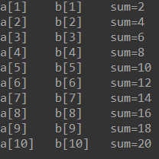

**Question#05:**

#include<iostream>

#include<conio.h>

using namespace std;

float a=0,b=0;

void add()

{cout<<"Enter two number for addition"<<endl;

cin>>a>>b;

float sum,*p,*q;

p=&a,q=&b;

sum=*p+*q;

cout<<"Sum of the two number is "<<sum<<endl;

}

void sub()

{cout<<"Enter two number for subtraction"<<endl;

cin>>a>>b;

float sum,*p,*q;

p=&a,q=&b;

sum=*p-*q;

cout<<"subtraction of the two number is "<<sum<<endl;

}

void div()

{cout<<"Enter two number for division"<<endl;

cin>>a>>b;

float sum,*p,*q;

p=&a,q=&b;

sum=*p/(*q);

cout<<"Division of the two number is "<<sum<<endl;

}

void mul()

{cout<<"Enter two number for multiplication"<<endl;

cin>>a>>b;

float sum,*p,*q;

p=&a,q=&b;

sum=*p*(*q);

cout<<"Multipication of the two number is "<<sum<<endl;

}

int main()

{

cout<<" WELLCOME TO KHALID CALCULATOR"<<endl;

cout<<"1.ADDITION<<\n2.SUBTRACTION\n3.DIVISION\n4.MULTIPLICATION\n5.Exit"<<endl;

int choice;

do

{cout<<"Enter your choice"<<endl;

cin>>choice;

switch(choice)

{

case 1:

add();

break;

case 2:

sub();

break;

case 3:

div();

break;

case 4:

mul();

break;

default:

cout<<"Press Enter to exit"<<endl;

}

}

while(choice!=5);

getch();

return 0;

}

