***OOPS LAB WEEK 5***

**Question#01:**

#include<iostream>

#include<string.h>

#include<conio.h>

using namespace std;

class flight

{ private:

int flightno,availseat,reserve;

string source,destination;

public:

flight() {}

flight(int f,int a,int r,string s,string d):flightno(f),availseat(a),reserve(r),source(s),destination(d) {}

flight(int f,int a,int r):flightno(f),availseat(a),reserve(r) {}

void setflightno(int f)

{ flightno=f; }

int getflightno()

{ return flightno; cout<<flightno; }

void setavailseat(int a)

{ availseat=a; }

int getavailseat()

{ cout<<"The available seats are "<<availseat<<endl; return availseat; }

void setreserve(int r)

{ reserve=r; }

int getreserve()

{ cout<<"you have reserved "<<reserve<<" seats"<<endl; return reserve; }

void setsource(string s)

{ source=s; }

string getsource()

{ if(source=="karachi") source="KAR";

else if(source=="peshawar") source="PES";

else source="invalid"; return source; }

void setdestination(string d)

{ destination=d; }

string getdestination()

{ if (destination=="lahore") destination="LAH";

else if(destination=="islamabad") destination="ISL"; return destination; }

void showdata()

{ cout<<"your flight no is "<<flightno<<endl;

cout<<"now available seats are "<<availseat-reserve<<endl;

cout<<"From:"<<getsource()<<endl;

cout<<"To:"<<getdestination()<<endl; } };

main()

{ int a,b,c,r;

string s,d;

flight f1(123,450,r,s,d),f2(124,460,r,s,d);

cout<<"Enter source of your first flight "<<endl;

cin>>s;

f1.setsource(s);

cout<<"Enter destination of your first flight "<<endl;

cin>>d;

f1.setdestination(d);

f1.getavailseat();

cout<<"Enter seats for reservation of your first flight "<<endl;

cin>>r;

f1.setreserve(r);

f1.getreserve();

f1.showdata();

cout<<"Enter source of your second flight "<<endl;

cin>>s;

f2.setsource(s);

cout<<"Enter destination of your second flight "<<endl;

cin>>d;

f2.setdestination(d);

f2.getavailseat();

cout<<"Enter seats for reservation of your second flight "<<endl;

cin>>r;

f2.setreserve(r);

f2.getreserve();

f2.showdata();

getch();

return 0; }

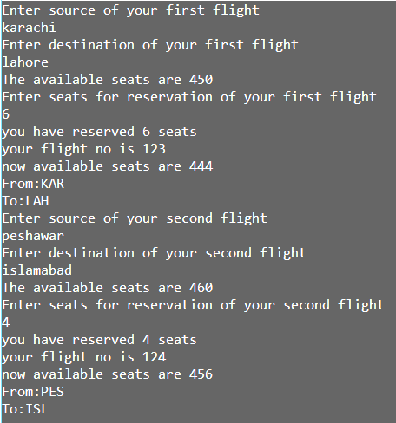

**Question#02:**

#include<iostream>

#include<conio.h>

#include<string.h>

using namespace std;

class car

{

private:

string brandname,color;

double newprice,odometer,secprice;

public:

car() {}

car(string b,string c,double p,double a,double s):brandname(b),color(c),newprice(p),odometer(a),secprice(s) {}

void setbrandname(string b)

{ brandname=b; }

string getbrandname()

{ return brandname; }

void setcolor(string c)

{ color=c; }

string getcolor()

{ return color; }

void setnewprice(double p)

{ newprice=p; }

double getnewprice()

{ return newprice ; }

void setodometer(double a)

{ odometer=a; }

long int getodometer(double a)

{ return odometer; }

void showdata()

{ cout<<"your car name is "<<brandname<<endl;

cout<<"your car color is "<<color<<endl;

cout<<"your car newprice is "<<newprice<<endl;

cout<<"your car odometer is "<<odometer<<endl;

cout<<"your second price is "<<(1-odometer/600000)*newprice; } };

main()

{ string b,c; double p,a,s; car c1(b,c,p,a,s);

cout<<"Enter your car brand, color, new price and odometer reading"<<endl;

cin>>b; c1.setbrandname(b);

cin>>c; c1.setcolor(c);

cin>>p; c1.setnewprice(p);

cin>>a; c1.setodometer(a);

c1.showdata();

getch(); return 0; }

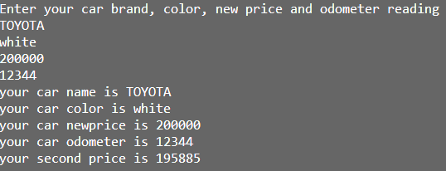

**Question#03:**

#include<iostream>

using namespace std;

class bags

{ private:

int nobags,l,m,s;

float cl,cm,cs;

public:

bags(int n):nobags(n){l=nobags/20,m=(nobags%20)/10,s=(nobags%20)%10;

if(s==0) s=0; if(s<=5) s=1; else s=2;

cl=l*1.8, cm=m*1.0, cs=s*0.6; }

void setnobags(int n)

{ nobags=n; }

int getnobags()

{ return nobags; }

void offer()

{ cout<<"The total no bags are "<<nobags<<endl;

cout<<"Number of boxes are used "<<endl;

cout<<"large box is "<<l<<" = "<<cl<<" $ "<<endl;

cout<<"medium box is "<<m<<" = "<<cm<<" $ "<<endl;

cout<<"small box is "<<s<<" = "<<cs<<" $ "<<endl;

cout<<"The total cost of all the bags is "<<(5.50*nobags)+cl+cm+cs<<" $"<<endl; } };

main()

{ int n;

cout<<"Enter no of coffie"<<endl; cin>>n;

bags c1(n);

c1.setnobags(n); c1.offer();

getch(); return 0; }

