***OOPS LAB WEEK#06***

**Question#01:**

#include<iostream>

#include<conio.h>

using namespace std;

class millbill

{ private:

float bill,tax,tip;

public:

millbill(float b)

{bill=b; tax = 0.1*bill; tip = 0.15*bill; }

void showdata()

{ cout<<"Meal cost = "<<bill<<endl;

cout<<"tax = "<<tax<<endl;

cout<<"tip = "<<tip<<endl;

cout<<"Total cost = "<<bill+tip+tax<<endl; }

void slip(float s)

{ if (s<(bill+tip+tax))

{cout<<"your amount is insufficient for payment please do again"<<endl;}

cout<<"Total cost = "<<bill+tip+tax<<endl;

cout<<"Payment = "<<s<<endl;

cout<<"Change = "<<s-(bill+tip+tax)<<endl;

cout<<"Thank you for visiting our resturant have a nice day"<<endl; } };

int main()

{ float bill,payment;

cout<<" WELLCOME TO THE KHALID RESTURANT"<<endl;

cout<<"Enter the meal cost"<<endl;

cin>>bill;

millbill m(bill);

cout<<"BILL OF YOUR MEAL "<<endl;

m.showdata();

cout<<"Please pay your bill"<<endl;

cin>>payment;

m.slip(payment);

getch();

return 0; }

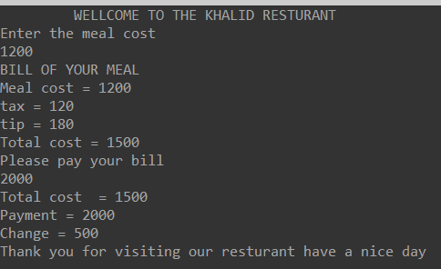

**Question#02:**

#include<iostream>

#include<conio.h>

using namespace std;

class account;

class millbill

{ float bill,tax,tip;

public:

millbill(float b)

{ bill=b; tax = 0.6*bill; tip = 0.15*bill;}

float showdata()

{ cout<<" AMOUNT OF YOUR BILL\n"<<endl;

cout<<"Meal cost = "<<bill<<endl;

cout<<"tax = "<<tax<<endl;

cout<<"tip = "<<tip<<endl;

cout<<"Total cost = "<<bill+tip+tax<<"\n"<<endl;

return (bill+tip+tax); }

void slip(float s)

{ if (s<(bill+tip+tax))

{cout<<"your amount is insufficient for payment please do again"<<endl;}

cout<<" SLIP OF YOUR BILL \n"<<endl;

cout<<"Total cost = "<<bill+tip+tax<<endl;

cout<<"Payment = "<<s<<endl;

cout<<"Change = "<<s-(bill+tip+tax)<<endl;

cout<<"Thank you for visiting our resturant have a nice day \n"<<endl; }};

class account

{ int bal;

public:

account(){}

void setbalance(int b)

{ bal=b; }

void showbalance(float b)

{ cout<<" ACCOUNT DETAILS \n"<<endl;

cout<<"NAME = MUHAMMAD KHALID "<<endl;

cout<<"ACCOUNT ID = SE-018 "<<endl;

cout<<"your previous = " <<bal<<endl;

cout<<"your current balance is"<<bal-b<<endl; } };

int main()

{ float bill,kh,payment;

account pay;

cout<<" WELLCOME TO THE KHALID RESTURANT"<<endl;

cout<<"Enter the meal cost"<<endl;

cin>>bill;

millbill m(bill);

kh=m.showdata();

pay.setbalance(2000);

cout<<"Please pay your bill by Khalid account"<<endl;

cin>>payment;

m.slip(payment);

pay.showbalance(kh);

getch();

return 0; }

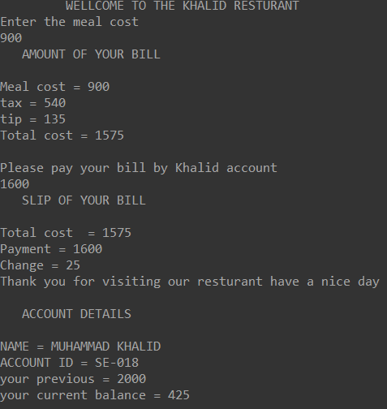

**Question#03:**

#include<iostream>

#include<conio.h>

#include<string>

using namespace std;

class grades

{ string studentid;

int credit;

char grade;

float gpa;

public:

grades(string id,char g,int c)

{ studentid=id;

grade=g;

credit=c; }

void showgrade()

{ int g;

cout<< "WLCOME TO NEDUET"<<endl;

cout<<"Student ID = "<<studentid<<endl;

if(grade=='A'){g=4;gpa=g*credit; }

else if(grade=='B'){g=3;gpa=g*credit; }

else if(grade=='C'){g=2;gpa=g*credit; }

else{cout<<"you are fail "<<endl;}

cout<<"Student grade = "<<grade<<endl;

cout<<"Credit hour = "<<credit<<endl;

cout<<"Student grade point = "<<gpa<<endl; }

void showdefault()

{ cout<<"student ID = "<<studentid<<endl;

cout<<"credit = "<<credit<<endl;

cout<<"Grade point = "<<grade<<endl; } };

int main()

{ string id; int credit; float gp;

cout<<"Are you a new student ?\n Enter 'y'/'Y' for (yes) and 'n'/'N' for (No)"<<endl;

char c,g;

cin>>c;

if(c=='Y'||c=='y')

{cout<<"you record would be Null please Enter your record "<<endl;

grades s2("0",'0',0);

s2.showdefault();}

cout<<"Enter your information\n1.Student ID\n2.Grade points (A,B,C)\n3.Credit hour "<<endl;

cin>>id;

cin>>g;

cin>>credit;

grades s1(id,g,credit);

s1.showgrade();

getch();

return 0; }

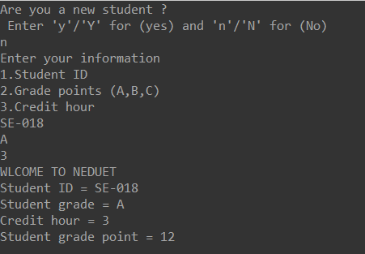

**Question#04:**

#include<iostream>

#include<conio.h>

#include<string>

using namespace std;

class person

{ protected:

string name;

int age;

char gender;

public:

person(){}

person(string n,int a,char g)

{name=n;age=a;gender=g;}

void showdata()

{ cout<<"Name of a person is "<<name<<endl;

cout<<"Age of a person is "<<age<<endl;

cout<<"Gender of a person is "<<gender<<endl; } };

class student:public person

{ protected:

string studentid;

int gradepoint;

public:

student(){}

student(string n,int a,char g,string id,int gp)

{ name=n;

age=a;

gender=g;

studentid=id;

gradepoint=gp; }

void showdata()

{ person::showdata();

cout<<"Student ID of a student is "<<studentid<<endl;

cout<<"Grade point of a student is "<<gradepoint<<endl; } };

class grauatedstuddent:public student

{ string degreeprogram;

public:

grauatedstuddent(string n,int a,char g,string id,int gp,string dp)

{ name=n;

age=a;

gender=g;

studentid=id;

gradepoint=gp;

degreeprogram=dp; }

void showdata()

{ student::showdata();

cout<<"Degree programm is "<<degreeprogram; } };

int main()

{ person p1("Khalid",18,'M');

student s1("Khalid",18,'M',"SE-018",4);

grauatedstuddent gs1("Khalid",18,'M',"SE-018",4,"Sofware Engineering");

p1.showdata();

s1.showdata();

gs1.showdata();

getch(); return 0; }

