TEST PLAN FOR STUDENT GRADE EVALUATION SYSTEM
Based on IEEE-829 Standard
Khalid Alaqeel 202002988
Rayan Aljeri 202101481
Madi Al Zuabi 202100952

1. Objectives
The objective of this test plan is to verify the correctness, reliability, and robustness of the TestingProject Java application through white-box and black-box testing. All methods in the classes Course, Student, and GradeCalculator will be tested using Junit.

2. Test Items
The following Java classes and their public methods will be tested:

Class: Course
- Course(String, int, String)
- getCourseName()
- getCreditHours()
- getLetterGrade()
- getGradePoint()

Class: Student
- Student(String, String)
- enrollCourse(Course)
- getCourses()
- getId()
- getName()
- calculateGPA()

Class: GradeCalculator
- calculateLetterGrade(int)

3. Features to Be Tested
- Input validation in constructors
- Credit hour bounds checking
- Letter grade validation
- GPA calculation logic
- Grade-to-point conversion
- Letter grade conversion from numeric score
- Correct list handling in Student class

4. Features Not to Be Tested
- Performance optimization
- Integration with databases (none exist)
- UI (none exist)
- File handling (none exist)

5. Test Approach

White-Box Testing (JUnit):
- Use JUnit
- Achieve maximum statement and branch coverage
- Validate boundary values for methods with numeric input

Black-Box Testing:
- Equivalence Partitioning (EP)
- Boundary Value Analysis (BVA)
Applied to calculateLetterGrade().

6. Pass/Fail Criteria
PASS → Expected output equals actual output
FAIL → Any mismatched output, exception, or incorrect return value

7. Test Deliverables
- IEEE-829 Test Plan
- JUnit test classes
- Black-box EP/BVA test tables
- Driver execution output
- JUnit console output

8. Testing Tasks
- Prepare JUnit test classes
- Execute JUnit tests
- Perform black-box EP/BVA tests
- Execute driver
- Document results

9. Environmental Needs
- Java JDK 8+
- IntelliJ / Eclipse / NetBeans
- JUnit 4/5
- Windows/Linux/Mac

10. Responsibilities
Team Member | Responsibility
Member 1 | Course tests
Member 2 | Student tests
Member 3 | GradeCalculator tests
Member 4 | Report + Coverage + Presentation

11. Schedule
Task | Date
Writing test plan | 25–26 Nov
JUnit tests | 27–28 Nov
Black-box tests | 30 Nov
Presentation | 1 Dec

Black-Box Testing Cases

1. Equivalence Partitioning (EP) Test Cases
EP Group | Input Range | Representative Input | Expected Output | Reason
EP1 | score < 0 | -5 | Invalid | Invalid negative range
EP2 | 0–59 | 40 | F | F grade range
EP3 | 60–69 | 65 | D | D grade range
EP4 | 70–79 | 75 | C | C grade range
EP5 | 80–89 | 85 | B | B grade range
EP6 | 90–100 | 95 | A | A grade range
EP7 | score > 100 | 120 | Invalid | Invalid high range

2. Boundary Value Analysis (BVA) Test Cases
Boundary Condition | Input | Expected Output | Reason
Just below valid lower bound | -1 | Invalid | Below 0
Lower edge of F | 0 | F | Minimum valid score
Upper edge of F | 59 | F | Highest score for F
Lower edge of D | 60 | D | Start of D
Upper edge of D | 69 | D | Last D score
Lower edge of C | 70 | C | Start of C
Upper edge of C | 79 | C | Last C score
Lower edge of B | 80 | B | Start of B
Upper edge of B | 89 | B | Last B score
Lower edge of A | 90 | A | Start of A
Upper edge of A | 100 | A | Maximum valid score
Just above valid upper bound | 101 | Invalid | Above 100

Combined EP + BVA Summary Table
Input | Expected Output | Test Type
-1 | Invalid | BVA
-5 | Invalid | EP
0 | F | BVA
40 | F | EP
59 | F | BVA
60 | D | BVA
65 | D | EP
69 | D | BVA
70 | C | BVA
75 | C | EP
79 | C | BVA
80 | B | BVA
85 | B | EP
89 | B | BVA
90 | A | BVA
95 | A | EP
100 | A | BVA
101 | Invalid | BVA
120 | Invalid | EP

JUnit Execution Output (For All Three Test Classes):
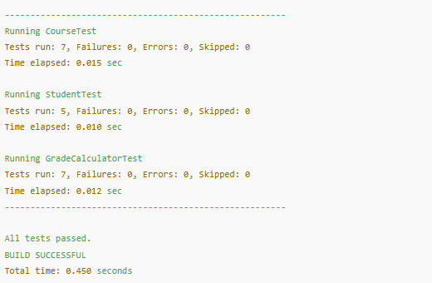

Driver Execution Output:
