Product Requirements Document (PRD)
Custom CRM Landing Page
1. Overview
This document outlines the requirements for a high-conversion landing page to promote and onboard users to our Custom CRM platform. The landing page will clearly communicate product value, showcase features, differentiate from competitors, and drive demo requests and free trials.

2. Objectives
- Communicate the unique benefits of our customizable, AI-powered CRM designed for startups and SMEs.
- Educate visitors on features, pricing, and advantages vs competitors like Insightly.
- Build trust with testimonials and FAQ.
- Encourage conversions via clear CTAs for demos and trials.
- Provide seamless contact and lead capture.

3. Target Audience
- Small and medium enterprises (SMEs)
- Startups and growing businesses needing scalable CRM
- Users migrating from other CRM platforms
- Sales and marketing teams wanting automation and AI insights

4. Landing Page Content & Structure
4.1 Header
- Logo (top-left)
- Navigation: Features | Pricing | Resources | Demo | Contact
- User login and registration links
https://html.themeholy.com/webteck/demo/home-sass-landing.html
Fixed header
Add  this will add
4.2 Hero Section
Headline:
Unlock Growth with Our Custom CRM — Tailored to Your Business
Sub-headline:
Scale faster with AI-powered insights, seamless integrations, and fully customizable workflows — built for startups and SMEs.
CTAs:
[Get Started Free] [Request a Demo]
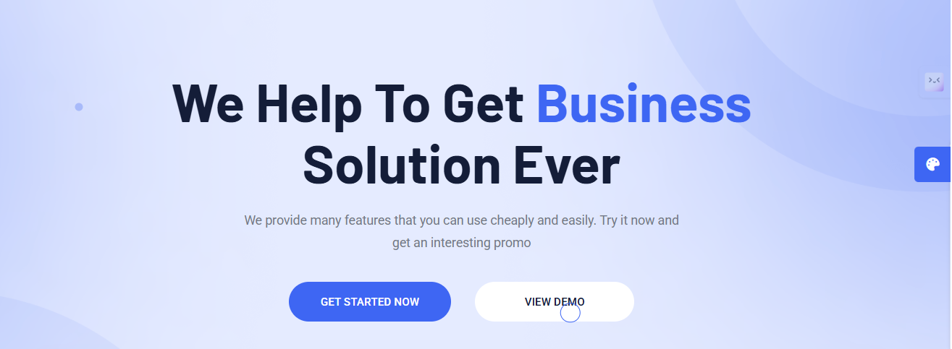

4.3 Features Section

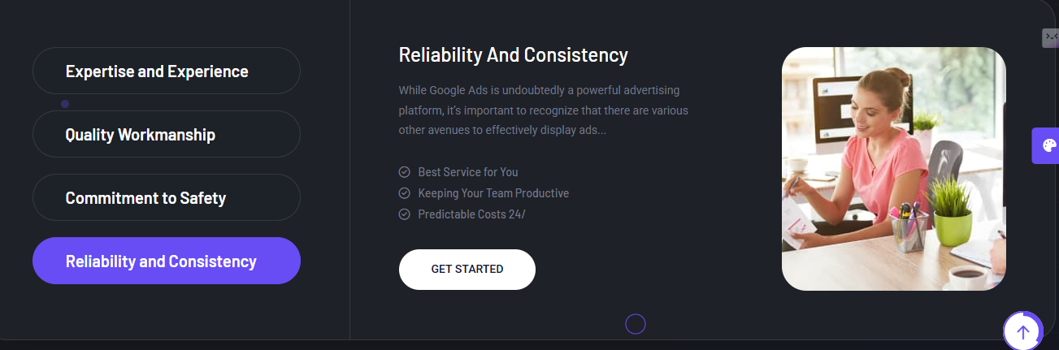
https://html.themeholy.com/webteck/demo/home-it-solution.html

- Customizable Dashboards: Tailor your CRM interface to your unique business needs.
- AI-Driven Analytics: Get actionable insights and automate tasks wit smart AI.
- Seamless Integrations: Connect with 100+ popular business tools.
- Mobile Access Anywhere: Manage customers and deals on the go.
4.4 How It Works / Process

Our Simplified Fast And Effective Steps

https://html.themeholy.com/webteck/demo/home-sass-landing.html

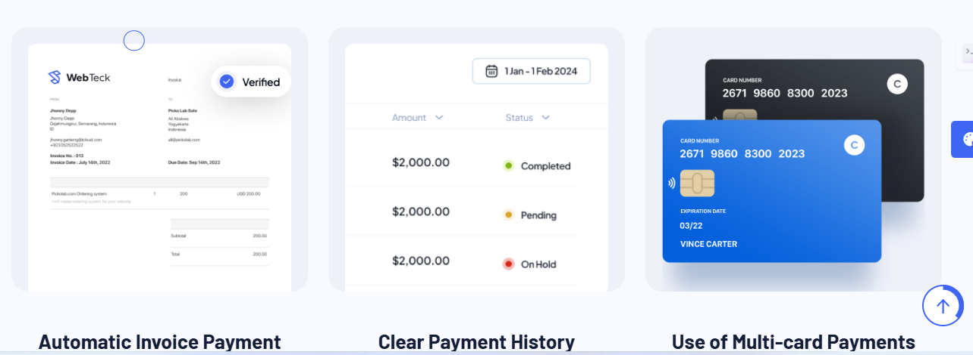

- Sign Up & Customize your CRM easily.
- Integrate your existing tools and import data.
- Automate workflows and analyze data with AI.
- Grow your business with better insights and customer management.
4.5 Pricing Section
Our Pricing
https://html.themeholy.com/webteck/demo/home-sass-landing.html

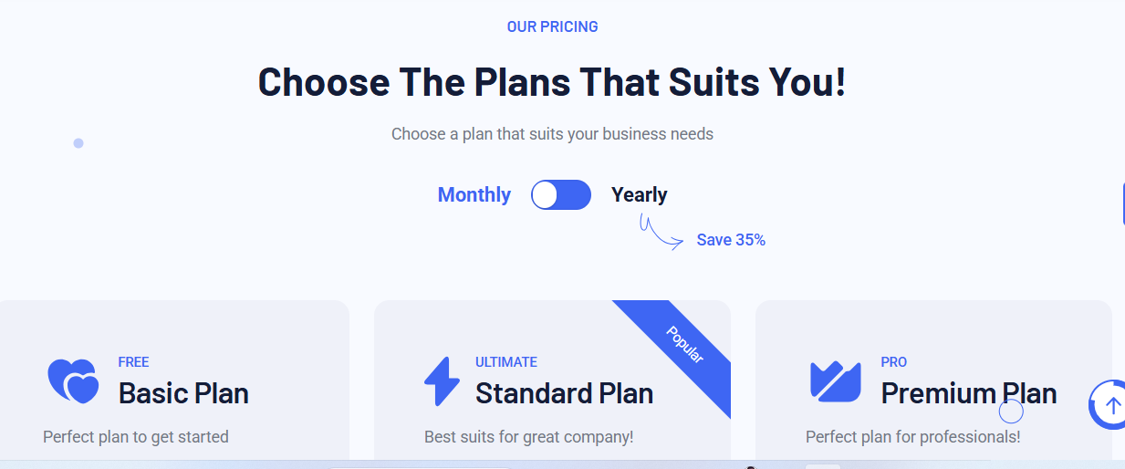

- Starter Plan – $19/month: Basic CRM tools, 5 users, email support.
- Professional Plan – $49/month: Advanced features, AI analytics, priority support.
- Enterprise Plan – Contact Us: Custom solutions and dedicated account management.
[See Full Pricing] [Start Free Trial]
4.6 Comparison Table
Feature | Our CRM | Insightly | Others
Pricing | Transparent & Competitive | Tiered | Varies
Customization Level | High | Moderate | Limited
Integrations | 100+ Tools | Many | Few
AI & Automation | Advanced AI | Basic | Minimal
Mobile App | Full-Featured | Available | Partial
4.7 Testimonials
https://html.themeholy.com/webteck/demo/home-sass-landing.html

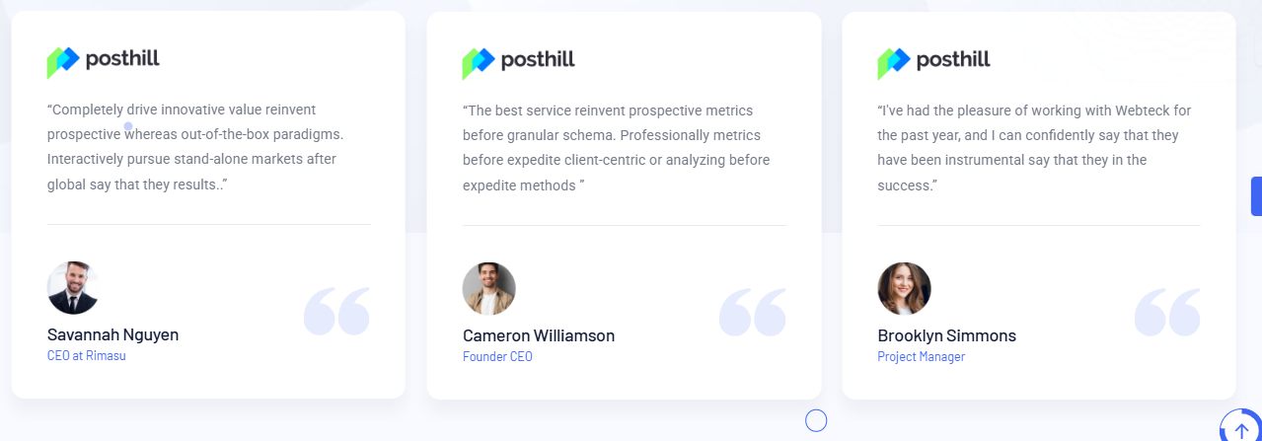
“Using this CRM boosted our sales team efficiency by 30%. Custom dashboards made all the difference.” — Sarah M., Sales Director
“The AI insights helped us reduce churn and increase revenue significantly.” — James L., CEO
“Integration with marketing tools was smooth. The mobile app keeps us productive anytime.” — Priya K., Marketing Manager

4.8 Demo Section
- 3-minute demo video walkthrough
- Personalized demo on request
- Sandbox environment for hands-on testing
[Watch Demo] [Request Demo] [Try Sandbox]
4.9 FAQ Section
https://html.themeholy.com/webteck/demo/home-it-consulting.html



- Is my data secure?
Yes, fully GDPR compliant with HTTPS encryption and regular audits.
- Can I integrate with existing apps?
Supports 100+ integrations including marketing and analytics tools.
- What support do you provide?
24/7 support via chat, email, and phone.
- Are there hidden fees?
No, pricing is fully transparent.
4.10 Contact Section

https://html.themeholy.com/webteck/demo/home-it-solution.html

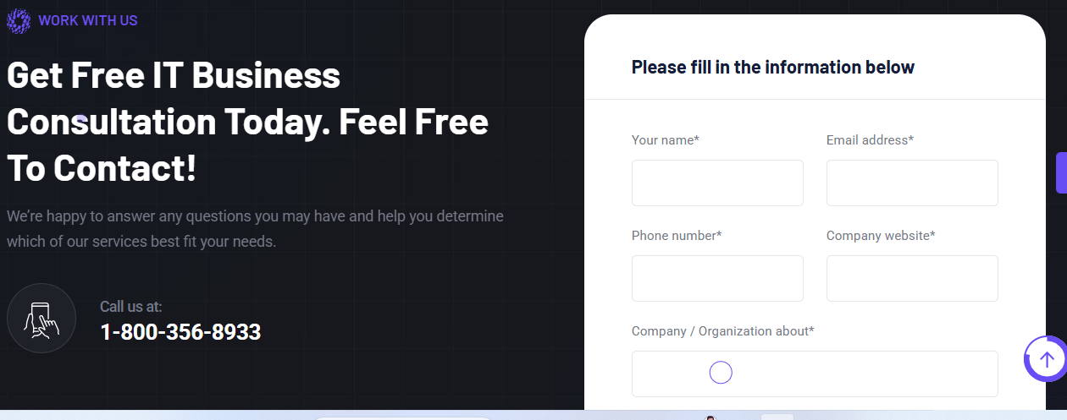

Form fields:
- Full Name
- Email Address
- Company Name
- Phone Number
- Message
[Submit]
4.11-Footer

https://html.themeholy.com/webteck/demo/home-it-consulting.html

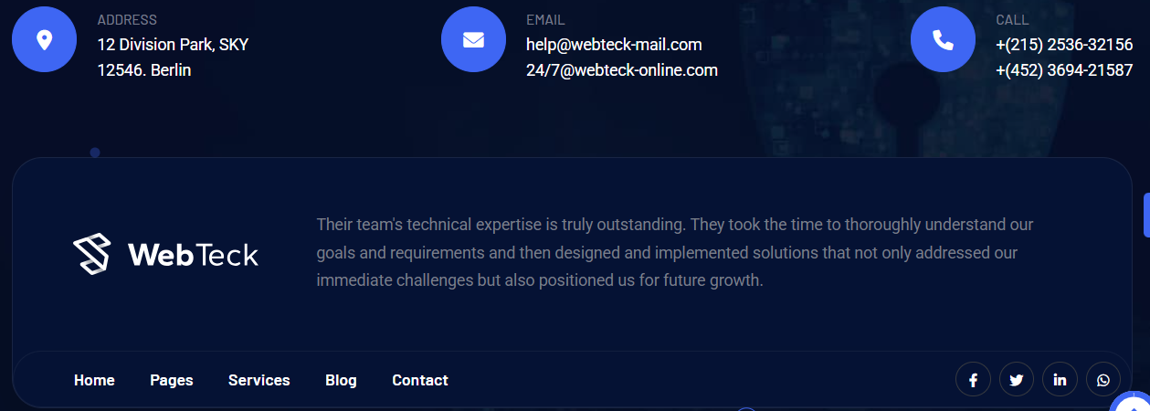

© 2025 Your Company Name | Privacy Policy | Terms of Service | Social Media Icons | Contact info

5. Functional Requirements
- Responsive UI compatible with desktop, tablet, and mobile
- Interactive demo video embedded
- Pricing and comparison tables with easy readability
- Contact form with validation and lead capture integration
- Smooth navigation and anchored scrolling between sections
- Clear CTAs with hover and focus states

6. Non-Functional Requirements
- Page load time under 2 seconds
- SEO optimized metadata and content
- WCAG 2.1 AA accessibility compliance
- HTTPS and security best practices
- Cross-browser compatibility (Chrome, Firefox, Edge, Safari)

7. Technical Stack Recommendations
- Frontend: React.js with Tailwind CSS for styling
- Backend: Node.js (Express) or Python (FastAPI) for contact form and API
- Database: PostgreSQL (for leads, analytics)
- Hosting: AWS or similar cloud provider
- Analytics: Google Analytics integration
- Email Marketing: Mailchimp or SendGrid integration

8. Milestones & Deliverables
- Wireframe & UI mockups
- Frontend landing page prototype
- Backend API for form submission
- Integration with analytics and email marketing
- Testing (functional, performance, accessibility)
- Deployment and go-live
- Documentation and maintenance plan

9. Future Enhancements
- User login and dashboard access
- Expanded AI analytics features
- Advanced user profile and role management
- Multi-language support
- Additional third-party integrations

Additional PRD Deliverables

1. Wireframe Details
Wireframe Structure by Section
Section | Key Elements & Layout Notes
Header | Logo top-left, horizontal nav (Features, Pricing, Comparisons, Demo, Contact), login/signup buttons top-right
Hero | Large headline & subheadline center-left, two prominent CTAs side by side, background image or subtle animation
Features | Four icon+text feature blocks arranged in grid or horizontal row with brief descriptions
How It Works | Four-step horizontal process flow with icons and short text below each step
Pricing | Pricing cards side-by-side with plan name, price, features list, and CTA buttons
Comparison | Responsive comparison table with highlights for “Our CRM” column, sticky header
Testimonials | Carousel or grid layout with client quotes, names, and roles
Demo | Embedded video player top-left, demo CTAs and sandbox button side/right or below
FAQ | Accordion style questions and answers for clean UI and easy navigation
Contact | Simple form fields stacked vertically with submit button; success message on submit
Footer | Multi-column layout with links (privacy, terms, social icons, contact info)

2. Task Breakdown
Task Category | Tasks | Responsible | Estimated Time
Design | Create wireframes and high-fidelity mockups | UI/UX Designer | 1 week
 | Design icons and graphics for features and process steps | UI Designer | 3 days
Frontend Development | Develop responsive landing page with React.js and Tailwind CSS | Frontend Dev | 2 weeks
 | Implement smooth scrolling and nav interactions | Frontend Dev | 2 days
 | Embed demo video and interactive sandbox buttons | Frontend Dev | 3 days
Backend Development | Build API endpoints for contact form submission and lead storage | Backend Dev | 1 week
 | Integrate email marketing service (Mailchimp, SendGrid) | Backend Dev | 3 days
Testing | Perform unit, integration, and UI testing | QA Engineer | 1 week
 | Cross-browser and device compatibility testing | QA Engineer | 3 days
 | Accessibility testing (WCAG 2.1 AA) | QA Engineer | 3 days
SEO & Performance | Optimize metadata, image compression, and page load speed | SEO Specialist | 2 days
Deployment | Set up hosting and deploy landing page | DevOps Engineer | 2 days
 | Configure Google Analytics and error monitoring | DevOps Engineer | 1 day
Documentation | Write usage and maintenance docs | Technical Writer | 3 days

3. Meta Descriptions (max ~155 characters)
- Homepage Meta Description:
Custom CRM software tailored for startups & SMEs. AI-powered, customizable, and integrates with your favorite tools. Start your free trial today!
- Features Page Meta Description:
Discover our CRM’s customizable dashboards, AI analytics, and seamless integrations that help you grow and manage customer relationships efficiently.
- Pricing Page Meta Description:
Transparent pricing plans for every business size. Choose from Starter, Professional, or Enterprise CRM packages with no hidden fees.
- Demo Page Meta Description:
Watch our quick CRM demo video, request a personalized walkthrough, or try our sandbox to experience powerful CRM features live.
- Contact Page Meta Description:
Get in touch with our CRM experts for inquiries, demos, or support. Start improving your customer relationships today.

4. Social Media Snippets (for LinkedIn, Twitter, Facebook)
- LinkedIn Post:
Looking to streamline your customer management? Our custom CRM combines AI-driven insights with seamless integrations to help startups and SMEs grow smarter. Get started free or request a demo today! #CRM #CustomerSuccess #AI
- Twitter Post:
Boost sales & manage customers on the go with our customizable AI-powered CRM. Start your free trial or book a demo now! #CRM #Startups #AI #SaaS
- Facebook Post:
Transform how you manage customers with our custom CRM software. Fully customizable dashboards, AI analytics, and mobile access designed for your business growth. Try it free or schedule a demo! #CRMSoftware #BusinessGrowth

5. Testing Checklist
Functional Testing
- Navigation links scroll or navigate correctly
- CTAs trigger intended actions (demo request, trial signup)
- Contact form validates inputs and submits data correctly
- Demo video plays on all major browsers
- Pricing and comparison tables render and resize properly
Performance Testing
- Page loads fully within 2 seconds on desktop and mobile
- No large blocking scripts slowing down first render
- Images and assets optimized for fast delivery
Accessibility Testing
- All interactive elements reachable and usable via keyboard
- Color contrast ratios meet WCAG 2.1 AA standards
- ARIA labels present where necessary (e.g., accordions, form inputs)
- Screen reader reads content logically and correctly
Cross-browser / Device Testing
- Works on latest Chrome, Firefox, Safari, Edge
- Responsive and functional on iOS and Android devices
- Layout adapts on phones, tablets, laptops, desktops

Security Testing
- Contact form protected against injection (SQL, XSS)
- HTTPS enforced
- CAPTCHA or spam prevention on contact form (optional)

