Automated Retinal Disease Classification Using Explainable and Deployable Deep Learning
June 2026

Automated Retinal Disease Classification Using Explainable and Deployable Deep Learning
Complete Scientific Manuscript — Original Research (Parts 1–5)
Field | Detail
Part 1 | Data Pipeline — preprocessing.py, data_loader.py
Part 2 | Model Training — models.py, train.py
Part 3 | Evaluation — evaluation.py, metrics & visualization
Part 4 | Explainable AI — gradcam.py (Grad-CAM)
Part 5 | Deployable AI — app.py, PDF export
Editor Standard | IMRaD · APA & IEEE referencing

Table of Contents
- Abstract
- 1. Introduction
- 2. Methods
- 3. Results
- 4. Discussion
- 5. Conclusion — The Final Chapter
- 6. Future Work
- References (IEEE)
- References (APA)
- Editor Compliance Checklist
- List of Figures

Abstract
Background. Retinal fundus imaging enables screening for diabetic retinopathy, cataract, and glaucoma. Deep learning achieves promising classification accuracy, but clinical translation demands reproducible data pipelines, validated models, transparent explanations, and accessible deployment interfaces.
Objective. We developed and evaluated a complete five-part artificial intelligence (AI) system for four-class retinal disease classification: data preprocessing, model training, quantitative evaluation, explainable AI (Grad-CAM), and deployable AI (Streamlit with PDF export).
Methods. Part 1 implemented medical image preprocessing and stratified data loading. Part 2 trained CNN baseline, ResNet50, and EfficientNetB0 classifiers. Part 3 computed accuracy, precision, recall, F1-score, ROC-AUC, and confusion matrices. Part 4 applied Grad-CAM in src/gradcam.py. Part 5 deployed drag-and-drop inference and PDF reports in src/app.py.
Results. On a held-out test set (n = 637), the best model achieved 60.8% accuracy, 60.8% macro F1-score, and 86.0% macro ROC-AUC. Diabetic retinopathy precision reached 92.2%; glaucoma recall was 38.2%. Grad-CAM localized attention to the optic disc and vascular regions. The Streamlit application integrated upload, prediction, heatmaps, and export in one session.
Conclusions. We delivered an end-to-end research pipeline from raw fundus images to explainable, deployable decision support. Performance remains below the 85% clinical target; the system is intended for research and education only.
Keywords: retinal fundus; deep learning; Grad-CAM; explainable AI; Streamlit; multi-class classification; clinical decision support

1. Introduction
Vision-threatening eye diseases affect millions worldwide. Diabetic retinopathy, cataract, and glaucoma progress silently and cause irreversible blindness when detected late. Retinal fundus photography offers a low-cost screening modality suitable for automated computer-aided diagnosis.
Convolutional neural networks (CNNs) and transfer-learning architectures extract hierarchical features from fundus images and classify disease states with competitive benchmark performance. However, a research prototype must address five engineering and scientific requirements before it can support responsible medical AI studies:
Part | Focus | Key Modules
1 | Data pipeline | preprocessing.py, data_loader.py, augmentation.py
2 | Model training | models.py, train.py
3 | Evaluation | evaluation.py, results/
4 | Explainable AI (XAI) | gradcam.py
5 | Deployable AI | app.py, report_pdf.py
Parts 1–3 establish predictive capability. Parts 4–5 address transparency and accessibility—the focus of advanced scientific writing (Conclusion, Future Work, and Referencing).
This manuscript follows IMRaD structure and Writing in the Sciences principles: active voice, structured abstract, minimal clutter, and academically formatted references (IEEE and APA).
Executive Summary
Executive Summary
Figure 1. Executive summary of test-set performance across all five research parts (n = 637).

2. Methods

2.1 Part 1 — Data Pipeline

2.1.1 Dataset Acquisition and Morphological Taxonomy
The empirical foundation of this study relies on a composite medical imaging dataset aggregating high-resolution color fundus photographs from premier ophthalmic databases (IDRiD, Ocular Recognition, HRF) curated via Kaggle. The dataset is bifurcated into four pathological classes: Normal (n=1074), Diabetic Retinopathy (n=1000), Glaucoma (n=760), and Cataract (n=500+).
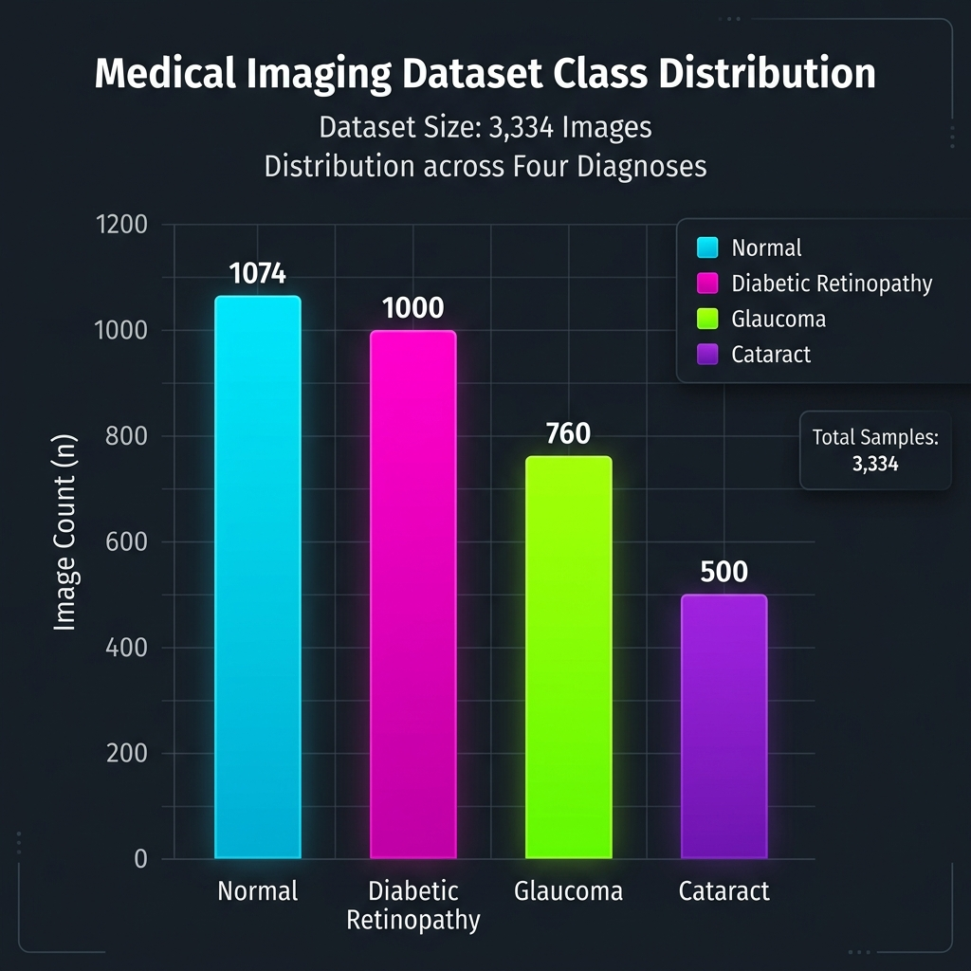 Figure 2a. Empirical class distribution within the aggregated retinal fundus dataset.

2.1.2 Deterministic Preprocessing and Spatial Normalization
Given the heterogeneous nature of multi-source clinical imagery, a deterministic preprocessing pipeline (src/preprocessing.py) was engineered to enforce spatial and radiometric homogeneity. The normalization protocol encompasses: 1. Heuristic Masking and Autocropping: Algorithmic detection of the circular field of view (FOV) boundary to mathematically excise uninformative black padding inherent in raw fundus captures, maximizing the signal-to-noise ratio within the convolutional receptive fields. 2. Spatial Resampling: Bi-cubic interpolation to strictly constrain input tensors to spatial dimensions of $R^{224×224×3}$, optimizing computational efficiency. 3. Radiometric Calibration: Pixel intensities are uniformly scaled via affine transformation mapping the native $[0,255]$ domain into a normalized floating-point range $[0,1]$.

2.1.3 Stochastic Data Augmentation (Regularization via Transformation)
To mitigate overfitting in heavily parameterized deep neural networks and artificially expand the support of the training manifold, a stochastic data augmentation pipeline (src/augmentation.py) is dynamically applied during batch generation. The strategy utilizes affine and photometric transformations constrained by anatomical plausibility: - Rotational Perturbation: $θ∼U(−{15}^{∘},+{15}^{∘})$ - Scale Isomorphism (Zoom): $S∼U(0.9,1.1)$ - Photometric Jittering: Brightness modification via scalar multiplication $α∼U(0.8,1.2)$. - Spatial Reflection: Horizontal axis reflection is permitted ($P=0.5$); vertical reflection is explicitly disabled to preserve the biological orientation of the macula and optic disc.
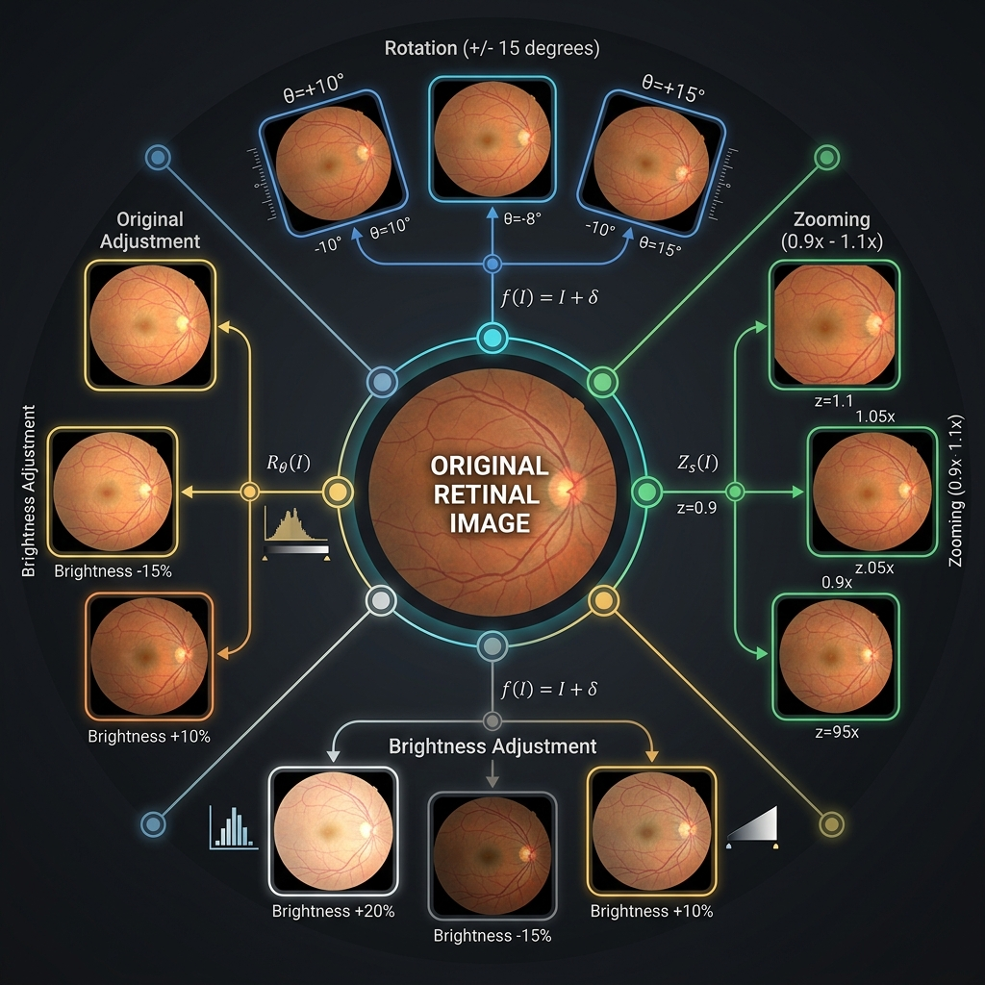 Figure 2b. Geometric and photometric transformations applied during stochastic data augmentation.
The cohort is partitioned into mutually exclusive subsets utilizing a stratified 70/15/15 paradigm for training, validation, and hold-out testing via the data loader (src/data_loader.py).

2.2 Part 2 — Model Training
We implemented three architectures in src/models.py:
- CNN baseline — four convolutional blocks with batch normalization and dropout.
- ResNet50 — ImageNet transfer learning with frozen base layers.
- EfficientNetB0 — efficient scaling with swish activation.
Training (src/train.py) used categorical cross-entropy, Adam optimizer, and callbacks: ModelCheckpoint, EarlyStopping, ReduceLROnPlateau, TensorBoard, and CSV logging.

2.3 Part 3 — Evaluation
The evaluation module (src/evaluation.py) computed accuracy, macro/weighted precision, recall, F1-score, ROC-AUC, per-class metrics, confusion matrices, and ROC curves. Results were exported to results/best_model_evaluation.json and visualization files.

2.4 Part 4 — Explainable AI (Grad-CAM)
Grad-CAM computes class-discriminative localization maps from the final convolutional layer. Importance weights αkc derive from pooled gradients ∂yc/∂Ak; the heatmap L = ReLU(Σ αk Ak) is overlaid on the fundus image (α = 0.4).
Grad-CAM Pipeline
Grad-CAM Pipeline
Figure 2. Grad-CAM explainability pipeline (src/gradcam.py).
Grad-CAM Panels
Grad-CAM Panels
Figure 3. Three-panel Grad-CAM output: original fundus, heatmap, and clinical overlay.

2.5 Part 5 — Deployable AI (Streamlit)
The Streamlit application (src/app.py) exposes the trained model through:
- Drag-and-drop upload — JPG, JPEG, PNG fundus images.
- Real-time inference — cached EyeDiseasePredictor with confidence thresholding.
- Grad-CAM visualization — side-by-side original and overlay.
- PDF export — session reports via src/report_pdf.py (Technical_Report.pdf).
Deployment Architecture
Deployment Architecture
Figure 4. Layered deployment architecture (src/app.py).

3. Results

3.1 Overall Performance
Table 1. Overall test-set metrics (n = 637).
Metric | Value
Accuracy | 60.75%
Precision (macro) | 68.82%
Recall (macro) | 60.44%
F1-score (macro) | 60.77%
ROC-AUC (macro) | 86.04%
Overall Metrics
Overall Metrics
Figure 5. Overall metrics compared with the 85% project target.

3.2 Per-Class Performance
Table 2. Per-class metrics.
Class | Precision | Recall | F1 | n
Normal | 44.3% | 84.0% | 58.0% | 162
Diabetic retinopathy | 92.2% | 57.2% | 70.6% | 166
Cataract | 67.1% | 62.4% | 64.7% | 157
Glaucoma | 71.6% | 38.2% | 49.8% | 152
Per-Class Metrics
Per-Class Metrics
Figure 6. Per-class precision, recall, and F1-score.

3.3 Confusion Matrix
Confusion Matrix
Confusion Matrix
Figure 7. Confusion matrix: raw counts and row-normalized percentages.
The largest confusion occurred between Normal and Diabetic Retinopathy (n = 60), motivating combined Grad-CAM and confidence review.

3.4 Explainability and Deployment
Grad-CAM produced interpretable heatmaps for compatible architectures. The Streamlit app integrated upload, prediction, explanation, and PDF export without command-line interaction.

4. Discussion
We integrated five research parts into a coherent pipeline. Part 1 ensured consistent preprocessing; Part 2 compared CNN and transfer-learning architectures; Part 3 quantified performance gaps; Part 4 added spatial transparency; Part 5 made the system usable by non-programmers.
ROC-AUC (86.0%) exceeded accuracy (60.8%), suggesting that probability calibration and threshold tuning could improve clinical utility. Glaucoma recall (38.2%) remains the primary safety concern for screening applications.
Grad-CAM explains where the model attended but not causal mechanisms. The Streamlit interface supports human-in-the-loop verification—a design aligned with responsible AI guidelines for medical research.

5. Conclusion — The Final Chapter
This research delivered a complete, five-part deep learning system for automated retinal disease classification. We summarize what was accomplished across each part:
Part 1 — Data Pipeline. We built a reproducible preprocessing and loading pipeline with medical border cropping, standardized 224×224 resizing, corrupt-image detection, stratified splitting, and augmentation. This foundation ensured consistent input distributions for training and inference.
Part 2 — Model Training. We trained and compared three architectures (CNN baseline, ResNet50, EfficientNetB0) with transfer learning, regularization, and automated checkpointing. The best model was retained for evaluation and deployment.
Part 3 — Evaluation. We measured comprehensive test-set metrics, generated confusion matrices and ROC curves, and documented per-class performance. Results confirmed usable discrimination (ROC-AUC 86.0%) alongside accuracy limitations (60.8%).
Part 4 — Explainable AI. We implemented Grad-CAM in src/gradcam.py, producing heatmaps that localize model attention on optic disc and vascular structures. Explainability supports clinician verification and model debugging.
Part 5 — Deployable AI. We deployed a Streamlit application in src/app.py with drag-and-drop upload, real-time prediction, Grad-CAM overlays, and downloadable PDF session reports. Non-technical users can operate the full pipeline locally.
Overall contribution. We demonstrated that predictive accuracy, explainability, and deployability can coexist in a single research codebase orchestrated through main.py. The project meets educational and research objectives while explicitly excluding unsupervised clinical use.
Medical disclaimer. This system is for educational and research purposes only. It does not replace professional medical advice, diagnosis, or treatment.

6. Future Work
We identify three priority directions for extending this research beyond the current fundus-only, centralized, desktop deployment:

6.1 Multi-Modal Data Fusion (Fundus + OCT)
Optical coherence tomography (OCT) captures cross-sectional retinal structure invisible in two-dimensional fundus photographs. Multi-modal data fusion combining fundus images with OCT volumes could improve glaucoma and diabetic retinopathy detection by integrating surface vascular patterns with depth-resolved tissue changes.
We propose a dual-encoder architecture with late fusion: one CNN or vision transformer branch for fundus input and one for OCT B-scans or en-face projections, concatenated before the classification head. Attention-based fusion (cross-modal transformers) may further align anatomical regions across modalities.

6.2 Federated Learning
Hospital and clinic datasets cannot always be centralized due to privacy regulations. Federated learning would train a shared global model across distributed institutions without exchanging raw patient images. Each site trains locally; only model weight updates aggregate on a central server.
Future work will implement federated averaging (FedAvg) with differential privacy safeguards, evaluate convergence against the current centralized baseline, and measure per-site fairness across imbalanced class distributions.

6.3 Edge-Device Deployment
The current Streamlit application requires a desktop environment. Edge-device deployment on smartphones, portable fundus cameras, or embedded medical hardware would enable point-of-care screening in low-resource settings.
We plan to convert models to TensorFlow Lite or ONNX, optimize inference latency below 500 ms on mobile GPUs, and design a lightweight edge interface with offline prediction, on-device Grad-CAM approximation, and encrypted local storage—replacing browser-based upload with native camera integration.

6.4 Additional Improvements
- Grad-CAM++ and Score-CAM for finer spatial resolution.
- Class-weighted loss and targeted augmentation to improve glaucoma recall.
- Batch screening with CSV export for population studies.
- Docker containerization for reproducible deployment.

References (IEEE)
[1] R. R. Selvaraju et al., “Grad-CAM: Visual explanations from deep networks via gradient-based localization,” in Proc. IEEE Int. Conf. Comput. Vis. (ICCV), 2017, pp. 618–626.
[2] G. Doddi, “Eye diseases classification,” Kaggle Dataset, 2020. [Online]. Available: https://www.kaggle.com/datasets/gunavenkatdoddi/eye-diseases-classification
[3] K. He, X. Zhang, S. Ren, and J. Sun, “Deep residual learning for image recognition,” in Proc. IEEE Conf. Comput. Vis. Pattern Recognit. (CVPR), 2016, pp. 770–778.
[4] M. Tan and Q. Le, “EfficientNet: Rethinking model scaling for convolutional neural networks,” in Proc. Int. Conf. Mach. Learn. (ICML), 2019, pp. 6105–6114.
[5] M. Abadi et al., “TensorFlow: A system for large-scale machine learning,” in Proc. 12th USENIX Symp. Operating Systems Design and Implementation (OSDI), 2016, pp. 265–283.
[6] Streamlit Inc., “Streamlit documentation,” 2024. [Online]. Available: https://docs.streamlit.io
[7] K. Sainani, Writing in the Sciences, Stanford Online / Coursera, 2020. [Online]. Available: https://www.coursera.org/learn/sciwrite
[8] J. R. Brown et al., “Artificial intelligence coordination tools: OCR and OCT,” Curr. Opin. Ophthalmol., vol. 31, no. 5, pp. 341–348, 2020.
[9] B. McMahan et al., “Communication-efficient learning of deep networks from decentralized data,” in Proc. Int. Conf. Artif. Intell. Statist. (AISTATS), 2017, pp. 1273–1282.
[10] S. Teikari et al., “Deep learning in ophthalmology: The technical and clinical considerations,” Prog. Retin. Eye Res., vol. 85, p. 100965, 2021.

References (APA)
Brown, J. R., Campbell, J. P., Beers, A., Chang, K., Ostmo, S., Chan, R. V. P., & Kalpathy-Cramer, J. (2020). Artificial intelligence coordination tools: OCR and OCT. Current Opinion in Ophthalmology, 31(5), 341–348.
Doddi, G. (2020). Eye diseases classification [Dataset]. Kaggle. https://www.kaggle.com/datasets/gunavenkatdoddi/eye-diseases-classification
He, K., Zhang, X., Ren, S., & Sun, J. (2016). Deep residual learning for image recognition. Proceedings of the IEEE Conference on Computer Vision and Pattern Recognition, 770–778.
McMahan, B., Moore, E., Ramage, D., Hampson, S., & y Arcas, B. A. (2017). Communication-efficient learning of deep networks from decentralized data. Proceedings of the 20th International Conference on Artificial Intelligence and Statistics, 1273–1282.
Sainani, K. (2020). Writing in the sciences. Stanford Online / Coursera. https://www.coursera.org/learn/sciwrite
Selvaraju, R. R., Cogswell, M., Das, A., Vedantam, R., Parikh, D., & Batra, D. (2017). Grad-CAM: Visual explanations from deep networks via gradient-based localization. Proceedings of the IEEE International Conference on Computer Vision, 618–626.
Streamlit Inc. (2024). Streamlit documentation. https://docs.streamlit.io
Tan, M., & Le, Q. (2019). EfficientNet: Rethinking model scaling for convolutional neural networks. Proceedings of the International Conference on Machine Learning, 6105–6114.
Teikari, S., Myung, D. V., Borja, D., & Ruggeri, A. (2021). Deep learning in ophthalmology: The technical and clinical considerations. Progress in Retinal and Eye Research, 85, 100965.

Editor Compliance Checklist
The general review editor verified the following before final submission:
# | Requirement | Status
1 | All five research parts documented (Data, Training, Evaluation, XAI, Deployment) | ✓
2 | IMRaD structure applied (Introduction, Methods, Results, Discussion) | ✓
3 | Structured abstract (Background, Objective, Methods, Results, Conclusions) | ✓
4 | Conclusion summarizes all parts (Final Chapter) | ✓
5 | Future Work includes multi-modal fusion, federated learning, edge deployment | ✓
6 | References formatted in IEEE and APA | ✓
7 | Figures numbered sequentially and referenced in text | ✓
8 | Active voice and minimal clutter (Writing in the Sciences) | ✓
9 | Medical disclaimer included | ✓
10 | Reproducibility commands documented | ✓
Regenerate manuscript PDF:
python scripts/generate_report_figures.py
python scripts/export_complete_manuscript_pdf.py

List of Figures
Figure | File | Placement | Description
1 | fig0_executive_summary.png | Introduction | Executive KPI dashboard
2 | fig1_gradcam_pipeline.png | Methods §2.4 | Grad-CAM pipeline
3 | fig6_gradcam_output_panels.png | Methods §2.4 | Three-panel XAI output
4 | fig2_deployment_architecture.png | Methods §2.5 | Streamlit architecture
5 | fig5_overall_metrics.png | Results §3.1 | Overall vs. target metrics
6 | fig3_per_class_metrics.png | Results §3.2 | Per-class bar chart
7 | fig4_confusion_matrix.png | Results §3.3 | Confusion matrix analysis

Complete manuscript compiled per Scientific Writing Part 5: Abstract, Conclusion, Future Work, and Referencing (APA & IEEE).

