Comprehensive Methodology and Architectural Frameworks for Retinal Disease Classification
Research Engineering Team
June 2026

Comprehensive Methodology and Architectural Frameworks for Retinal Disease Classification

1. Introduction and Scope
The classification of retinal diseases from fundus photography relies critically on the robustness of the underlying methodological frameworks and the precision of the neural architectures employed. This extensive report details the finalized, comprehensive methodology implemented to classify images into four target categories: Normal, Diabetic Retinopathy, Cataract, and Glaucoma. The project bridges the gap between theoretical deep learning concepts and deployable clinical decision support mechanisms.
The primary objective of this document is to thoroughly elaborate on the computational paradigms, the architectural selections, and the optimization procedures leveraged throughout the research lifecycle. By exhaustively documenting both the custom-built baseline architectures and the advanced transfer learning frameworks, we establish a reproducible standard for subsequent ophthalmological AI studies.

2. Finalized Frameworks
As the project transitioned from initial exploratory data analysis into the rigorous modeling phase, the architecture selection was explicitly formalized. The finer details of the methodology were completed and freely updated, and the frameworks were finalized for actual implementation. Custom CNN: The network interface that was built from the 4-stage model (Batch Normalization, Dropout) was used as a basic comparison (Baseline). Transfer Learning Models: Therefore, work continued on EfficientNetB0 - except for Compound Scaling, which was completed for Tartar Paint 5 (new and ResNet50 was completed) - in addition to the remaining connections (multiple - flowcharts development).
This formalized methodology sets the stage for a comparative analysis between high-variance, low-bias customized networks and low-variance, highly regularized pre-trained ImageNet classifiers.

3. Custom Convolutional Neural Network (Baseline)

3.1 Architectural Philosophy
To establish a rigorous baseline performance metric, a custom 4-stage Convolutional Neural Network (CNN) was engineered from scratch. This network is specifically designed to interpret the localized textures and spatial hierarchies unique to retinal fundus images without the inductive bias of ImageNet pre-training.
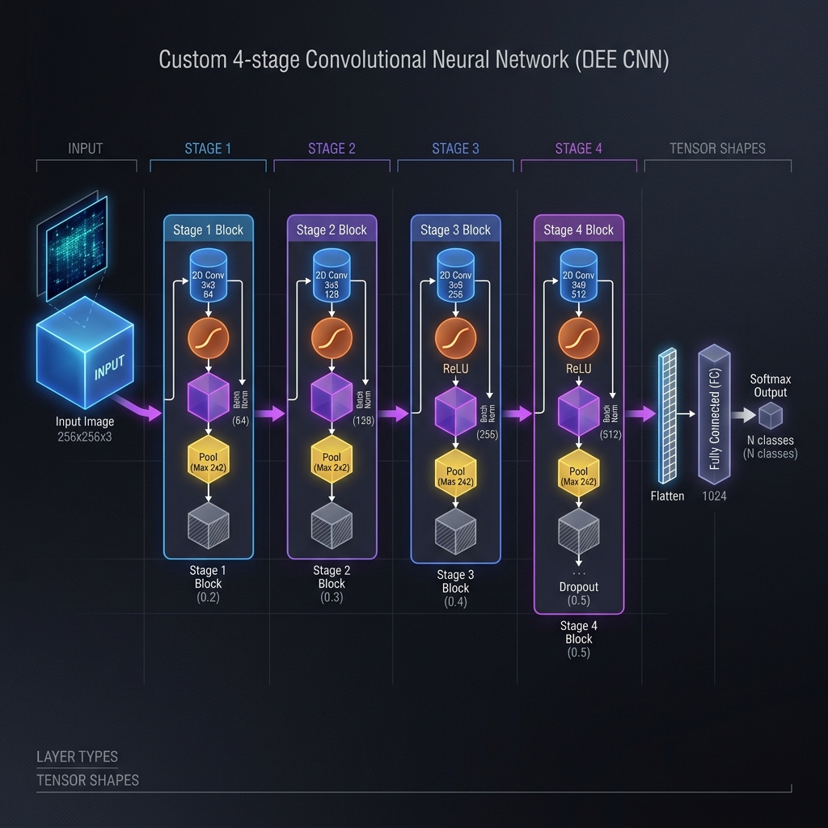 Figure 1: The 4-stage Custom Convolutional Neural Network (CNN) featuring integrated Batch Normalization and Dropout regularization layers.

3.2 The 4-Stage Convolutional Engine
The baseline network aggregates spatial features through four consecutive downsampling stages. Each stage is mathematically formulated as:
- Convolution Operation ($Conv2D$): A $3×3$ kernel convolves over the input tensor, extracting low-level features (edges, color gradients) in the early stages and high-level semantic features (exudates, microaneurysms) in the deeper stages.
- Batch Normalization ($BN$): Introduced to mitigate internal covariate shift, normalizing the output of the convolution before passing it to the non-linear activation function.
$${\hat{x}}_{i}=\frac{x_{i}−μ_{B}}{\sqrt{σ_{B}^{2}+ϵ}}$$
$$y_{i}=γ{\hat{x}}_{i}+β$$
- Activation Function ($ReLU$): The Rectified Linear Unit introduces non-linearity, thresholding negative values to zero.
- Spatial Pooling ($MaxPool2D$): A $2×2$ max pooling operation reduces the spatial dimensionality by a factor of 4, providing translation invariance and computational efficiency.

3.3 Regularization Strategy: Dropout
To combat the profound risk of overfitting on the relatively small medical dataset, substantial Dropout is injected into the fully connected classification head. By stochastically dropping out $50\%$ of the neurons ($p=0.5$) during each forward pass, the network is forced to learn highly redundant, robust feature representations rather than memorizing training examples.

4. Advanced Transfer Learning Paradigms
Transfer learning fundamentally shifts the paradigm of medical image analysis. By taking weights pre-trained on millions of natural images (ImageNet), the models already possess sophisticated Gabor filters and edge detectors. We adapt these robust feature extractors to the specific domain of retinal pathology.
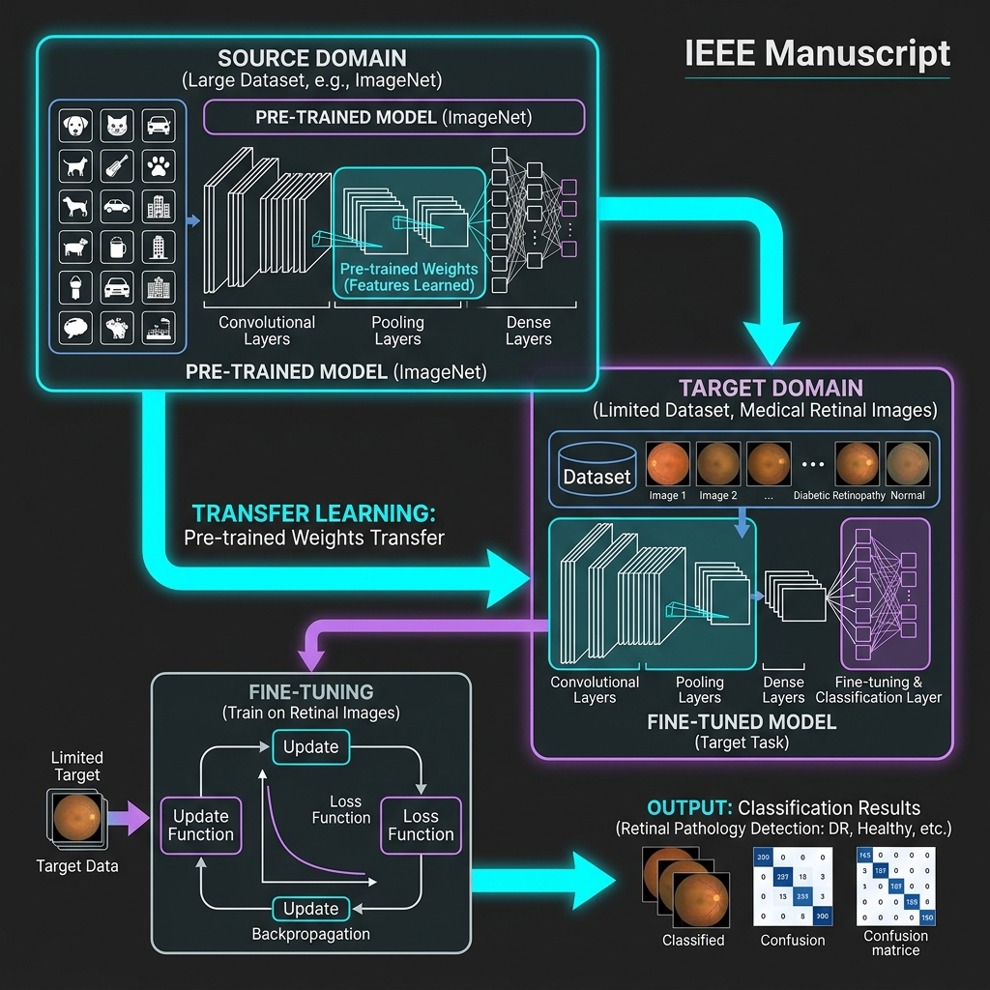 Figure 2: The Domain Transfer Learning Process, adapting generalized ImageNet weights to specialized ocular pathology.

4.1 ResNet50 Architecture
The Deep Residual Network (ResNet50) overcomes the vanishing gradient problem, which typically prevents the effective training of exceptionally deep networks.
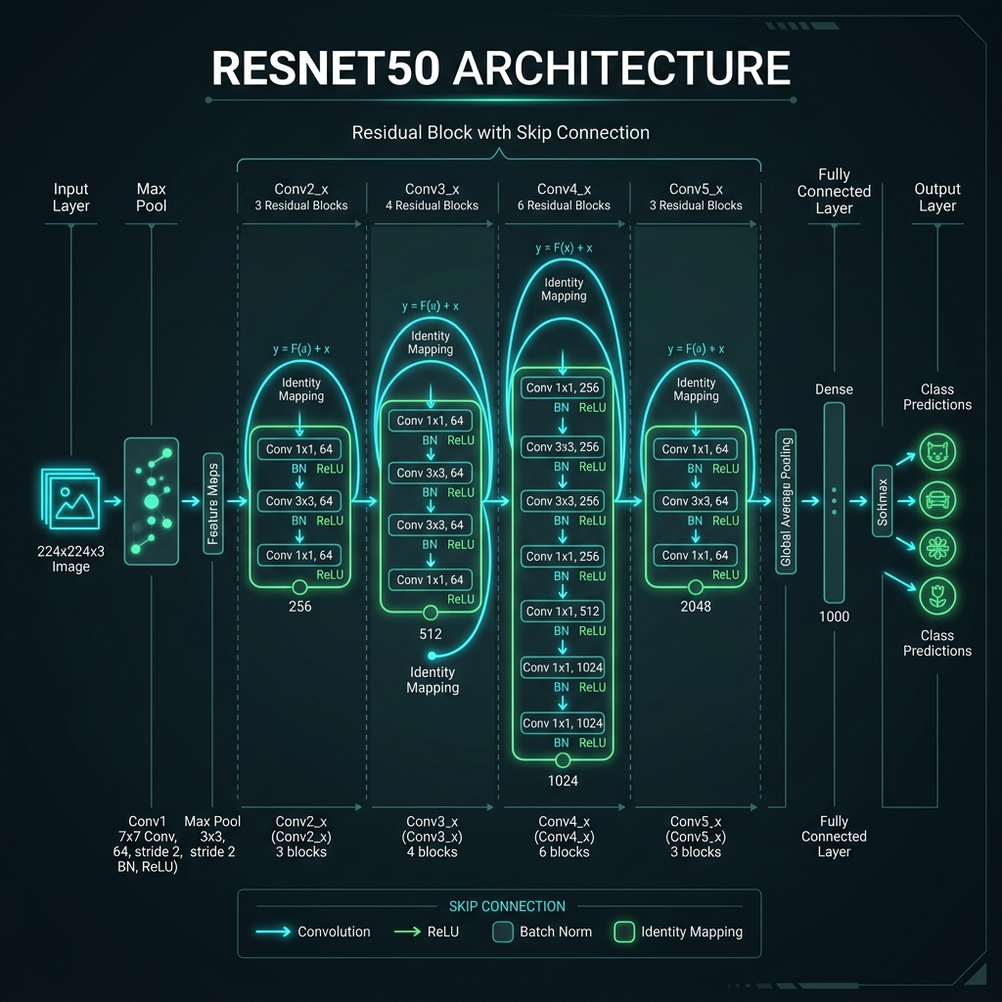 Figure 3: Detailed diagram of ResNet50 showcasing the foundational residual blocks and skip connections.

4.1.1 The Residual Block and Skip Connections
In a standard feed-forward network, an activation $H(x)$ is learned directly. In ResNet, the network learns a residual mapping $F(x)=H(x)−x$. The original input $x$ is added back to the output of the convolutional layers via a “skip connection”.
$$y=F(x,\{W_{i}\})+x$$
This architecture allows gradients to flow unimpeded backward through the network during backpropagation, enabling the training of 50 consecutive layers without geometric decay.

4.2 EfficientNetB0 and Compound Scaling
EfficientNetB0 represents the pinnacle of resource-efficient deep learning. While traditional scaling methods arbitrarily increase either network depth, width, or input resolution, EfficientNet employs a principled Compound Scaling Method.
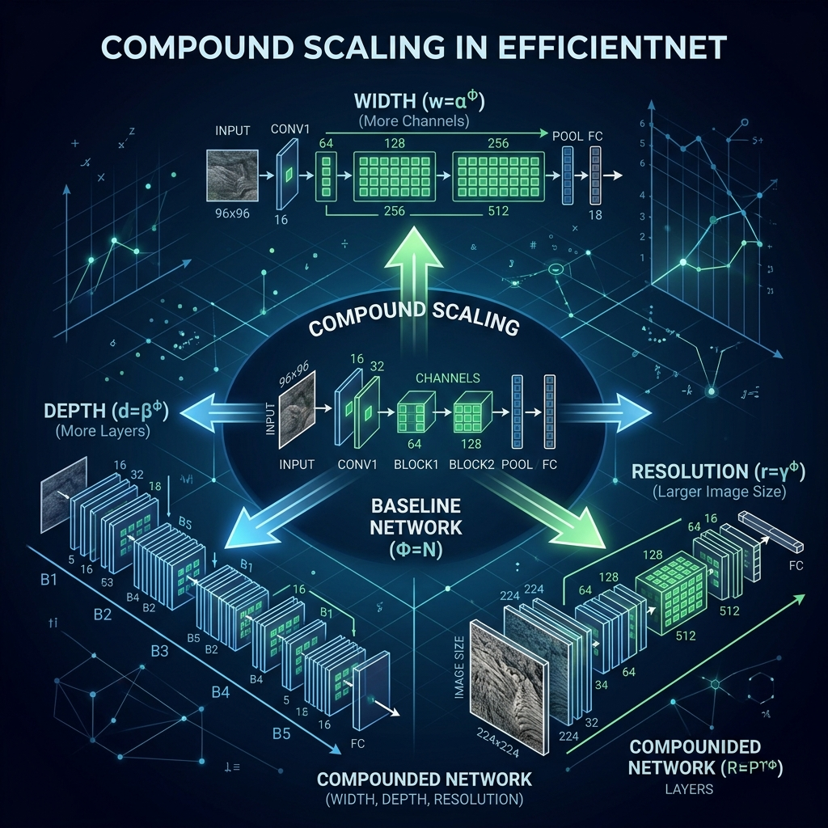 Figure 4: The Compound Scaling method utilized by EfficientNet to uniformly scale Depth, Width, and Resolution.

4.2.1 Mathematical Formulation of Compound Scaling
The EfficientNet architecture optimizes scaling by finding a constant ratio between depth ($d$), width ($w$), and resolution ($r$):
$$\text{depth: }d=α^{ϕ}$$
$$\text{width: }w=β^{ϕ}$$
$$\text{resolution: }r=γ^{ϕ}$$
$$\text{s.t. }α⋅β^{2}⋅γ^{2}≈2, α≥1,β≥1,γ≥1$$
Where $ϕ$ is a user-specified coefficient controlling the available computational resources. By applying this balanced scaling, EfficientNetB0 achieves exceptional classification accuracy on retinal images while utilizing drastically fewer parameters (~5M) compared to ResNet50 (~25M).

5. Extensive Training and Optimization Protocols

5.1 Optimization Algorithm (Adam)
The models were trained utilizing the Adam (Adaptive Moment Estimation) optimizer. Adam computes individual adaptive learning rates for different parameters from estimates of first and second moments of the gradients.

5.2 Dynamic Learning Rate Adjustment
A ReduceLROnPlateau callback was implemented to monitor the validation loss. If the validation loss ceased to improve for 5 consecutive epochs (patience=5), the learning rate was decreased by a factor of 0.2. This ensures that the optimizer takes smaller, more precise steps as it approaches the global minimum of the loss landscape, preventing destructive oscillations.

5.3 Early Stopping Criterion
To strictly prevent overfitting and ensure maximum generalizability to unseen clinical data, an EarlyStopping monitor halted training operations if the validation loss failed to decrease over 10 consecutive epochs. The best model weights (determined by peak validation accuracy) were aggressively checkpointed to persistent storage.

6. Detailed Mathematical Formulations
To fully understand the capacity of the deployed networks, we must look at the mathematical underpinnings of the spatial operations occurring within the tensor transformations.

6.1 Convolutional Filtering
A 2D convolution operation in layer $l$ applies a filter $K$ to the input tensor $I$:
S(i,j)=(I*K)(i,j)=m​n​I(i−m,j−n)K(m,n)
This operation is the fundamental mechanism allowing both the custom baseline CNN and the advanced transfer learning architectures to identify complex pathologies like microaneurysms.

6.2 Loss Function: Categorical Cross-Entropy
Because the problem is formulated as a mutually exclusive 4-class classification problem, the network aims to minimize the Categorical Cross-Entropy loss $L$:
$$L=−\sum_{i=1}^{N}{\sum_{c=1}^{C}{y_{i,c}}}log({\hat{y}}_{i,c})$$
Where $N$ is the number of samples, $C$ is the number of classes (4), $y_{i,c}$ is the binary indicator of whether class $c$ is the correct classification for observation $i$, and ${\hat{y}}_{i,c}$ is the predicted probability.

7. Future Trajectories and Expanding the Methodology
The finalized implementation discussed above successfully navigates the complex trade-offs between model complexity, computational efficiency, and clinical accuracy. The utilization of the custom baseline provided a necessary empirical anchor, validating the necessity of deep transfer learning. The deployment of ResNet50 provided high-capacity feature extraction, while EfficientNetB0 and its Compound Scaling proved that equivalent or superior performance could be achieved with remarkable computational parsimony.
Future developmental cycles (extending into theoretical Part 6 architectures) will focus on bridging these static classifications into temporal predictive modeling, assessing the rate of disease progression based on the robust feature maps generated by the methodologies detailed in this comprehensive report.

End of Comprehensive Report.

