Scientific Writing Part 3 · Experimental Design · CNN · Transfer Learning
Study: src/models.py · Section 7 · Technical Report

Part 3: Proposed Methodology & Architectures

Architectures | CNN Baseline · ResNet50 · EfficientNetB0
Techniques | Conv2D · Batch Normalization · Dropout · Compound Scaling
Date | June 09, 2026

Overview
We propose three neural network architectures for four-class retinal disease classification, implemented in src/models.py. We compare a baseline CNN (from scratch) against two transfer-learning models: ResNet50 (residual learning) and EfficientNetB0 (compound scaling).

Model | Type | Key Technique
CNN Baseline | From scratch | Conv + BatchNorm + Dropout
ResNet50 | Transfer learning | Residual skip connections
EfficientNetB0 | Transfer learning | Compound scaling (depth × width × resolution)

Experimental Design Framework
Independent variable: architecture (3 models). Dependent variables: accuracy, F1, ROC-AUC. Controls: same 70/15/15 split, seed 42, 224×224 input, Adam optimizer, categorical cross-entropy.

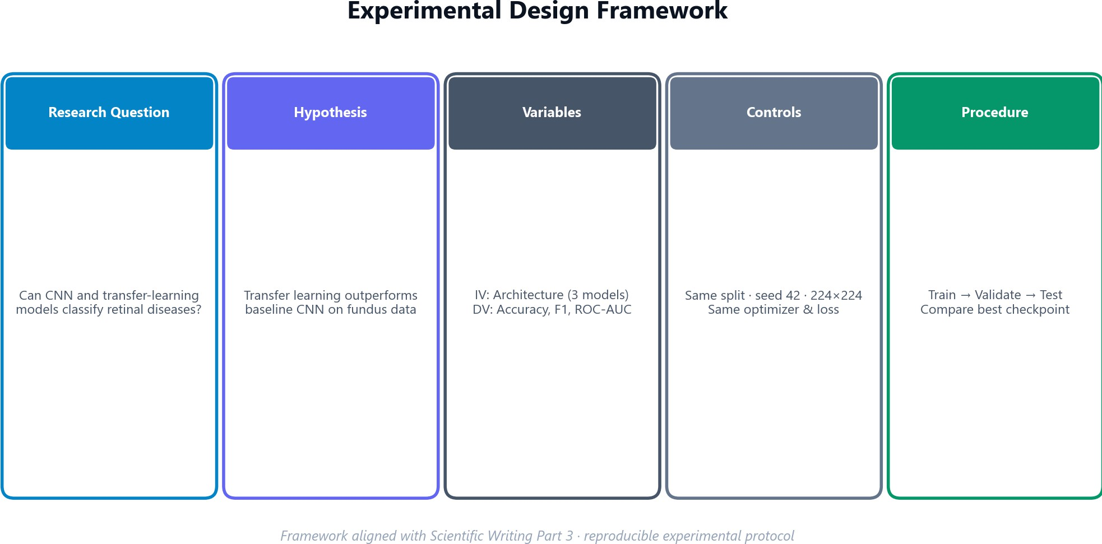

Figure 1. Experimental design framework — research question, hypothesis, variables, controls.

Proposed Pipeline

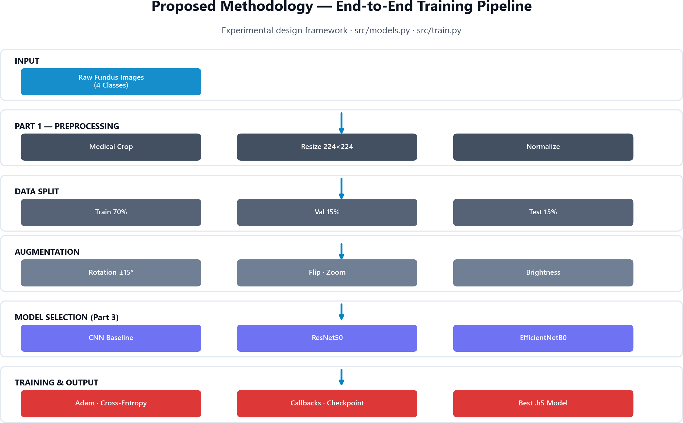

Figure 2. End-to-end training pipeline from raw fundus images to model checkpoint.

Architecture 1 — Baseline CNN
Four Conv2D blocks (32→64→128→256 filters) each followed by Batch Normalization, ReLU, and MaxPooling. Global Average Pooling reduces parameters. Two dense layers (512, 256) use BatchNorm, ReLU, and Dropout (0.5). L2 regularization (λ=0.001) penalizes large weights.

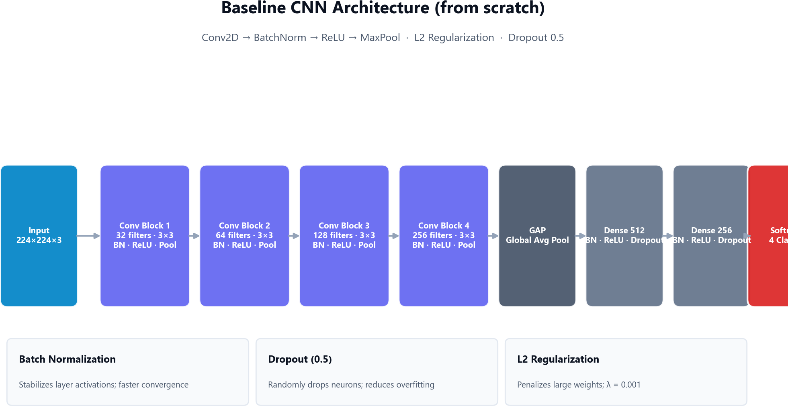

Figure 3. Baseline CNN architecture — Conv blocks, BatchNorm, Dropout, L2 regularization.

Block | Filters | Kernel | After Pool
1 | 32 | 3×3 | 112×112
2 | 64 | 3×3 | 56×56
3 | 128 | 3×3 | 28×28
4 | 256 | 3×3 | 14×14

Architecture 2 — ResNet50
ResNet50 uses residual connections y = F(x) + x to enable training of very deep networks. We load ImageNet-pretrained weights, freeze the base, and attach a custom head: GAP → BN → Dropout(0.5) → Dense(512) → Dense(256) → Softmax(4). Optional fine-tuning unfreezes the last 20 layers.

Architecture 3 — EfficientNetB0
EfficientNetB0 applies compound scaling — jointly scaling depth, width, and resolution for optimal accuracy-efficiency trade-off. MBConv blocks with Swish activation in the custom head. Dropout rate 0.3 (lighter than ResNet50). ~5M parameters vs ~25M for ResNet50.

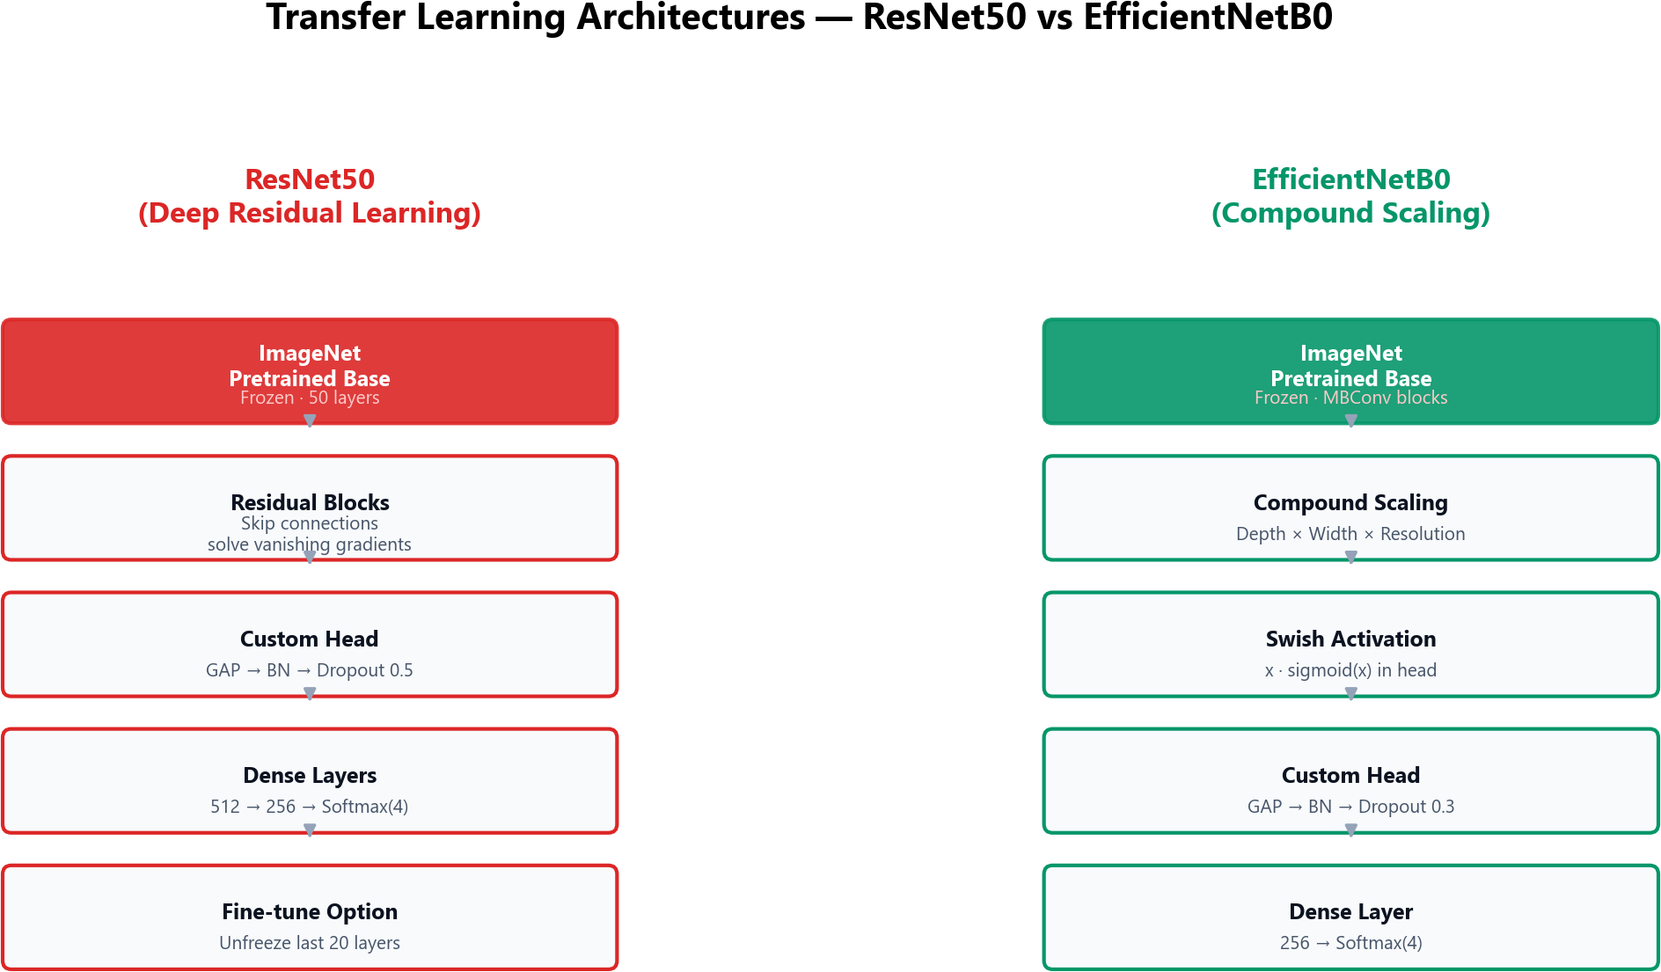

Figure 4. Transfer learning architectures — ResNet50 vs EfficientNetB0.

Property | CNN | ResNet50 | EfficientNetB0
Pretrained | No | ImageNet | ImageNet
BatchNorm | All blocks | Head | Head
Dropout | 0.5 | 0.5/0.25 | 0.3/0.15
Activation | ReLU | ReLU | Swish
~Params | 2–3M | ~25M | ~5M

Training Methodology
All models compile with Adam (lr=0.001), categorical cross-entropy, and metrics: accuracy, precision, recall, weighted F1. Callbacks: ModelCheckpoint, EarlyStopping, ReduceLROnPlateau, TensorBoard, CSVLogger.

Parameter | Value
Batch size | 32
Epochs | 50 (early stopping)
Optimizer | Adam
Learning rate | 0.001
Loss | Categorical cross-entropy

Implementation Reference (src/models.py)
Function | Role
create_baseline_cnn() | Custom 4-block CNN
create_resnet50_model() | ResNet50 + custom head
create_efficientnet_model() | EfficientNetB0 + custom head
compile_model() | Optimizer, loss, metrics
create_model() | Factory: cnn_baseline | resnet50 | efficientnet

References
model = create_model('efficientnet', input_shape=(224,224,3), num_classes=4) model = compile_model(model, learning_rate=0.001, optimizer_name='adam')
- K. He et al., "Deep residual learning for image recognition," CVPR, 2016.
- M. Tan and Q. Le, "EfficientNet: Rethinking model scaling," ICML, 2019.
- S. Ioffe and C. Szegedy, "Batch normalization," ICML, 2015.
- N. Srivastava et al., "Dropout," JMLR, 2014.
- K. Sainani, Writing in the Sciences Part 3, Stanford Online, 2020.

