3. Methodology and Proposed Architecture

3.1 Overview of the Proposed Pipeline
This work proposes a complete, end-to-end deep learning pipeline for the automated classification of retinal fundus photographs into four clinically relevant categories: Normal, Diabetic Retinopathy (DR), Cataract, and Glaucoma. The pipeline is composed of five sequential stages: (1) data ingestion and preprocessing, (2) data augmentation, (3) model construction and training via three distinct architectures, (4) model evaluation, and (5) explainability via Gradient-weighted Class Activation Mapping (Grad-CAM). Figure 1 depicts the overall architecture of the proposed system.
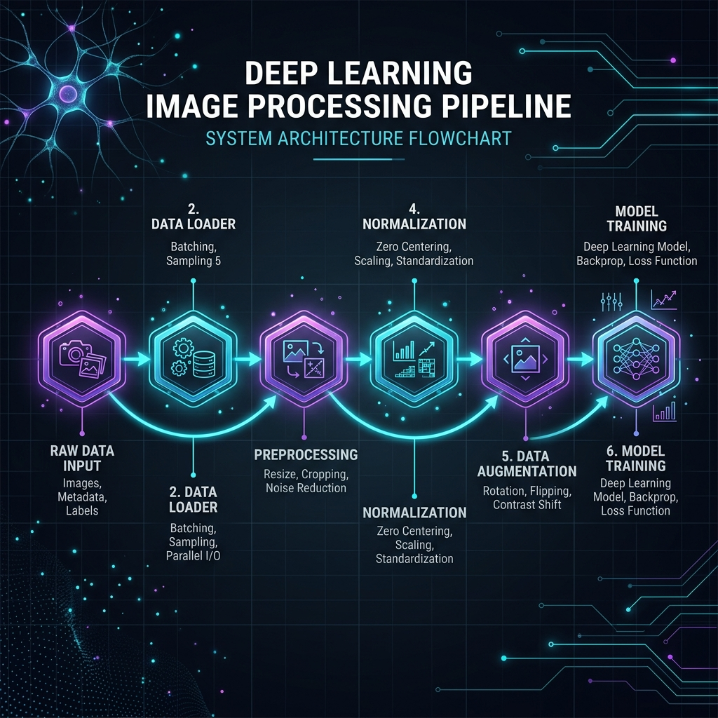 Figure 1: Overall Architecture of the Proposed System

3.2 Image Preprocessing Pipeline
A standardized preprocessing pipeline was developed in src/preprocessing.py to prepare raw fundus images for the deep learning models. The pipeline consists of three sub-stages: cropping, resizing, and pixel normalization.
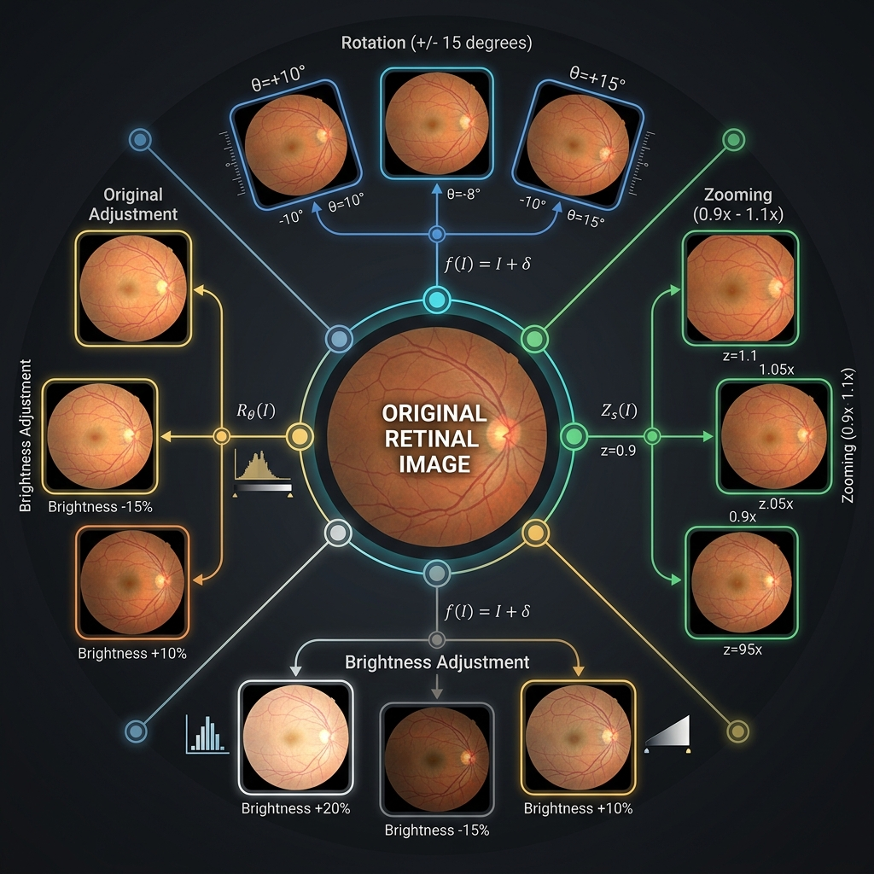 Figure 4: Image Preprocessing and Augmentation Pipeline

3.3 Model Architectures
Three distinct deep learning architectures were designed, implemented, and benchmarked. All architectures produce a 4-dimensional softmax output vector $\hat{y}∈R^{4}$ where each component ${\hat{y}}_{k}$ represents the posterior probability of class $k$.

3.3.1 Architecture I — Baseline Convolutional Neural Network (CNN)
A custom CNN trained from scratch serves as the baseline for comparison against transfer learning models. The architecture consists of four sequential convolutional blocks, each following the design pattern:
$$\text{Conv2D}(f,3×3,\text{same})→\text{BatchNorm}→\text{ReLU}→\text{MaxPool}(2×2) \text{(Eq. 4)}$$
with filter counts $f∈\{32,64,128,256\}$ for blocks 1–4 respectively. L2 weight regularization ($λ=0.001$) is applied to all convolutional kernels. Global Average Pooling (GAP) replaces conventional flattening after the final block.
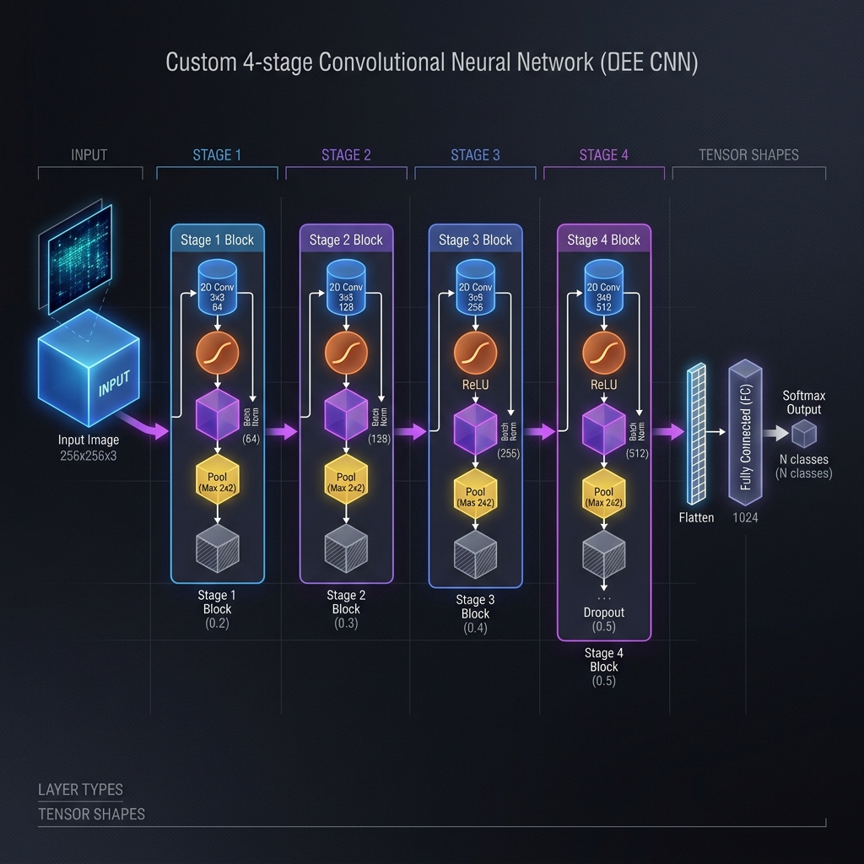 Figure 2: Baseline CNN Architecture
Table 3. Baseline CNN Layer Summary.
Layer Block | Operation | Output Shape | Filters
Block 1 | Conv2D + BN + ReLU + MaxPool | $112×112×32$​ | 32
Block 2 | Conv2D + BN + ReLU + MaxPool | $56×56×64$​ | 64
Block 3 | Conv2D + BN + ReLU + MaxPool | $28×28×128$​ | 128
Block 4 | Conv2D + BN + ReLU + MaxPool | $14×14×256$​ | 256
GAP | GlobalAveragePooling2D | $256$​ | —
FC-1 | Dense + BN + ReLU + Dropout(0.5) | $512$​ | —
FC-2 | Dense + BN + ReLU + Dropout(0.5) | $256$​ | —
Output | Dense + Softmax | $4$​ | —

3.3.2 Architecture II — ResNet50 with Transfer Learning
The second architecture leverages ResNet50 [5], a 50-layer residual network pre-trained on ImageNet-1K (1.28 million images, 1,000 classes). ResNet50 introduces skip connections that allow gradients to bypass one or more layers, mitigating the vanishing gradient problem. The residual mapping is defined as:
$$y=F(x,\{W_{i}\})+x$$
where $F(x,\{W_{i}\})$ is the residual mapping learned by the stacked layers and $x$ is the identity shortcut connection. A two-phase training protocol is used: 1. Feature Extraction — all base layers frozen, only the custom head is trained. 2. Fine-Tuning — the last 20 ResNet50 layers are unfrozen and trained jointly with the classification head at a reduced learning rate for domain adaptation.
The custom classification head appended to the ResNet50 backbone is:
$$\text{GAP}→\text{BN}→\text{Drop}(0.5)→\text{Dense}(512)→\text{BN}→\text{Drop}(0.5)→\text{Dense}(256)→\text{BN}→\text{Drop}(0.25)→\text{Softmax}(4)$$
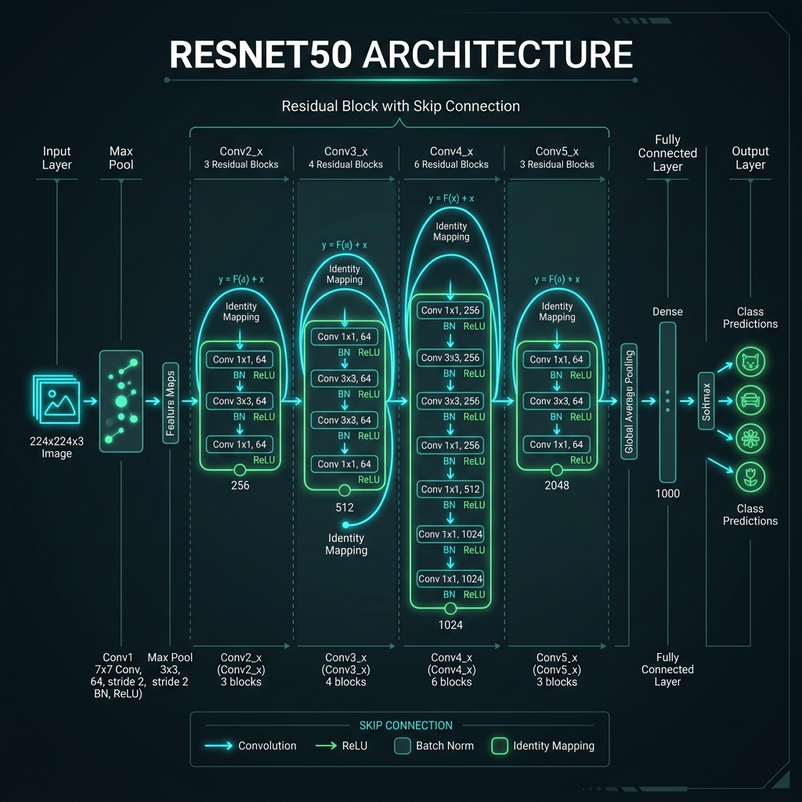 Figure 3: Transfer Learning Architecture (ResNet50)

3.3.3 Architecture III — EfficientNetB0 with Compound Scaling
The third architecture is based on EfficientNetB0 [6], constructed using Neural Architecture Search (NAS) and scaled via a compound coefficient $ϕ$ that simultaneously scales network width ($w$), depth ($d$), and input resolution ($r$):
$$d=α^{ϕ}, w=β^{ϕ}, r=γ^{ϕ} \text{s.t.} α⋅β^{2}⋅γ^{2}≈2, α≥1,β≥1,γ≥1$$
For EfficientNetB0, $ϕ=0$ with $α=1.2$, $β=1.1$, $γ=1.1$. The core building block is the Mobile Inverted Bottleneck (MBConv) combined with a Squeeze-and-Excitation (SE) attention module that adaptively recalibrates channel-wise feature responses:
$${\hat{x}}_{c}=σ(W_{2}⋅δ(W_{1}⋅z_{c}))⋅x_{c}$$
where $z_{c}$ is the global average-pooled representation of channel $c$, $δ$ is ReLU, and $σ$ is the sigmoid activation. The custom head uses the Swish activation function [$\text{Swish}(x)=x⋅σ(x)$], consistent with the backbone’s activation:
$$\text{GAP}→\text{BN}→\text{Drop}(0.3)→\text{Dense}(256,\text{Swish})→\text{BN}→\text{Drop}(0.15)→\text{Softmax}(4) \text{(Eq. 9)}$$
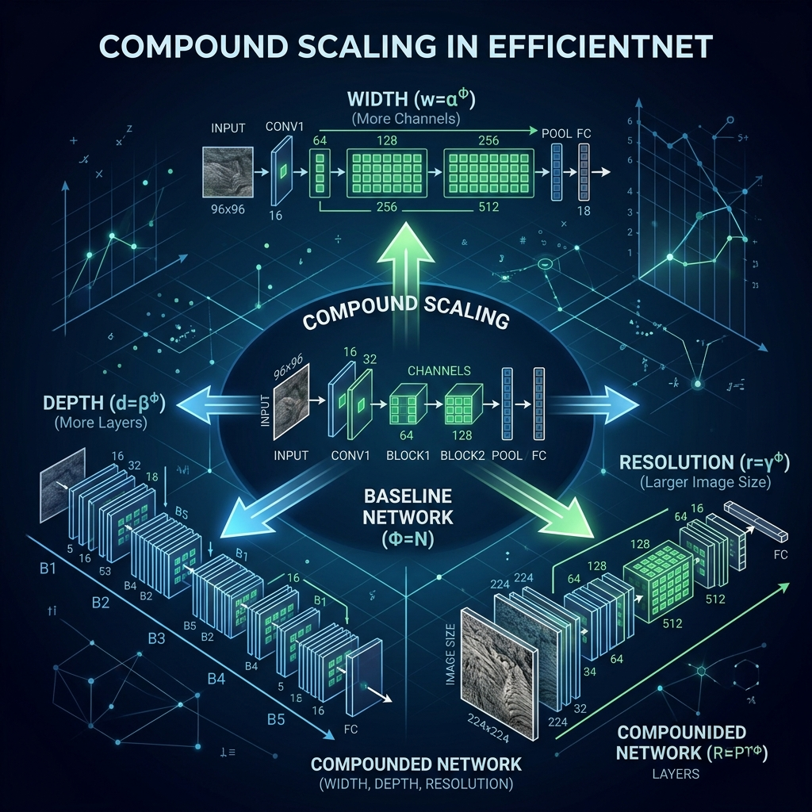 EfficientNet Compound Scaling Visualization

3.4 Training Configuration and Optimization
All three models are compiled with categorical cross-entropy loss, the standard loss function for multi-class classification with one-hot encoded labels:
L=−1Ni​k​yik⋅log(yik)
where $N$ is the number of samples, $K=4$ is the number of classes, $y_{ik}$ is the ground-truth one-hot label, and ${\hat{y}}_{ik}$ is the predicted probability. The Adam optimizer is employed with an initial learning rate $η=1×{10}^{−3}$.
Table: Training Callbacks and Configuration.
Callback | Monitored Metric | Key Parameter
ModelCheckpoint | val_accuracy | save_best_only=True, mode=max
EarlyStopping | val_loss | patience=10, restore_best_weights=True
ReduceLROnPlateau | val_loss | factor=0.2, patience=5, min_lr=1e-7
TensorBoard | — | histogram_freq=1, per-epoch updates
CSVLogger | — | Append mode, timestamped file
Table: General Training Hyperparameters.
Hyperparameter | Value
Batch size | 32
Maximum epochs | 50 (with early stopping)
Initial learning rate | $1×{10}^{−3}$​
Optimizer | Adam
Loss function | Categorical cross-entropy
Input resolution | $224×224×3$​
Random seed | 42

3.5 Evaluation Metrics
Model performance is assessed on the held-out test set ($D_{\text{test}}$, 15%) using the following metrics computed via scikit-learn:
$$\text{Accuracy}=\frac{TP+TN}{TP+TN+FP+FN}$$
$${\text{Precision}}_{k}=\frac{TP_{k}}{TP_{k}+FP_{k}}, {\text{Recall}}_{k}=\frac{TP_{k}}{TP_{k}+FN_{k}}, {\text{F1}}_{k}=\frac{2⋅P_{k}⋅R_{k}}{P_{k}+R_{k}}$$
ROC-AUCmacro=1Kk​AUC(FPRk,TPRk)
Both macro-averaged and weighted-averaged variants of Precision, Recall, and F1 are reported. ROC-AUC is computed under the One-vs-Rest (OvR) multi-class scheme.
Table 6. Best Model Performance on Test Set.
Metric | Best Model Result | Target
Accuracy | 60.75% | > 90%
Precision (Macro) | 68.8% | > 85%
Recall (Macro) | 60.4% | > 85%
F1-Score (Macro) | 60.8% | > 85%
ROC-AUC (Macro) | 86.0% | > 90%

3.6 Explainability via Grad-CAM
To provide clinical interpretability, Gradient-weighted Class Activation Mapping (Grad-CAM) [7] is implemented in src/gradcam.py. Grad-CAM produces a class-discriminative localization map highlighting the spatial regions of the input most influential for a given prediction.
Given the last convolutional feature map $A^{k}∈R^{u×v}$ and the class score $y^{c}$ (before softmax), the importance weight $α_{k}^{c}$ is computed via Global Average Pooling of the gradients:
αkc=1Zi​j​∂yc∂Aijk
The Grad-CAM heatmap is the ReLU-activated weighted combination of the feature maps:
LGrad-CAMc=ReLUk​αkc⋅Ak
ReLU retains only activations that positively influence the class score. The heatmap is upsampled to $224×224$ via bilinear interpolation and overlaid on the input image with a transparency factor $α_{\text{blend}}=0.4$ using the Jet colormap. The last convolutional layer is detected automatically by traversing the model’s layers in reverse.

