Section E: Justification for methods used In MongoDB implementation

- Embedding vs referencing:
The design decision was to use referencing for BName_clean data. Each person has a unique Name_id and is store in a separate collection (BName_clean). These documents referenced from BTitle_clean collection via their principle IDs.
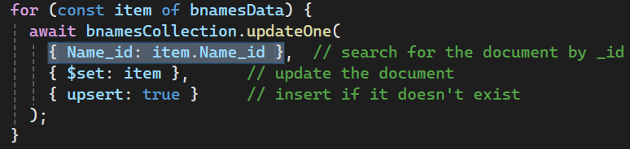
Code Example (referencing by ID)
The justification for this was it avoids duplication, especially as many individuals (e.g. actors, director, writers) are associated with multiple titles. By centralising name data, we also made it easier to update and maintain biographies or personal details.
Embedding was used for principles within each title in BTitle_clean.json. Each title document embeds a list of principle objects (with id, job, and name)
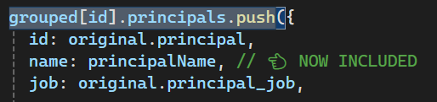
Code Example (embedding principle data)
This was done so the principle data is directly relevant to each movie and frequently accessed together. Embedding improves query efficiency and reduces the need for complex joins during reads. The name is duplicated for readability and convenience in the transformed file.
- Data Cleaning and Transformation
Custom code was written to load and parse raw JSON files, group title data by titleID, combining scattered rows into a unified document per movie. The code also consolidates genres, directors and writers into arrays, embedding an array of principles, pulling names from the referenced BName_clean data that are readable.
Code Example (transforming arrays)
The code also removes nulls and undefined fields to keep documents clean, this structure aligns with MongoDB best practices, de-normalising only when necessary, using arrays for logically grouped values, and embedding for tightly coupled data.

- Insertion Strategy
Node.js was used with mongodb driver to read transformed JSON (BName_clean.json and BTitle_clean.json), inserting or updating (upsert) each document by unique identifier (Name_id or title_id). We used this method to ensure that running multiple scrips would not create duplicates.

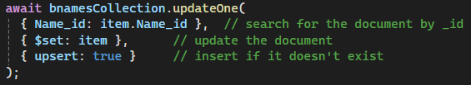
Code Example (upsert logic to avoid duplicates)

- Conclusion
The structure we chose balances referencing and embedding based on data relationships and access patterns, it avoids redundancy, supports efficient queries, and allows for future extensions (e.g. adding bios to names or awards to titles). Custom scripts handle both transformation and insertion, creating a transparent, clear process for moving raw data into MongoDB.

