SGS Flight Handling Reports
High-Level Design (HLD)
Document 01 of 12
Version 1.0 — September 2026
Technical documentation set: HLD · LLD · Architecture · Data flow · Database · Servers · UAT · GitHub · Code review

1. Purpose
SGS Flight Handling Reports is a web application for ground-handling operations. Station supervisors record how each flight was handled; the airline representative reviews the record, rates the service and signs it on screen; management follows volumes, service quality and delays on a dashboard and exports the data to PDF and Excel.

2. Scope
In scope | Out of scope
Arrival and departure flight handling reports | Flight schedules or live flight data feeds
Coordination sheets (turnaround time chart) | Integration with airline or airport systems
Airline approval with satisfaction rating and signature | E-mail / SMS notifications
Return-for-correction workflow | Billing or invoicing
Dashboard, PDF and Excel exports | Mobile native apps (the web UI is responsive)
Users, roles, permissions and stations administration | Single sign-on (users sign in with e-mail and password)
Activity (audit) log

3. Users and roles
Roles are data, not code: administrators can create roles and tick any of the 19 permissions. Three roles are created on a new database:
Role | Typical user | Main permissions
admin (locked system role) | IT / system owner | All 19 permissions
management | Operations management | Lists of pending, returned, approved reports; dashboard; exports; all stations
data_entry ("Handling Supervisor") | Station supervisor | Create, edit, delete reports; coordination sheets; approval screen; exports

Station scoping: a user assigned to a station sees only that station's data. A user without a station and with the stations.viewAll permission sees every station.

4. Functional modules
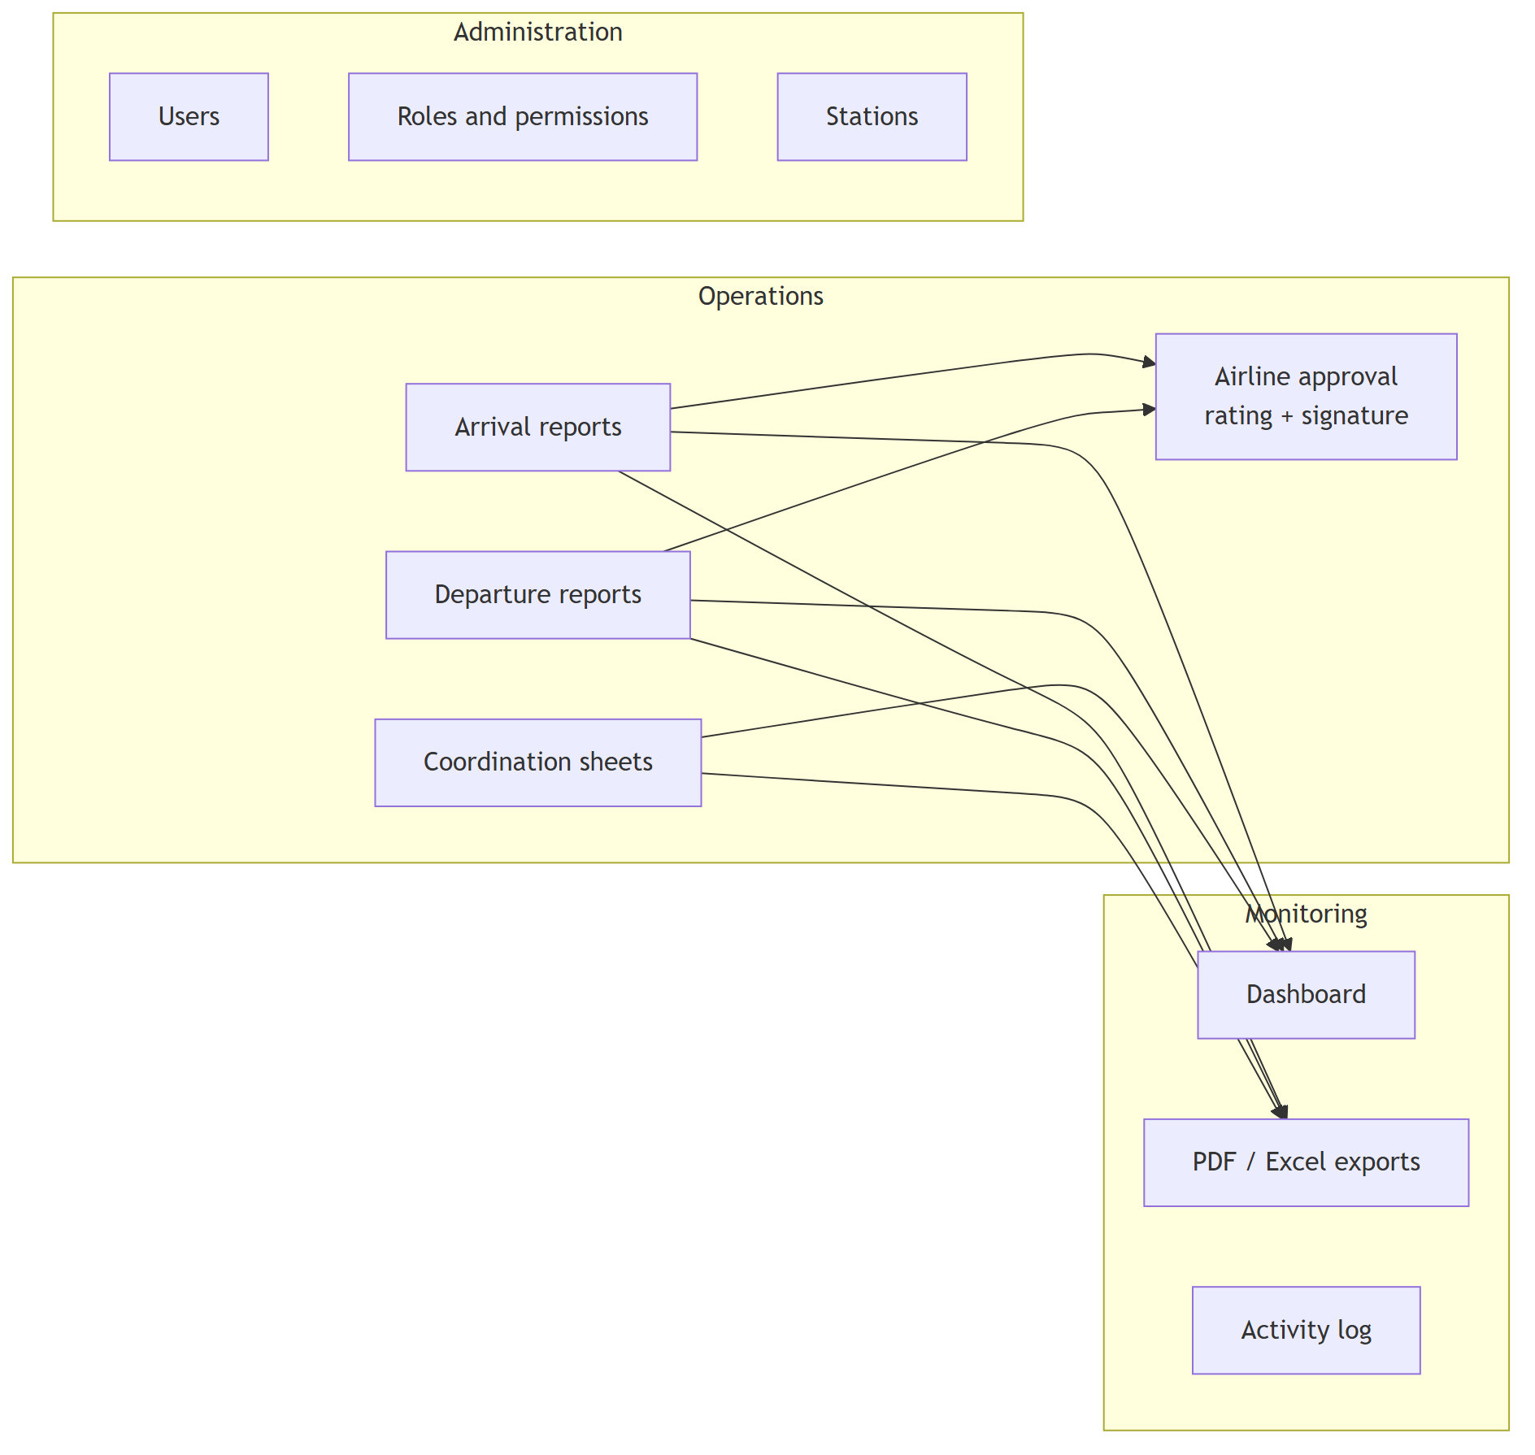
Module | Description
Arrival / Departure reports | Flight details, times, passengers by class, baggage by type, boarding, delays (code, reason, minutes), staff productivity, remarks. Saved as draft or submitted for approval.
Coordination sheet | Arrival and departure flight of a turnaround, handling type, 24-activity time chart (actual start/finish), buses, delay, GAIN time.
Airline approval | The airline representative reviews a submitted report, gives a 1–5 rating and signs, or returns it with a reason.
Lists | Pending approval, drafts, returned, approved, coordination — search, filters and paging (50 rows per page).
Dashboard | Totals by status, trend over time, by station, by airline, satisfaction distribution, latest approved reports.
Exports | PDF per report / coordination sheet; Excel for a chosen selection (type, status, period, airline, station, search).
Administration | Users, roles (permission matrix), stations.
Activity log | Every create, update, submit, approve, return and delete, with user, station and time.

5. Architecture overview
A single ASP.NET Core application serves both the web pages and the REST API; data is stored in MySQL.
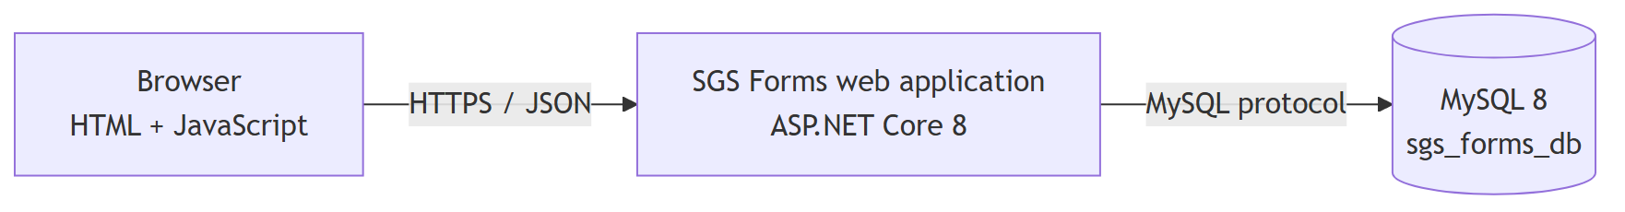
Details: document 03 (solution), 04 (infrastructure), 05 (network), 06 (integrations).

6. Technology
Layer | Technology
User interface | Static HTML5, CSS and vanilla JavaScript (15 pages + shared nav.js), Chart.js 4.4.1, Arabic / English, RTL / LTR
Application | ASP.NET Core 8 Web API (.NET 8.0.18 runtime), Kestrel web server
Data access | Entity Framework Core 8.0.10, Pomelo MySQL provider 8.0.2, MySqlConnector 2.3.5
Security | JWT bearer tokens (HS256), BCrypt password hashing (BCrypt.Net-Next 4.0.3), permission-based authorisation
Documents | PDFsharp / MigraDoc 6.2.4 (PDF), ClosedXML 0.104.1 (Excel)
Database | MySQL 8.0, InnoDB, utf8mb4
API documentation | Document 02 (the Swagger page was removed from production builds to reduce attack surface)

7. Quality attributes
Attribute | How it is achieved
Security | Hashed passwords, signed tokens re-checked against the database on every request, permission checks on every endpoint, station isolation, input validation, output escaping, security headers, login rate limiting. See document 12.
Performance | Measured on the development machine: about 700 list-page requests/s and 4,000 single-report requests/s; dashboard 8 ms for 30 days and ≈0.4 s for 100,000 reports. See document 09.
Scalability | Stateless application (the token carries the session), so more application instances can be added behind a load balancer.
Availability | Single server today; recommendations in document 04.
Auditability | Activity log of every change; approvals keep rating, representative and signature image.
Usability | Bilingual UI, responsive layout, per-permission menus.
Maintainability | Layered code (controllers → services → data), one place for each rule (permissions, parsing, flight codes).

8. Constraints and assumptions
- Windows is the reference platform (PDF rendering uses the Windows fonts).
- MySQL 8 is required; the schema is created and upgraded by EF Core migrations at start-up.
- Users reach the system from a browser on the company network or over HTTPS through a reverse proxy.
- The source was recovered from the deployed build (decompiled). Original comments were lost; code has since been reviewed and cleaned (document 12).

