SGS Flight Handling Reports
Low-Level Design (LLD)
Document 02 of 12
Version 1.0 — September 2026
Technical documentation set: HLD · LLD · Architecture · Data flow · Database · Servers · UAT · GitHub · Code review

1. Source layout
Decompiled Source/
├── SGSForms.Api/
│ ├── Program.cs start-up: services, security, middleware pipeline
│ ├── appsettings.json non-secret settings (secrets: appsettings.Production.json or env vars)
│ ├── Forms Source/ the web UI (static files served by the application)
│ └── SGSForms/Api/
│ ├── Controllers/ 12 REST controllers (thin: routing + authorisation)
│ ├── Services/ business rules, one service per module
│ ├── Auth/ JWT, current user, permission catalogue and policies
│ ├── Data/ AppDbContext (EF Core model), DbSeeder
│ ├── Entities/ 15 database entities
│ ├── Dtos/ request / response contracts
│ ├── Enums/ ReportStatus, ReportKind, ApprovalDecision, BoardingMode
│ ├── Middleware/ ErrorHandlingMiddleware (errors → JSON {detail})
│ └── Migrations/ EF Core migrations (9)
├── lib/ third-party assemblies referenced by the project
└── SQL Deploy/ database creation scripts and deployment guide

2. Request pipeline (Program.cs)
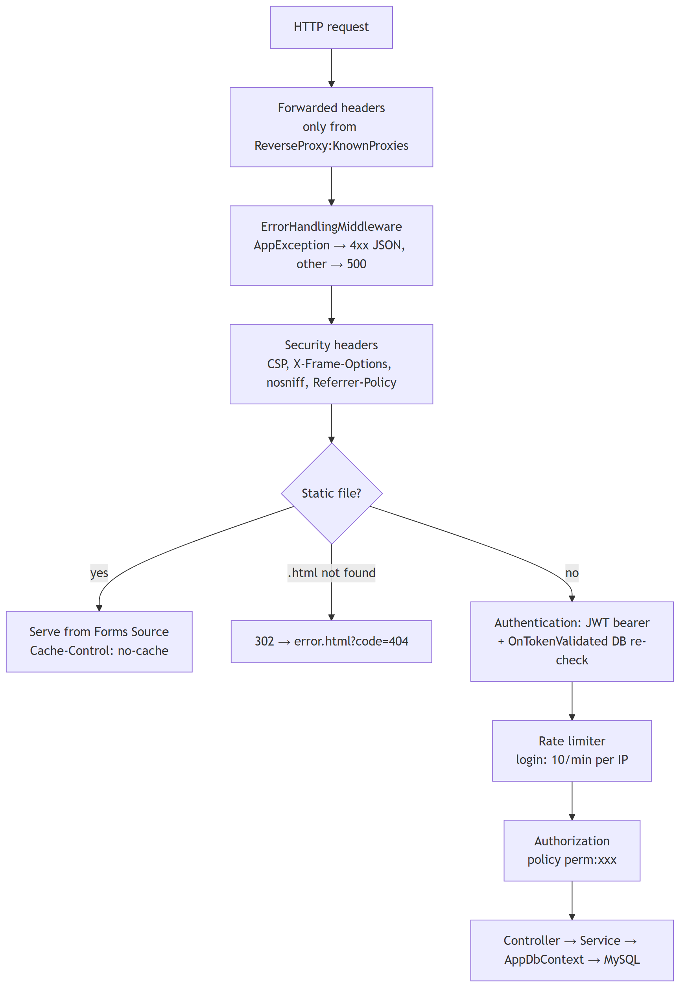

3. Components
Component | Responsibility
JwtTokenService | Issues tokens (claims: user id, name, role, station, permissions, security stamp); validates the signing key (≥ 32 bytes).
OnTokenValidated (Program.cs) | On every request: user must exist and be active, role active, security stamp equal to SHA-256(password hash); rebuilds the permissions from the database, so changes apply immediately.
PermissionPolicyProvider / PermissionHandler | Turns [Authorize(Policy = "perm:x")] into a permission check.
CurrentUser | Id, name, role, station, permissions of the caller; CanAccessStation, StationScope.
AuthService | Login: constant-time failure path, BCrypt verification, last-login update, token.
ArrivalService, DepartureService, CoordinationService | Create / update / read / delete forms; validation; status transitions.
ReportService | Paged lists of arrival + departure reports by status.
ApprovalService | Approve (rating, representative, signature) or return (reason).
DashboardService | Aggregates for a period.
ExportService | PDF (MigraDoc) and Excel (ClosedXML) for reports and coordination sheets.
AdminService, RoleService | Users, stations, roles; escalation guard; "at least one role administrator" guard.
AuditService | Writes the activity log after each change (never blocks the change).
Parse, FlightNo, ReportRules, CoordinationActivities | Shared rules: input parsing and limits, airline designator, station resolution, activity catalogue.

4. REST API
All endpoints except login require a valid bearer token. "Permission" is the policy on the endpoint; services add station checks (CanAccessStation / StationScope) and, where noted, further permission checks.
Method | Route | Permission | Notes
POST | /auth/login | anonymous, rate-limited | Form fields username, password → token and profile
GET | /reports?status&from&to&stationId&airline&q&page&pageSize | list permission of the status* | Arrivals + departures, max 50 per page
POST | /reports/{kind}/{id}/return | reports.approve | Body {reason}; only submitted reports
POST / PUT | /arrival, /arrival/{id} | reports.create | Save draft or submit
GET | /arrival/{id} | any report-reading permission**
DELETE | /arrival/{id} | reports.delete | Not allowed once approved
POST / PUT / GET / DELETE | /departure[...] | same as arrival
POST | /approvals | reports.approve | {kind, reportId, satisfaction 1–5, airlineRemarks, rep{name, airline, position}, signature}
GET | /approvals/{kind}/{id} | any report-reading permission** | Latest decision
GET | /coordination?status&from&to&stationId&airline&q&page&pageSize | coordination.view or .create
POST / PUT | /coordination, /coordination/{id} | coordination.create
GET | /coordination/{id} | coordination.view or .create
DELETE | /coordination/{id} | coordination.delete
GET | /dashboard/summary?from&to&stationId&airline | dashboard.view
GET | /export/report/{kind}/{id}/pdf | export.pdf + report reading
GET | /export/coordination/{id}/pdf | export.pdf + coordination view
GET | /export/reports.xlsx, /export/reports/count | export.excel + list permission per status | status (comma list or all), kind, period, airline, station, q
GET | /export/coordination.xlsx, /export/coordination/count | export.excel + coordination view | status, handling, period, airline, station, q
GET | /logs?action&kind&date&q&page&pageSize | logs.view
GET | /stations?includeInactive | authenticated | Inactive ones only for admin.stations
POST / PUT / DELETE | /stations[...] | admin.stations | Delete refused while referenced
GET / POST / PUT / DELETE | /users[...] | admin.users | Escalation guard (§7)
GET | /roles | admin.roles or admin.users
GET | /roles/permissions | admin.roles | Permission catalogue
POST / PUT / DELETE | /roles[...] | admin.roles | Locked role keeps its permissions

* draft → reports.drafts, submitted → reports.pending, returned → reports.returned, approved → reports.approved. ** any of reports.view, reports.create, reports.approve, reports.pending, reports.drafts, reports.returned, reports.approved, dashboard.view.
Errors are returned as {"detail": "<message>"} with 400 (invalid input), 401, 403, 404, 409 (conflicting state), 429 (too many logins) or 500.

5. Permission catalogue
Group | Permissions
Reports | reports.view, reports.create, reports.delete, reports.approve
Lists | reports.pending, reports.drafts, reports.returned, reports.approved
Coordination | coordination.view, coordination.create, coordination.delete
Export | export.pdf, export.excel
Monitoring | dashboard.view, logs.view
Administration | admin.users, admin.roles, admin.stations
Scope | stations.viewAll

6. Report life cycle
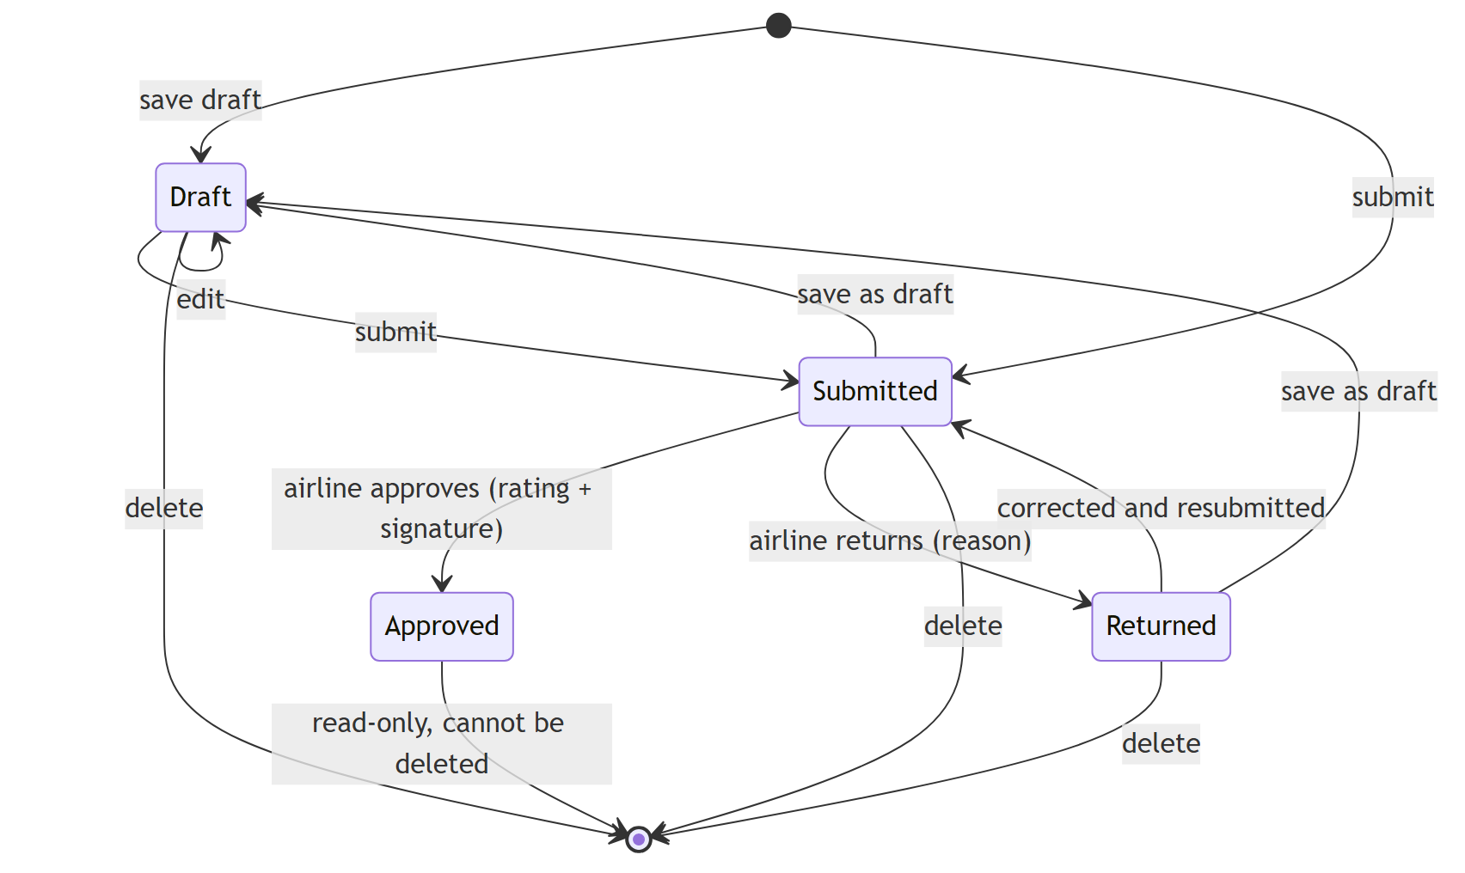
Coordination sheets use Draft and Submitted ("Completed") only.

7. Business rules
Area | Rule
Station | A form is filed under the requested station (if the user may access it) or the user's own station; the station must exist and be active.
Approval | Only a *Submitted* report can be approved or returned (prevents double approval and approving drafts). Rating 1–5; representative name and airline required; signature must be a PNG/JPEG data URL (≤ 2 MB).
Totals | Departure passenger total = F + J + W + Y + Hajj + Altanfeethi + VIP (infants excluded); baggage total = sum of all baggage types.
GAIN time | STD − ATD in minutes, never negative, not computed for terminating flights.
Drafts | Marked with an expiry of creation + 24 h (shown as "hours left"); drafts are not deleted automatically.
Users | A manager without admin.roles can only create or edit users whose role permissions are all held by the manager (no self-promotion to administrator). Users cannot change their own role or deactivate themselves. At least one active user must keep admin.roles. Password ≥ 8 characters.
Roles | Key ^[a-z][a-z0-9_]{1,39}$, colour #RRGGBB, names ≤ 80 characters. System roles cannot be deleted; roles in use cannot be deleted.
Airline code | IATA two-character designators including digits (SV, XY, F3, 6E) and three-letter ICAO designators followed by a number (SVA123). Same rule in the server (FlightNo.Prefix) and the pages (SGS.airlineCode).
Paging | At most 50 rows per page (enforced by the server). Search term ≤ 50 characters.
Excel export | At most 20,000 records per file; larger selections are refused with a message to narrow the period or filters (the dialog shows the count first).
Input limits | Counts 0–100,000; lists ≤ 100 items; flight number ≤ 20; route ≤ 100; remarks ≤ 2,000; delay reason ≤ 500 characters. Invalid dates and times are rejected.

8. Front-end design
File | Role
nav.js | Session check, side menu by permission, SGS.esc (HTML escaping), SGS.can, shared pager, export dialog, airline code rule, notifications
index.html | Login
main.html | Home: create report / sheet, counters
report_form.html | Arrival / departure form
airline_approval.html | Review, rating, signature pad, return; read-only view of approved reports
pending.html, drafts.html, returned.html, approved.html | Lists with search, filters, paging, Excel export
coordination.html, coordination_form.html, coordination_view.html | Coordination list, form, read-only view
dashboard.html | Charts and KPIs
admin.html | Users, roles, stations
logs.html | Activity log
error.html | Friendly error page

The token and profile are kept in localStorage; every API call sends Authorization: Bearer <token>. A 401 response clears the session and returns to the login page. All data inserted into the page is HTML-escaped.

