SGS Flight Handling Reports
Solution Architecture Diagram
Document 03 of 12
Version 1.0 — September 2026
Technical documentation set: HLD · LLD · Architecture · Data flow · Database · Servers · UAT · GitHub · Code review

The solution is a three-tier web application packaged as one deployable: the ASP.NET Core process serves the user interface (static files) and the REST API, and persists data in MySQL.
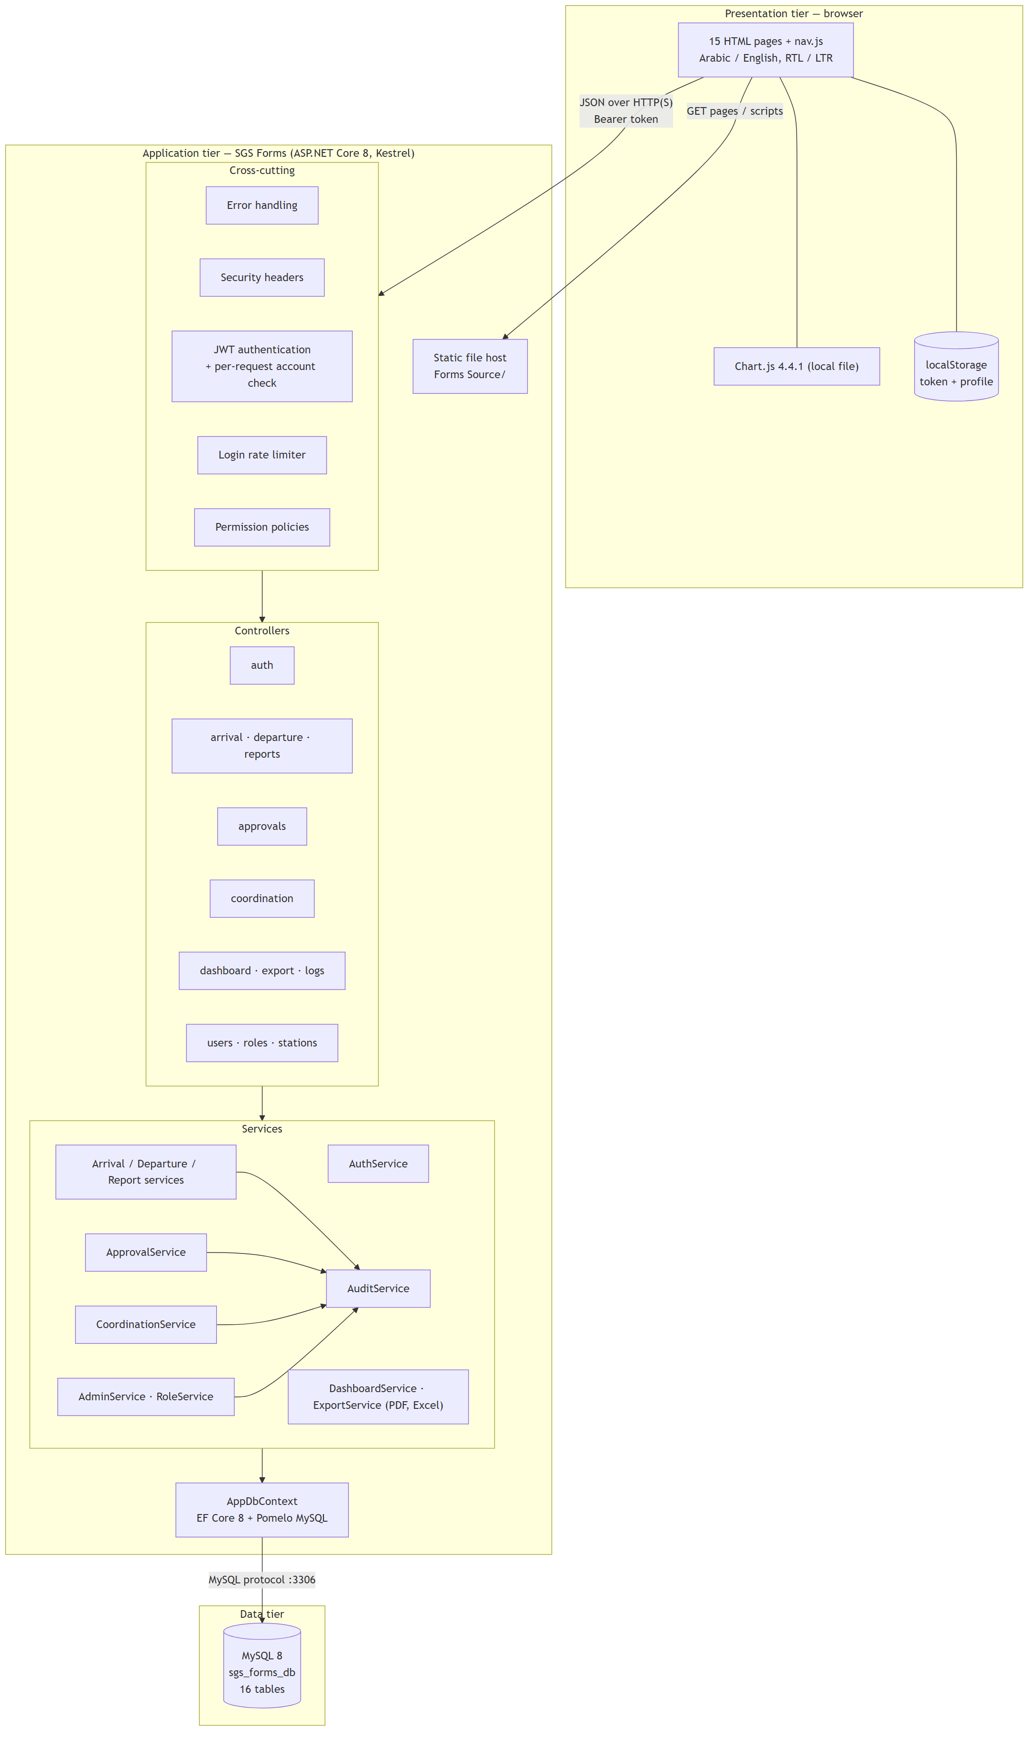

Component responsibilities
Tier | Component | Responsibility
Presentation | Pages | Forms, lists, dashboard, administration; call the API with fetch
Presentation | nav.js | Menu by permission, escaping, paging, export dialog, notifications
Application | Cross-cutting middleware | Error mapping, headers, authentication, rate limiting, authorisation
Application | Controllers | Routes and endpoint permissions
Application | Services | Validation, business rules, station isolation, audit
Application | AppDbContext | Object-relational mapping, migrations
Data | MySQL | Persistent storage of forms, approvals (including signatures), users, roles, audit log

Design decisions
Decision | Reason
One process for UI and API | Simple deployment, no cross-origin configuration (CORS is disabled)
Stateless bearer tokens | No server session store; scales horizontally
Per-request account check | Deactivation, password change and permission change take effect immediately
Permissions instead of role names | Administrators can define new roles without code changes
Documents generated on the server | Consistent PDF / Excel layout; permission and station checks apply to exports

