SGS Flight Handling Reports
Infrastructure Architecture Diagram
Document 04 of 12
Version 1.0 — September 2026
Technical documentation set: HLD · LLD · Architecture · Data flow · Database · Servers · UAT · GitHub · Code review

1. Current installation (development / pilot)
Everything runs on one Windows PC. The application is started from run.bat (dotnet run, Debug build) and stops when that window is closed.
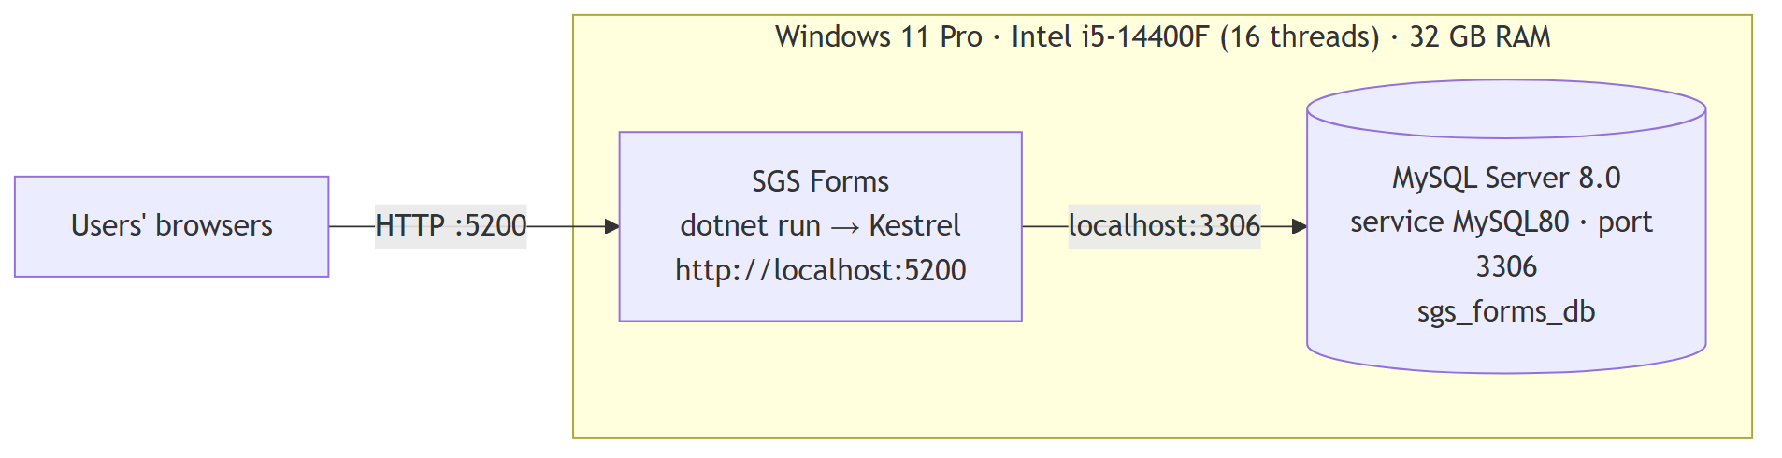

2. Recommended production deployment
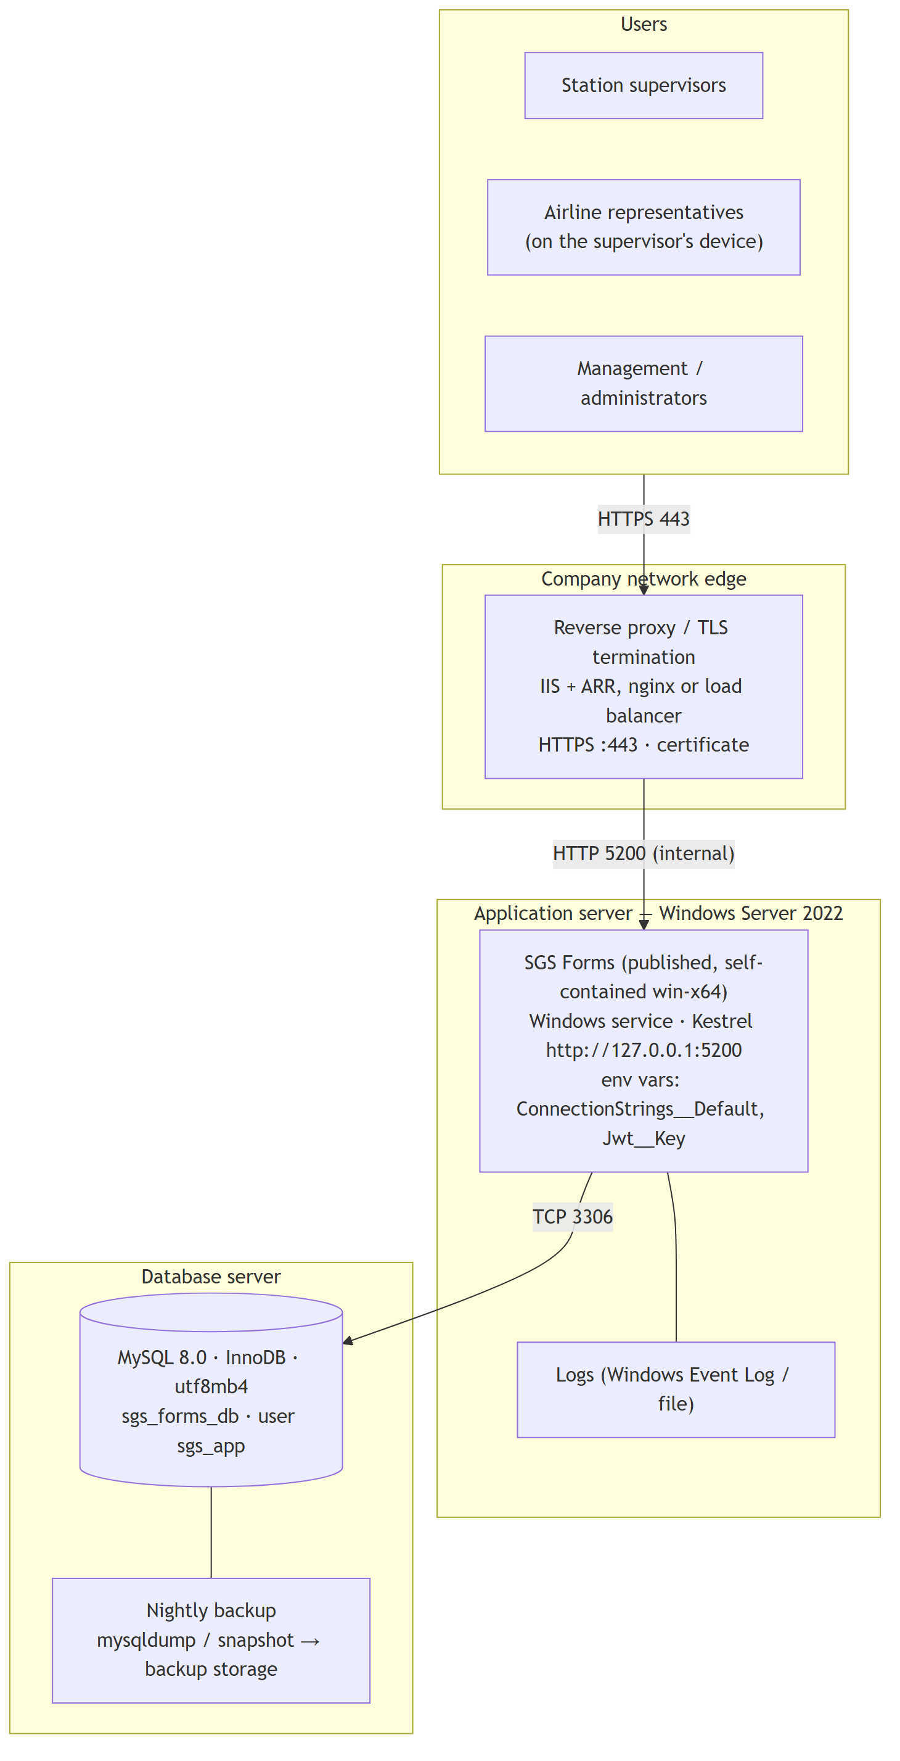

3. Components
Component | Specification
Application runtime | .NET 8 (8.0.18); published self-contained so no .NET install is needed on the server
Web server | Kestrel inside the application, behind a reverse proxy that provides HTTPS
Process management | Windows service or scheduled task with automatic restart (see install-service.ps1 of the original package)
Database | MySQL Community / Enterprise 8.0, InnoDB, utf8mb4
Secrets | Machine environment variables ConnectionStrings__Default and Jwt__Key (or appsettings.Production.json with restricted file permissions)
Backups | Daily full backup of sgs_forms_db; keep at least 30 days; test a restore quarterly
Monitoring | Windows service state, HTTP check of /index.html, disk space of the database volume

4. Environments
Environment | Database | Demo accounts
Test / UAT | separate database (e.g. sgs_forms_test) | Optional: Seed__DemoUsers=true
Production | sgs_forms_db / sgs_forms_prod | Never — first administrator via SQL Deploy/02_seed_production.sql

5. Availability options
Level | Setup | Result
Basic (current design) | One application server + one database server + nightly backup | Restart-on-failure; restore from backup after a server loss
Improved | Two application instances behind the load balancer; MySQL replica | Survives loss of one application server; faster database recovery

Note for more than one application instance: the login rate limit is kept in memory per instance, and all instances must share the same Jwt__Key.

