SGS Flight Handling Reports
Network Architecture Diagram
Document 05 of 12
Version 1.0 — September 2026
Technical documentation set: HLD · LLD · Architecture · Data flow · Database · Servers · UAT · GitHub · Code review

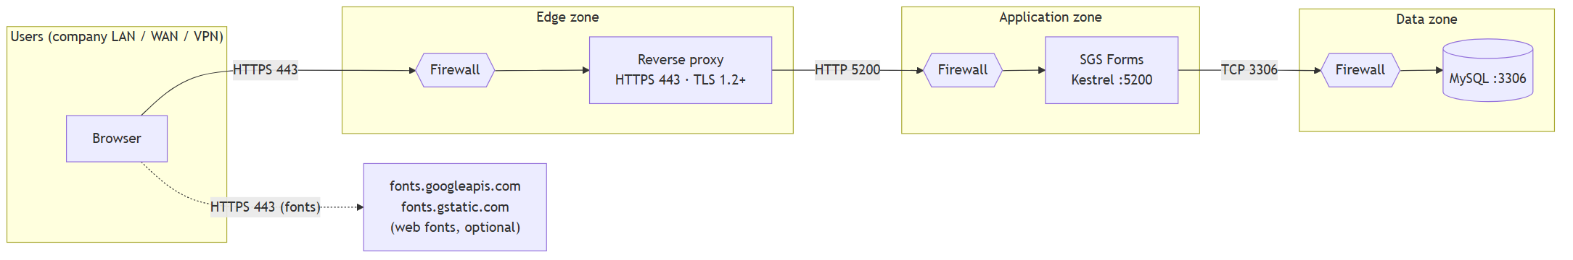

Ports and flows
# | From | To | Port / protocol | Purpose | Required
1 | User browser | Reverse proxy | 443 / HTTPS | Pages and API | Yes
2 | Reverse proxy | Application server | 5200 / HTTP (internal only) | Forward requests | Yes
3 | Application server | Database server | 3306 / MySQL | Data access | Yes
4 | User browser | Google Fonts | 443 / HTTPS | Tajawal and DM Mono fonts | Optional — pages fall back to system fonts
5 | Administrators | Database server | 3306 / MySQL | Administration, backups | From the admin network only

The application makes no outbound calls of its own.

Firewall rules
Rule | Source | Destination | Port | Action
Users to proxy | User networks | Reverse proxy | 443 | Allow
Proxy to application | Reverse proxy | Application server | 5200 | Allow
Application to database | Application server | Database server | 3306 | Allow
Direct access to 5200 | Any other source | Application server | 5200 | Deny
Direct access to 3306 | Any other source | Database server | 3306 | Deny
Everything else | Any | Any | Any | Deny

Settings that depend on the network
Setting | Value
Urls (appsettings.json) | http://127.0.0.1:5200 when a reverse proxy is on the same server; http://0.0.0.0:5200 only when the proxy is on another host and the firewall restricts the source
AllowedHosts | The public host name, e.g. reports.company.com (currently *)
ReverseProxy:KnownProxies | The reverse proxy address(es); only these may set X-Forwarded-For (real client address for logging and the login limit)
MySQL user | sgs_app limited to localhost or the application server's address (the script now creates it for localhost)
MySQL bind address | The database server's internal address, never a public interface

Security on the wire
- HTTPS terminates at the reverse proxy; the proxy-to-application hop stays on the internal network.
- The application sends Content-Security-Policy, X-Frame-Options: DENY, X-Content-Type-Options: nosniff,
Referrer-Policy: no-referrer and a restrictive Permissions-Policy.
- Once HTTPS is in place, add Strict-Transport-Security at the reverse proxy.

