SGS Flight Handling Reports
Integration Architecture Diagram
Document 06 of 12
Version 1.0 — September 2026
Technical documentation set: HLD · LLD · Architecture · Data flow · Database · Servers · UAT · GitHub · Code review

SGS Forms is a self-contained system: it has no integrations with airline, airport or enterprise systems today. Its interfaces are the browser-facing REST API, the database and file exports.
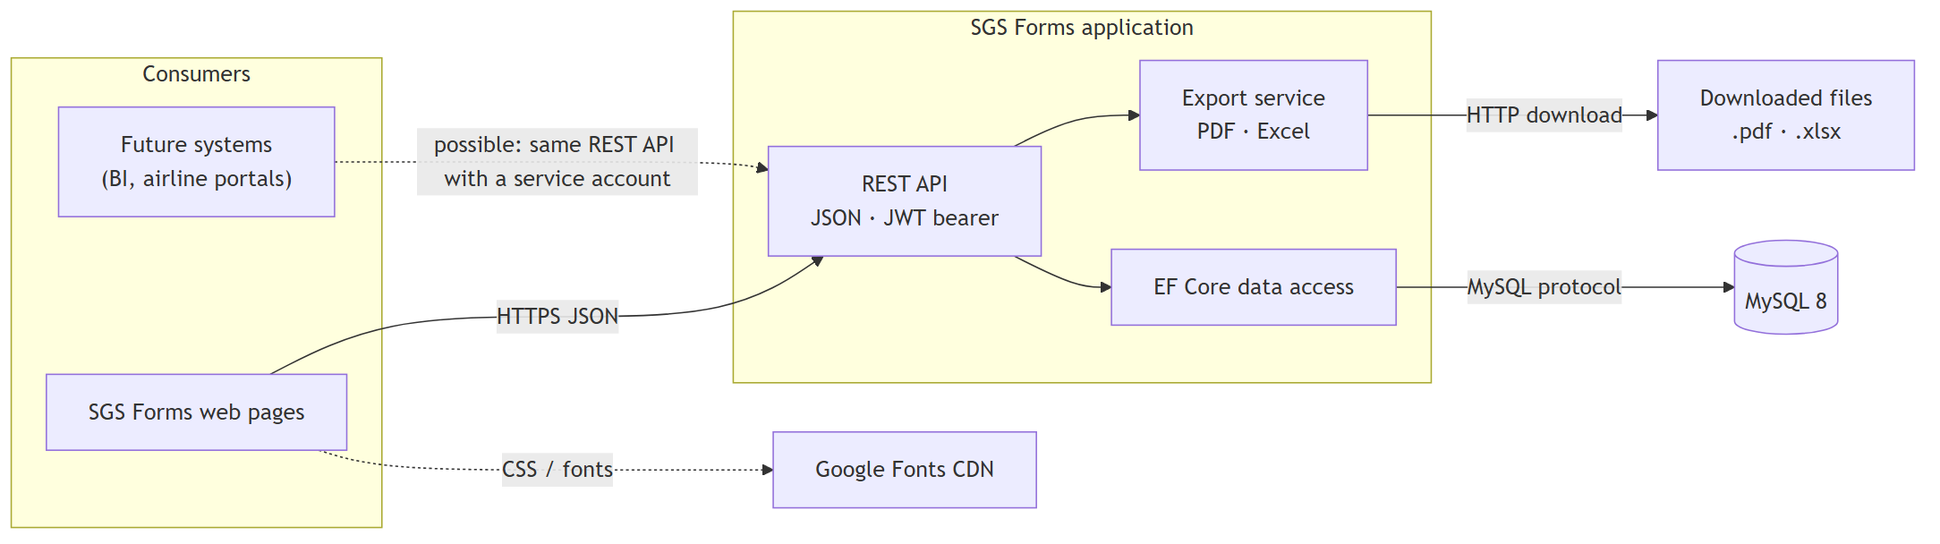

Interface catalogue
ID | Interface | Direction | Protocol / format | Authentication | Notes
INT-01 | REST API | Browser → application | HTTPS, JSON | JWT bearer (login with e-mail + password) | Endpoints listed in document 02
INT-02 | Login | Browser → application | HTTPS, form-urlencoded | None (rate-limited) | Returns token + profile + permissions
INT-03 | Database | Application → MySQL | MySQL protocol (MySqlConnector) | MySQL user / password | EF Core; migrations applied at start-up
INT-04 | PDF export | Application → user | application/pdf | JWT + export.pdf | Report and coordination sheet
INT-05 | Excel export | Application → user | .xlsx (OpenXML) | JWT + export.excel | Arrival / departure / coordination sheets
INT-06 | Web fonts | Browser → Google | HTTPS, CSS | None | Optional; no user data is sent

Integration guidelines for future systems
Need | Recommended approach
Read reports into BI | A read-only MySQL user on a replica, or a new read-only API endpoint
Push flights from an airport system | New endpoint protected by a dedicated permission and a service account
Single sign-on | Add an OpenID Connect provider in front of the existing permission model
Notifications | Outbound e-mail / webhook service triggered from the audit events

Any external caller uses the same permission model; a dedicated role with only the needed permissions should be created for it.

