SGS Flight Handling Reports
Data Flow Diagram
Document 07 of 12
Version 1.0 — September 2026
Technical documentation set: HLD · LLD · Architecture · Data flow · Database · Servers · UAT · GitHub · Code review

Level 0 — context
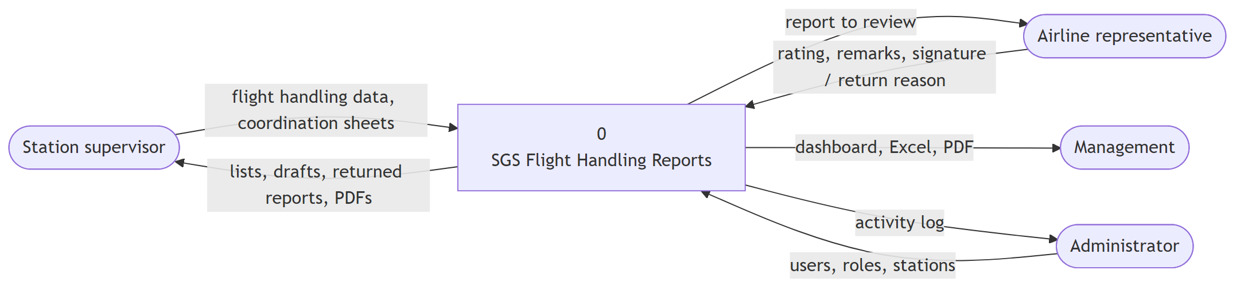

Level 1 — processes and data stores
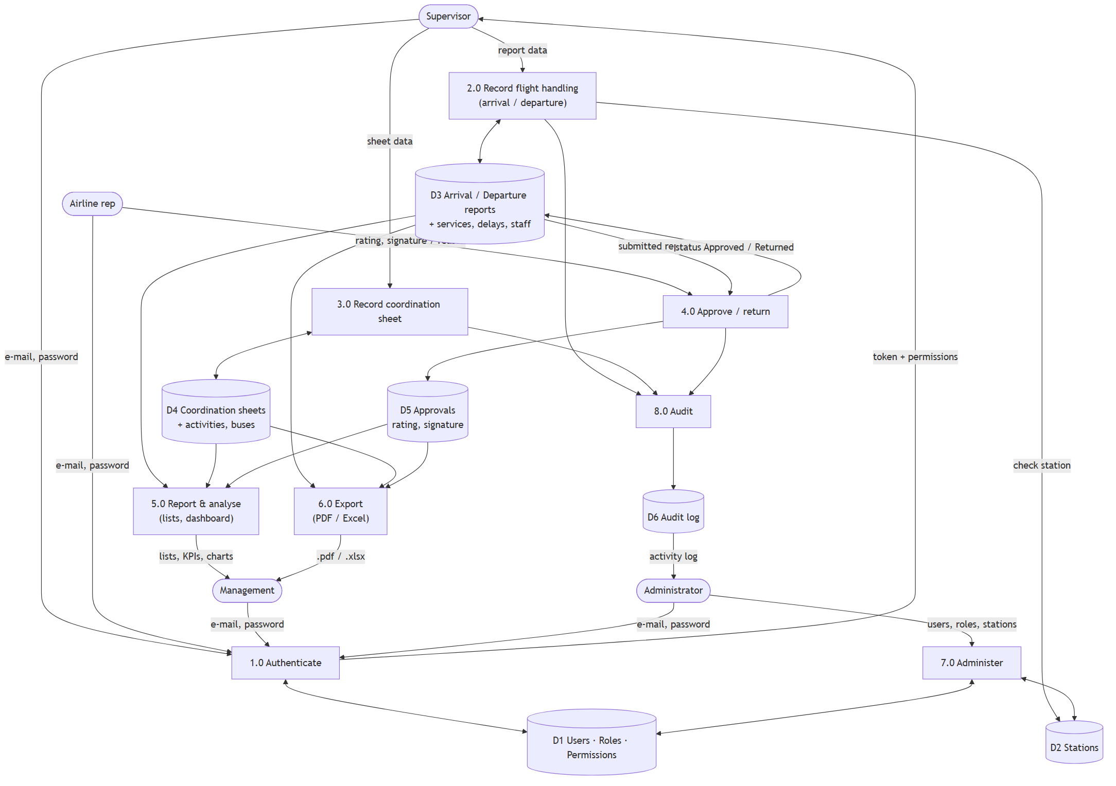

Sequence — submit, approve, export
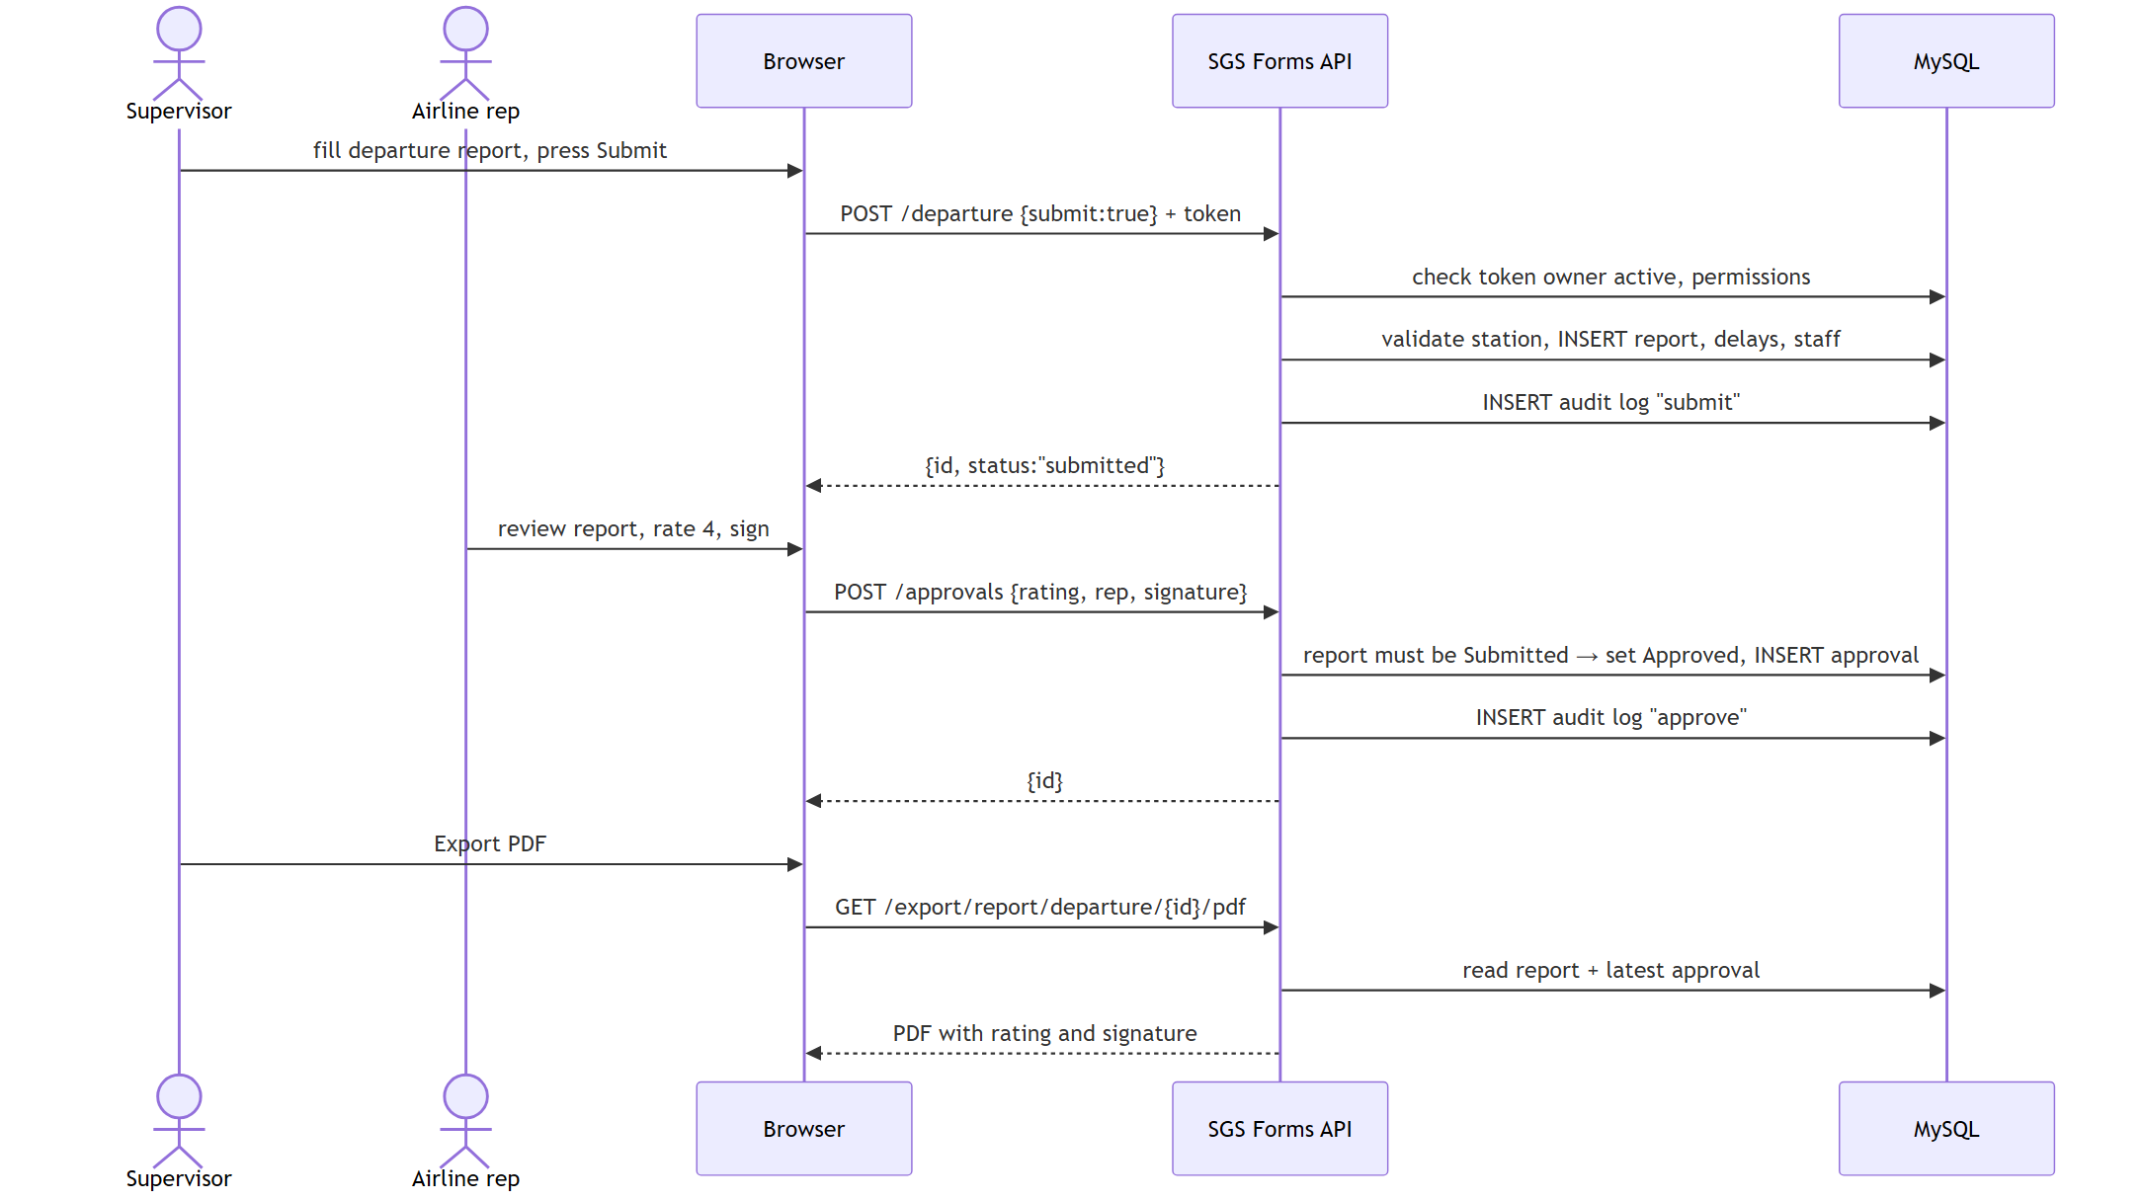

Data classification
Data | Store | Sensitivity | Protection
Passwords | D1 users.PasswordHash | Secret | BCrypt hash only; never returned by the API
Signatures | D5 approvals.SignatureImage | Personal | Visible only to users with report access for that station
Operational flight data | D3, D4 | Internal | Permission + station checks
Audit log | D6 | Internal | logs.view only; written by the server, not editable from the UI

